Now full application means Developing, Testing, Deploying a docker application:-

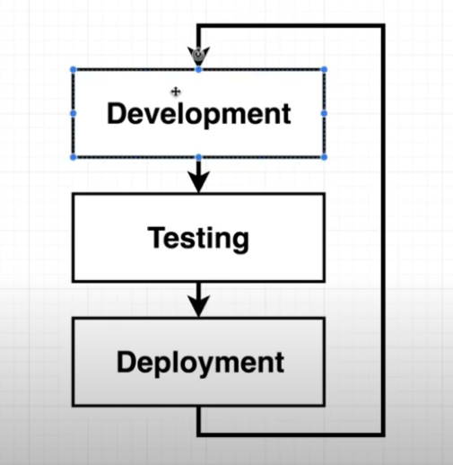
Things required:-

1. Github:-
1.1 Feature branch:- here we are pushing our changes here and create a pull request to be merge in master. Then it will be test and later merge on the master branch to deploy.

1.2 Master Branch:- main code lie here and it will test and then it will be deployed on cloud/anywhere else.

2. Travis CI :- This is continues deployment provider through which we can pull changes and do certain test (we are going to write these test).
Now here in our case we are going to use pre-genetared test.
Travis CI is also responsible to push our code to aws,

3. AWS:- we use Elastic Beanstalk.

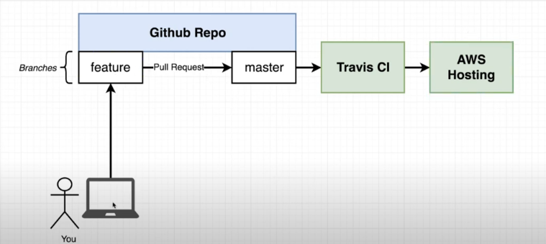
Our work flow will look like this.

Another way to understand the flow like:-

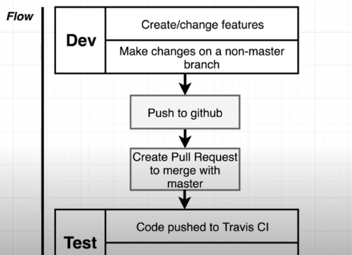

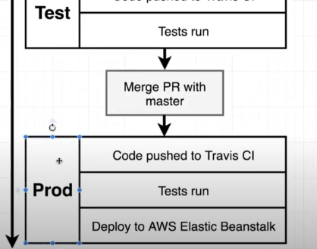
here we can see that we have three phase:-
1. Dev
2. Test
3. Prod

so travis CI is responsible to test freature branch pull request and put that into master.
After merging to Master it will test code again and deploy on AWS Beanstalk.

Here we can notice there is no need for docker:-

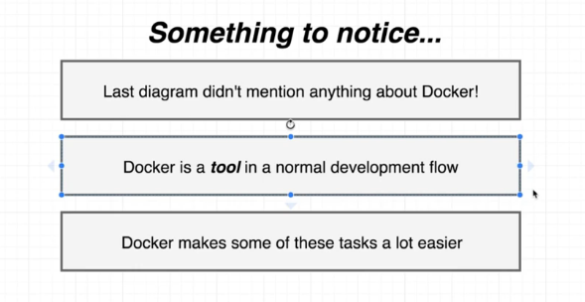
Docker involvement is not mandatory here. But using docker here, make things lot more easier.

Here we are using JS code, but we are not focusing about what code we are using, we need to make focus on how docker is managing all this.

So what we are making is very simple react application.
We will rap it on docker container, and test it on docker container.

Here we are not gonna write anything we are going to use a tiny little project generator.

Now from here we are doing Nodejs stuff, later we will come back to docker.

1. To test nodejs is install or not; $ node -v

we have node js install

2. install a tool :- npm install -g create-react-app
3. run this tool to create a react project name “frontend”:-
$ create-react-app frontend

