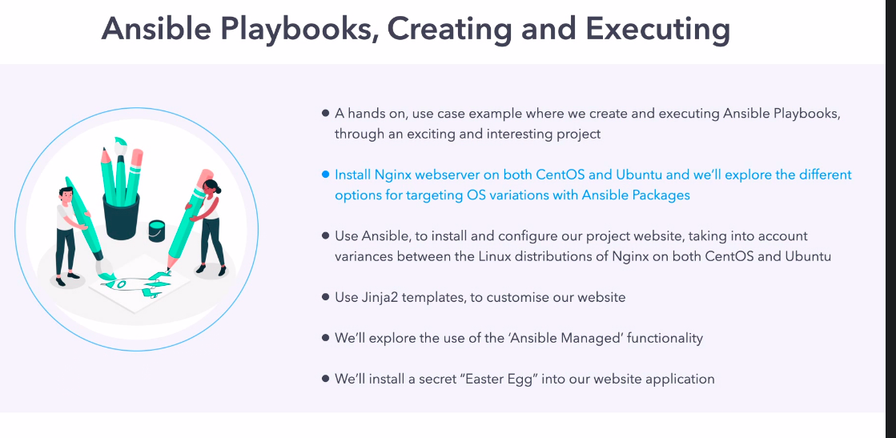
Revision 1
epel-release ==> this is an extra package for nginx when we need to install that on REHL/centos/amazon linux.

this is not required for debian based OS.

we also need when to carry out the task

we are going to use template for this lesson.

cd "/home/ansible/diveintoansible/Ansible Playbooks, Introduction/Ansible Playbooks, Creating and Executing/template"

now lets try to write an ansible script to install nginx on centos and ubuntu.

task 1

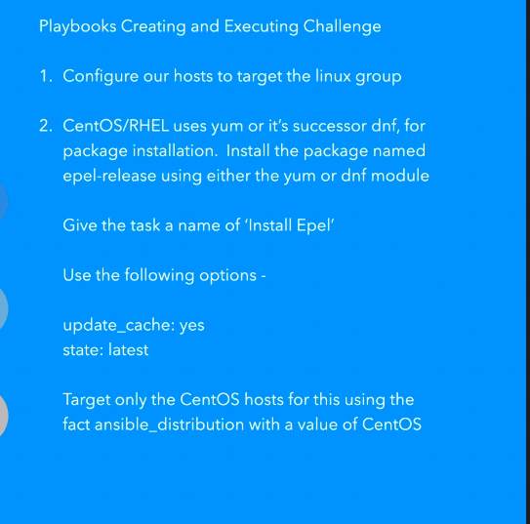

we write that playbook:-

# YAML documents begin with the document separator ---

# The minus in YAML this indicates a list item. The playbook contains a list
# of plays, with each play being a dictionary
-
# Hosts: where our play will run and options it will run with
hosts: linux
#gather_facts: True
#connection:
# Vars: variables that will apply to the play, on all target systems
# Tasks: the list of tasks that will be executed within the play, this section
tasks:
- name: install epel for rhel
yum:
name: epel-release
update_cache: yes
state: latest
when: ansible_distribution == 'CentOS'

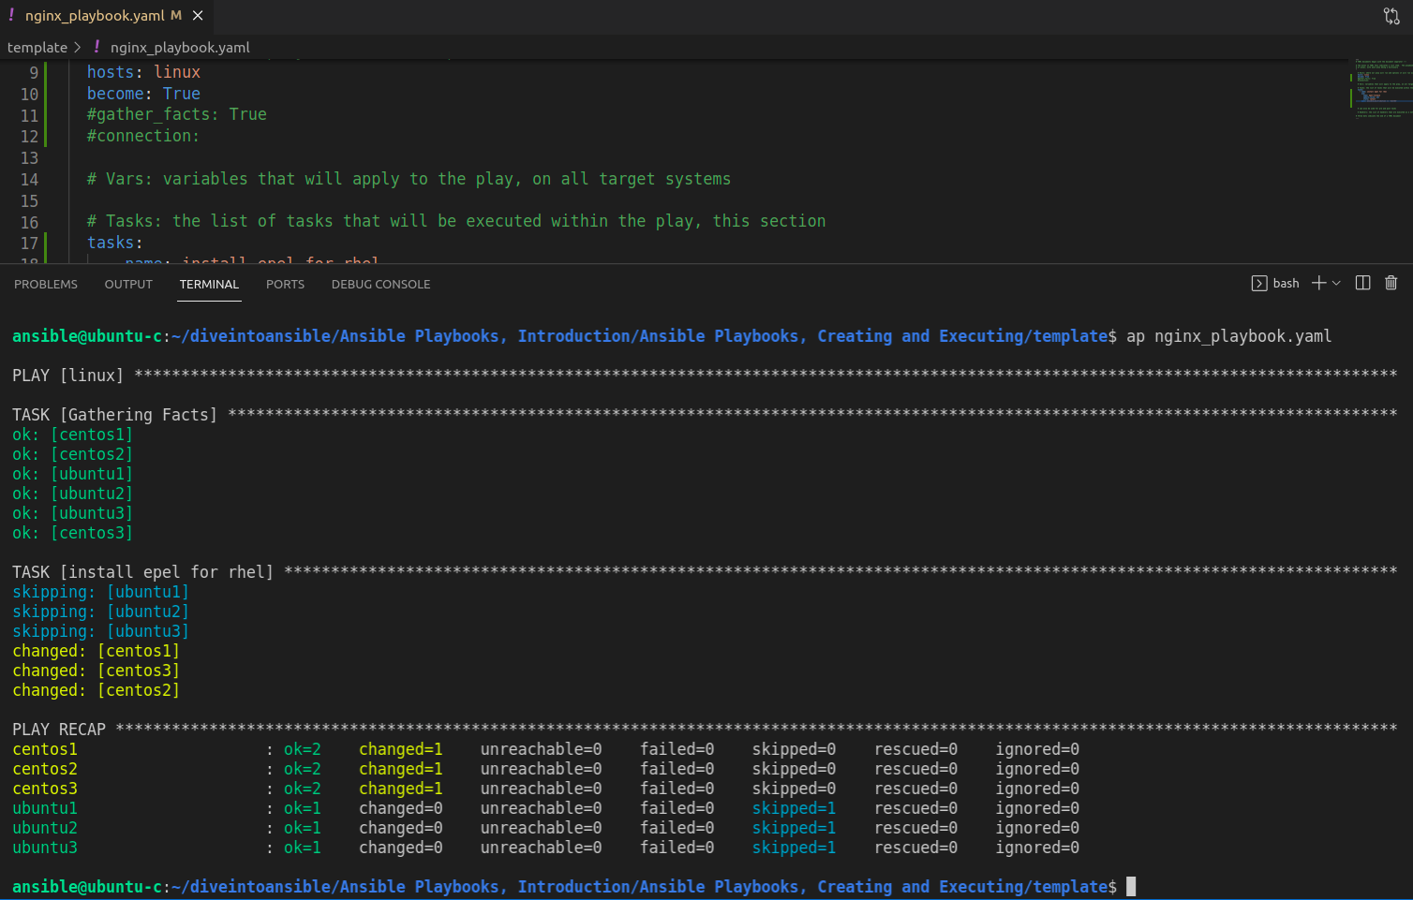

okay this is being successful.

TASK 2

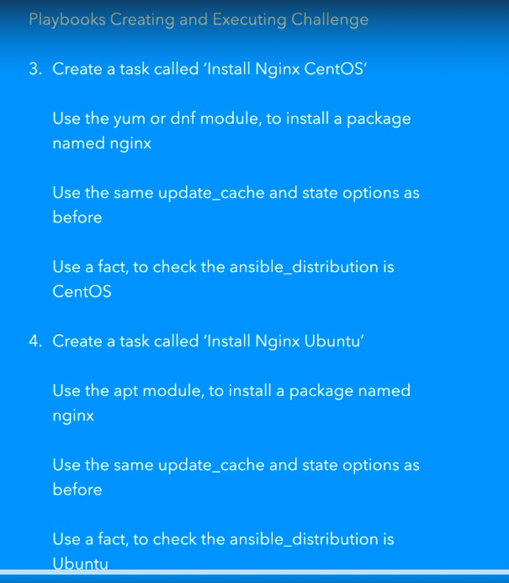

use write that code:-

# of plays, with each play being a dictionary
-

# Hosts: where our play will run and options it will run with
hosts: linux
become: True
#gather_facts: True
#connection:
# Vars: variables that will apply to the play, on all target systems
# Tasks: the list of tasks that will be executed within the play, this section
tasks:
- name: install epel for rhel
yum:
name: epel-release
update_cache: yes
state: latest
when: ansible_distribution == 'CentOS'
- name: install nginx on centos
yum:
name: nginx
update_cache: yes
state: latest
when: ansible_distribution == 'CentOS'
- name: install nginx on ubuntu
apt:
pkg: nginx
update_cache: yes
state: latest
when: ansible_distribution == 'Ubuntu'

and result is :-

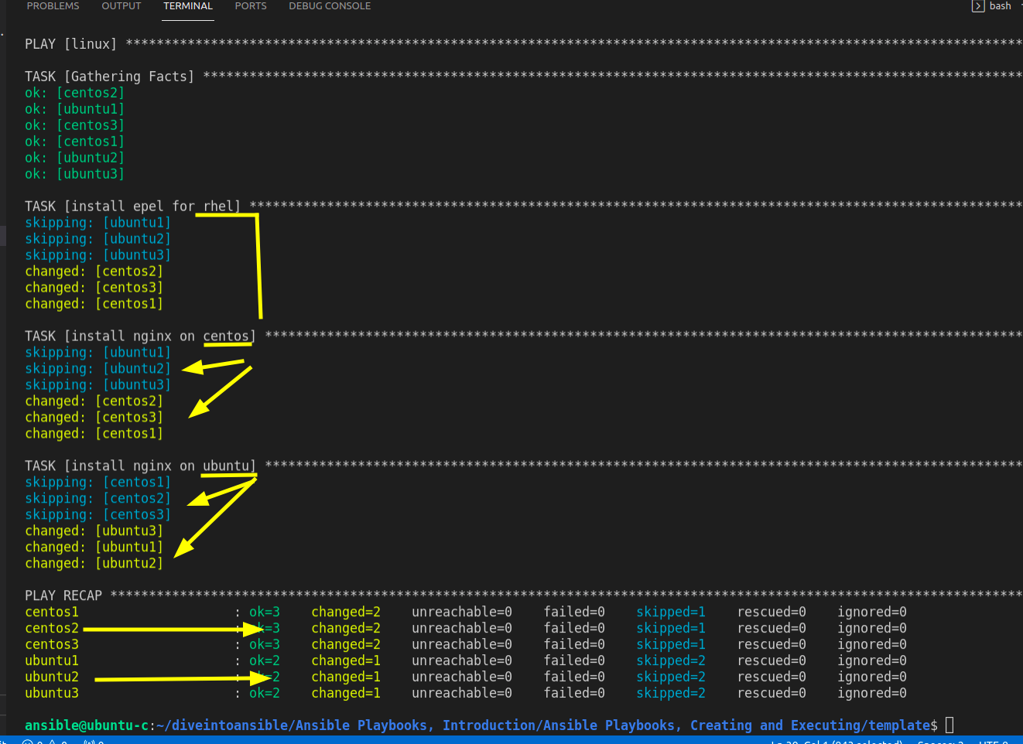

But we have to use two different module like "yum" and "apt" as different flavour of linux used. to make it convenient we can also use "package" module which is be common for linux flavour.
Also we do not need to use when clause.

TASK 3

package module

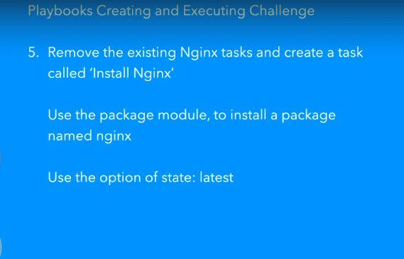

tasks:
- name: install epel for rhel
yum:
name: epel-release
update_cache: yes
state: latest
when: ansible_distribution == 'CentOS'

- name: install nginx on centos
package:
name: nginx
state: latest

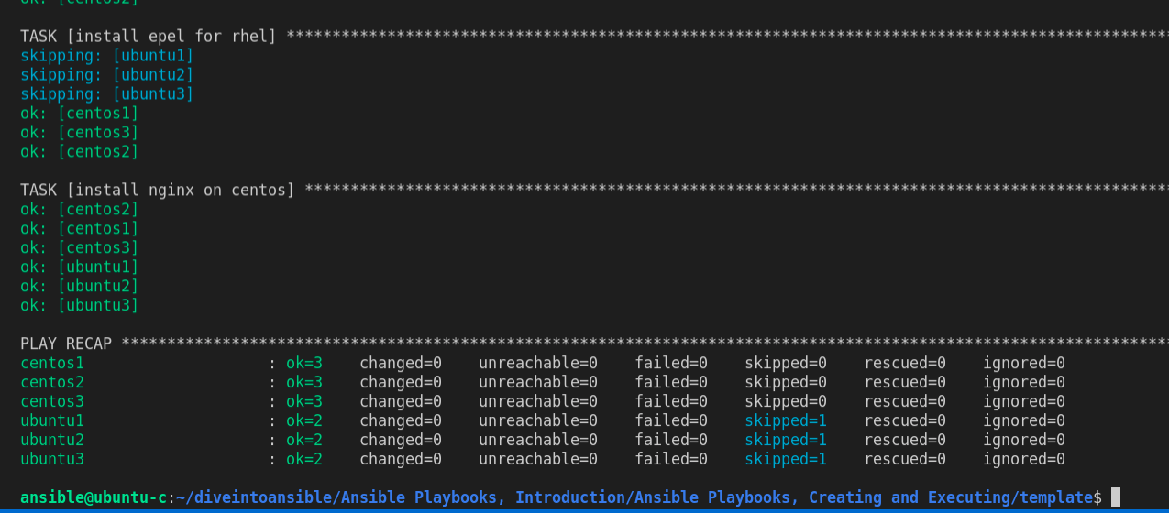

TASK 4

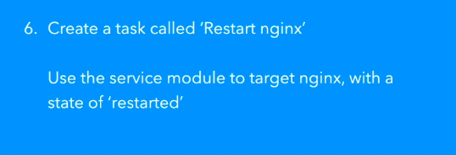

tasks:
- name: install epel for rhel
yum:
name: epel-release
update_cache: yes
state: latest
when: ansible_distribution == 'CentOS'

- name: install nginx on centos
package:
name: nginx
state: latest
- name: restart nginx service
service:
name: nginx
state: restarted

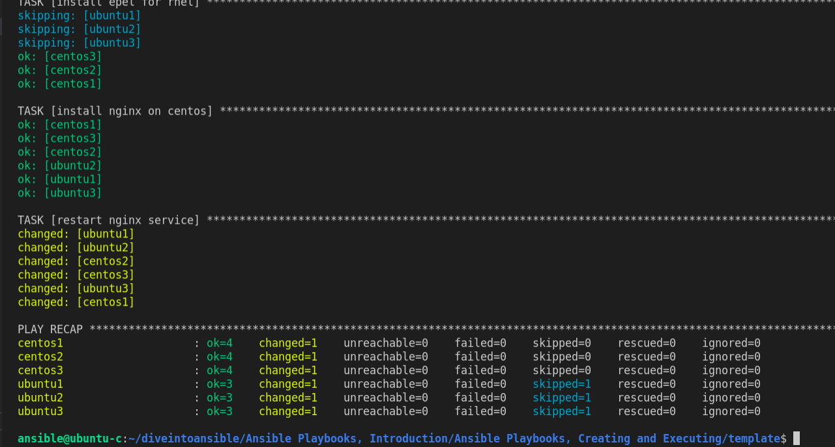

Yellow means change happens.

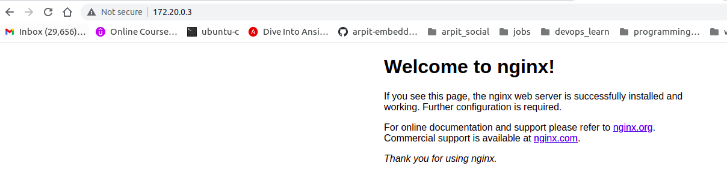

Alright, but here we are making an assumption that all will go well for sure, but it is not good to do so.

suppose nginx is not restarted properly, to handle this senario we need to check its http response as well.

we are going to use URI module and we are going to use facts to get ip address ans check status code of 200, of ansible hosts.

we will use handler to achieve this.

Remember:- for handlers to work it need to be notify.

CSV file full form --> comma separated value file

tasks:
- name: install epel for rhel
yum:
name: epel-release
update_cache: yes
state: latest
when: ansible_distribution == 'CentOS'

- name: install nginx on all
package:
name: nginx
state: latest
- name: restart nginx service
service:
name: nginx
state: restarted
notify: check http status
# can also be used for pre and post tasks
# Handlers: the list of handlers that are executed as a notify key from a task
handlers:
- name: check http status
uri:
url: http://{{ ansible_default_ipv4.address }}
status_code: 200
# Three dots indicate the end of a YAML document
...

here we are expecting status code of 200.

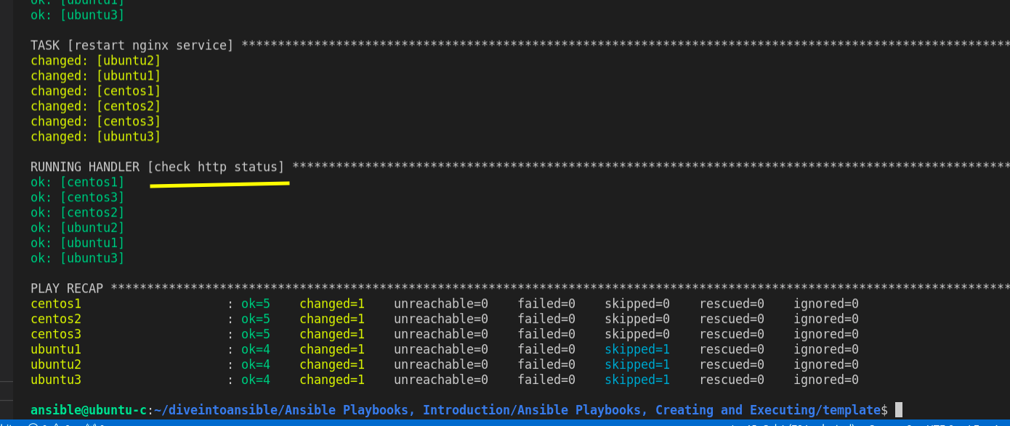

OKay.
but we can see putting index.html on nginx for ubuntu and centos we have different path

for centos:- /usr/share/nginx/html.

for ubuntu:- /var/www/html
we need to consider this while putting index.html using nginx.

TASK 5

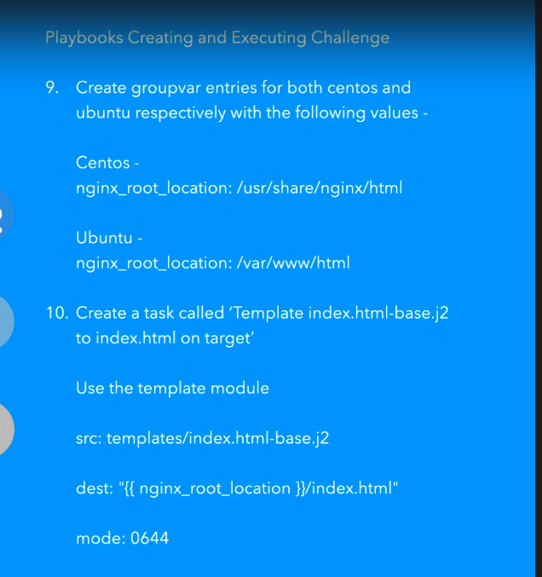

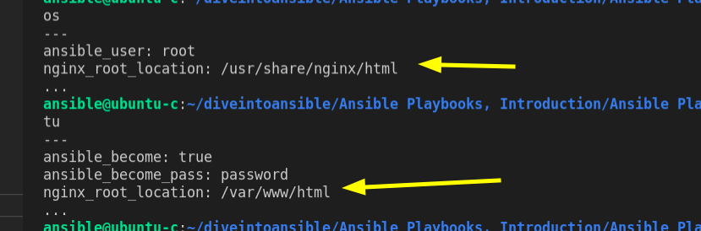

we are going to use index.html with our template.

we are going to use template module.

code is:-
tasks:
- name: install epel for rhel
yum:
name: epel-release
update_cache: yes
state: latest
when: ansible_distribution == 'CentOS'

- name: install nginx on all
package:
name: nginx
state: latest
- name: restart nginx service
service:
name: nginx
state: restarted
notify: check http status
- name: Template index.html-base.j2 to index.html on target
template:
src: index.html-base.j2
dest: "{{ nginx_root_location }}/index.html"
mode: 0644
# can also be used for pre and post tasks
# Handlers: the list of handlers that are executed as a notify key from a task
handlers:
- name: check http status
uri:
url: http://{{ ansible_default_ipv4.address }}
status_code: 200
# Three dots indicate the end of a YAML document
...

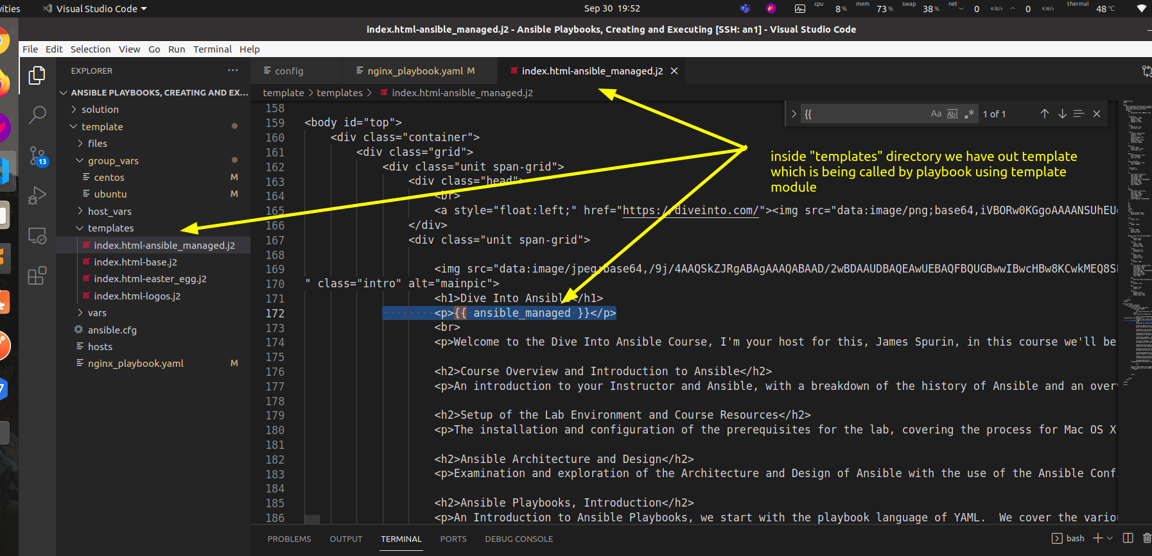

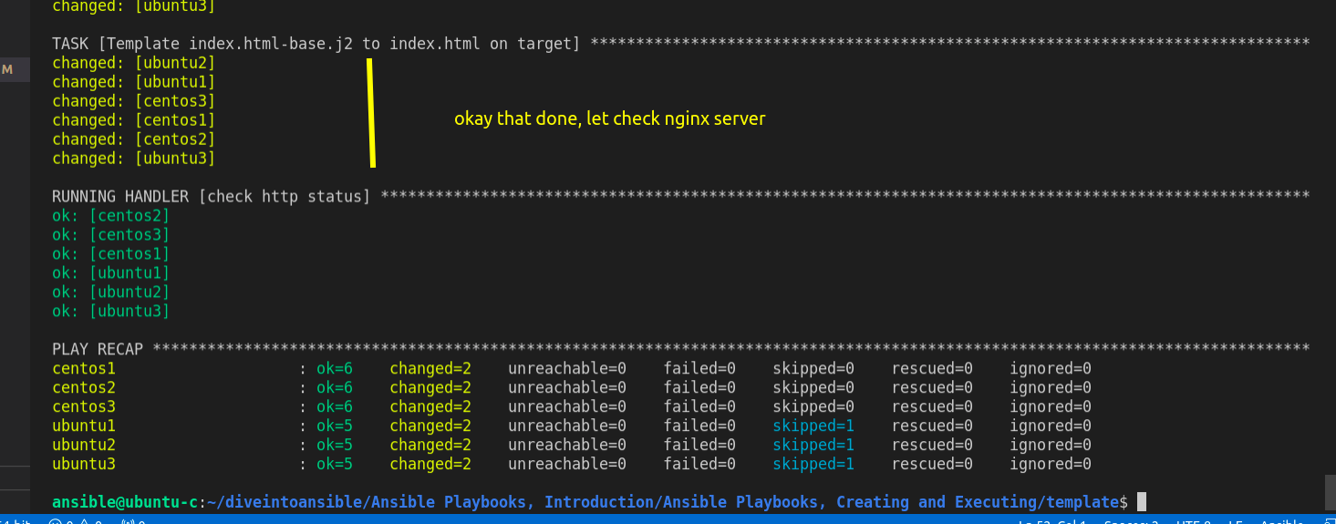

okay

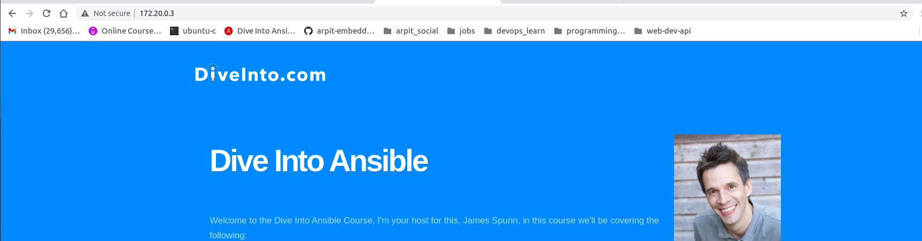

Now we are going to look how ansible_managed

ansible_managed allow us to reference variable to make template and activity.
this is used to derive how action is derived.

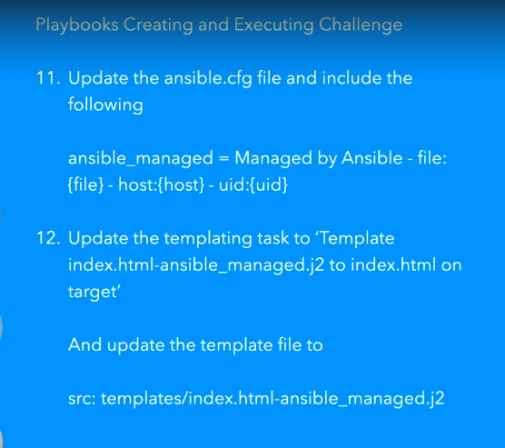

Task 11

lets change ansible.cfg

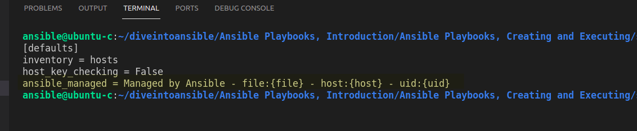

so this is managed by ansible with filename, host, uid.

basically it is exporting variable "ansible_managed" to template.

we have this variable into template.
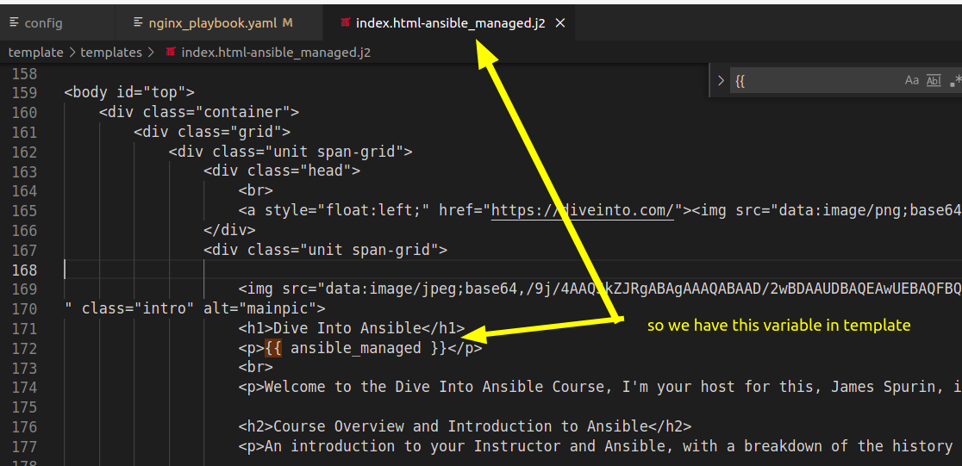

now run this playbook.

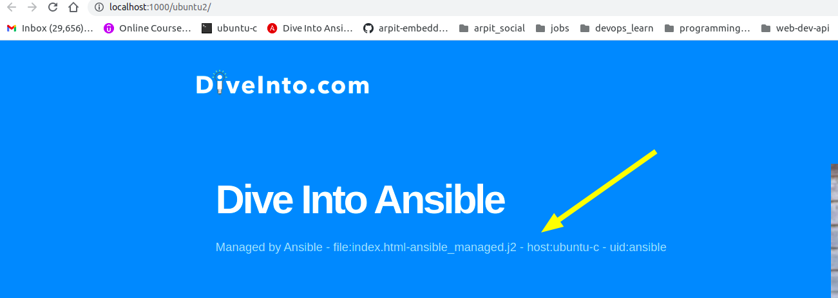

Revision 8
we will try to use vars

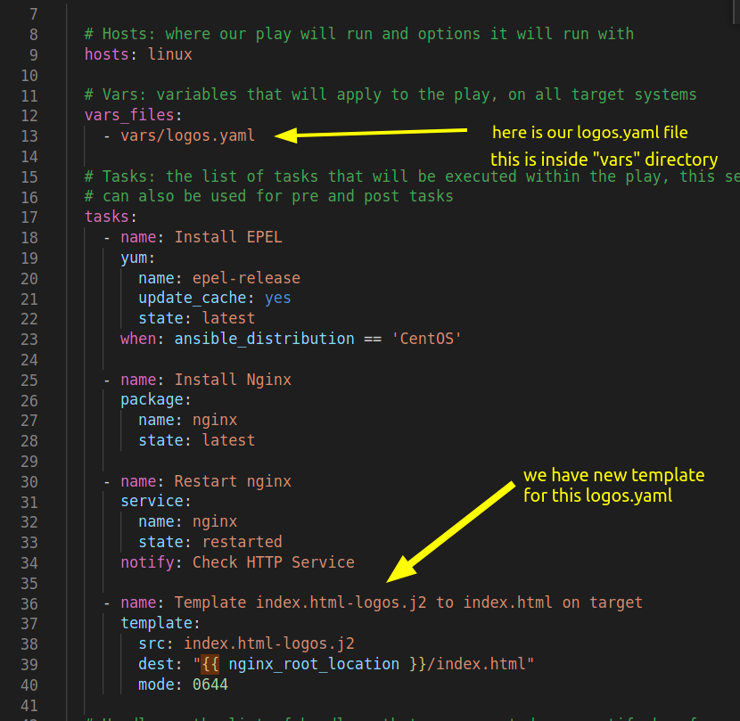

lets run this playbook.

and if we run this.

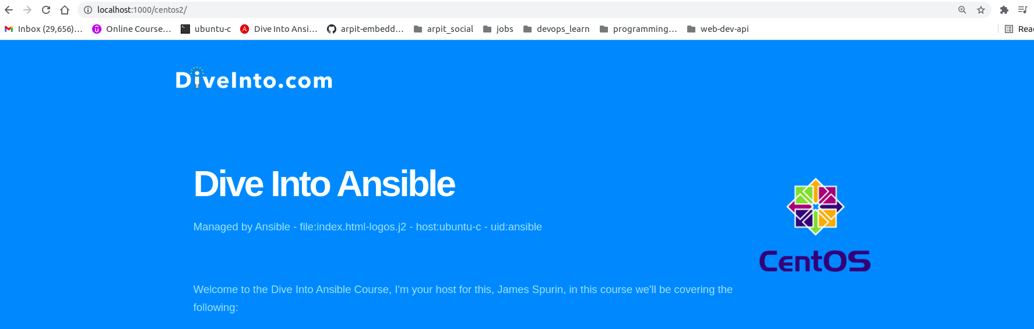

we have this centos logo.

in template file, we use jinja2 template if condition like:-

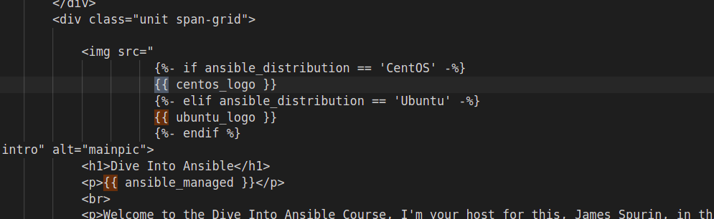

Revision 9

unarchive module to unzip the archive. but is relie on unzip. like if we see playbook.

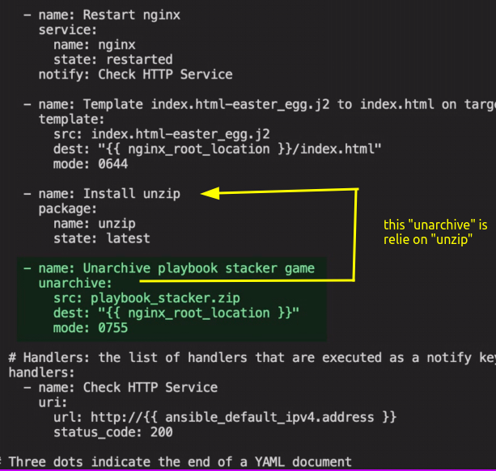

lets run this playbook.

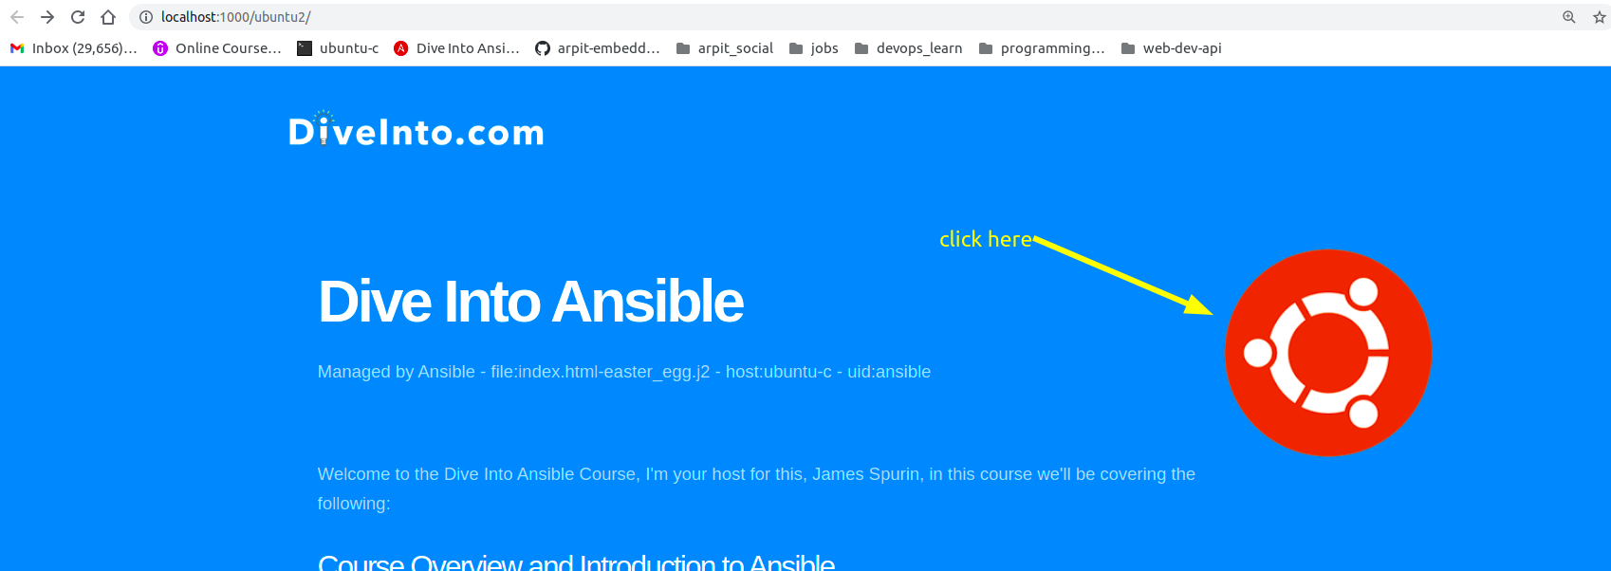

this will take us to game.



