AWS Solution Architect -> Associate level

Cloud computing is the on-demand delivery of compute power, database, storage, application, other IT resources, through cloud service platform via Internet with pay-as-you-go pricing model.

Characteristic of cloud:-
- On demand self service => where are you want service you will get
- Broad Network Access
- Scalability
- Resource Pooling => all the resource is at one place, we just need to get which amount we want like water in pool.
- Measure services => we can measure what kind of people, which place, even which age and like this all stuff visited of on our resource.

Three type of certificate are famous in AWS

- AWS -> solution Architect (begineer level) -> $150 dollor
- AWS-> Devops => developer and operation
- AWS-> Sysops => System Admin and Operation

In Solution Architect there are two levels :-
- Asscociate (begineer)
- Professional

Lecture -2

AWS Solution Architecture -> Associate

Service Model / service in cloud

- IAAS -> infrastructure as a service
- PAAS-> platform
- SAAS->software

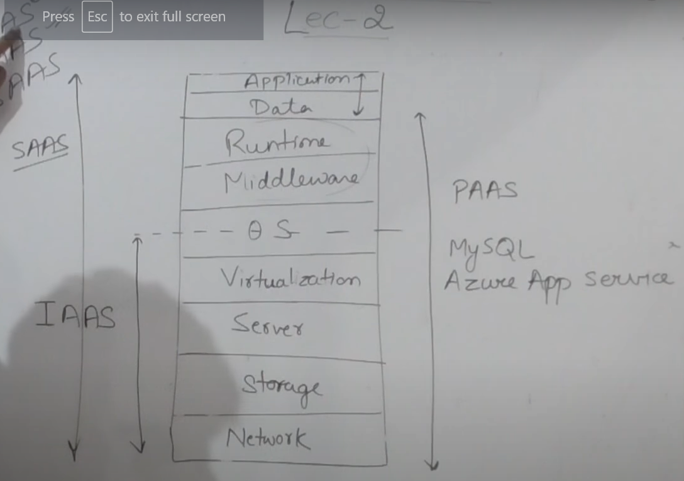

Deployment Model of Cloud:-
- Public cloud => AWS, AZURE, GCP.
- Private cloud => like company made a cloud for there own use, enterprises cloud.
- Hybrid cloud => you can integrate public cloud with there own private cloud -> Azure is good for that.

There is also a concept in Public cloud i.e virtual private cloud.
It is private cloud but created virtually by public cloud.

Virtualisation :- by the help of hypervisor

Microsoft use -> hyper-V
VMWARE use -> Vsphere ESXI
AWS use -> citrics

So the logic is -> first you have Infra then by doing virtualise the Infra then you have cloud.

Lecture -3

How to create AWS free Tier Account

Search is google -> AWS free Tier Account.

-> create a free account -> create a new AWS account. -> fill all the cred.

Kind of account -> personal -> fill required info -> do payment information.

-> in AWS we can put Debit card detail also.

And get 1 year subscription. -> now your account is create -> you can start using this .

Lecture -4

Full Theory of Elastic Compute cloud Part-1

Here we learn about virtual server , virtual machine.

Azure called this is Virtual machine , while AWS called this as EC2.

EC2 -> Elastic compute cloud.

EC2 provides Scalable computing capacity in the AWS cloud.
Using Amazon EC2 eliminates your need to invest in hardware up front, so you can develop and deploy application.

This means if you want 4GB ram server or 8GB ram server or 500hdd or 256ssd , all you can configure there.

Here “instances” word is use for “virtual machine”

In Amazon server you can create many EC2 instance, so you can create many server , configure its security, networking and manage resources as well.

You can upgrade you existing server as well, without creating new one if you required more.
And if you required less , then you can downgrade it as well, this will reduce your operation cost as well.

Amazon EC2 having two storage option:-
- EBS => Elastic block store
- Instance store

Root volume are those volume where operating lies. So for that Root volume we can use two types of storage EBS and Instance store.

Difference is that EBS is reside separate from physical server. But instance store is coming from Host memory.

So, instance store is fast but it is volatile , so when we switch off the server , this memory will be deleted.

Pre-configure templates are already available known as Amazon Machine Image. Such as Windows server 2012, ubuntu server, centos server, etc.

If you want you can choose from that as well.

Important Remember:- By default , when you create an EC2 account with amazon, you account is limited to a maximum of 20 instances per EC2 Region with two default High I/O instance.

There is by default 20 instance in an region , if you want more you can request from Amazon.

Types of EC2 Instance -> there are 7 type (in july 2019)

- General Purpose -> Balance Memory and CPU.
- Compute Optimized -> More CPU than RAM
- Memory Optimized -> More RAM
- Accelerated Computing /GPU-> Graphics Optimized
- Storage Optimized-> Low Latency
- High Memory Optimized -> high Ram and Nitro system .
- Previous Generation

Nitro system is kind of hypervisor , used for virtualization, optimoize all resources smartly, increase throughput.

Lecture -5

Full Theory of Elastic Compute cloud Part-2

General Purpose Instances provide a balance of compute memory and networking resource, and can be used for variety of workload.

