step for deploying EKS on aws:-
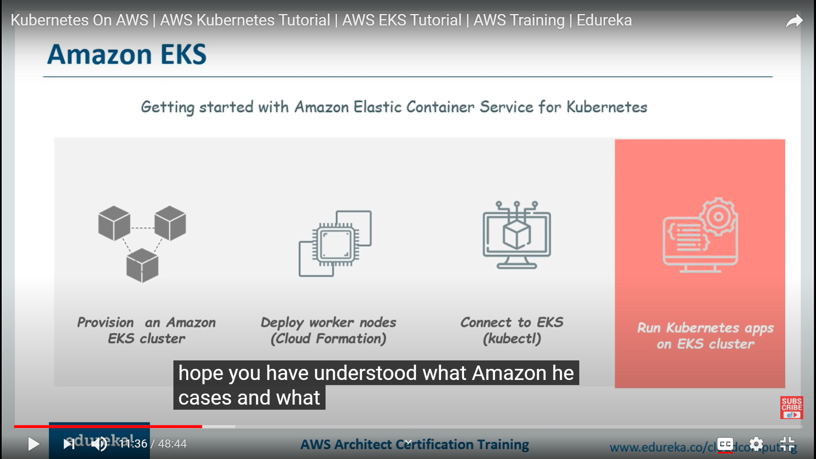

here there is no concept of "master node" we are we need to add "worker nodes" to EKS endpoint.

first, we need to assign IAM role to give permission to k8s so it can control resources on your behalf.
secondly, we need to create VPC and security group.

create IAM roles

IAM -> roles-> create roles ->EKS -> set permission
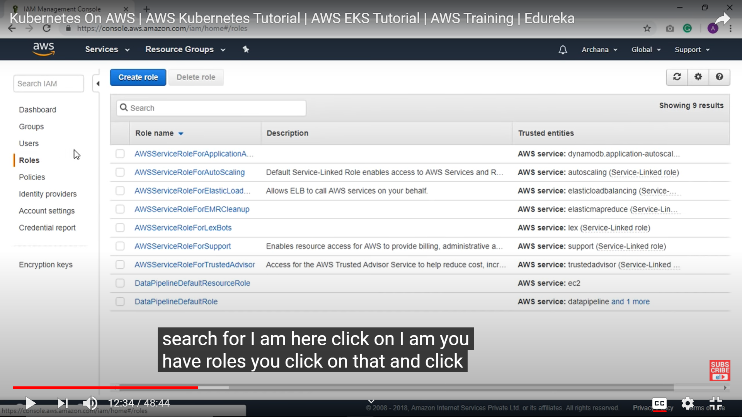

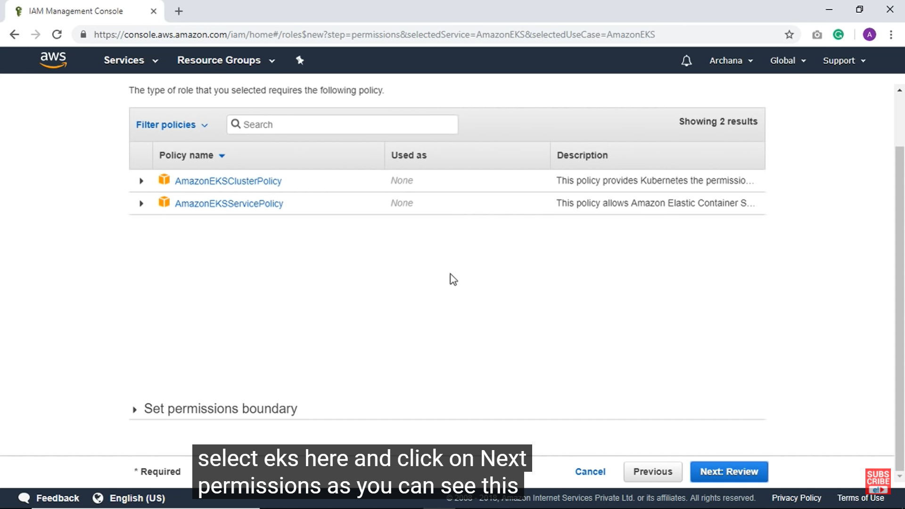

So there were two policy:-
- EKS cluster policy :- this will allow k8s to manage resource on your behalf.
- EKS service policy :- this allow to create and manage necessay resource that will help to manage k8s.

click to review and give role name and create.

Secondly, we need to create VPC ans security groups.

we will do that using "cloudformation tool" this tool is just like Terraform.

this is our cloud formation console and click on "create stack" button.

