the most important services for solution architect associate exam:-

- compute -> Ec2 and Lambda
- storage -> S3
- database -> RDMS, dynamoDB, redshift
- Network and content delivery
- Security, Identity and Compliance

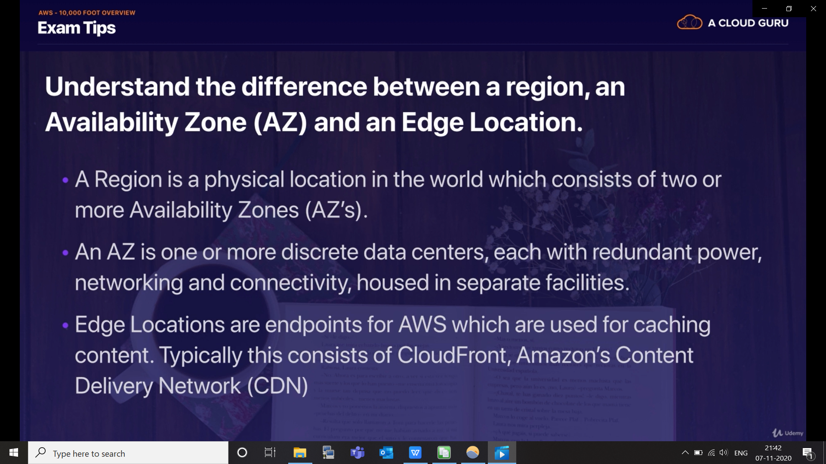

when you try to make a new account in AWS:-

you email is consider as root account login.

