Billing Alert

login in to console -> billing dashboard -> billing preference -> received billing preferences -> save preference.
and now go to management console -> services -> cloudwatch -> billing -> create alarm

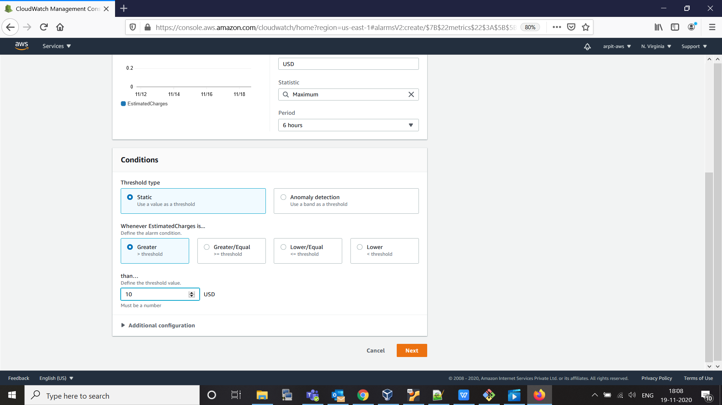

mention amount you want to set for alarm , I set it to 10 usd.

now for alarm we need to mention our email -> create a new topic and put your email address

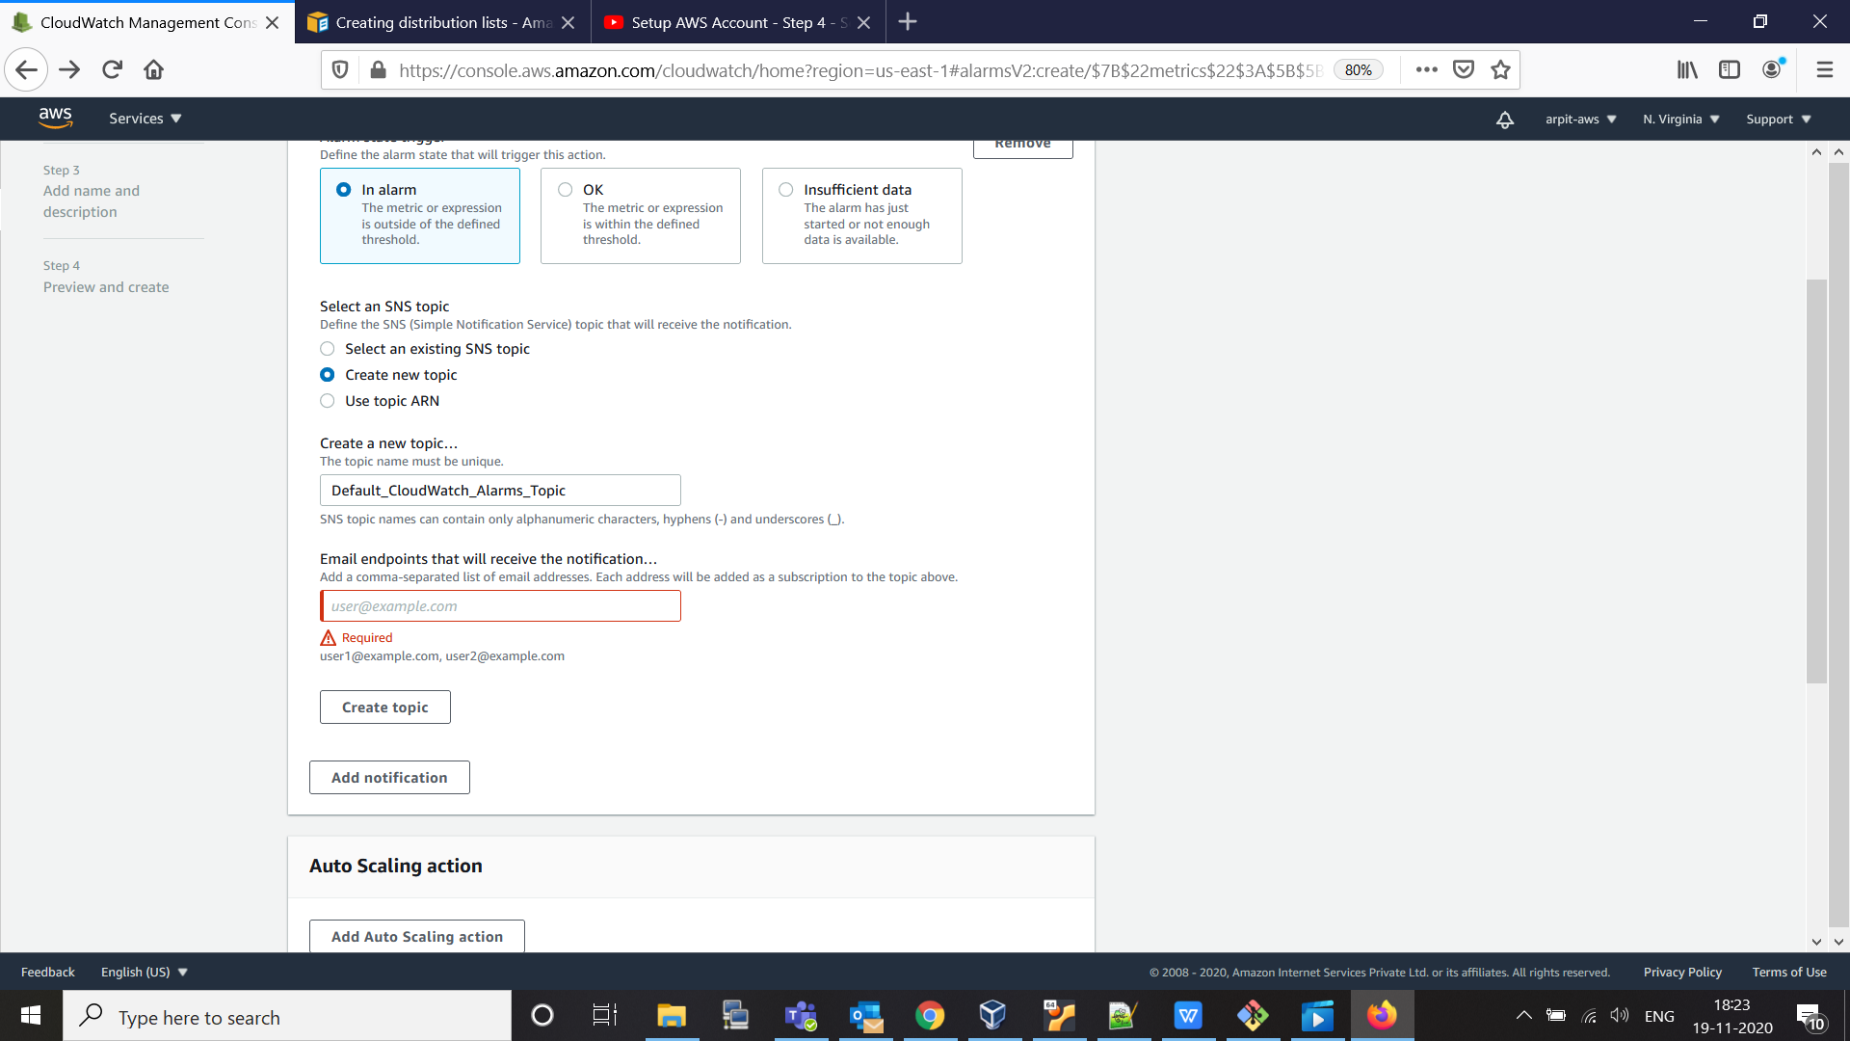

then -> create topic -> do next -> create your alarm .
now a conformation mail send to your email id , to confirm notification service.

