Context :-
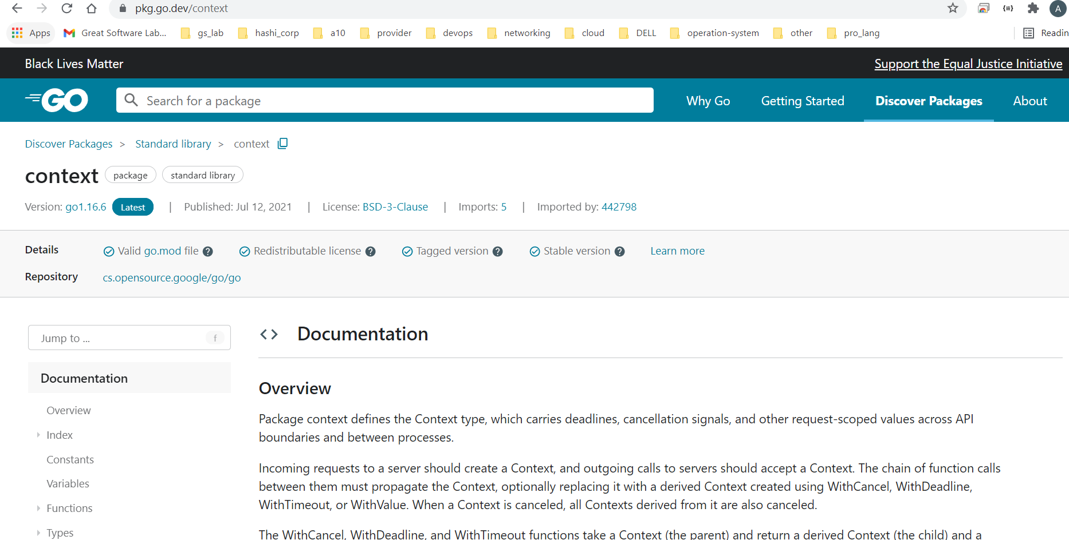

we need to look into context as:-
1. what is context value ?
- how to create context value to pass them to function ?
- how to define those function that receive those value ?
- how context make your http client and server more efficient ?

Now lets get start with theory

Cancellation:- when you are requesting some service and in meanwhile when the service is being prepared to be deliver, you realise that you don't need that service any more, So at that time the whole process stop at that moment.

Context actually transfer value and those value are important especially when you want to log stuff.

when you go through document :-
There is an important datatype called context type

In context package there is an interface and four method
out of four method, three are related to cancellation and propagation and one is for values.

- context.Background

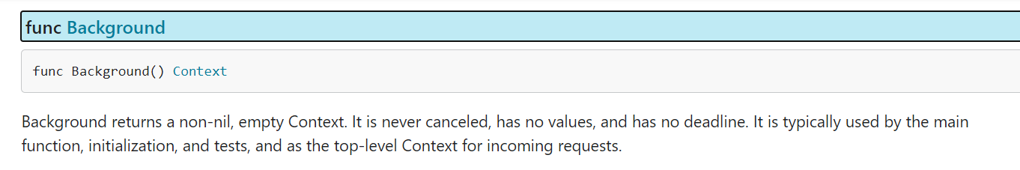

here we are starting the action and at that very early point even we don’t need cancellation at that early point.
basically this is root context.
Imp ==> rest is children created from that background context

So Actually we are creating that is tree of context.

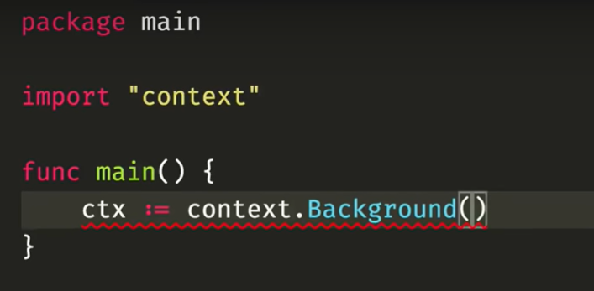

this is how we define context.Background()

Now assume a dummy function sleepandTalk this will sleep for some time and then print

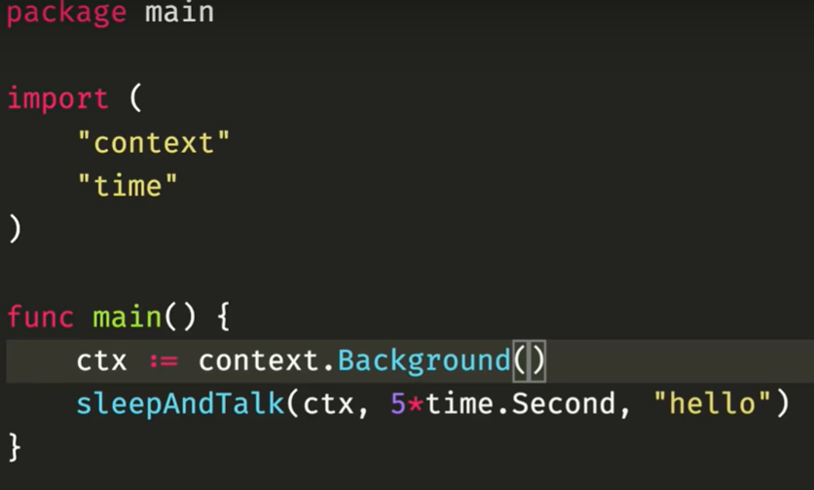

Now lets take a condition where we need to cancel while sleepAndTalk is executing when and user input is given.

for that lets create a new context that is child of previous context (backgroung) with cancellation.
ctx, cancel := context.WithCancel(ctx)

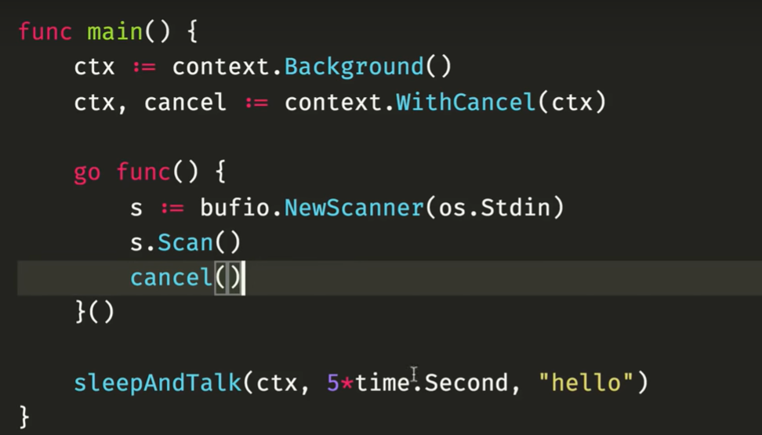

here there is anonymous function, which is running concretely, and when somethings some in s.Scan() that will move toward cancel() .

time.Sleep(time.Second * 5) ===> this will going to sleep for 5 second

time.AfterFunc(time.Second, cancel) ==> this will cancel

for http client:-

