Map is pretty much similar to struct, but have some significant difference.
some analogy :-
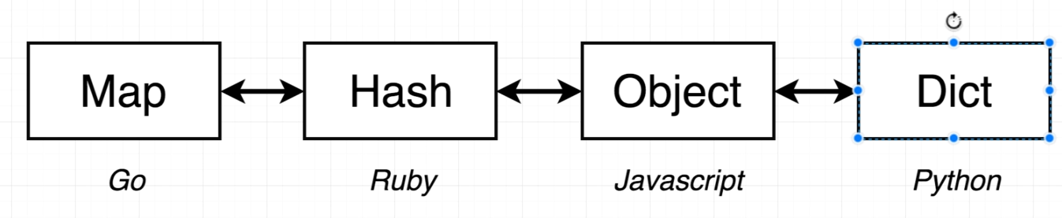

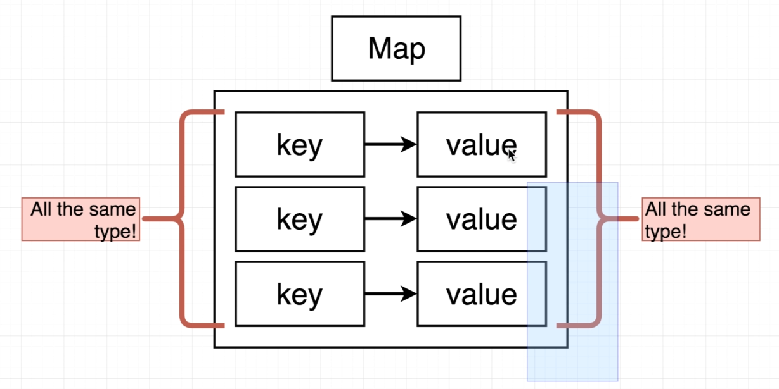

Here one thing to understand about maps is LHS (all keys) must have same datatype,
and all RHS (all values) must have same datatype.

there were more thatn one way to declare a map in go.

g=> colour := map[string]string => this means all keys will be string only and all value must be string only.

package main

import "fmt"
func main() {
colours := map[string]string{
"RED": "R",
"BLUE": "B",
"GREEN": "G",
}
fmt.Println(colours)
}

O/p => map[BLUE:B GREEN:G RED:R]

fmt.Println(colours["RED"]) => R

now we want to just initialise a map but don’t want to declare now, may be later.
Then we can use two statement like:-
- var colors map[string]string
- colors := make(map[string]string)

both about two statement are equivalent and have empty value of map init.

when we want to later add value we can always use :-

colors["white"] = "W"

