we are using TCP network onto which we are running http protocol.

HTTP is just bunch of rules how we will send stuff.

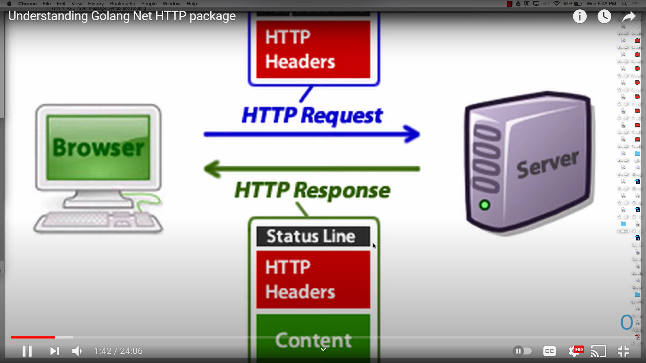

In golang "http" comes under "net" package.

So best Entrypoint to learn about net/http package is "handler interface"

like:-
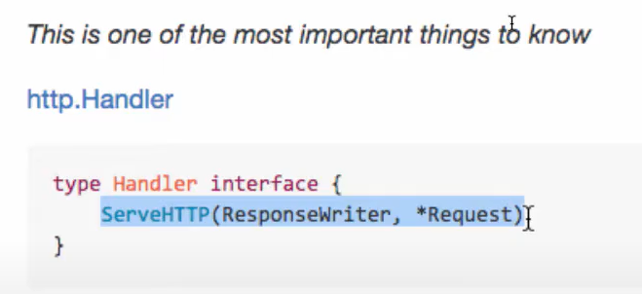

so anything (any type) which has this method(ServeHTTP) will be member of handler interface.

