Video no-37, name - structs in go

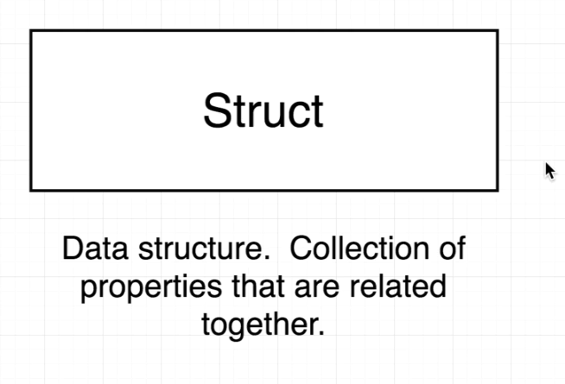

so we can create a data-structure that contain value and suit for cards.

so struct is datastructure in go that collect in different datatype.

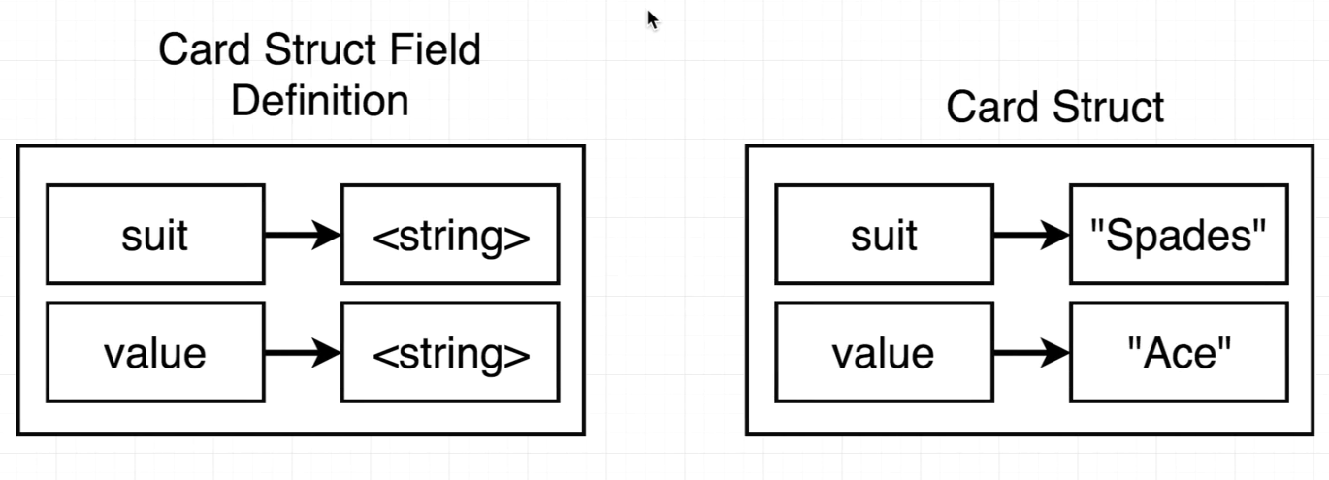

just a analog, as dictionary in python we have struct in go.

Now we are going to create a new project just to under struct.
create a directory name "struct" and write editing.

