flow to setup go

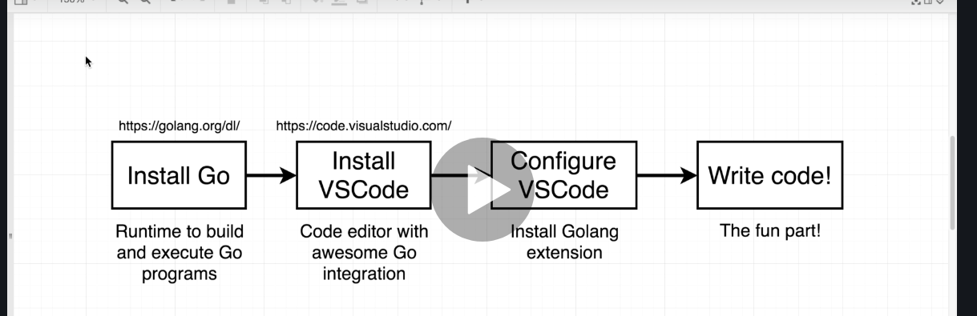

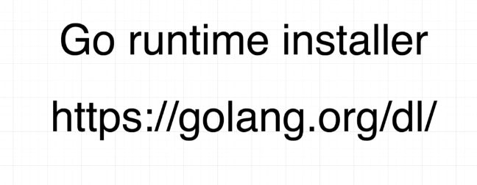

go to this link
download it and install.
then in command line type
> go

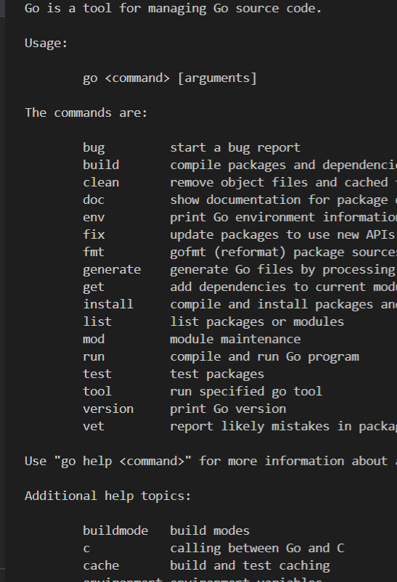

this go command is primary tool to interact with golang.
so we use this go tool to build, compile, test and other stuff.

download vscode and install go extension.
after that 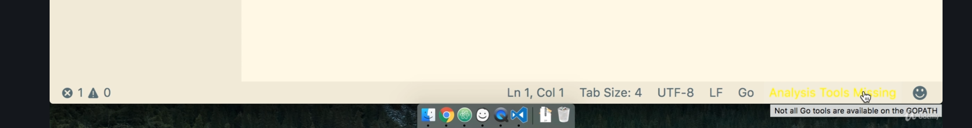
at bottom , new file -> select go -> click in analysis tools and install them.

