lets assume an example to playing with the deck of cards.

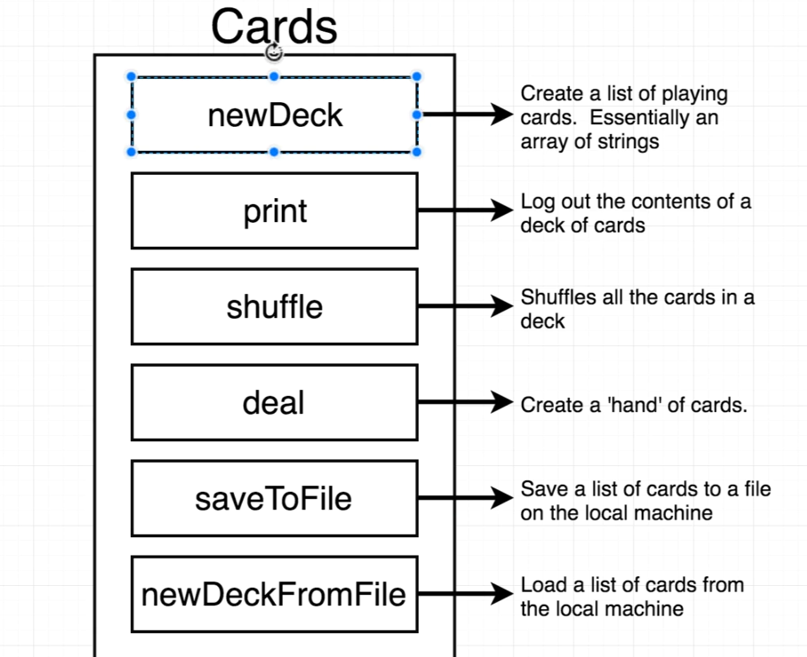

This above example we are going to treat it like project.

so create a new directory that work as new project. let it be "CARDS"
and create a create a file "main.go" have package "main" and main() function.

lets define a variable like
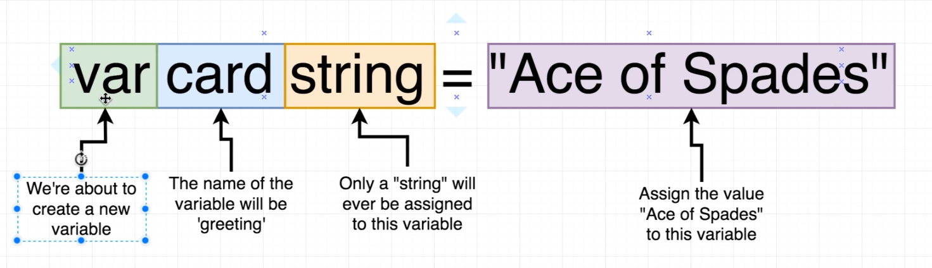

GO is refer to statically type language, look at the picture

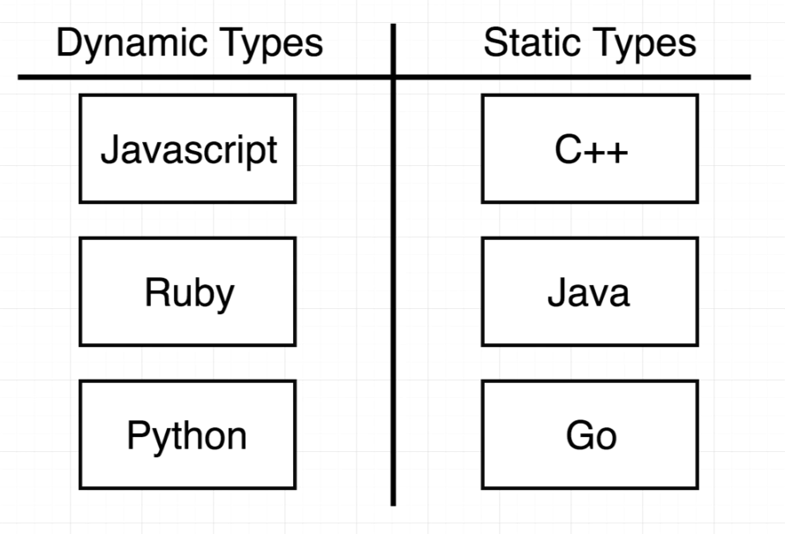

g=> this represent go line or code.

so by doing

g=> var card string =>this card variable will always contain a string only, you can not assign integer into it. that why it is statically typed language.

Some basic datatype for golang is

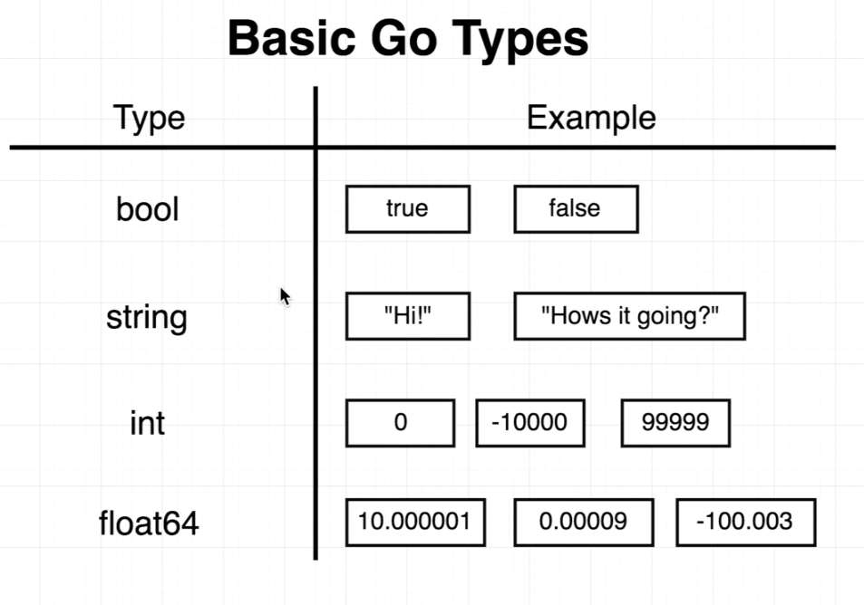
this is just a basic list it contain many type.

g=> var card string = "Ace of Spade"
can also be written in shorter way like
g=> card := "Ace of Spade"

so above two lines of code is 100% equivalent.

this ":=" is only use when we want to declare and assign value for new variable only.
but for reassigning an existancing variable we use only "="

card = "Five of Diamaonds" => here we didn't use ":=" because it is reassigning.

this have some error as per decksize is globally declare

package main

import "fmt"

deckSize := 20 // this have issue while global declaration. don’t know why ?

func main() {
fmt.Println(deckSize)
}

package main

import "fmt"

var deckSize int = 20 // this work fine as of global declaration

func main() {
fmt.Println(deckSize)
}

Function declaration in golang:-

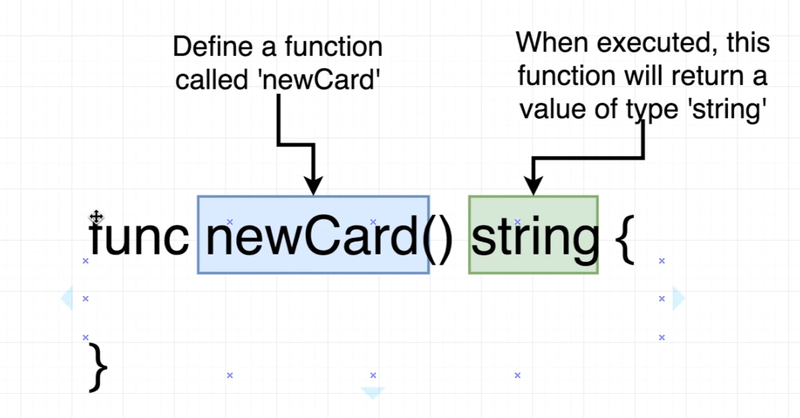

so new thing return is written after paranthesis

now if we want to run two file simultaneously
> go run main.go try.go

here main.go and try.go have same package main

Now lets talk about array (list of particular things):

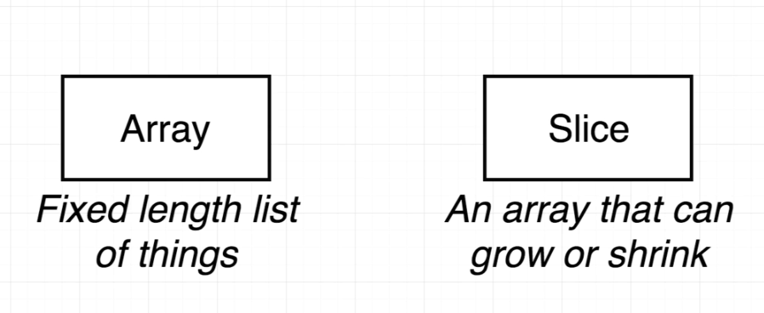
So, yes list is kind of data structure, in go lang list structure are implemented by two ways:-

- Array
- Slice -> this is actually an array with some fancy name and with some shrink and grow feature.

Also array and slice both will have a homogenous datatype,
multiple datatype is not supported in golang.

