Used to find files and folders in linux directory.

Synatx:-

$ find <path> <search criteria> <action>

All option are optional

If you just type “find” it will search out all the files and folders in the current directory.

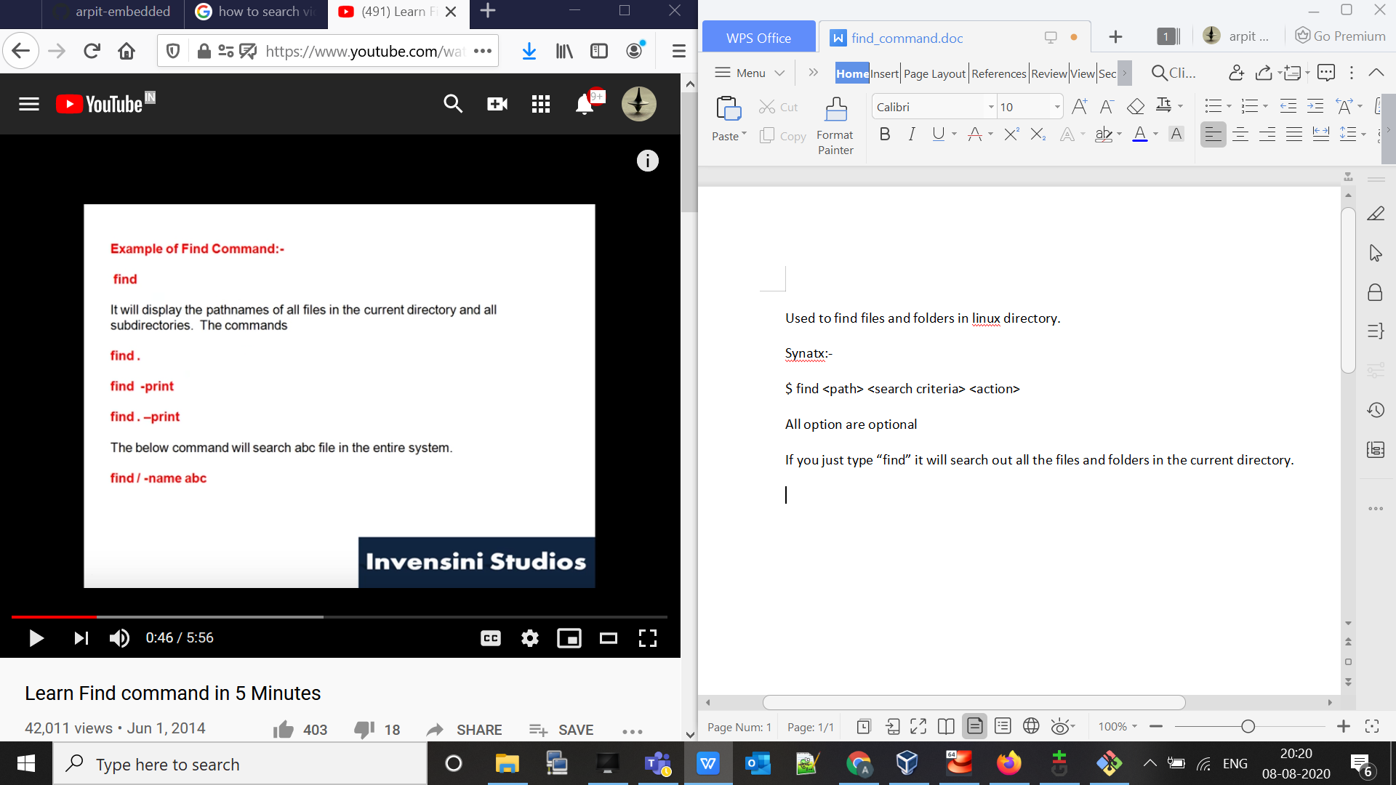

If we want to find any file we just need to do :-

$ find / -name <file-name>

$ find -type d => this will search for only directories.

$ find -type f => this will search for only files.

$ find . -type f -name abc.txt => this will find “file” in “current directory” with name “abc.txt”

$ find . -type f -iname abc.txt => this will find “file” in “current directory” with name “abc.txt” with case sensitive

$ find . -type f -name “*.txt” => this will find “file” in “current directory” with name “abc.txt” With case sensitive

