what is Iptables ?

=> it is main interface into "linux kernel netfilter which does all the packet filtering" in linux.

Essentially Iptables can be thought as Firewall.

Iptables tables
By default there are three tables in the kernel that contain sets of rules :-

- The filter table is used for packet filtering. (default table)
- The nat table is used for address translation.
- The mangle table can be used for special-purpose processing of packets.

Series of rules in each table are called a chain.

command :-

# iptables -L => this will show chain and rules in default filter table.

sudo iptables -L

Chain INPUT (policy ACCEPT)
target prot opt source destination

Chain FORWARD (policy ACCEPT)
target prot opt source destination

Chain OUTPUT (policy ACCEPT)
target prot opt source destination

By default most system didn't have any rule (red-hat is exception)
Without any rules, all traffic would be allowed.

There are three default chain in the filter tables, these are input chain, forward chain and output chain .

The input chain contains rules that filters traffic that coming into linux box.
The output chain contains rules that filters traffic that are leaving linux box.
The Forward chain is for traffic being forward via linux box.

we will focus on input and output chain for now.

"(policy ACCEPT)" => policy is what happen when no rules matches to chain.
So by default with ACCEPT rules all traffic is allowed.
other policy is like:-
- drop policy => if traffic not matches the rule, using this policy the packet is drop like "packet never received"
- reject policy => it also don’t accept packet, but it will send ICMP rejection back to sender.

# iptables -A INPUT -j ACCEPT

here "A" is for append
"INPUT" is the name of the chain
"-j" which is target or jump chain
"ACEEPT" is new policy for INPUT

To change the policy:-

# iptables -P INPUT DROP

here "-P" is for policy then chain name and new policy

now we going to change all the policy in out system and see what has happen.

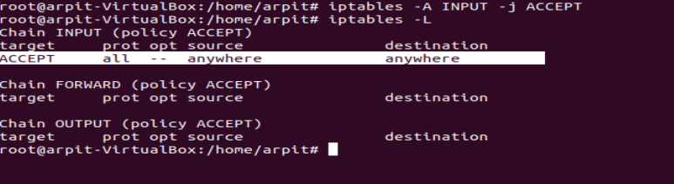

we have created a rule for input.

now lets try to change policy

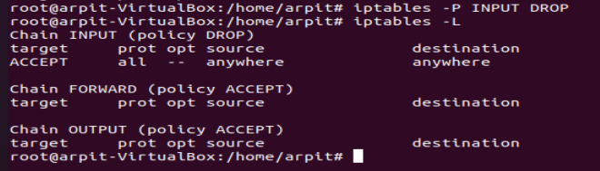

we can see policy for INPUT is change to DROP

for http /curl access:-
iptables -I INPUT -p tcp --dport 80 -j ACCEPT

use this

