POSIX ---> Portable Operating-system interface

Access control list :- by this we can determine access permission to file and directories.
it is not about chmod.
lets suppose you want to some user to give access to a file.
one way to achieve is you add that user into your group, by doing so the user will get access to all other files in that group.

So how to give user permission for specific file only.

$ getfacl <file/directory name> ==> info about permission for specific file
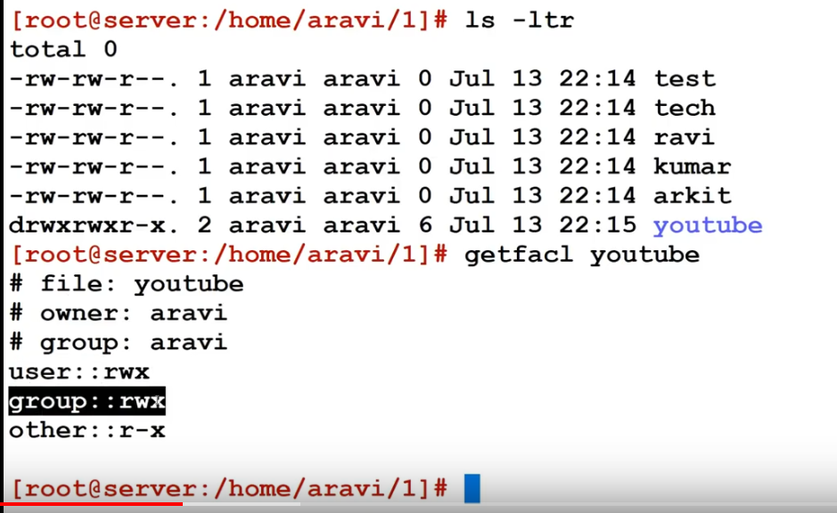

to add the permission use

$ setfacl -m <-u for user, -g for group, o for other>:<user-name>:<r for read, w for write, x for execute> <path to directory or file>

eg :- setfacl -m -u:user2:rwx /download/

