so bash is having debugger,

to start a sub shell use "-x" option
-x Print commands and their arguments as they are executed

run script as $bash -x script.sh

bash -x 3_try_for.sh
+ (( i=0 ))
+ (( i<5 ))
+ echo 0
0
+ (( i++ ))
+ (( i<5 ))
+ echo 1
1
+ (( i++ ))
+ (( i<5 ))
+ echo 2
2
+ (( i++ ))
+ (( i<5 ))
+ echo 3
3
+ (( i++ ))
+ (( i<5 ))
+ echo 4
4
+ (( i++ ))
+ (( i<5 ))
root@k8s-master-VirtualBox:/home/k8s_master/bash_practice# vim 3_try_for.sh
root@k8s-master-VirtualBox:/home/k8s_master/bash_practice# bash -x 3_try_for.sh
3_try_for.sh: line 4: syntax error near `;i++)'
3_try_for.sh: line 4: `for((i=0;i<5;i++)'
root@k8s-master-VirtualBox:/home/k8s_master/bash_practice# vim 3_try_for.sh

we can also we "-x" as #! /bin/bash -x

we can also use "set -x" code "set +x"

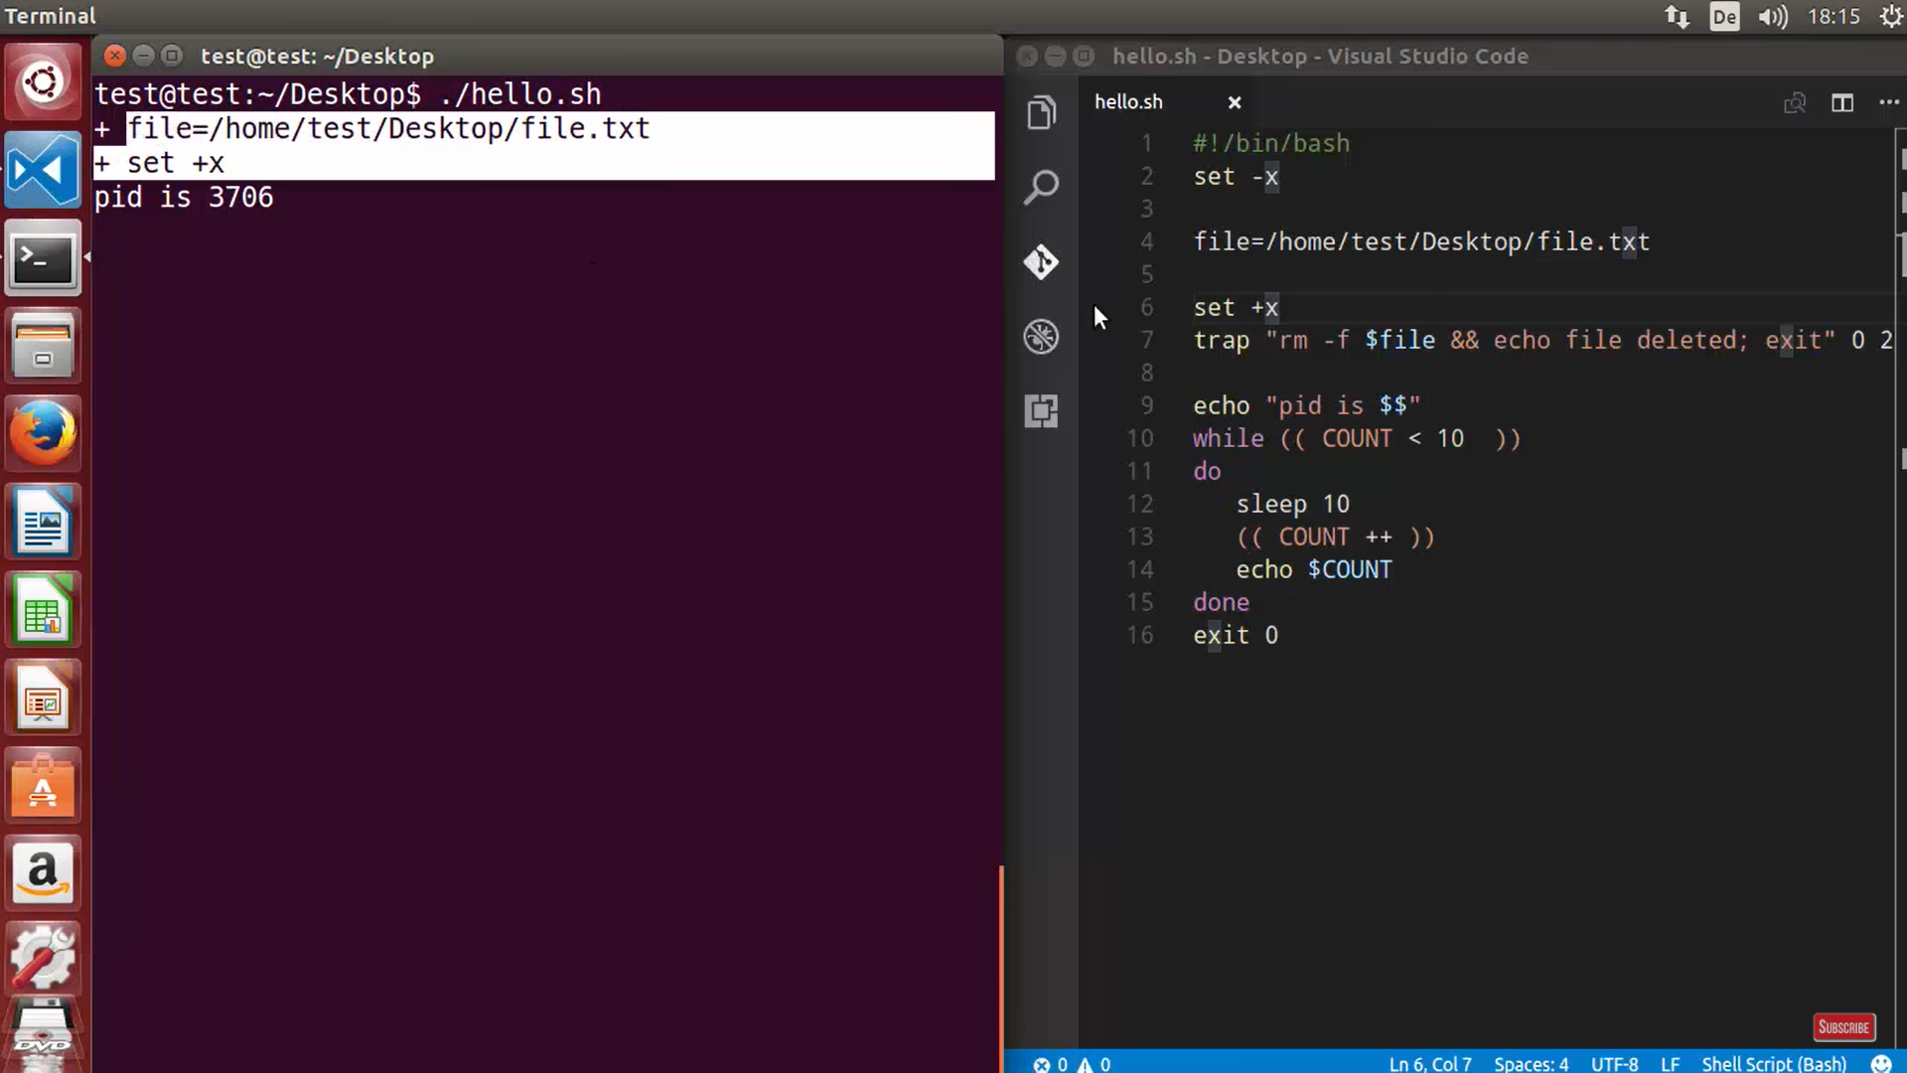

so it will do debugging for for those line which comes in between "set -x" and "set +x"

