Single qutoes basically string literals means they literally contain character by character, they dont care you have doller signs and back ticks .

If you put variable in single code they won’t expand/care. It just print string like

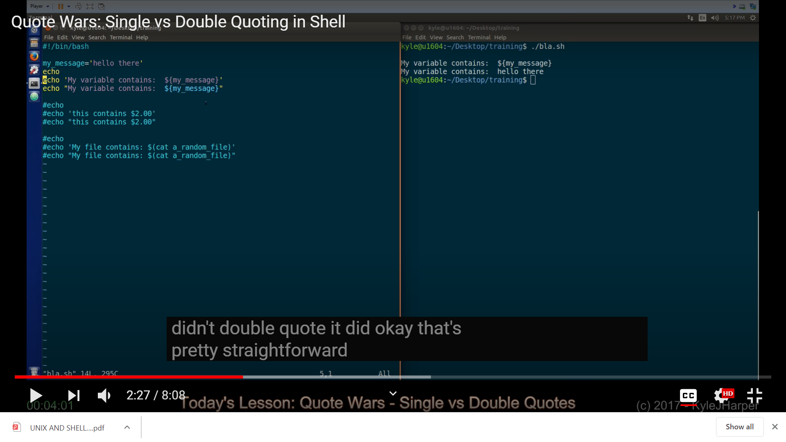

Here we can see that , string in single quotes is print as it is while , string in double quotes expand the variable.

Now look at this example as well :-
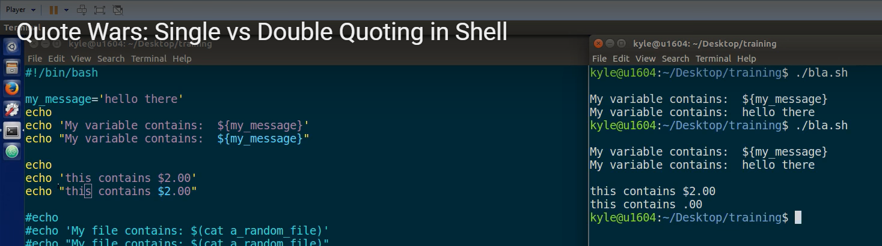

Here you can see that in double code “$2” will be treated as variable while, in single quotes ‘$2’ will be treated as string .

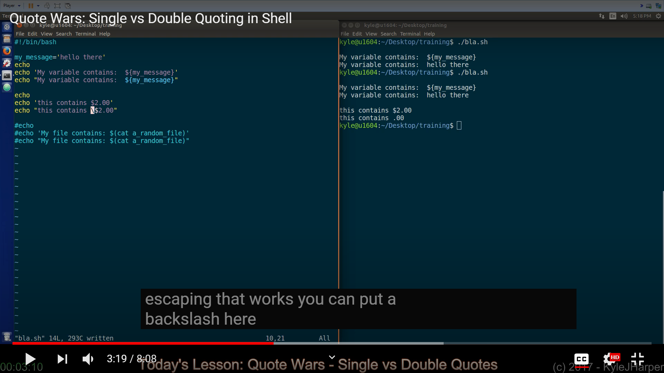

Also by putting the backslash “\$2” in double quote we will also get string value as well.

Hey take a look here we can see sub shell :-
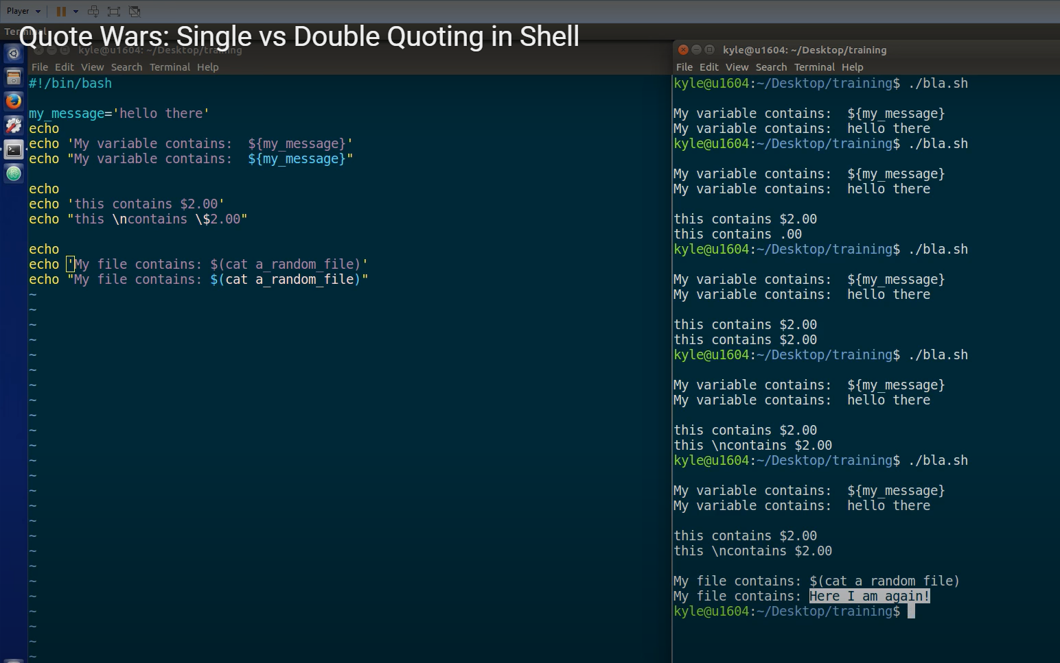

Here in double quotes “$(cat a_random_file)” is called as “sub shell”.

Here for giving tab we need to give like
$ echo -e ‘one\ttwo’ here in single quotes
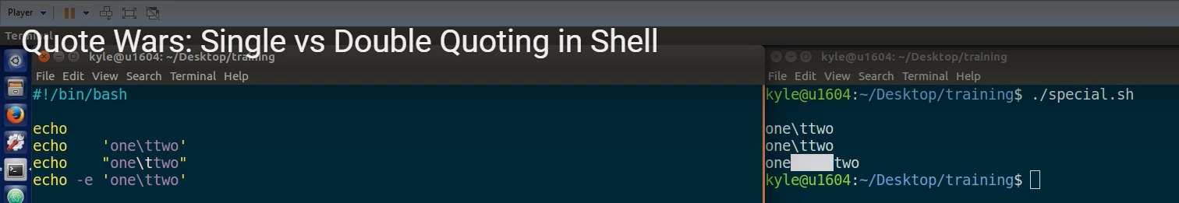

Now if we want to create a variable which contain single quotes we need to have like this

$ my_variable=$’one\ttwo’

Back_ticks are use to execute any linux command
Like `cal` => calender
`ls` `cd` `date`

