first we will learn about awk command:-

awk is one of most powerfull command in UNIX environment.

what we can do with awk command:-

- we can manipulate data using awk command.
- we can generate some report by processing from file.
- It also allow us to use logical operations.
- we can use variables , string function

Mostly use for pattern scanning and processing.

we are going to perform, we can
1. scanf input line by line.
- we can split input line by line.
- we can compare input fields to some pattern.



the basic syntax for awk command.
$ awk [option] 'pattern{action}' input.txt > output.txt

or

$ awk options 'selection _criteria {action }' input-file > output-file

To print content of file as it is:-
$ awk '{print}' filename.txt

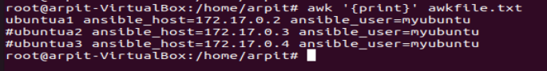

$ awk '{print $0}' filename.txt => this will print all the column.
$ awk '{print $1}' filename.txt => this will print first column
similary

$ awk '{print $n}' filename.txt => this will print nth column

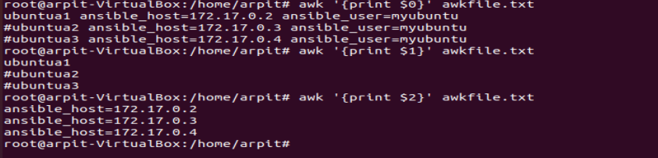

$ awk '{print $2 "\t" $3}' file.txt

Now we can add matching pattern this pattern come inside forward slash like:-

$ awk '/ansible_host/ {print $0}' filename.txt

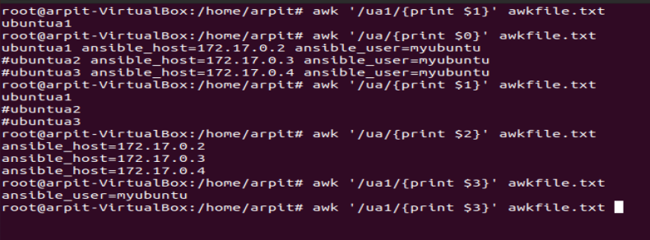

print line for according to no of character:-

$ awk 'length($0) > 20' file.txt

Now we are going to use some variables

$ awk '{print NR,$0}' filename.txt => this will give you line number or row number
$ awk '{print NF,$0}' filename.txt => this will give you total line number or total row number

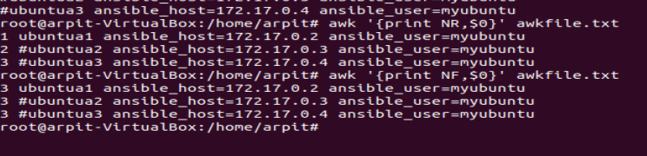

there is also $NF this is different from NF this will print last column.

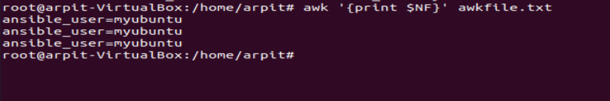

suppose we have to print 2 column we can mention column using comma separated.

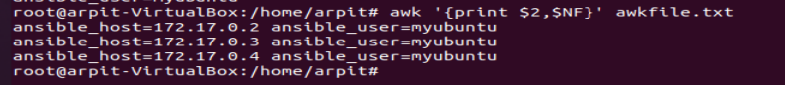

and of we want second last column we then we can give like $(NF-1)

Note:- for row printing use
{
awk 'FNR == 2 {print}'

To print the third field of the fifth line:
awk 'FNR == 5 {print $3}'

here i = row and j is coloumn
# print the j'th field of the i'th line
awk -v i=5 -v j=3 'FNR == i {print $j}'
}

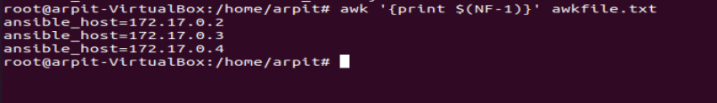

we also have ORS which is output report separator.
$ awk 'BEGIN{ORS="\n\n" }{print $0}' awkfile.txt

---> BEGIN and END these will be useful to print information before and after actual awk command to take place respectively.

now our output is formated and have 2 new line

we can also use $OFS which is output field separator
this will establish filed between two column element

