Regular Expressions in Bash Conditional statements
Bash allows you to compare Literal strings and variables against regular expressions when you use the [[ (double bracket) and =~ (regex comparator, equal sign tilde) in your if statements. I'll be showing examples and explaining them.
Example 1: A simple match
#!/bin/bash
#
# This script demonstrates regular expressions in bash
# String we want to analyze
var="this is A text9 strin7g with numb3rs in it"
echo "this is the string we are going to analyze:"
echo "$var"
echo " "
# Regular expression we'll use to analyze the string
regex="[a-zA-Z]+"
echo "This is the regex we will use to try analyzing the text:"
echo "$regex"
echo " "
# Perform regex check and determine match / no match
if [[ $var =~ $regex ]]
then
echo "matched the following text:"
echo ${BASH_REMATCH[0]}
else
echo "didn't match!"
fi

Here's a screen capture of the script output:
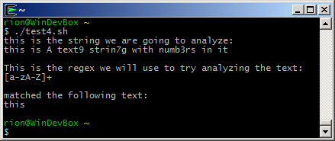

Key points:
- The =~ operator is used for regular expression testing in bash conditionals
  - It is only available in Bash 3.0+
- Regex testing is only available when used within the double bracket expression [[ ]]
- BASH_REMATCH[0] shows the part of the text string that matched regex (if there is a match)

---------------------------------------------------------------------------------------------------------------------------
checking if user entry is integer or not :- (by self)

ubuntuserver@ubuntuserver:~/arpit_testing$ cat check_input_is_int_regex.sh
#! /bin/bash

read -p "enter a number : " num

regex=^[0-9]*[0-9]+$

if [[ $num =~ $regex ]]
then
echo "matched"
echo ${BASH_REMATCH[0]}
else
echo "not matched"
fi

