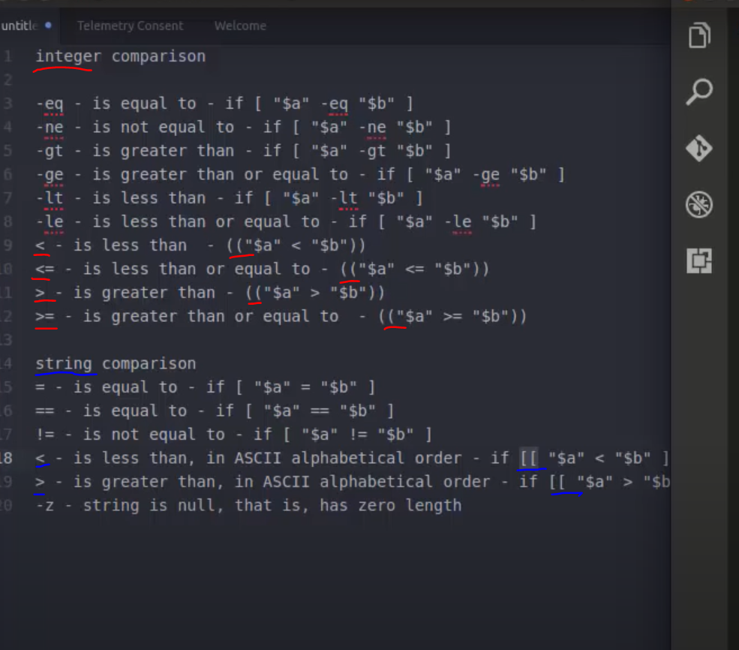

here what we can observer is like

for integer
- single [] ==> if you want to use option to compare like (-eq, -ne)
- double (()) ==> when you have to use angle bracket for comparison

for string
- single [] ==> "=" and "=="
- double [[]] ==> for angle bracket in string > <

"=" and "==" for string used for same purpose.

to check string is null:-

#!/bin/bash
echo -n "enter string : "
read str1
if [ -z "$str1" ]
then
echo "null"
else
echo "not null"
fi

