to print message when you do ssh to your server

/etc/update-motd.d/*

.d --> means its directory



Scripts should be named named NN-xxxxxx where NN is a two digit number indicating their position in the MOTD, and xxxxxx is an appropriate name for the script.

these were bash script only

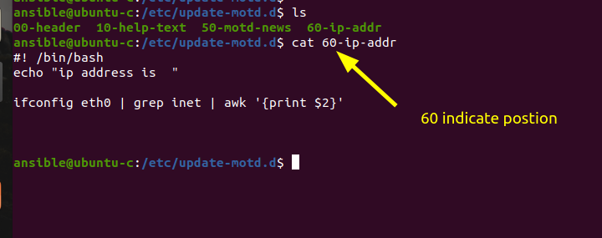

ansible@ubuntu-c:/etc/update-motd.d$ cat 60-ip-addr
#! /bin/bash
echo -n "ip address is "

ifconfig eth0 | grep inet | awk '{print $2}'

