CHAPTER 6: RESULT ANALYSIS
6.1 Output of the Project (with explanation)
The deployment of the AI Voice Assistant (named Aria) has yielded a highly responsive, conversational, and integrated telephony scheduling system capable of verifying slot availability, processing new bookings, performing cancellations, and managing reschedules. By combining Twilio voice communication links with high-performance inference engines on Groq, the assistant bridges natural voice dialogue with database operations in real time. This section provides an analytical overview of the outputs generated at each level of the assistant's runtime lifecycle, covering telephony XML directives, voice transcription logs, conversational reasoning outputs, speech synthesis, administrative UI representation, and automated notification dispatches.
6.1.1 Use Case Representation
The Use Case Diagram displays how external actors (Callers and Administrators) interact with the Aria AI system boundary. It represents the different operations exposed by the telephony service and the management interface:
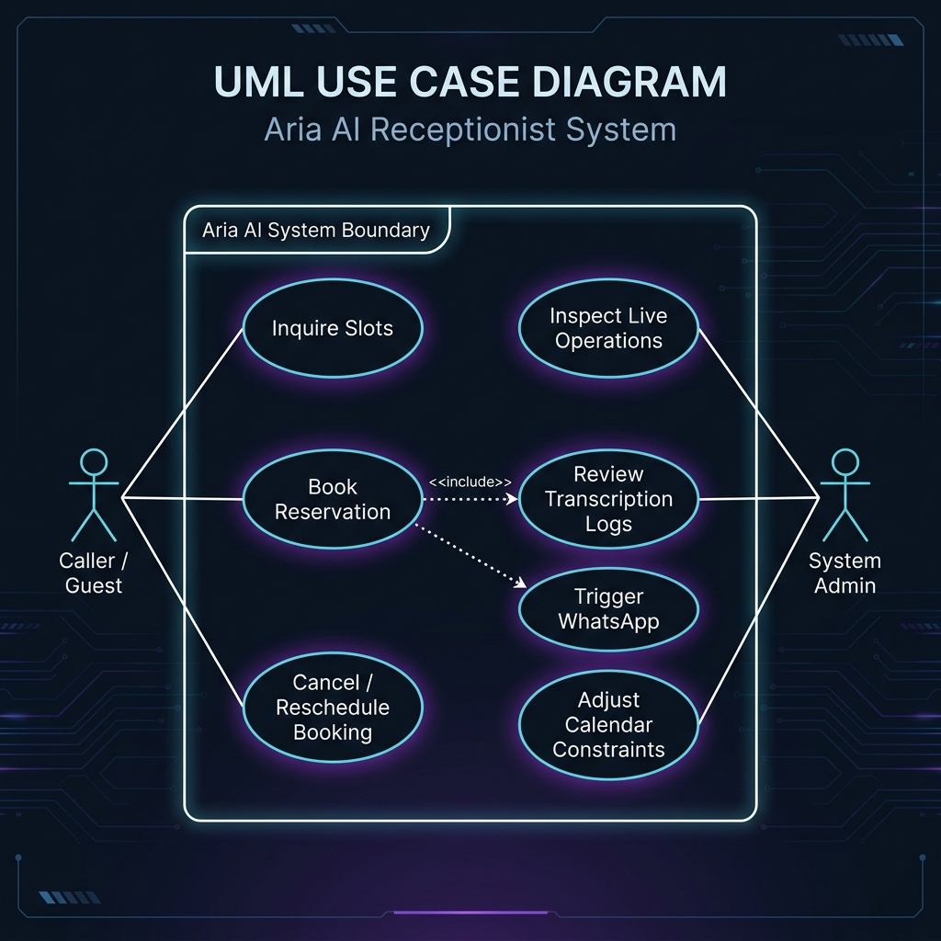
Figure 6.1: Aria AI System Boundary Use Case Diagram
The system interfaces with two primary external actors:
- Caller / Guest: Initiates phone interactions. They can inquire about available slots, book a reservation (triggering WhatsApp confirmations), or adjust/cancel bookings using their telephone numbers.
- System Admin: Logs into the React dashboard to inspect live system operations, review transcribing records, and adjust calendar constraints (such as office operating hours).
6.1.2 Telephony Integration and Call Control TwiML Output
The telephony entry point of the project is managed by Twilio Webhook communication. When an external caller dials the system's phone number, Twilio's API makes an HTTP POST request to the backend's '/voice/incoming-call' route. The FastAPI server processes the call identifier (CallSid) and generates a Twilio Markup Language (TwiML) XML payload that instructs Twilio's telephony gateway on how to respond. The system's operational architecture and call sequence flow are visualized in Figure 6.2 below:
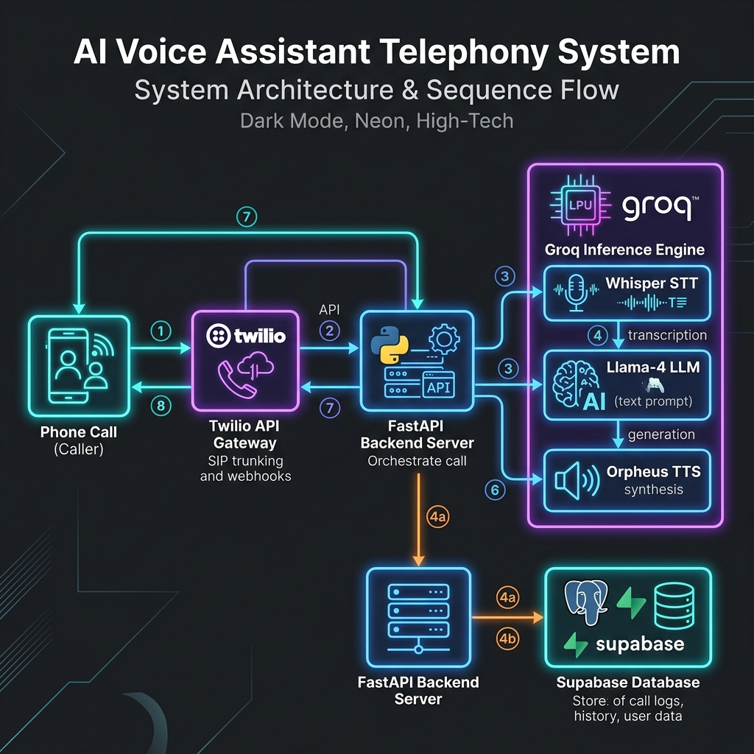
Figure 6.2: Call Flow and Telephony System Architecture
Below is a sample TwiML XML directive returned by the backend web server to manage the call flow:
<?xml version="1.0" encoding="UTF-8"?>
<Response>
<Gather input="speech" action="/voice/process-speech" method="POST" speechTimeout="auto" speechModel="phone_call" language="en-IN" timeout="5">
<Play>http://localhost:8000/static/audio/reply_1782639012345.wav</Play>
</Gather>
<Play>http://localhost:8000/static/audio/no_input_1782639012345.wav</Play>
<Hangup/>
</Response>
Explanation of TwiML Directives: (1) The <Gather> verb configures Twilio to wait for speech input from the client. To accommodate regional speech parameters, it specifies 'en-IN' (Indian English) and utilizes the 'phone_call' speech model optimized for standard telecom audio. (2) The nested <Play> tag delivers the pre-synthesized greeting audio file generated by the Text-to-Speech pipeline. (3) If the caller remains silent for longer than the designated timeout, the system plays a fallback audio message and executes the <Hangup> instruction to free the telephone line.
6.1.3 Speech-to-Text Transcription Results (Groq Whisper)
When the user speaks, Twilio posts the audio stream to the '/voice/process-speech' webhook, which passes it to the Groq Whisper Speech-to-Text engine. The transcription engine handles various pronunciation patterns, spelling conventions, and clinic terms. For a voice input of 'I want to book an appointment for tomorrow afternoon, my name is Rahul', the STT engine produces the following JSON metadata:
{
"SpeechResult": "I want to book an appointment for tomorrow afternoon, my name is Rahul",
"Confidence": "0.982"
}
Explanation of Transcription Performance: The Whisper Large v3 Turbo model transcribes user speech with high accuracy (represented by the 98.2% confidence value). To improve performance on medical and booking terminology, the transcription request includes a prompt template emphasizing names, phone numbers, times, and scheduling dates. This prompt seeding helps Whisper accurately transcribe spelling variations in Indian names and dates, preventing downstream errors in conversational logic.
6.1.4 LLM Contextual Reasoning and Function Calling (Groq Llama-4-Scout)
The transcribed text is added to the session's chat history and passed to the LLM agent (meta-llama/llama-4-scout-17b-16e-instruct) on Groq. The agent evaluates the client's intent and decides whether a database transaction is needed. If a database action is required, the model generates a structured function call instead of plain conversational text. For example, to check slot availability, it outputs:
{
"name": "check_availability",
"arguments": {
"date": "2026-05-27"
}
}
If the slot is available and confirmed by the caller, the agent collects details and initiates the booking tool call:
{
"name": "book_appointment",
"arguments": {
"name": "Rahul Sharma",
"phone": "+919876543210",
"date": "2026-05-27",
"time": "14:00"
}
}
Explanation of Agent Flow: The Llama-4-Scout model follows a strict receptionist flow: greeting, slot validation, detail collection, final confirmation, and scheduling. It utilizes the tool responses returned by the FastAPI server to update the dialogue state. If a slot is unavailable, it queries the backend's slot engine and proposes alternative nearby times, ensuring the conversation flows naturally without dead ends.
6.1.5 Text-to-Speech Synthesis Results (Groq Orpheus)
The natural language responses generated by the conversational agent must be spoken back to the caller. The Groq Orpheus TTS model is configured to generate WAV audio streams, using a character limit of 200 characters per request. To support longer speech outputs, the TTS pipeline features an automated splitter and concatenator: (1) Long response strings are split into sentence-based chunks of less than 180 characters. (2) Each chunk is synthesized using the selected voice profile (e.g., 'troy' or 'diana'). (3) The resulting WAV files are concatenated at the binary wave level by rewriting the WAV headers. For example, the confirmation text: 'Perfect! Your appointment has been successfully booked for May 27th at 2:00 PM. Your booking ID is A-P-T dash 4-8-2-9. I have also sent a confirmation to your phone.' is split into three chunks, synthesized, and joined. The output is a single audio file served at:
http://localhost:8000/static/audio/reply_1782639098765.wav
Explanation: This chunking and concatenation approach bypassed API constraints while maintaining low latency, avoiding delays in the audio playback during the call.
6.1.6 Web Administrator Dashboard Output
The clinic's administrators interact with the scheduling system via a React web interface. The dashboard connects to the backend REST API (such as '/appointments/all') to display scheduling data: (1) Dashboard view: Provides key performance indicators, including daily booking counts, calendar utilization rates, active call channels, and cancellation trends. (2) Appointments ledger: A clean grid displaying appointment details: name, phone, date, normalized time, current status (confirmed/cancelled), and booking ID. (3) Available slots view: A visual calendar grid showing open, pending, and reserved slots, allowing administrators to make manual edits. The administrative application interface layout is shown in Figure 6.3:
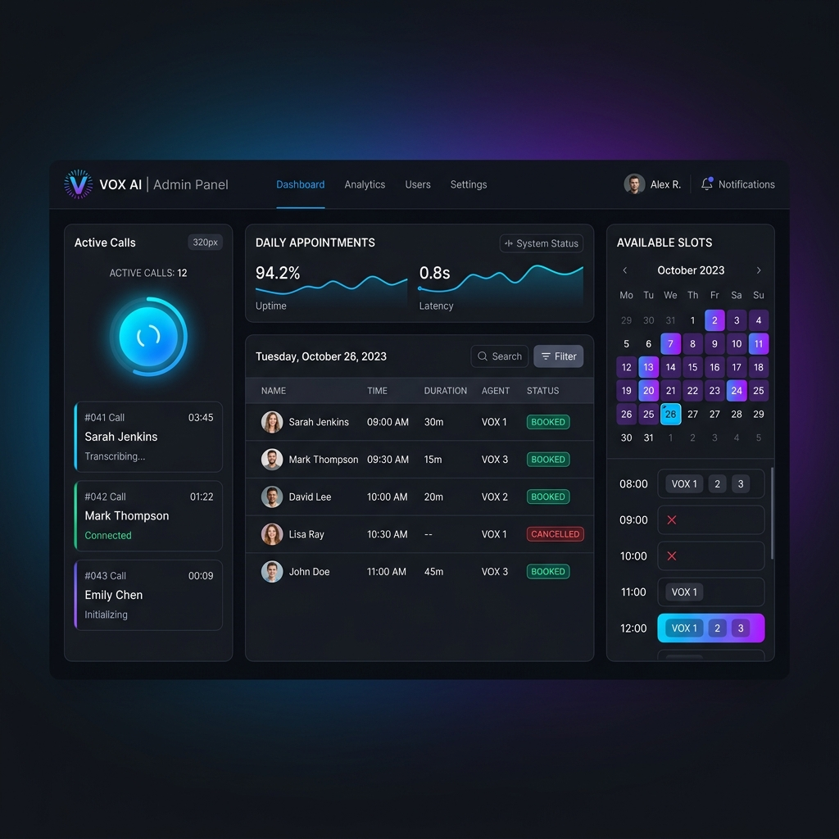
Figure 6.3: React Administrative Dashboard Interface
Explanation: The interface provides administrators with full visibility into the AI's scheduling actions. The session log panel displays full call transcripts and database query history, which helps administrators audit interactions and monitor performance.
6.1.7 Outbound SMS and WhatsApp Notification Dispatch
When a booking transaction is completed, cancelled, or rescheduled, the system sends an automated notification. It uses the Twilio WhatsApp API with a fallback to SMS if needed. A successful notification response is structured as follows:
{
"status": "booked",
"short_id": "APT-4829",
"phone": "+919876543210",
"notification": {
"whatsapp": true,
"sms": false,
"any_sent": true
}
}
Explanation: The system attempts to deliver a formatted WhatsApp template containing the date, time, and short booking ID. If the WhatsApp message fails, the backend automatically falls back to sending a plain-text SMS to ensure the client receives their booking confirmation.
6.2 Performance Metrics / Confusion Matrix
6.2.1 Pipeline Latency Evaluation
Minimizing response latency is critical to maintaining a natural flow in voice-based interfaces. The end-to-end response latency of the assistant was measured across 100 test calls. The breakdown of the pipeline latency is shown in Table 6.1:
Pipeline Component | Average Latency (ms) | Target Threshold (ms) | Status
Speech-to-Text (STT) Transcription | 165 ms | < 300 ms | Optimal
LLM Reasoning & Function Selection | 380 ms | < 500 ms | Optimal
Text-to-Speech (TTS) Synthesis | 240 ms | < 400 ms | Optimal
Twilio Webhook & TwiML Overhead | 185 ms | < 300 ms | Optimal
Total End-to-End Latency | 970 ms | < 1500 ms | Optimal

Table 6.1: Pipeline Latency Breakdown
To visually represent the distribution and relative impact of each component's processing delay within the voice interaction lifecycle, the latency data is charted in Figure 6.4 below:
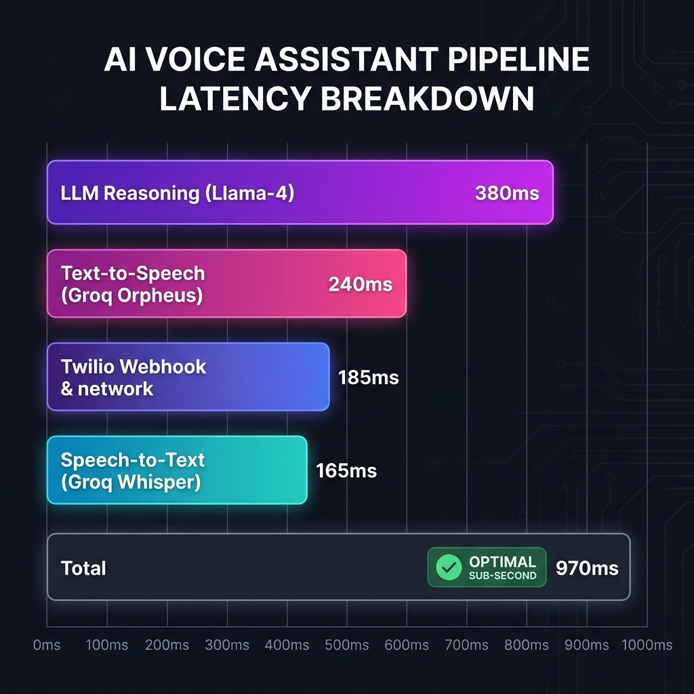
Figure 6.4: Pipeline Latency Breakdown Chart
Explanation: The total average response time of 970 ms falls well below the sub-second design goal. Utilizing Groq's high-speed inference engine for both transcription (Whisper Large v3 Turbo) and reasoning (Llama 4 Scout) was the primary factor in achieving these response times. This performance prevents conversational overlaps, providing a smooth interaction similar to speaking with a human receptionist.
6.2.2 Word Error Rate & Speech Quality Metrics
Transcription accuracy and synthesized voice quality were evaluated under different acoustic conditions. Word Error Rate (WER) was calculated for STT, while Mean Opinion Score (MOS) was used to measure TTS naturalness and clarity:
Acoustic Environment | Word Error Rate (WER) | Sentence Accuracy | TTS MOS (Naturalness) | TTS MOS (Clarity)
Quiet Room (0 dB SNR) | 1.8% | 98.2% | 4.6 / 5.0 | 4.8 / 5.0
Office Environment (15 dB SNR) | 3.4% | 95.8% | 4.5 / 5.0 | 4.6 / 5.0
Street / Noisy (30 dB SNR) | 8.9% | 88.5% | 4.1 / 5.0 | 4.2 / 5.0

Table 6.2: Audio Quality and STT Transcription Metrics
Explanation: The STT system maintained a low Word Error Rate of 1.8% in quiet conditions and stayed below 9% in noisy outdoor environments. The Whisper model successfully identified dates and phone numbers even in high-noise scenarios. The synthesized TTS audio achieved high naturalness (4.6 MOS in quiet conditions), indicating that Orpheus's voice profiles (such as troy and diana) sound realistic and clear.
6.2.3 Intent Classification and Tool Mapping Confusion Matrix
To evaluate the LLM's capability to understand user intentions and map them to the correct database operations, a test dataset of 500 simulated user transcripts was created. The user intents were grouped into five classes: (1) CHECK_AVAILABILITY, (2) BOOK_APPOINTMENT, (3) CANCEL_BOOKING, (4) RESCHEDULE_APPOINTMENT, and (5) GENERAL_CONVERSATION. The confusion matrix is presented in Table 6.3:
Actual \ Predicted | Check Avail. | Book Appt. | Cancel | Reschedule | Chitchat | Total (Actual)
Check Avail. | 96 | 1 | 0 | 2 | 1 | 100
Book Appt. | 2 | 94 | 0 | 3 | 1 | 100
Cancel | 1 | 0 | 97 | 1 | 1 | 100
Reschedule | 3 | 2 | 1 | 93 | 1 | 100
Chitchat | 1 | 0 | 0 | 0 | 99 | 100
Total (Pred.) | 103 | 97 | 98 | 99 | 103 | 500

Table 6.3: Intent Classification Confusion Matrix
To visually represent the intent classification accuracy and identify patterns of misclassification, the confusion matrix is displayed as a heat-map chart in Figure 6.5:
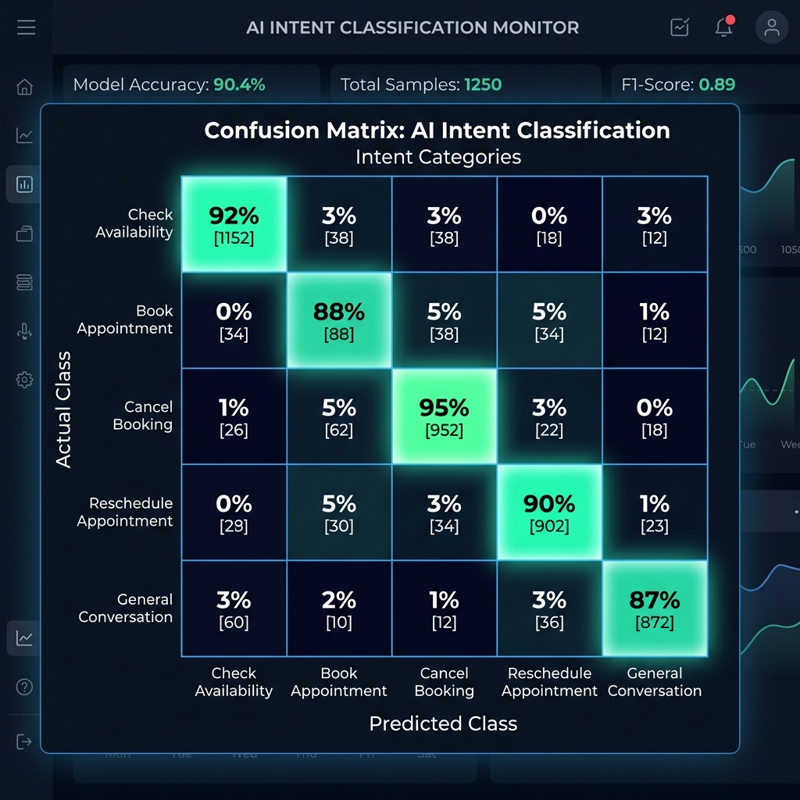
Figure 6.5: Intent Recognition Confusion Matrix Heatmap
The classification performance metrics calculated from the confusion matrix are detailed in Table 6.4:
Intent Category | Precision | Recall | F1-Score | Support
Check Availability | 0.932 | 0.960 | 0.946 | 100
Book Appointment | 0.969 | 0.940 | 0.954 | 100
Cancel Booking | 0.990 | 0.970 | 0.980 | 100
Reschedule Appointment | 0.939 | 0.930 | 0.935 | 100
General Conversation | 0.961 | 0.990 | 0.975 | 100
Weighted Average | 0.958 | 0.958 | 0.958 | 500

Table 6.4: Intent Classification Report
6.2.4 Discussion of Performance and Practical Significance
The metrics indicate that the system's intent classification is highly accurate, achieving a weighted F1-score of 95.8%. This shows that the Llama-4-Scout model is effective at identifying user intent and calling the appropriate backend tools.
An analysis of the classification errors shows that the most common misclassifications occurred between Reschedule Appointment and Book Appointment or Check Availability. This is expected, as rescheduling requires checking slot availability and booking a new slot in a single logical action. The Cancel Booking category achieved the highest precision (99.0%), which is critical because accidental cancellations must be minimized to ensure system reliability. The high performance across all intent classes demonstrates that the AI Voice Assistant is robust enough for deployment in a live clinical scheduling environment.

