Name: **Arpit Sharma**

**Voting App Assignment**

Master node:

Initially,

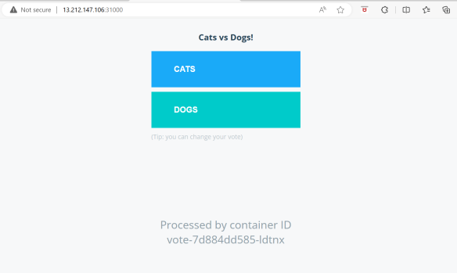 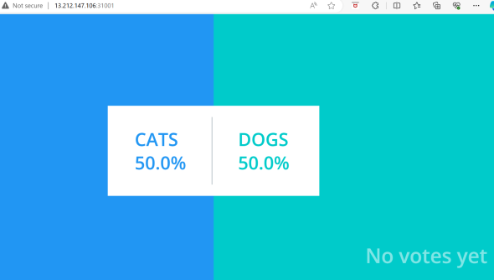

Vote page Result page

After voting changes:

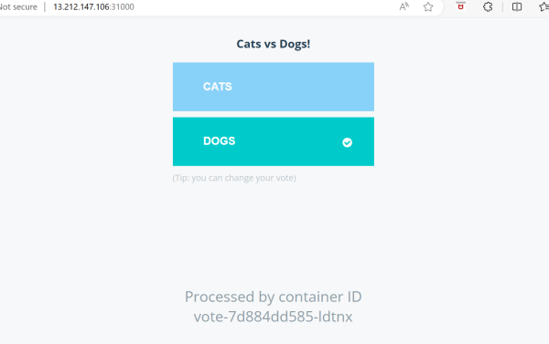 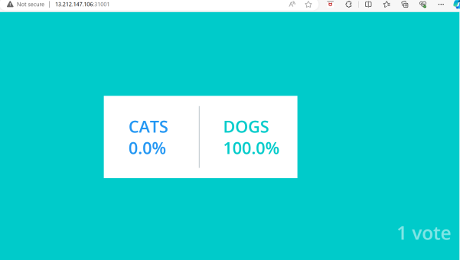

Vote page Result page

Worker -1 node:

Initially,

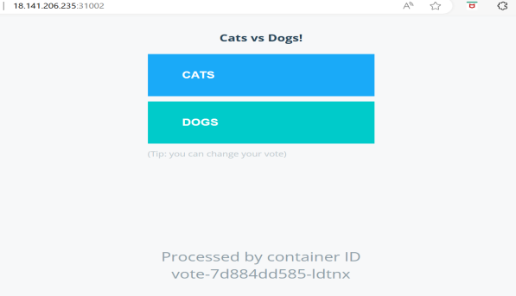 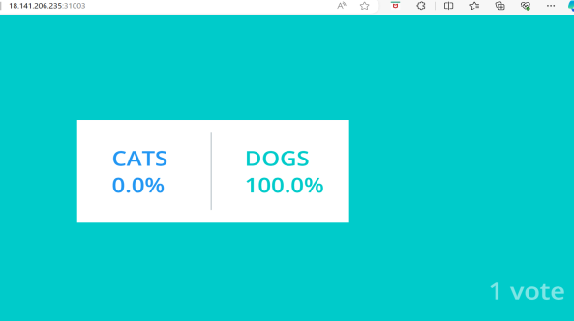

After voting:

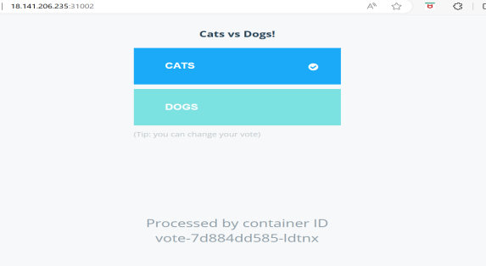 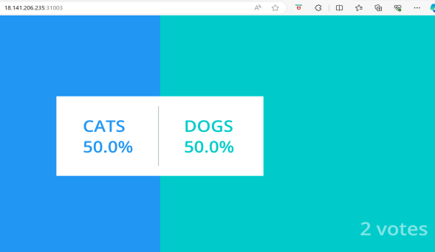

Worker -2 node:

Initially,

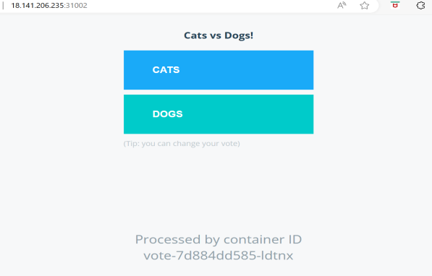 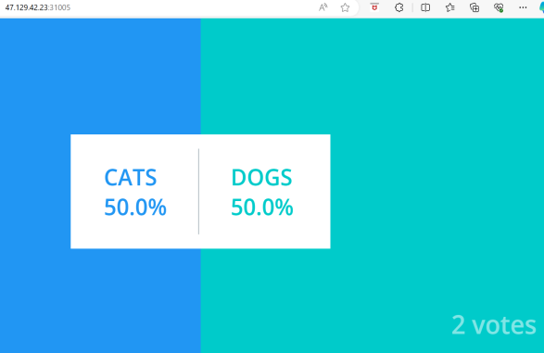

After voting,

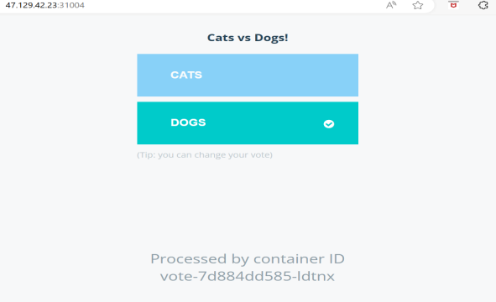 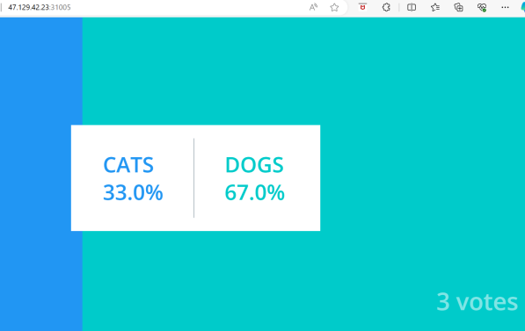

Deleting pods:

1. Vote pod:

root@ip-172-31-10-117:~# kubectl delete po/vote-7d884dd585-swnw7

pod "vote-7d884dd585-swnw7" deleted

root@ip-172-31-10-117:~#

Observation:

1. Unix –

Vote pod replicates itself and name of pod changes.

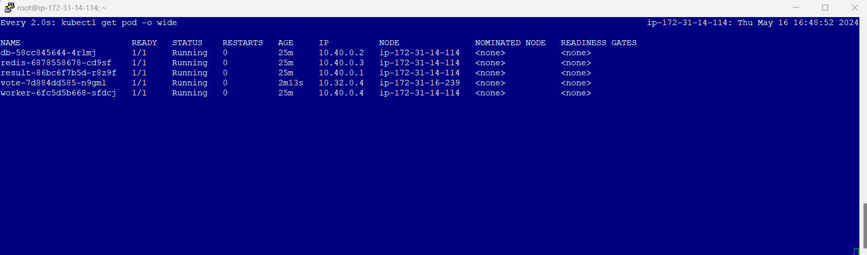

1. GUI –

Newly created pod name is shown in web.

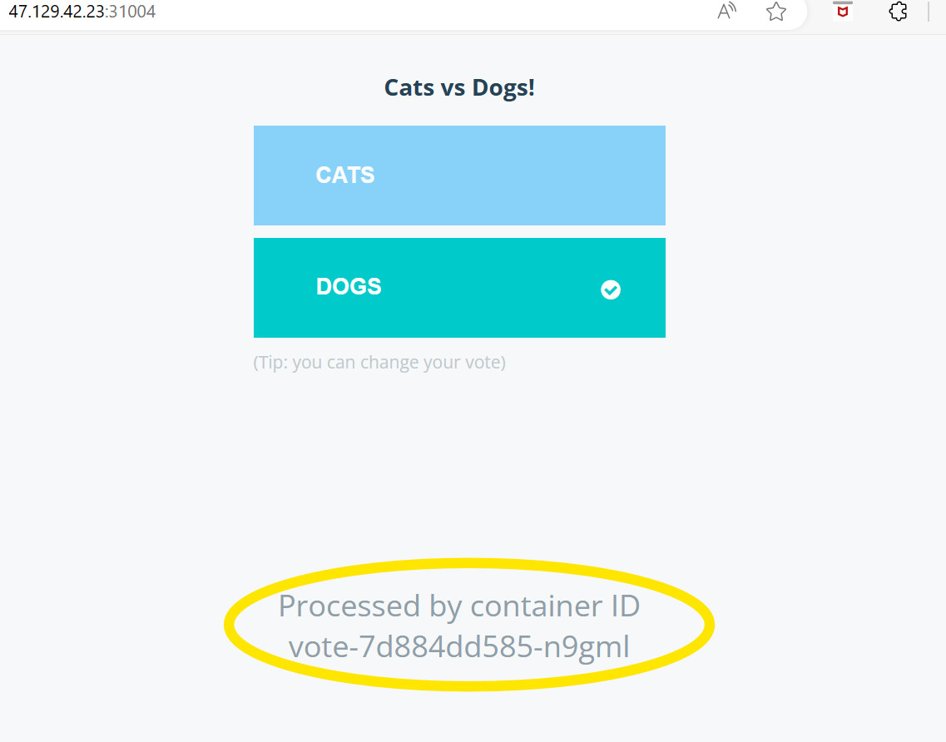

1. Worker pod

root@ip-172-31-10-117:~# kubectl delete po/worker-6fc5d5b668-sfdcj

pod "worker-6fc5d5b668-sfdcj" deleted

root@ip-172-31-10-117:~#

Observation:

1. Unix –

Worker pod replicates itself and name of pod changes.

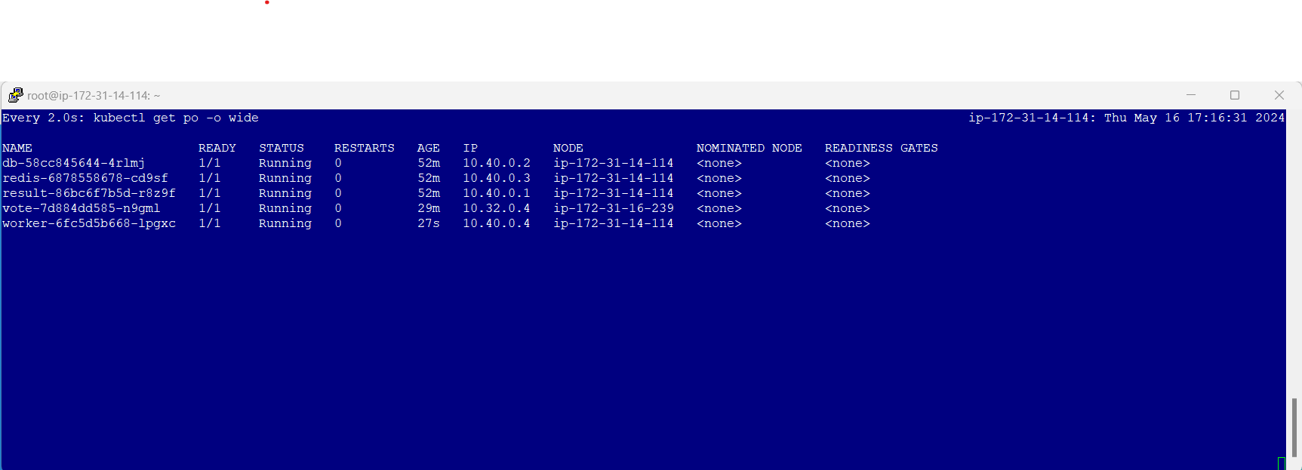

1. GUI- No changes.
2. DB pod

root@ip-172-31-10-117:~/example-voting-app/k8s-specifications# kubectl delete po/db-58cc845644-4rlmj

pod "db-58cc845644-4rlmj" deleted

root@ip-172-31-10-117:~#

Observation:

1. Unix –

DB pod replicates itself and name of pod changes.

Result pod and worker pod restarts.

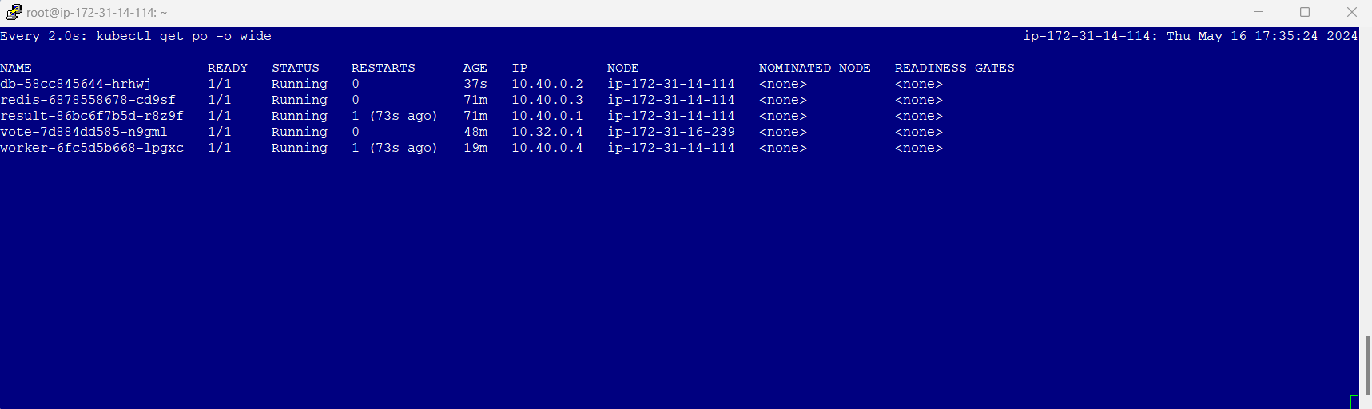

1. GUI-

As result & worker pod restarts web pages are also resets to initially and record of votes also deleted i.e. it shows no votes yet.

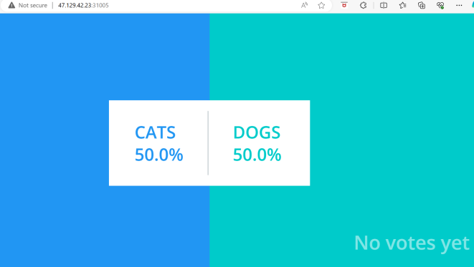 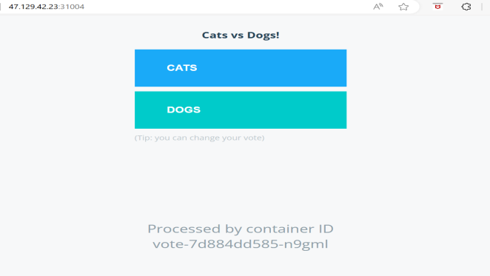

After deleting DB pod, result and worker pod restarts and are running fine only old voting record is has been deleted as result pod is restarted.