Healthcare Analytics Pipeline for MediCare Hospital
Submitted By:
Arpit Sharma — Roll No: G25AI1012
Ankita Dwivedi — Roll No: G25AI1011
Astosh Ranjan — Roll No: G25AI1013
Bharat Sharma — Roll No: G25AI1014
Damini Khatri — Roll No: G25AI1015
Course: Post Graduate Diploma in Data Engineering (PGDDE)
Institute: IIT Jodhpur

Plagiarism Declaration
We declare that this project report, implementation, configurations, scripts, workflows, dashboards, database designs, and deployment procedures are the original work of our team carried out during academic practice.
All necessary references, documentation sources, and publicly available resources used during the implementation have been properly acknowledged. Any form of plagiarism may lead to disciplinary action as per academic policies.

PART 1 — OBJECTIVE
The objective of this project is to:
• Build an end-to-end Healthcare Analytics Pipeline.
• Automate healthcare data ingestion, processing, and reporting.
• Store and manage healthcare data using cloud technologies.
• Perform large-scale healthcare analytics using PySpark.
• Design a healthcare data warehouse using Star Schema.
• Develop interactive dashboards for healthcare insights.
• Implement machine learning for predictive healthcare analytics.
This project demonstrates the practical implementation of Data Engineering, Cloud Computing, Big Data Processing, Data Warehousing, Analytics, and Visualization technologies in a healthcare environment.

PART 2 — PROBLEM STATEMENT
Healthcare organizations generate large volumes of patient, treatment, and operational data every day.
Traditional approaches:
• Require manual data processing and reporting.
• Are time-consuming and error-prone.
• Lack centralized data management.
• Struggle with large-scale data processing.
• Provide limited analytical capabilities.
This system addresses these challenges by:
• Automating data ingestion and processing.
• Centralizing healthcare data storage.
• Enabling scalable analytics using cloud infrastructure.
• Providing automated workflow execution.
• Delivering interactive dashboards and business insights.

PART 3 — DATASET DESCRIPTION
The project uses a healthcare dataset containing patient records and treatment information.
Dataset Characteristics:
• Total Records: 5000
• Data Format: CSV
• Domain: Healthcare Analytics
• Storage Platform: AWS S3
Dataset Attributes:
• Patient ID
• Patient Name
• Age
• Gender
• Disease
• City
• Treatment Cost
• Admission Status
• Admission Date
The dataset contains anonymized healthcare information and was used for ETL processing, analytics, data warehousing, dashboard development, and machine learning implementation.

PART 4 — TECHNOLOGY STACK
The following technologies were used during project implementation:
Component | Technology Used
Programming Language | Python
Data Processing | Pandas
Workflow Automation | Apache Airflow
Big Data Processing | PySpark
Cloud Storage | AWS S3
Database | PostgreSQL
Cloud Database | AWS RDS PostgreSQL
Data Warehouse | Star Schema
Dashboard | Streamlit
Machine Learning | Scikit-Learn
Version Control | Git & GitHub
Containerization | Docker
The selected technology stack provides scalability, automation, cloud integration, and analytical capabilities required for modern healthcare data engineering solutions.

PART 5 — IMPLEMENTATION
The Healthcare Analytics Pipeline was implemented using a modular architecture consisting of cloud storage, ETL processing, workflow automation, database integration, big data processing, analytics, and visualization components.
Step 1 — AWS S3 Data Storage
Healthcare records were stored in AWS S3 cloud storage before processing.
Benefits:
• Centralized data storage
• Cloud-based accessibility
• Scalability for future data growth
• Integration with ETL workflows
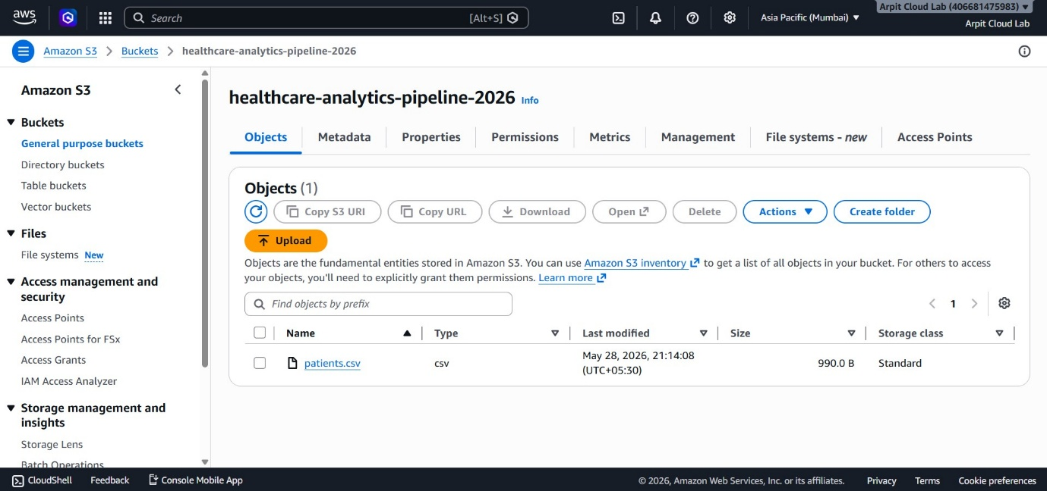

Step 2 — ETL Pipeline Implementation
An ETL (Extract, Transform, Load) pipeline was developed using Python and Pandas.
Activities Performed:
• Dataset extraction
• Data cleaning
• Missing value handling
• Data validation
• Data transformation
• Loading into PostgreSQL
The ETL pipeline automated healthcare data processing and reduced manual effort.
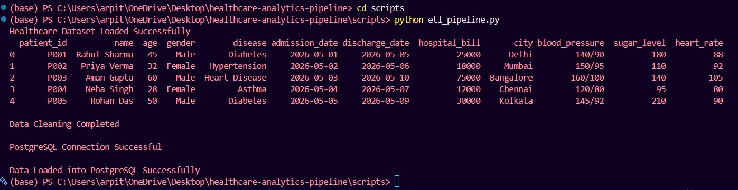

Step 3 — Apache Airflow Automation
Apache Airflow was implemented for workflow orchestration and automation.
Features:
• DAG-based workflow execution
• Automated scheduling
• Monitoring and logging
• Pipeline management
The Airflow DAG successfully automated ETL execution and workflow monitoring.
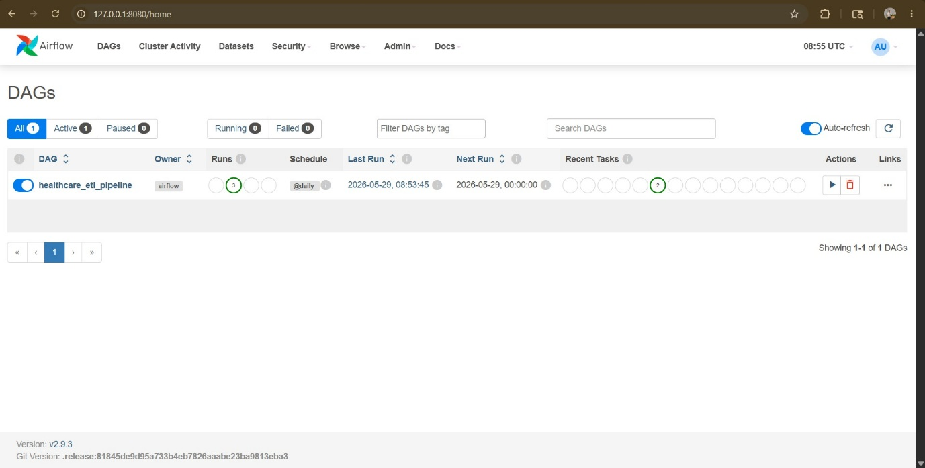
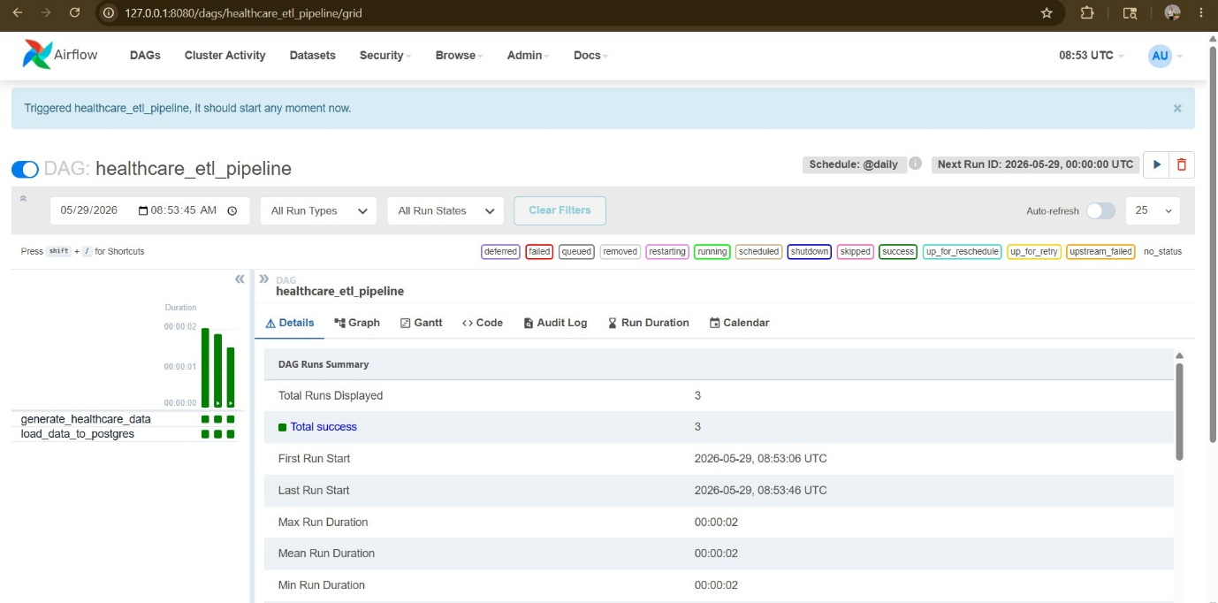

Step 4 — PySpark Big Data Processing
Apache Spark was integrated into the pipeline using PySpark to process large healthcare datasets efficiently.
Activities Performed:
• Loading healthcare dataset into Spark
• Schema validation
• Record counting
• Disease distribution analysis
• Treatment cost analysis
Results Obtained:
• Successfully processed 5000 healthcare records
• Generated disease-wise analytics
• Demonstrated scalable distributed processing
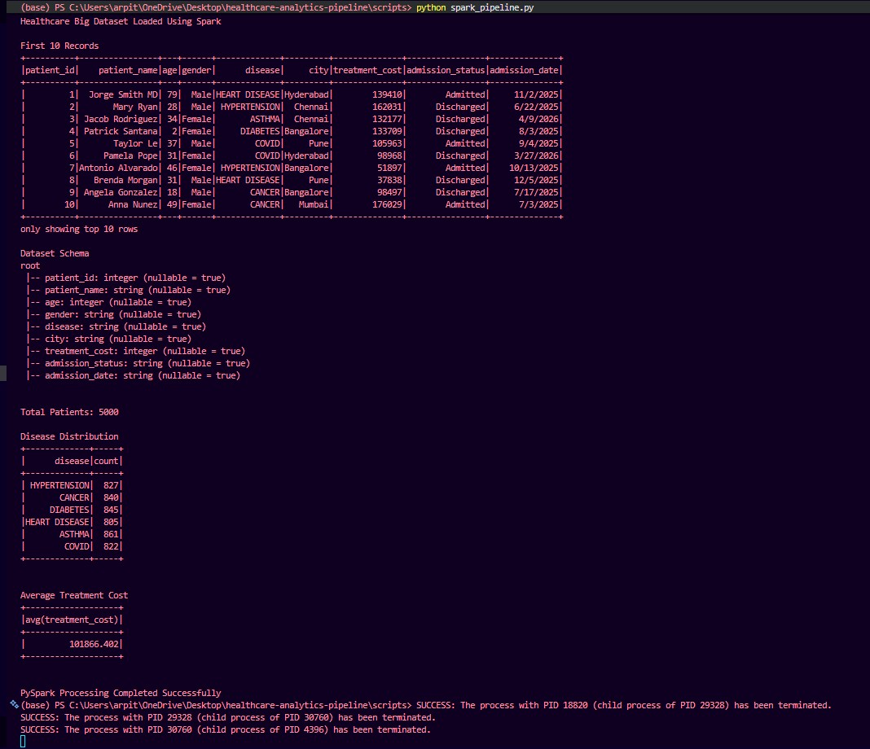

Step 5 — AWS RDS PostgreSQL Integration
AWS RDS PostgreSQL was used as the cloud database for storing processed healthcare records.
Benefits:
• Managed database service
• Cloud-based accessibility
• Secure data storage
• High availability and reliability
The ETL pipeline successfully loaded healthcare records into AWS RDS PostgreSQL.
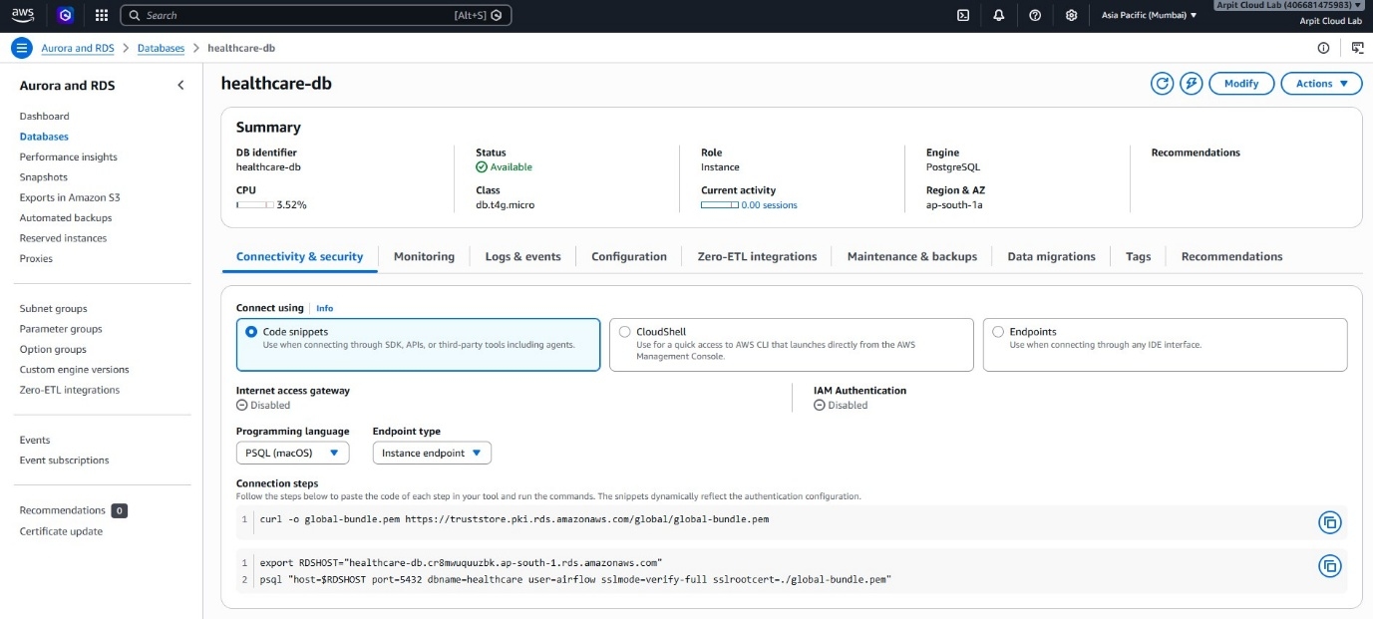

Step 6 — Data Warehouse Design
A Star Schema Data Warehouse was implemented to support analytical reporting and dashboard development.
Warehouse Components:
Dimension Tables
• dim_patient
• dim_disease
• dim_date
Fact Table
• fact_patient_visits
Benefits:
• Faster analytical queries
• Better reporting performance
• Simplified data analysis
• Improved dashboard responsiveness
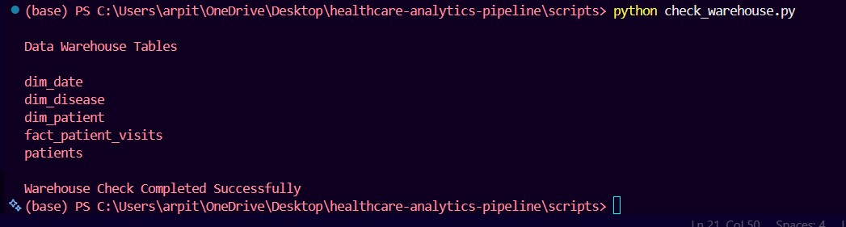

Step 7 — Interactive Dashboard Development
A Streamlit dashboard was developed for healthcare analytics and reporting.
Dashboard Features:
• Total Patients KPI
• Average Treatment Cost
• Disease Distribution Analysis
• Patient Data Visualization
• Interactive Reporting
The dashboard provides healthcare insights through a user-friendly interface.
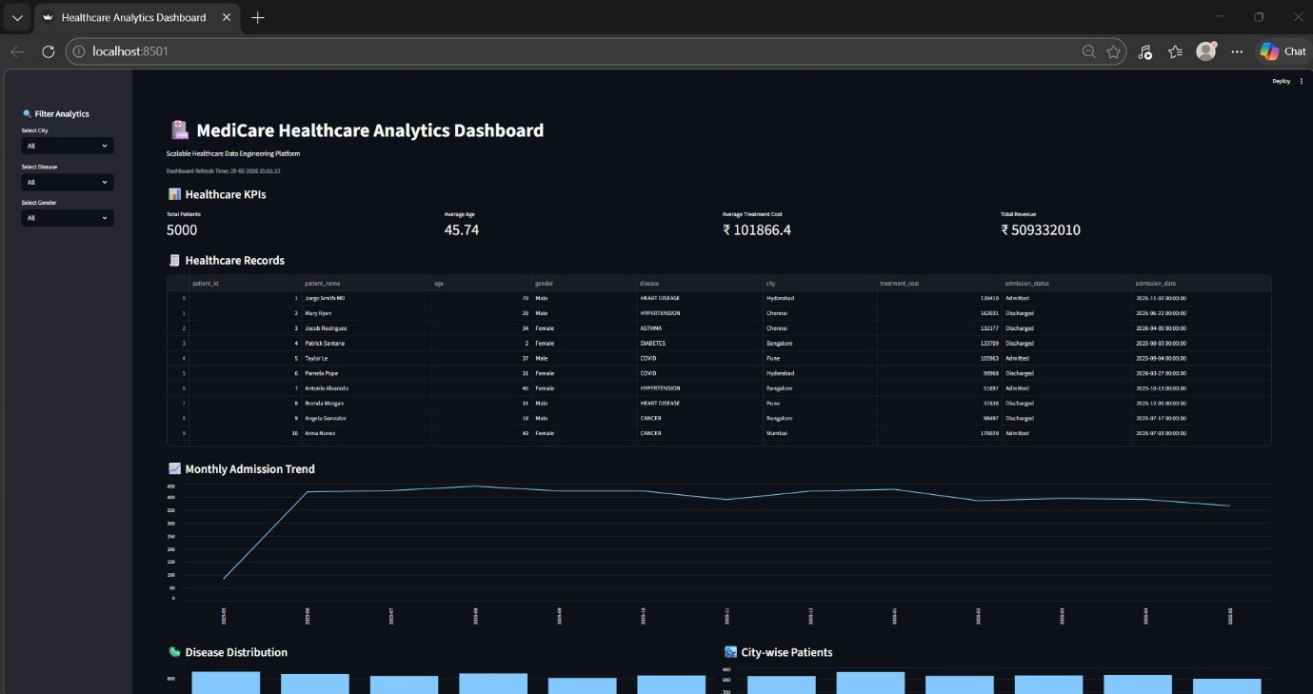

PART 6 — RESULTS
The Healthcare Analytics Pipeline was successfully implemented and validated.
Major Achievements:
• Processed 5000 healthcare records successfully
• Automated ETL workflow using Python
• Integrated AWS S3 cloud storage
• Implemented Apache Airflow automation
• Performed distributed processing using PySpark
• Integrated AWS RDS PostgreSQL
• Designed a Star Schema Data Warehouse
• Developed a Streamlit analytics dashboard
• Implemented machine learning analytics
Performance Summary
Component | Status
AWS S3 Integration | Successful
ETL Pipeline | Successful
Airflow Automation | Successful
PySpark Processing | Successful
AWS RDS Integration | Successful
Data Warehouse | Successful
Dashboard Development | Successful
Machine Learning | Successful

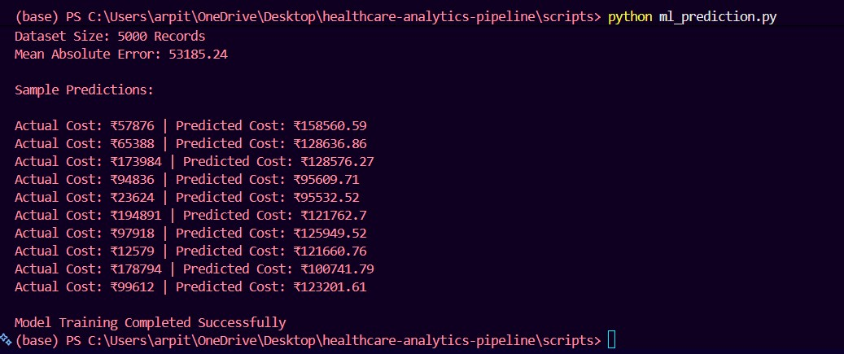
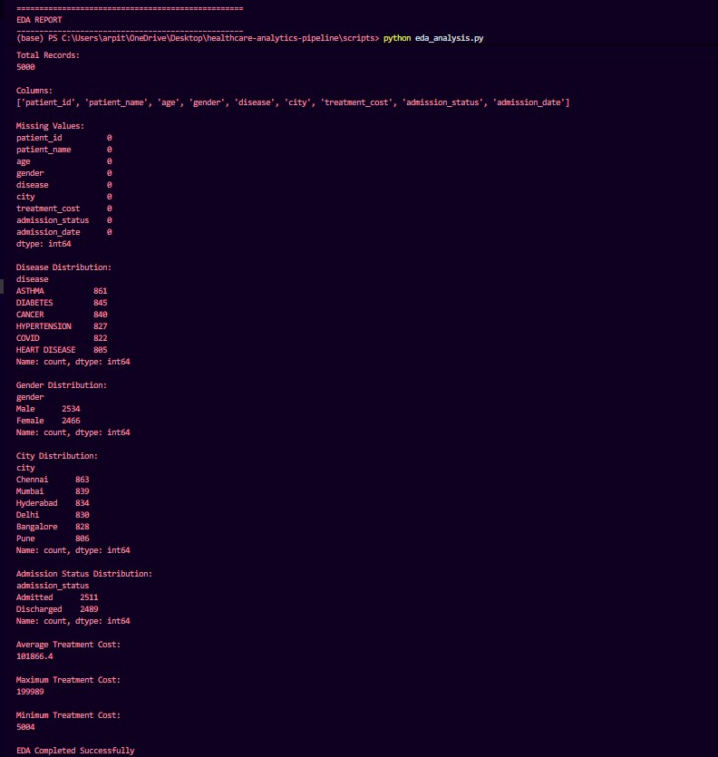

PART 7 — COMPARISON AND ANALYSIS
Feature | Traditional Approach | Proposed System
Data Processing | Manual | Automated
Storage | Local Files | AWS Cloud
Workflow Management | Manual | Airflow
Big Data Support | Limited | PySpark
Reporting | Static | Interactive Dashboard
Scalability | Low | High
Analytics | Basic | Advanced
Machine Learning | Not Available | Implemented

The proposed system significantly improves scalability, automation, reporting capabilities, and analytical performance compared to traditional healthcare data processing approaches.

PART 8 — ARCHITECTURE DIAGRAM
Healthcare Analytics Pipeline Architecture
This architecture represents the complete flow of data from ingestion and processing to analytics, machine learning, and dashboard visualization.
The pipeline is designed using modern Data Engineering principles and integrates cloud storage, workflow automation, big data processing, data warehousing, and predictive analytics into a single platform.
Healthcare data is collected, processed, transformed, and stored through multiple layers before being analyzed and visualized for decision-making purposes.
The architecture ensures scalability, automation, reliability, and efficient reporting while demonstrating the practical application of industry-standard tools and technologies.
The following diagram illustrates the overall architecture and data flow of the Healthcare Analytics Pipeline Project.

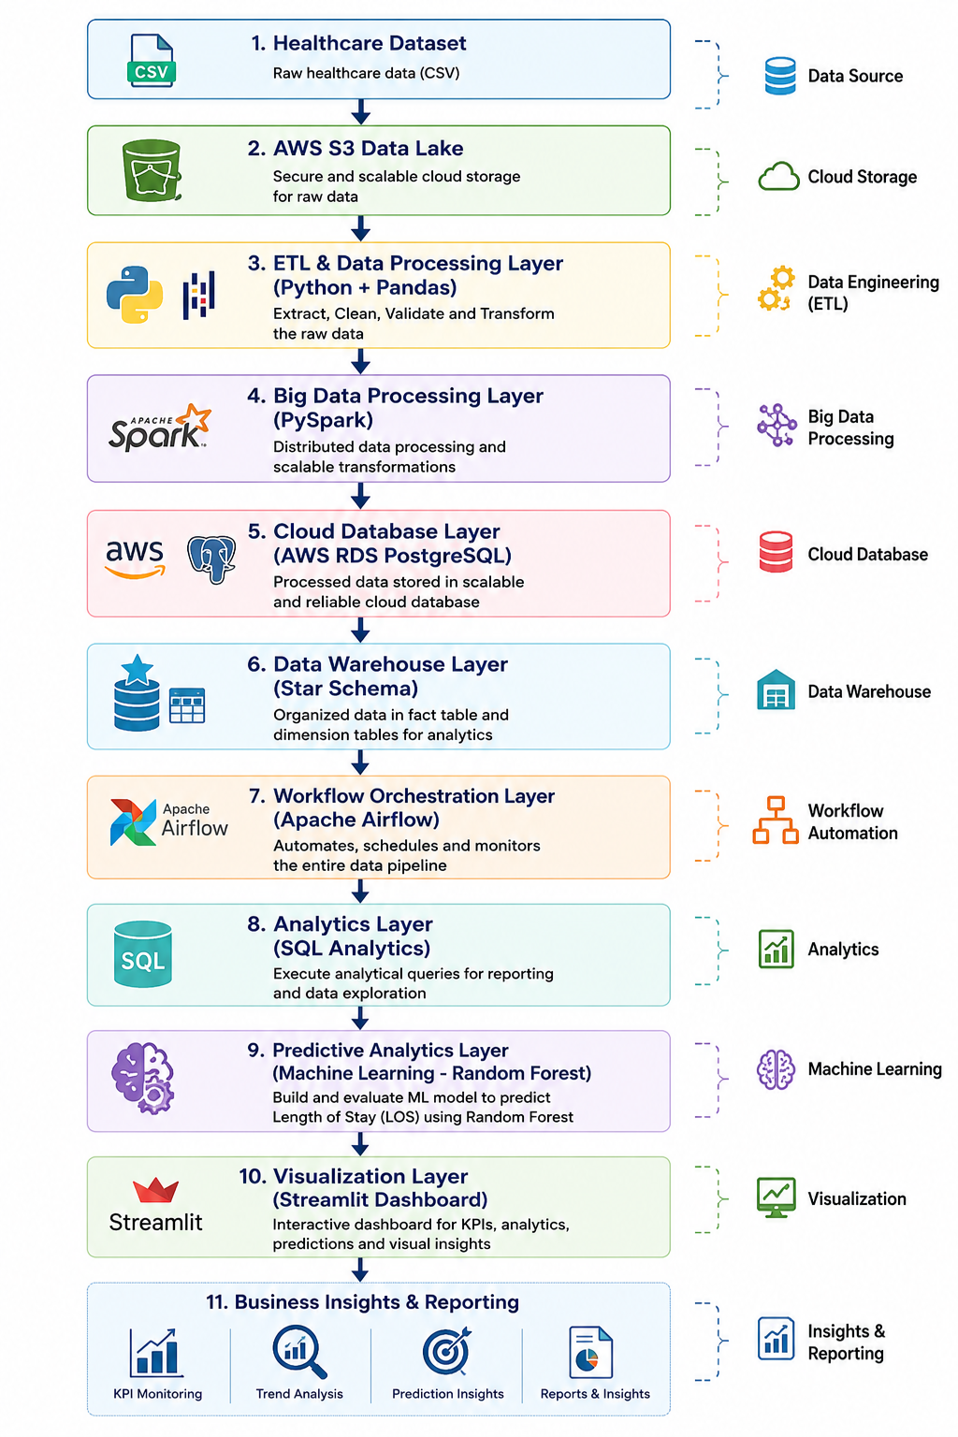
Figure: Healthcare Analytics Pipeline Architecture

PART 9 — DATA GOVERNANCE
Healthcare data requires proper governance, validation, and security controls to ensure data quality and reliability.
Data Governance Measures:
• Validation of incoming healthcare records
• Missing value detection and handling
• Duplicate record identification
• Data consistency checks
• Structured database design
• Secure cloud storage using AWS services
• Controlled access to healthcare information
Benefits:
• Improved data quality
• Reliable analytics
• Better reporting accuracy
• Enhanced data integrity

PART 10 — CONCLUSION
This project successfully demonstrates the implementation of a complete Healthcare Analytics Pipeline for MediCare Hospital.
The system integrates AWS S3, Apache Airflow, PySpark, PostgreSQL, AWS RDS, Data Warehousing, Machine Learning, and Streamlit into a single analytics platform.
Major Achievements:
• Automated healthcare data processing
• Cloud-based storage and database integration
• Big data processing using PySpark
• Interactive dashboard development
• Machine learning implementation
• Data warehouse design for analytics
The project demonstrates practical applications of Data Engineering concepts and provides a scalable solution for healthcare analytics.

PART 11 — FUTURE SCOPE
The Healthcare Analytics Pipeline can be further enhanced using advanced technologies and real-time processing capabilities.
Future Enhancements:
• Real-time data streaming using Apache Kafka
• Advanced machine learning models
• Integration with hospital management systems
• Automated alert generation
• Cloud-native deployment
• Mobile dashboard integration
• Predictive healthcare analytics
• Enterprise-scale implementation
These improvements can further increase the scalability and analytical capabilities of the platform.

PART 12 — SOURCE CODE STRUCTURE
Project Directory Structure:
healthcare-analytics-pipeline/
├── dashboards/
│ └── app.py
├── data/
│ ├── patients.csv
│ └── healthcare_big_data.csv
├── docker_airflow/
│ └── dags/
│ └── healthcare_etl_dag.py
├── docs/
├── screenshots/
├── scripts/
│ ├── etl_pipeline.py
│ ├── spark_pipeline.py
│ ├── data_warehouse.py
│ ├── ml_prediction.py
│ └── eda_analysis.py
├── sql/
│ └── healthcare_queries.sql
├── README.md
├── requirements.txt
└── .gitignore

PART 13 — ISSUES FACED & SOLUTIONS
Issue | Solution
Airflow Webserver Not Starting | Reconfigured Docker Compose Setup
AWS RDS Connectivity Issues | Corrected Database Configuration
ETL File Path Errors | Updated Relative File Paths
PySpark Dataset Loading Issues | Modified Dataset References
Dashboard Rendering Issues | Updated Streamlit Components
Data Warehouse Loading Errors | Corrected Table Structure and Schema

The above issues were resolved through testing, debugging, and configuration improvements.

PART 14 — DEMO & LINKS
GitHub Repository
The complete project source code, documentation, ETL scripts, Airflow DAGs, PySpark jobs, SQL queries, data warehouse implementation, and dashboard code are available on GitHub.
GitHub Repository Link:
https://github.com/arpit-systems/healthcare-analytics-pipeline
Live Dashboard
The Streamlit dashboard provides healthcare analytics, KPI monitoring, disease analysis, and interactive reporting.
Dashboard Link:
https://medicare-healthcare-dashboard.streamlit.app

Project Demonstration
Project Workflow:
Healthcare Dataset → AWS S3 → ETL Pipeline → Apache Airflow → PySpark → AWS RDS PostgreSQL → Data Warehouse → Machine Learning → Streamlit Dashboard
The project successfully automates healthcare data processing, analytics, and reporting through an end-to-end data engineering pipeline.

PART 15 — TEAM CONTRIBUTION
This project was completed through the collaborative efforts of all team members. Responsibilities included data collection, data cleaning, ETL development, workflow automation using Apache Airflow, cloud integration, PySpark processing, data warehousing, machine learning, dashboard development, testing, documentation, presentation preparation, and project review.
All team members actively contributed to the successful completion of the Healthcare Analytics Pipeline for MediCare Hospital project.

FINAL NOTE
This report presents the complete implementation of a Healthcare Analytics Pipeline developed using modern Data Engineering technologies. The project demonstrates cloud integration, workflow automation, big data processing, analytics, machine learning, and interactive visualization within a healthcare domain.
The implementation successfully fulfills the objectives of the capstone project and provides a scalable foundation for future healthcare analytics applications.

