AIR QUALITY DATA ACQUISITION,
CLEANING AND PREPROCESSING USING PYTHON
Week 1 Technical Report

Student | Arpit Chauhan
University | LJ University, Ahmedabad
Program | B.E. Computer Science & Engineering
Semester | 4th Semester
Tools | Python, Pandas, NumPy, Matplotlib, Jupyter Notebook

1. Introduction
This report documents the Week 1 technical work carried out on an air-quality dataset. The work focuses on acquiring the dataset, understanding its structure, identifying data-quality issues, treating invalid and missing observations, examining distributions and outliers, and performing a final quality validation. The analysis was performed in Python using a Jupyter Notebook.

1.1 Objectives
- Understand the structure and variables of the air-quality dataset.
- Identify missing values and the dataset's invalid-value marker (-200).
- Assess duplicate records and data types.
- Treat invalid/missing observations before statistical analysis.
- Study numerical distributions and potential outliers.
- Inspect temperature and relative-humidity behaviour over time.
- Validate the final cleaned dataset before further analysis or modelling.

2. Dataset and Working Environment
The notebook analysis uses the UCI Air Quality dataset. The working environment is based on Python and Jupyter Notebook, with Pandas used for tabular data handling and Matplotlib for visual analysis. The dataset contains sensor measurements related to carbon monoxide, hydrocarbons, nitrogen oxides, ozone, temperature, humidity and absolute humidity.

2.1 Main Variables
CO(GT), PT08.S1(CO), NMHC(GT), C6H6(GT), PT08.S2(NMHC), NOx(GT), PT08.S3(NOx), NO2(GT), PT08.S4(NO2), PT08.S5(O3), T, RH, AH.

3. Initial Data Quality Assessment
The initial inspection identified -200 as an invalid/missing-value marker in the raw dataset. A direct count in the notebook reported 16,701 occurrences of -200.
print("Total -200 values:", (df == -200).sum().sum())
Output: Total -200 values: 16701
The missing-value summary showed that NMHC(GT) had the highest proportion of missing observations (90.23%). CO(GT), NO2(GT), and NOx(GT) each had approximately 17.5–18.0% missingness. Several other variables had 3.91% missingness, while Date and Time had no missing values.
Feature | Missing Count | Missing %
NMHC(GT) | 8443 | 90.231912
CO(GT) | 1683 | 17.986534
NO2(GT) | 1642 | 17.548360
NOx(GT) | 1639 | 17.516298
PT08.S2(NMHC) | 366 | 3.911510
C6H6(GT) | 366 | 3.911510
PT08.S1(CO) | 366 | 3.911510
PT08.S5(O3) | 366 | 3.911510
T | 366 | 3.911510
PT08.S3(NOx) | 366 | 3.911510
PT08.S4(NO2) | 366 | 3.911510
RH | 366 | 3.911510
AH | 366 | 3.911510
Date | 0 | 0.000000
Time | 0 | 0.000000
The corresponding missing-value percentage visualization is included below.
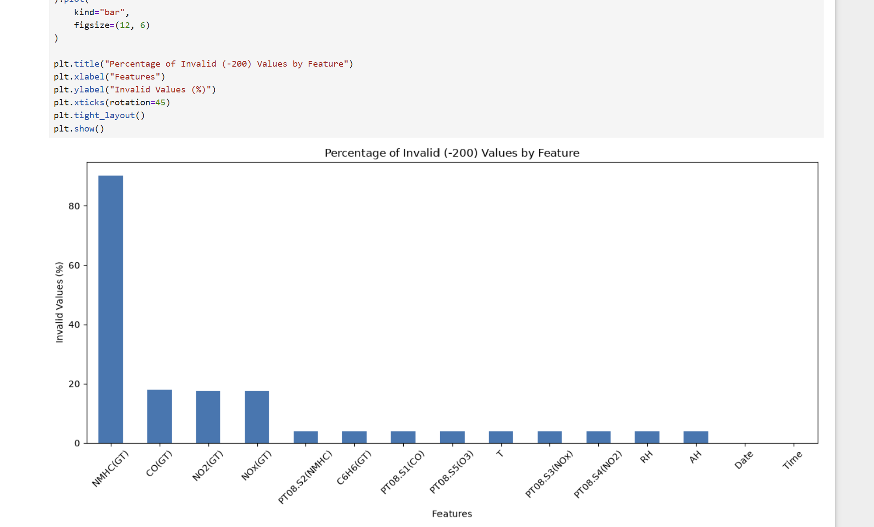

4. Missing and Invalid Value Treatment
The analysis treats -200 as an invalid placeholder rather than as a genuine physical measurement. This distinction is important because retaining -200 would severely distort descriptive statistics, histograms and boxplots. The final cleaned data therefore excludes the invalid marker from the analytical values.
NMHC(GT) was particularly problematic because approximately 90.23% of its observations were missing. For analytical purposes, a feature with this level of missingness provides very limited reliable information unless a strong domain-specific reconstruction method is available. The subsequent cleaned numerical analysis therefore focuses on the usable features.

5. Descriptive Statistics After Cleaning
After missing-value treatment, the numerical variables were summarized using count, mean, standard deviation, minimum, quartiles and maximum. The cleaned dataset contained 9,357 rows in the final quality check.
df_clean[numeric_columns].describe().T
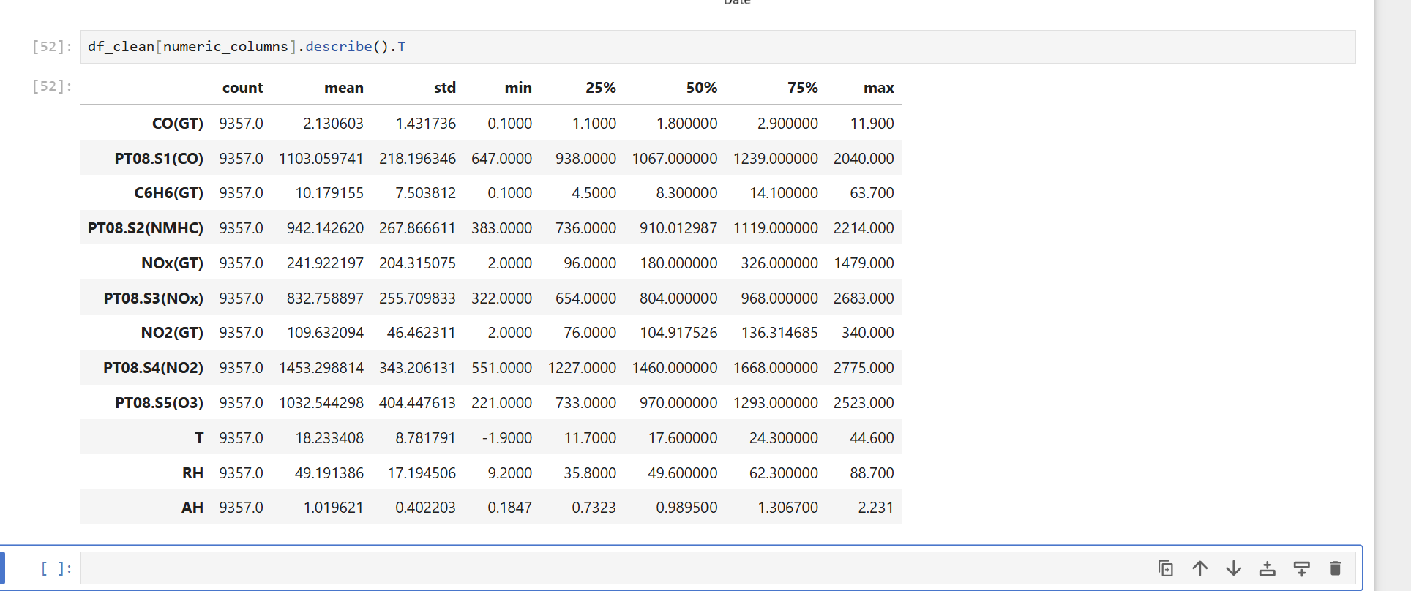
Examples from the cleaned summary include CO(GT) with a mean of approximately 2.13 and a median of 1.80, while temperature (T) has a mean of approximately 18.23. The difference between mean and median for several pollution variables indicates skewed distributions.

6. Distribution Analysis
Histograms were used to examine the shape and spread of the numerical variables. Several pollution-related features are visibly right-skewed, with longer upper tails. This is consistent with the presence of higher pollution measurements in a subset of observations.
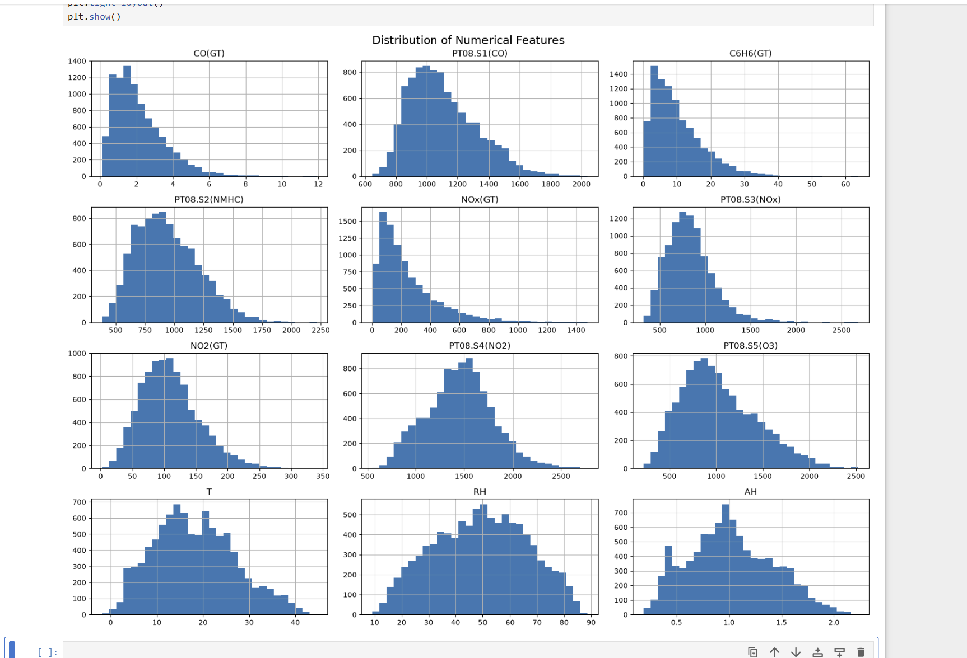

7. Outlier Analysis
Boxplots were used to identify observations that lie beyond the typical interquartile range. The plots show a number of high-value observations in several pollutant and sensor variables.
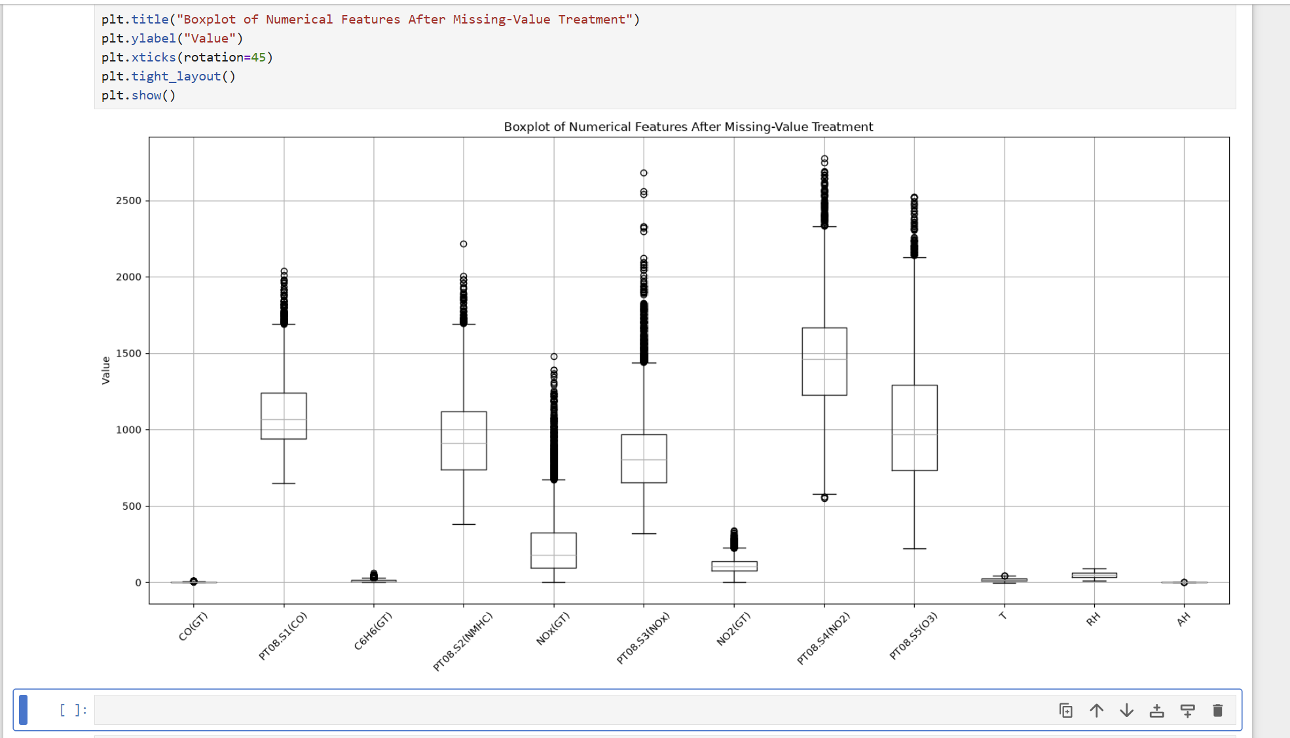
These observations were not automatically deleted. In an air-quality dataset, extreme values can represent genuine pollution events or environmental conditions. Therefore, statistical outliers should be investigated using domain knowledge before being removed.

8. Time-Series Analysis
Temperature and relative humidity were visualized against date to observe their variation over the recorded period. The plot shows substantial short-term variability as well as broader seasonal changes.
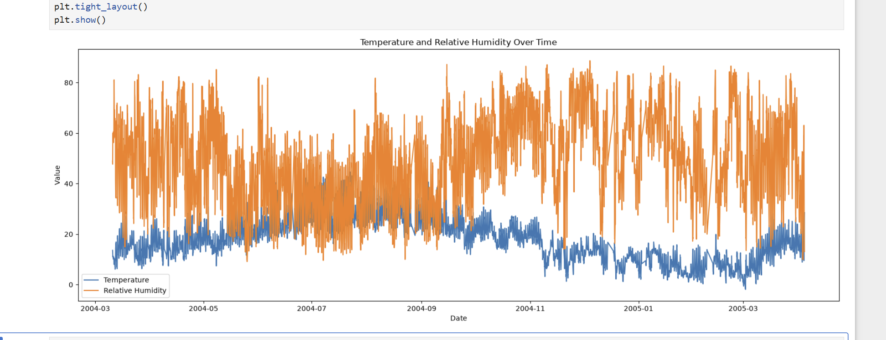
The visualization provides a useful first view of environmental behaviour over time. For a final publication-quality version, temperature and relative humidity can be displayed with separate y-axes because they have different units and numerical scales.

9. Final Data Quality Validation
A final validation cell was used to verify the state of the cleaned dataset. The reported result was:
print("Rows:", df_clean.shape[0])
print("Columns:", df_clean.shape[1])
print("Missing values:", df_clean.isna().sum().sum())
print("Invalid -200 values:", (df_clean == -200).sum().sum())
print("Duplicate rows:", df_clean.duplicated().sum())
print("Data types:")
print(df_clean.dtypes)
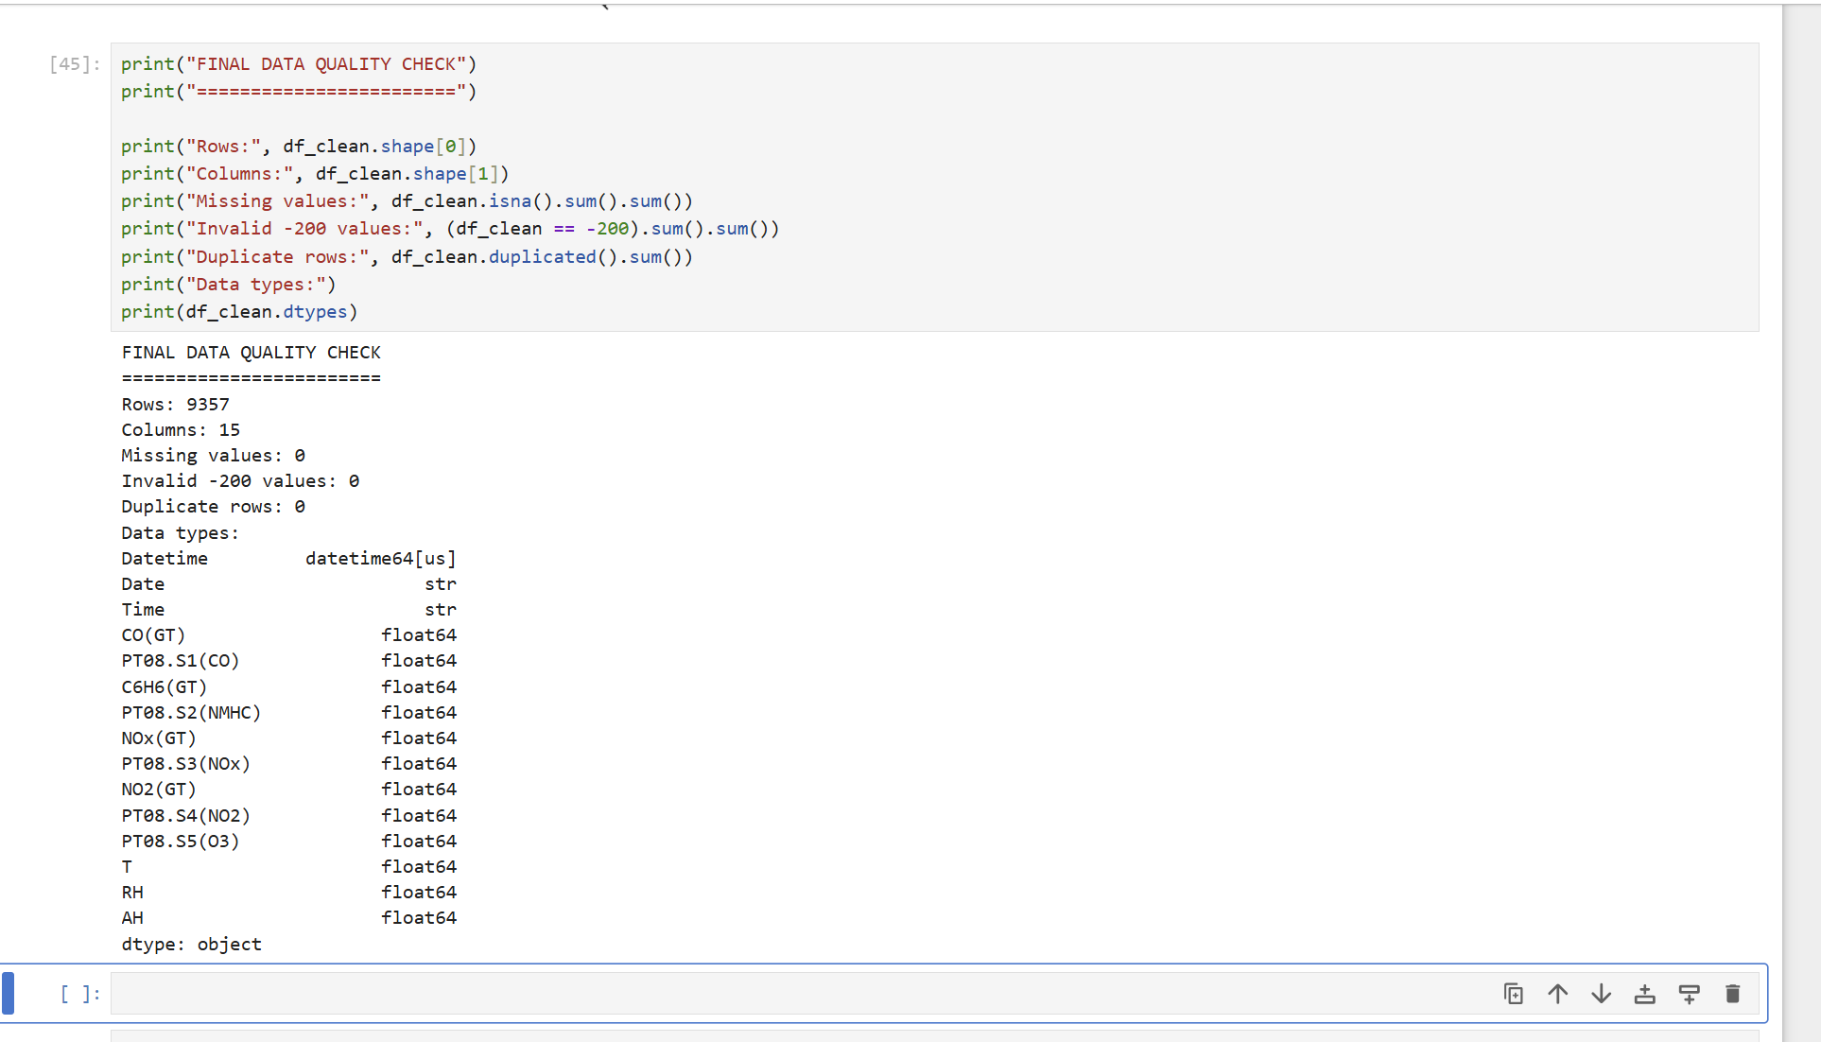
Final validation reported 9,357 rows, 15 columns, 0 missing values, 0 remaining -200 values and 0 duplicate rows. This confirms that the displayed cleaned dataset passed the main quality checks used in the notebook.

10. Before and After Preprocessing
Quality Aspect | Before Treatment | After Treatment
Invalid -200 values | 16,701 occurrences | 0
Missing values | Present in multiple features | 0 in final check
NMHC(GT) | 90.23% missing | Excluded from usable numerical analysis
Duplicate rows | Required validation | 0
Statistical analysis | Distorted by invalid marker | Performed on cleaned values
Distributions/outliers | Affected by invalid values | Analysed after treatment

10.1 Correlation Analysis
A Pearson correlation matrix was calculated for the cleaned numerical features to examine linear relationships between pollutant concentrations, sensor readings and environmental variables.
The heatmap shows several strong positive relationships among pollution-related variables. For example, C6H6(GT) and PT08.S2(NMHC) have a very strong positive correlation (0.98), while PT08.S1(CO) and PT08.S5(O3) show a strong positive correlation (0.90). PT08.S3(NOx) has strong negative correlations with several pollutant/sensor variables, including PT08.S5(O3) (-0.80), PT08.S2(NMHC) (-0.79) and PT08.S1(CO) (-0.78).
The environmental variables show different patterns. Temperature (T) has a moderate positive correlation with absolute humidity (AH) (0.66) and a moderate negative correlation with relative humidity (RH) (-0.57). AH also has a positive relationship with PT08.S4(NO2) (0.63). These relationships indicate that the cleaned dataset contains both strongly related sensor/pollutant measurements and distinct environmental variables.
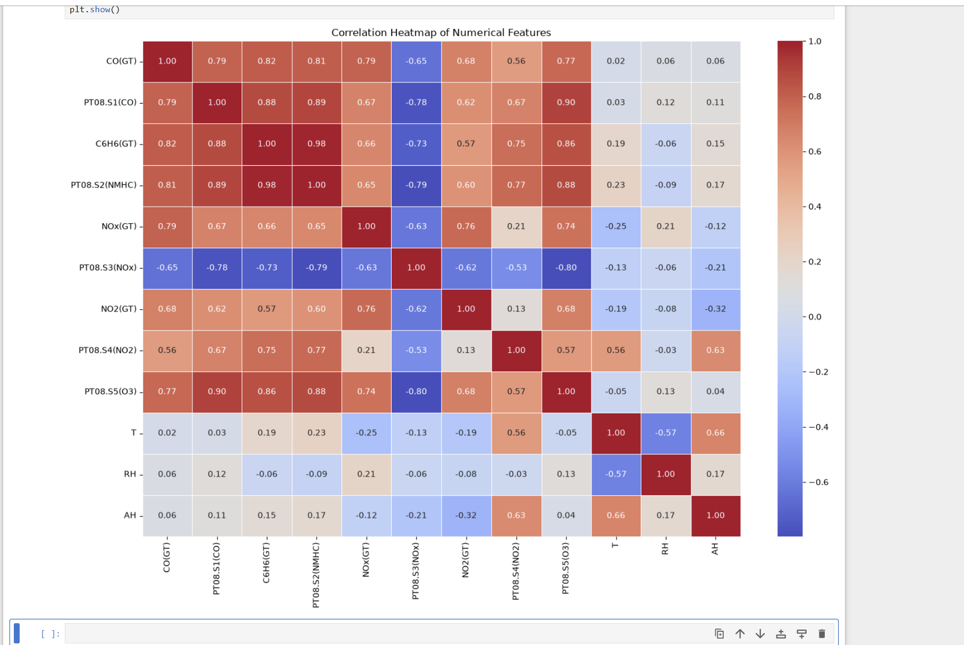
Figure: Correlation Heatmap of Numerical Features

11. Challenges and Solutions
Challenge | Observation | Solution/Decision
Invalid-value representation | The dataset uses -200 as a missing/invalid marker. It had to be recognized as a placeholder rather than a real measurement. | Counted -200 values first, then treated them as invalid before the final analysis.
Very high missingness | NMHC(GT) had 8,443 missing observations (90.23%). | The feature was not relied upon in the cleaned numerical analysis because the missingness was too high for simple imputation.
Skewed distributions | Several pollutant features have long upper tails. | Used histograms and descriptive statistics to understand distribution shape before deciding on further modelling transformations.
Potential outliers | Boxplots show many extreme observations. | Retained them unless domain evidence indicates that they are erroneous, because real pollution events can be extreme.

12. Impact of Preprocessing
- Removed the influence of the -200 invalid marker on descriptive statistics and visualizations.
- Produced a final analytical dataset with no remaining missing values according to the validation check.
- Made distributions and outlier patterns more interpretable.
- Reduced the risk of treating missing-value placeholders as genuine sensor measurements.
- Provided a cleaner foundation for later correlation analysis, feature engineering and machine-learning tasks.

13. Reflective Commentary
The main learning from this task was that data preprocessing is not simply a sequence of mechanical cleaning commands. It requires understanding how a dataset represents missing information and deciding whether unusual values are errors or meaningful observations. The -200 marker demonstrated how a single placeholder can distort statistical summaries if it is not handled correctly. The high missingness in NMHC(GT) also showed why missing-value percentage should be considered before choosing an imputation strategy. Visual analysis through histograms, boxplots and time-series plots was useful because it revealed skewness, extreme observations and temporal patterns that are not obvious from a simple table. Overall, the preprocessing stage made the dataset more suitable for reliable exploration and future modelling.

14. Conclusion
The Week 1 air-quality data preparation task successfully covered data-quality assessment, invalid-value treatment, missing-value analysis, descriptive statistics, distribution analysis, outlier inspection and final validation. The raw data contained 16,701 occurrences of the -200 marker, while the final quality check reported zero remaining invalid -200 values, zero missing values and zero duplicate rows in the cleaned dataset. The resulting dataset is therefore substantially more suitable for downstream exploratory analysis and modelling.

15. Technical Submission / Repository
The technical work should be maintained in a GitHub repository containing the notebook, relevant data folders, screenshots, README and dependency information.
GitHub: https://github.com/arpit005c
Suggested repository organization:
- data/raw/ – original dataset
- data/processed/ – cleaned/processed dataset
- notebooks/ – Jupyter Notebook
- screenshots/ – analysis evidence
- README.md – project documentation
- requirements.txt – Python dependencies
- LICENSE – project license

16. Portal Description (200+ Words)
This project focuses on the acquisition, cleaning and preprocessing of an air-quality dataset using Python. The objective of the work is to convert a raw environmental dataset into a reliable analytical dataset that can be used for further exploratory analysis and machine-learning tasks. The project was implemented in a Jupyter Notebook using Python-based data analysis tools. The first stage involved understanding the structure of the data, its variables and the representation of missing observations. A major data-quality issue was the use of -200 as an invalid-value marker. A total of 16,701 such values were identified in the raw data. Missing-value percentages were then calculated feature by feature. NMHC(GT) was found to have approximately 90.23% missing values, while CO(GT), NO2(GT) and NOx(GT) had approximately 17.5–18.0% missingness. These findings were considered before deciding how the variables should be used in the cleaned dataset. Descriptive statistics, histograms and boxplots were used to understand numerical distributions, skewness and potential outliers. A time-series visualization of temperature and relative humidity was also created to observe environmental variation over time. The final validation step reported 9,357 rows and 15 columns, with zero missing values, zero remaining -200 values and zero duplicate rows. The project demonstrates the importance of data-quality assessment before statistical analysis or modelling. It also highlights that outliers should not be removed automatically because extreme environmental observations can represent real-world conditions. The completed preprocessing workflow provides a cleaner and more reliable foundation for correlation analysis, feature engineering and predictive modelling. The correlation analysis also revealed strong relationships among several pollutant and sensor variables.

17. Evidence Screenshots

Missing-value summary

Invalid -200 value analysis

Descriptive statistics

Numerical feature distributions

Outlier boxplot

Temperature and relative humidity over time

Final data-quality check

