Project Description

Brief Description of what's going on in the game.

Game has two main agents:

Farmer and Baker

Farmer harvest wheat and deliver 1 set of wheat to windmill.

Baker bakes bread and needs 2 units of flour to make bread.

Baker then delivers 5 set of bread to market place.

He waits for farmer to stock 5 units of wheat.

Then he collects those 5 units of wheat and bring it to bakery where he bakes bread until he has 5 stocks of bread.

Then he delivers those bread to market.

Windmill and Bakers production and stock is visible on inventories of left top of the game.

-------------------------------------------------------------------------------------------------------------------------

GOAP - As I discussed in my presentation, I have used GOAP to create the above AI. It was good amount of learning. GOAP doesn't work on FSM but creates on GOAP queue based on priority and cost.

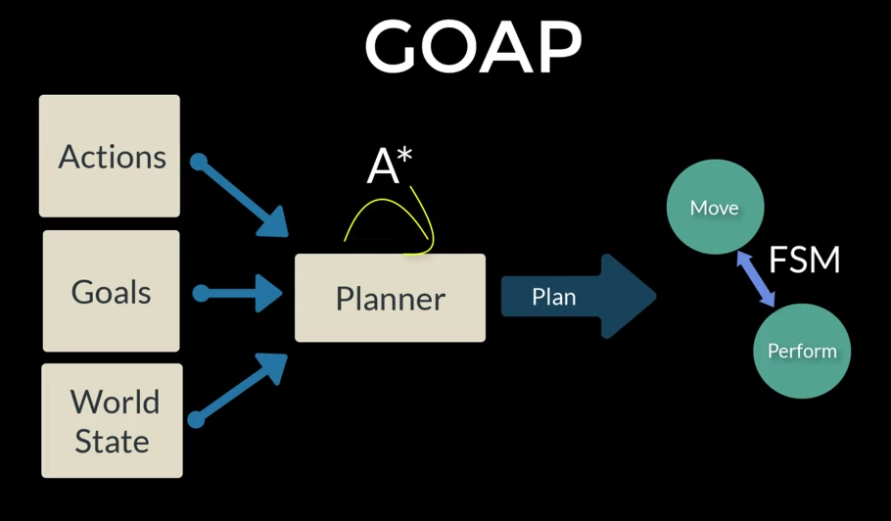In AI Folder, there are two folder FSM, GOAP

In FSM Folder there are 2 classes: FSM and FSM state

In GOAP folder there are 4 classes.

GoapAction, GoapAgent, GoapPlanner, IGoap.

GoapAgent: It takes care of agent actions. It looks for goals and it keep tracks for goals and world stage as it changes.

GoapAction: It is inheritable class. It has preconditions and effects. All the actions supposed to be done by our agents, should inherit from this class. Action can be added at anytime by being the child of this class.

GoapPlanner: It gathers Goap Actions when AI agent has been given a goal and piece them together according to precondition and effects. Then it makes a queue out of it to according to cost, precondition, effects and world state to complete a goal. Finally, it make a chain of actions which it sends to GoapAgent, which uses FSM to perform actions along the chain.

IGoap: It is an interface to create GOAP for the project. AI is going to inherit from this class. In our case, it is Worker and Baker.

If they don’t have precondition or effects which are joined with other actions they will never be used. So, its important to properly chain them together.

If further information or data required to understand the functioning of the project, do tell me I will provide more details. However, I think it should be enough to have basic understanding of this project.