**PROJECT BACKGROUND**

Business Intelligence, Analytics, and Big Data are all among the hottest buzzwords in today’s IT as well as Business environment. The shared aims of these concepts is data management. The ultimate purpose of data management is to support decision making. Among all the Business Intelligence and Decision Support systems, the most fundamental one is a reporting. The main goal of this project is to build a web based reporting system based on a given data set. This report system is based on a real-time dataset from Dillard’s Department store. We will utilize this dataset to build a sample data mart/data store. Using this data store, we will answer a few questions that are useful for decision making and generate reports that we think are important from the executive and the store manger’s point of view.

We created a data warehouse based on the real time Dillard’s data and below is the ER diagram for the design.

**DECISION MAKING QUESTIONS**

1. Which store sells max quantity of products in a specific year?
2. Which store sells max number of different products (variety)?
3. What is the sales of a product in a store in a specific quarter?
4. What is the sales of a brand in a year?
5. Which store in a statistical area is better than the rest in terms of sales?
6. Which departments have the least and maximum sales in a year?
7. Which products in a department generated more sales?
8. Which register generated max number of sales in a quarter?
9. Which quarter resulted in maximum and minimum sales for a given store?
10. Which vendor is responsible for generating maximum amount of sales in a quarter?

**ER - DIAGRAM**

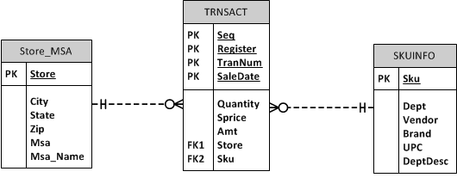

**USE CASE DIAGRAM – REPORTING SYSTEM**



**FUNCTIONAL REQUIREMENTS**

1. The very first page that manager sees on clicking the URL <http://uisacad.uis.edu/~kmulpu2/DillardsReporting.html> is the below login screen. This page will have fields for entering credentials – User ID, Password, Submit button and “Forgot Password?” link in order for the user to reset password

*Login Page:* 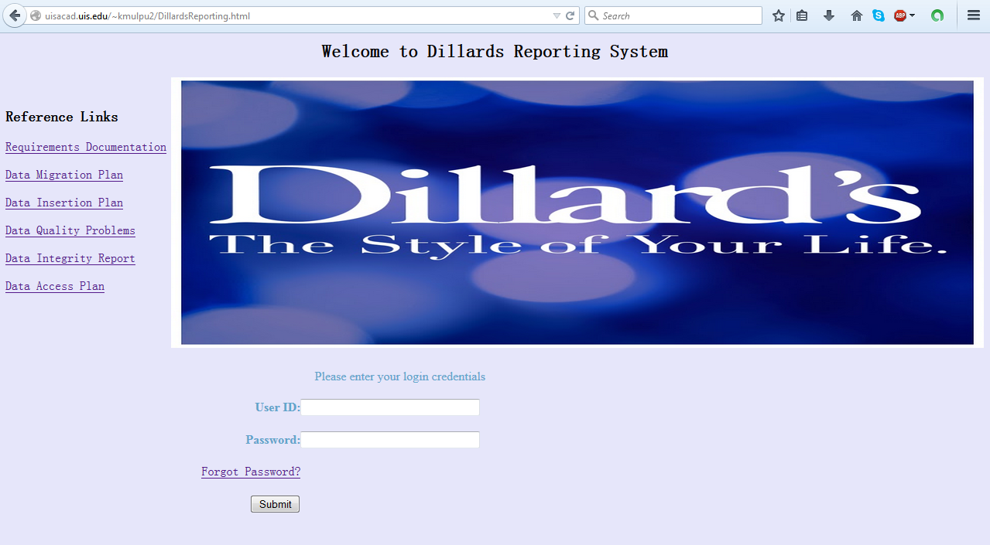

1. The credentials given by the user are then, verified by the system and an acknowledgement message appears on the next page. If the credentials entered are correct, then the user is allowed to view/generate reports.

*Credentials Page:*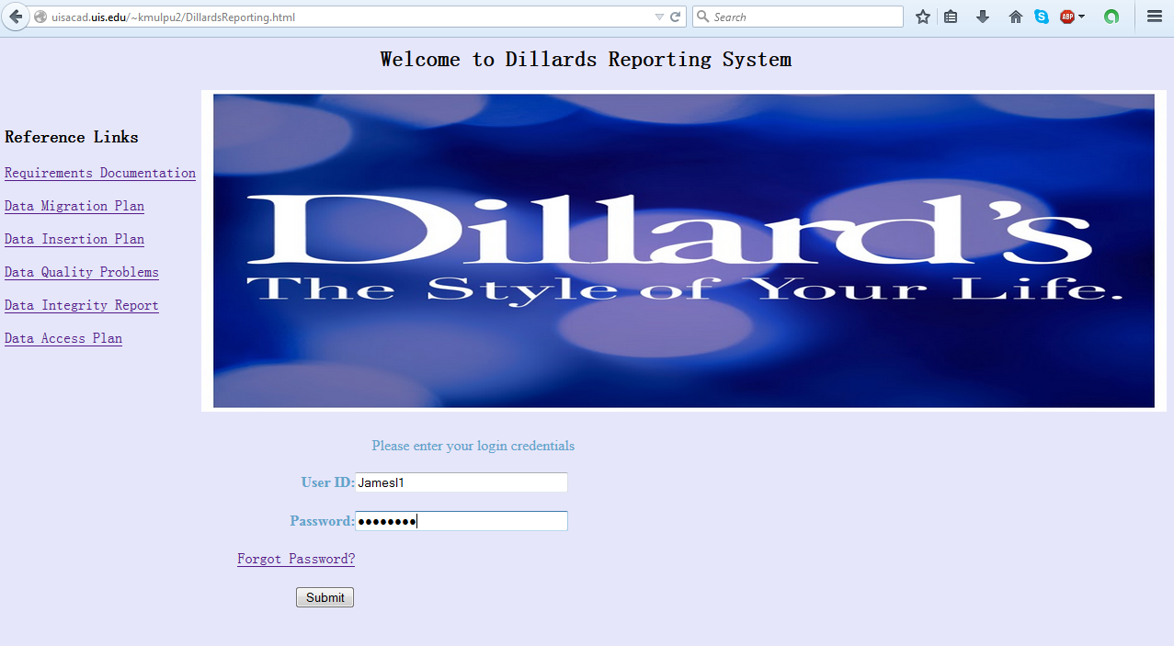

*Login Successful page: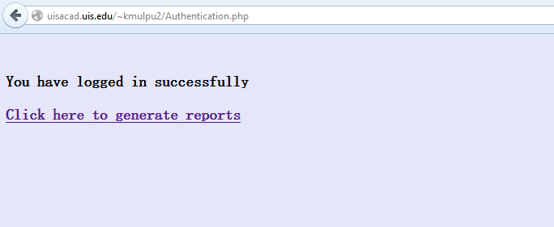*

1. If the credentials are invalid, an error message will appear as shown in the below screenshot

*Login unsuccessful Page:*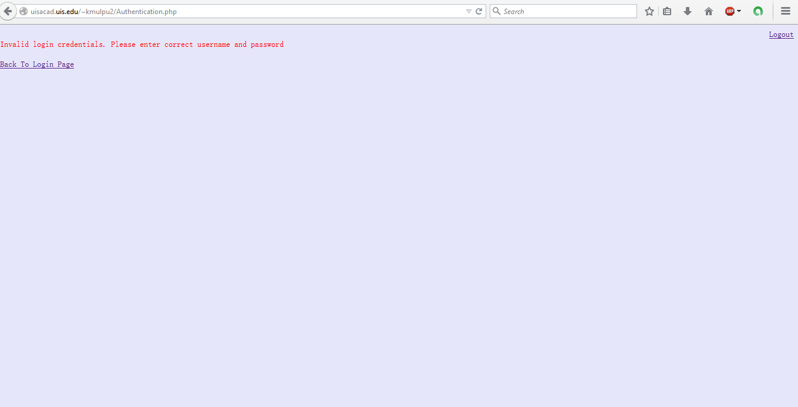

1. “Forgot password?” option helps the user to reset password. Once the user click on “Forgot Password?” link, the following page appears.

*Password Reset Page:*

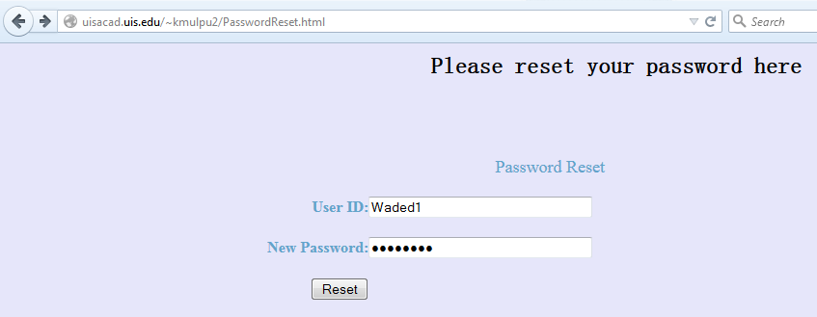

1. After user ID and new password are entered, the user clicks on “Reset” button and the following page appears.

*Password Reset successful page:*

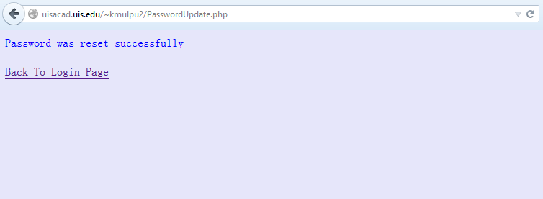

1. If new password is blank, then an error message appears as shown below

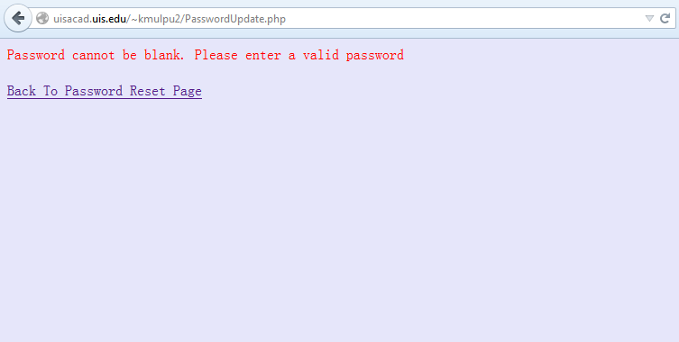

1. In the next step, the manager enters the criteria, for which he wants the reports to be generated. This page has 3 drop down boxes and 1 text box as shown in the below screenshot.

Values in Category dropdown – Product, Department, Brand, Vendor, Product And Department, Register And SKU

Year – 2004, 2005

Quarter – None, First Quarter, Second Quarter, Third Quarter, Fourth Quarter

*Criteria Page:*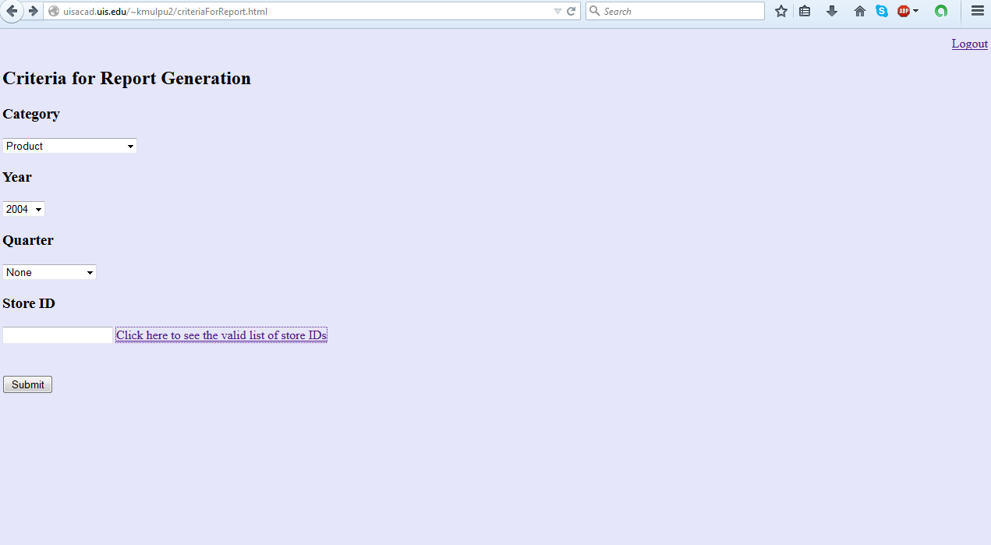

1. The manager can also click on the “Click here to see the valid list of store IDs” link to know correct store ID.

*Store ID page:*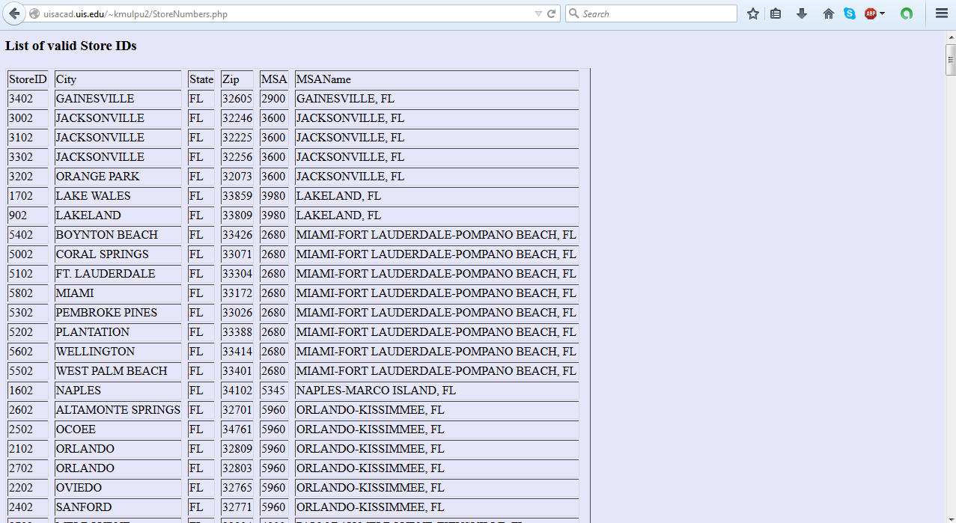

1. After the manager enters criteria, the system executes query and a report is generated for the query.

*Report Generation page:*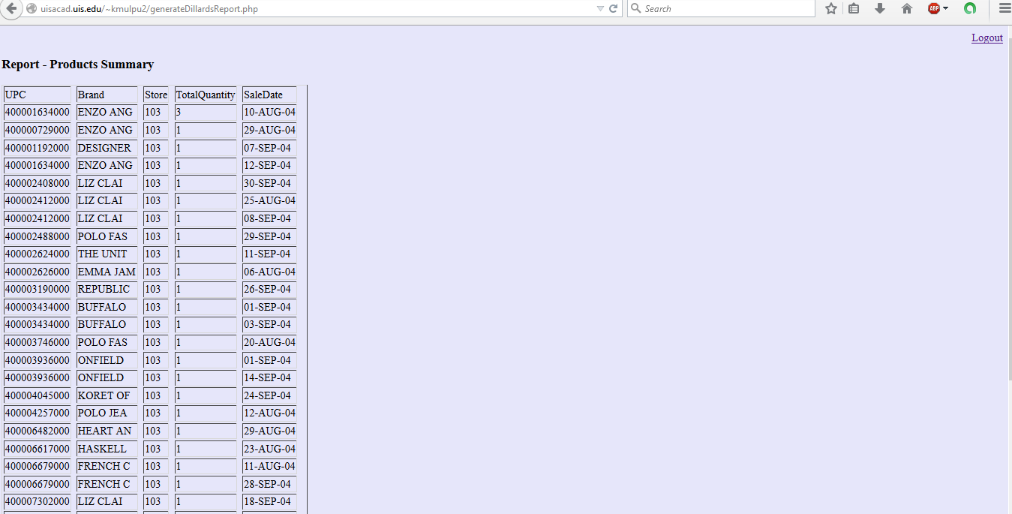

1. The manager can then modify the criteria.

*Modify Criteria:*

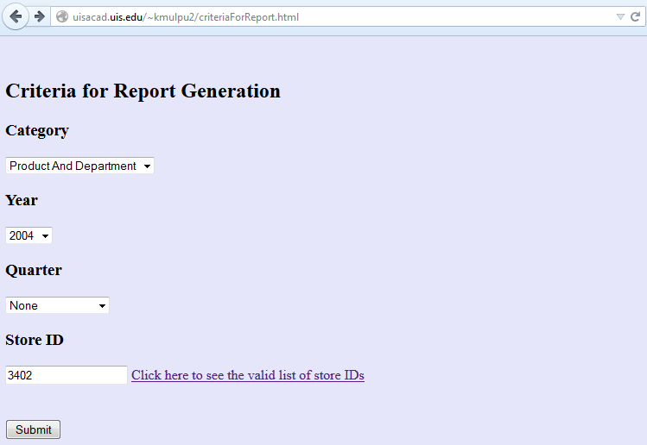

1. The system will again reprocess query and generate report for the same.

*Reprocess Query:*

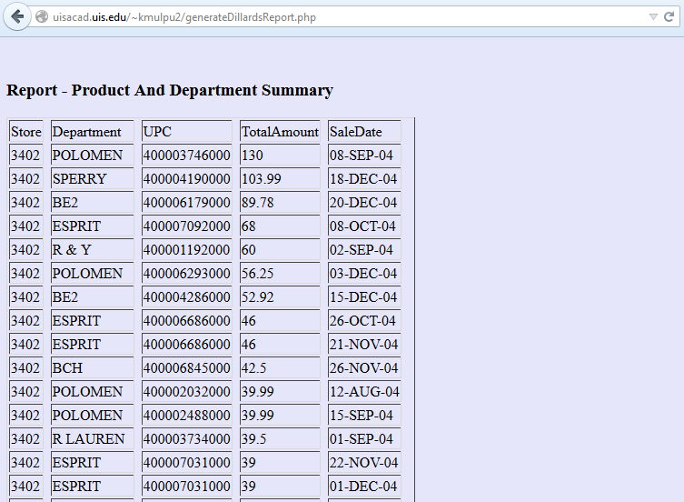

1. If there is no information available for selected criteria, the following error message appears.

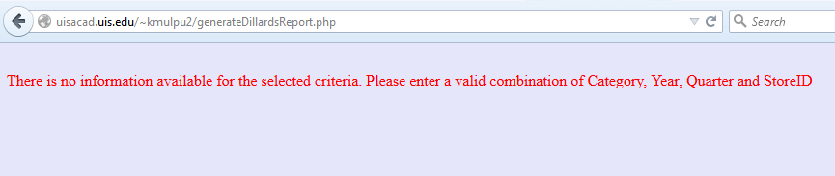

1. In order to logout of the reporting system, user may choose to click on “Logout” link that is present at top right part of the screen. Once the user clicks on the link, an alert pops up as shown below

*Logout page:*

