Vicinato- A Smart Society Application

Software Design Specification

Version 1.4

**Arpit Agarwal 13BCE0022**

**Sai Akshaya 13BCE0222**

Contents

1. Overview 3

2. Purpose 3

3. Scope 3

4. System Architecture 4

5. Class Diagram 5

6. Sequence Diagrams 6

7. Activity Diagrams 7

8. Data Design Diagrams 8

9. Flow Diagrams 9

10. Collaboration Diagram 10

11. User Interface Design 11

12. Requirements Tracebility Matrix 15

13 References 16

14. Glossary 16

|  |  |  |  |
| --- | --- | --- | --- |
| **Name** | **Date** | **Reason for Changes** | **Version** |
| S Sai Akshaya Pillai | 4/4/2016 | Initial Draft | 1.0 |
| Arpit Aggarwal | 10/4/2016 | Added Collaboration and sequence diagrams | 1.1 |
| S Sai Akshaya Pillai | 11/4/2016 | Added UI prototypes | 1.2 |
| Arpit Aggarwal | 12/4/2016 | Added Database diagrams | 1.3 |
| Arpit Aggarwal  S Sai Akshaya Pillai | 27/4/2016 | Structure and Content Revised | 1.4 |

**Revision History**

1. **Overview**

Vicinato is a smart society application that aims to bridge the gap between neighbours and use technology in bringing them closer. The vision is to improve communication between people living in complex or apartment by changing the way they interact. The app will provide a channel for the residents to reach out to their fellow residents, help each other in times of need, send invitations for celebrations, schedule play dates for their children and even plan carpools together. Further the app would also provide information about domestic help, repair and maintenance personnel, lost and found, society meetings et cetera.

1. **Purpose**

The purpose of this Software Design Specification document is to outline the software architecture and design for Vicinato. It will explain the detailed design of the application through various UML diagrams.

1. **Scope**

This document outlines the architecture of Vicinato and shows how the design of the application will help accomplish the functional and non-functional requirements of the system. This document also intends to explain the underlying architecture of Vicinato to any engineers working on the development of the app and to professionals from the management side.

1. **System Architecture**

System Interface

* Family Login
* Admin Login
* Guard



1. **Class Diagram**

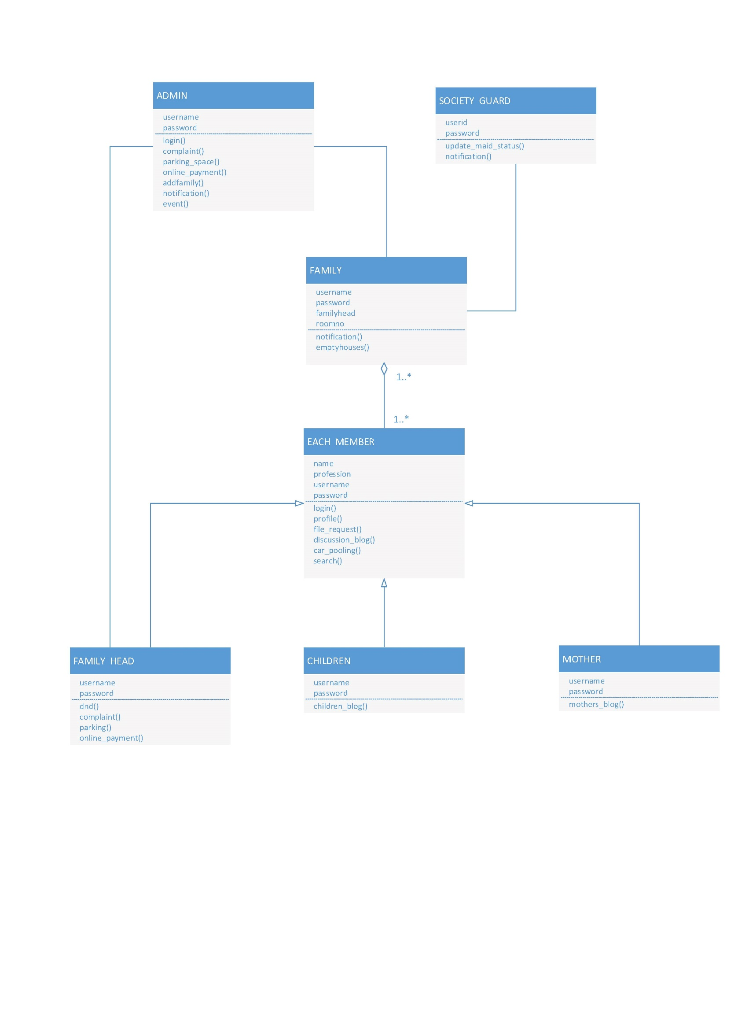The class diagram given shows a static view of the system. It shows all the classes along with their attributes and methods and the interrelationships between the different classes.

*Fig 5.1 Class Diagram for Vicinato*

1. 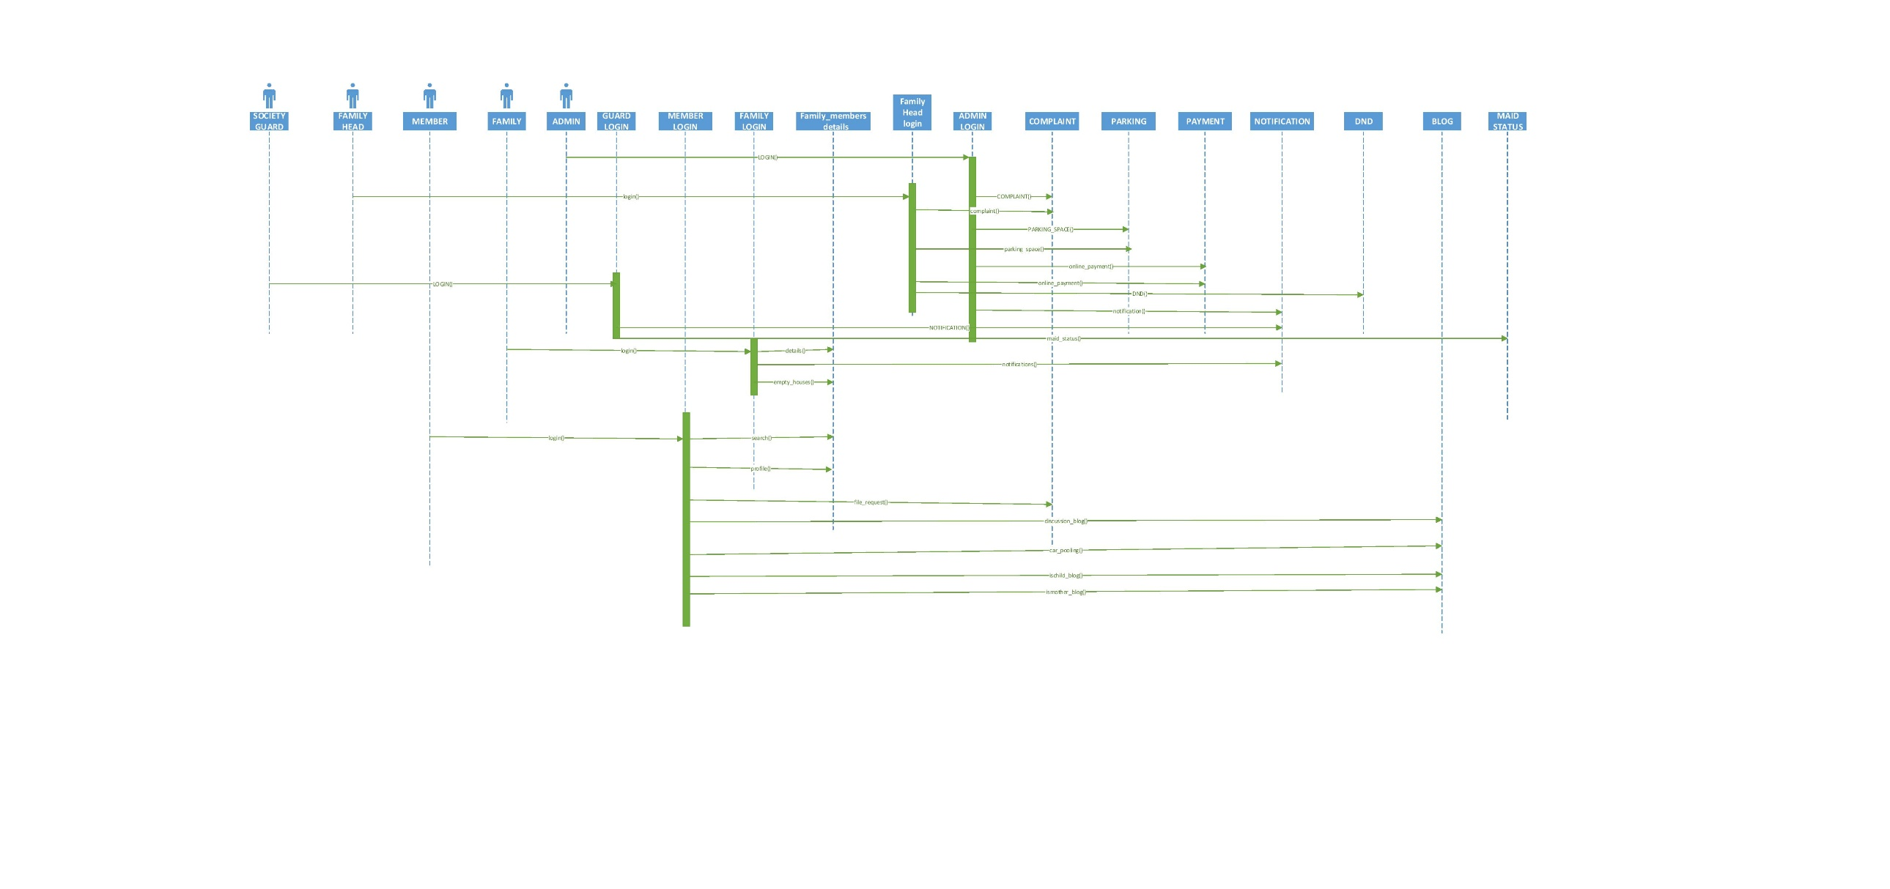**Sequence Diagrams**

*Fig 6.1 Set of Sequence Diagrams for the system*

Sequence diagrams covering various functions of the system are shown here. For example the interactions that must take place for a member or admin or family to login and do various tasks such as posting a blog post, enquiring about parking space, adding a complaint, doing online payment, posting a DND request etc. are shown in the above set of sequence diagrams. All the functionalities of the system given in the SRS have been covered.

1. 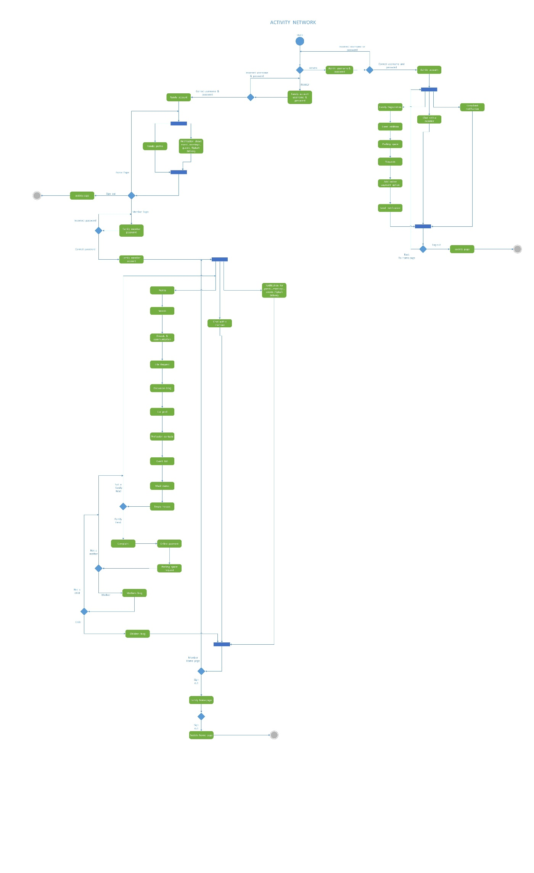**Activity diagrams**

This figure shows an activity network diagram for the system. It represents the flow from one activity to another in the system.

1. 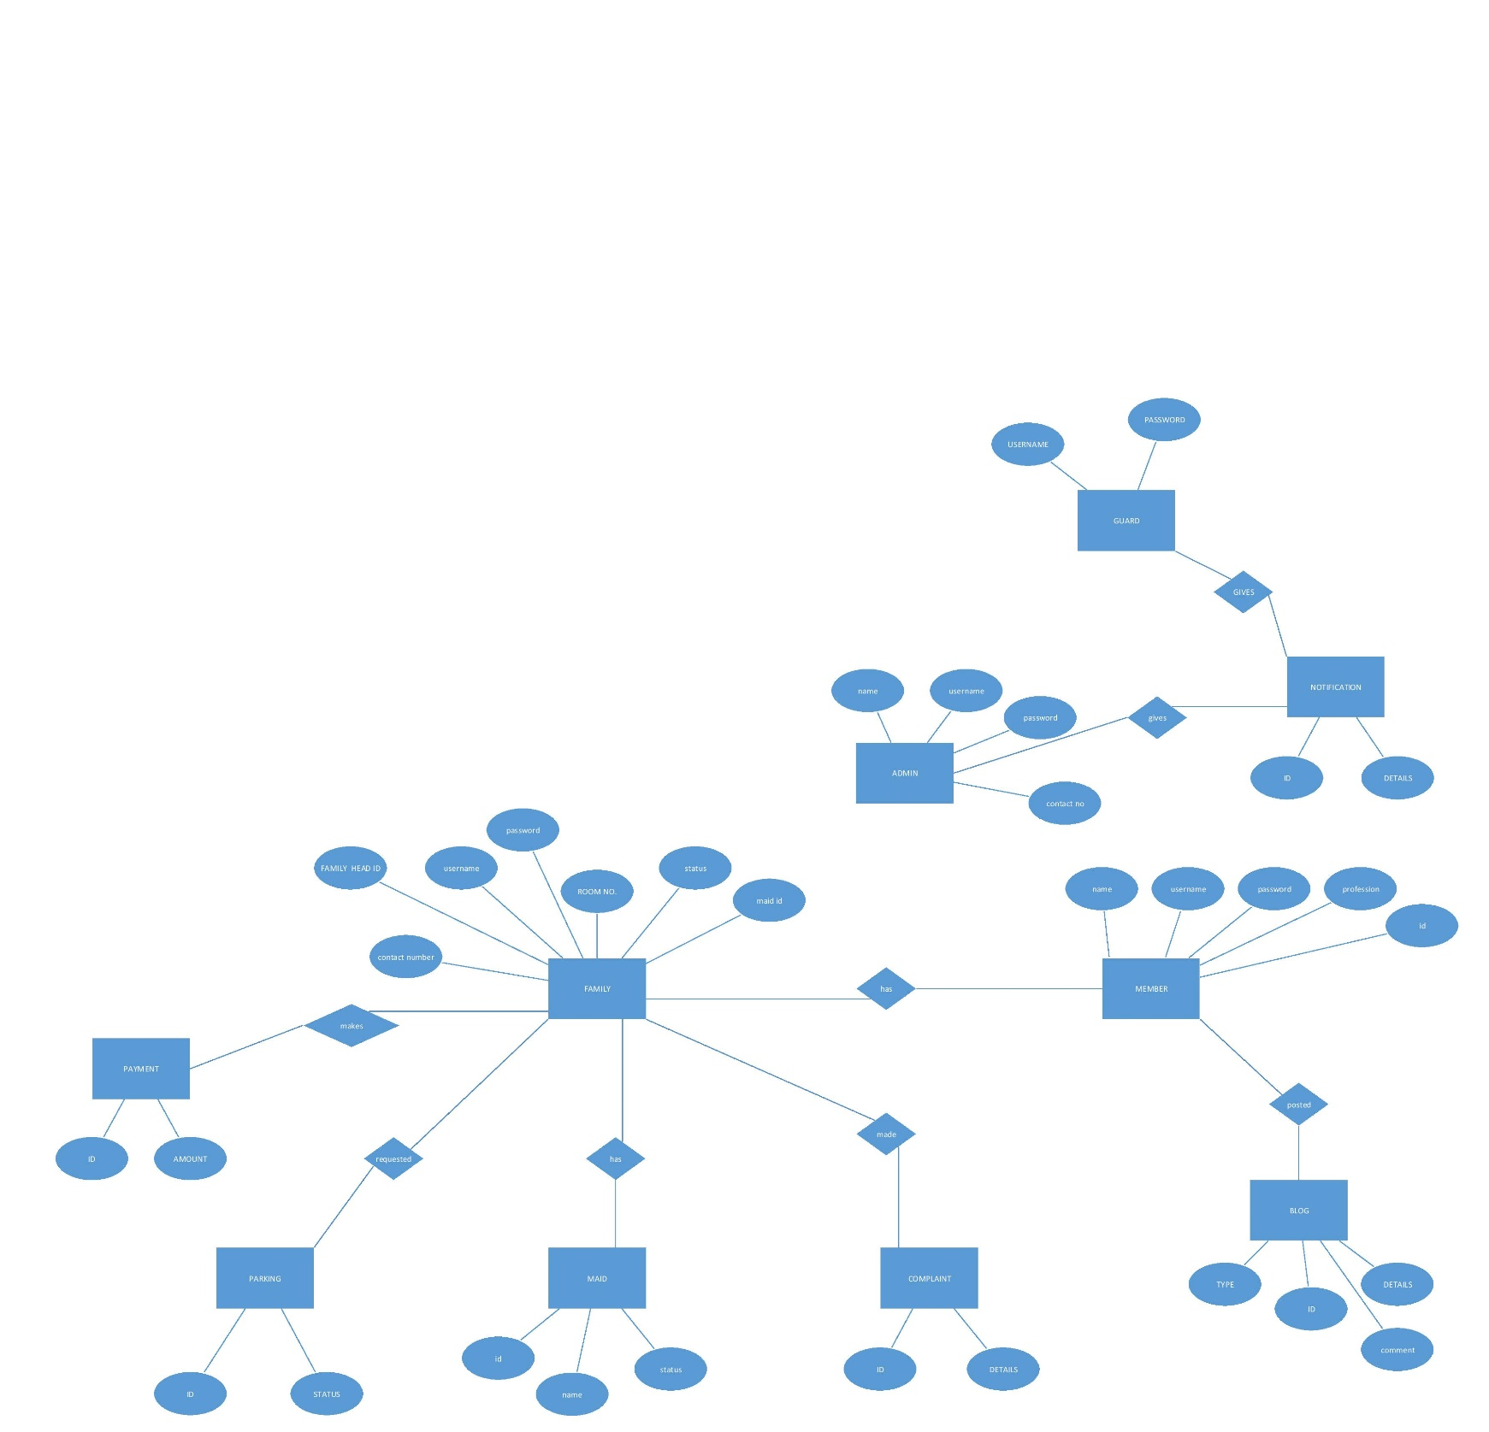**Data Design diagram**

*Fig 9.1 ER Diagram for the System*

The Entity Relationship Diagram for the system is as shown. All the different entities with their attributes along with the relationships between different entities are shown in the diagram

1. 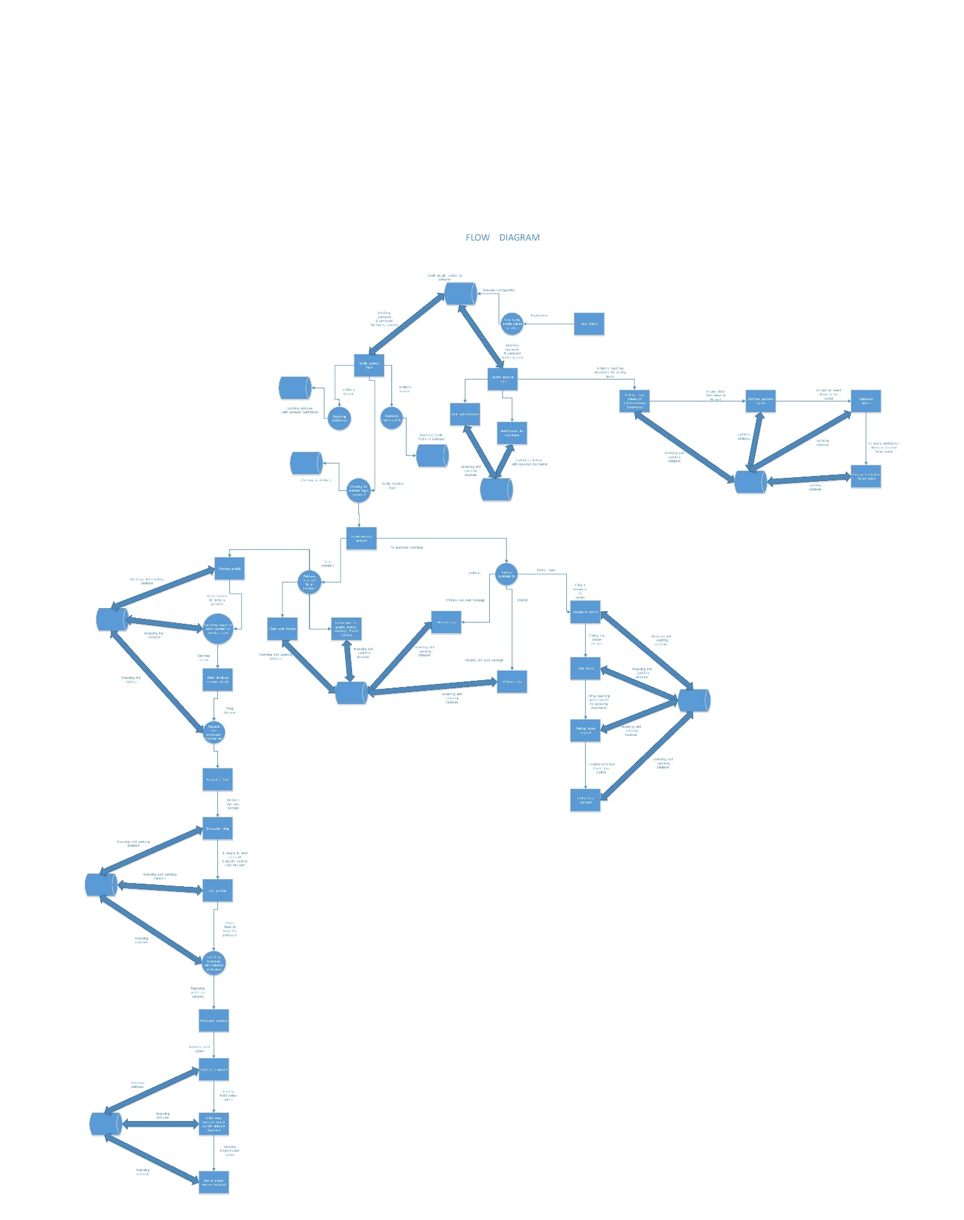**Flow Diagram**

A flow diagram for the entire system has been presented. All the functions given in the SRS have been covered.

1. 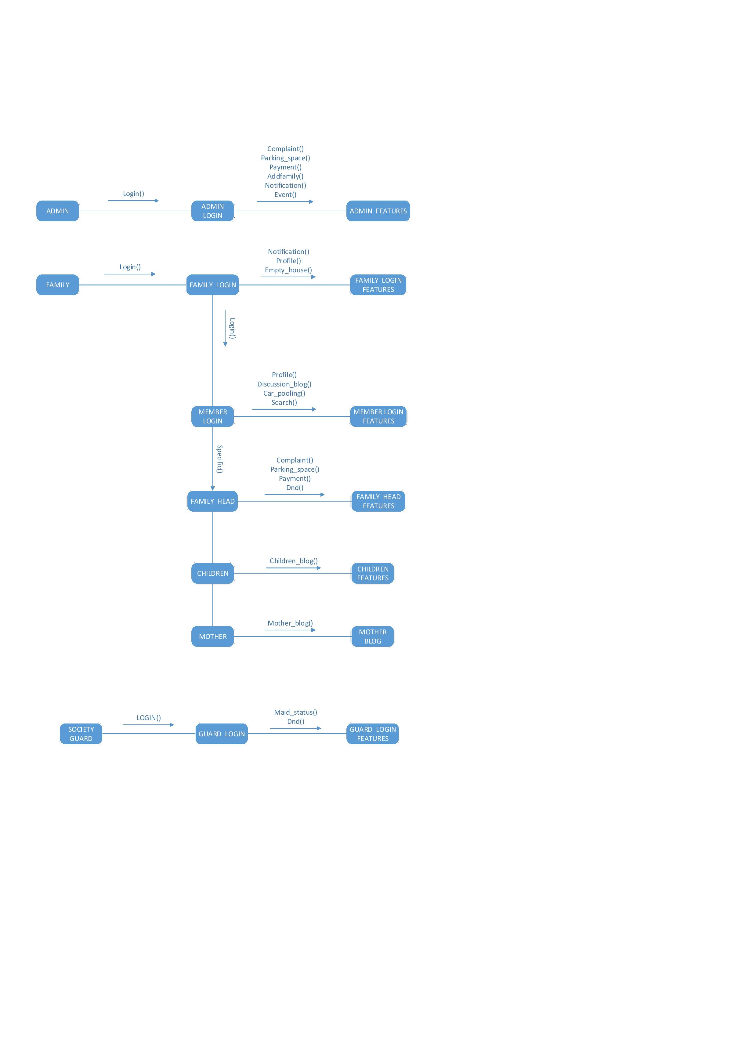**Collaboration Diagrams**

The collaboration diagram presents an illustration of the relationships and interactions among the various ‘software objects’ in the system.

1. **User Interface Design**

The user interface design for the system interfaces have been shown. These designs have been rendered using Balsamiq tool.

1. 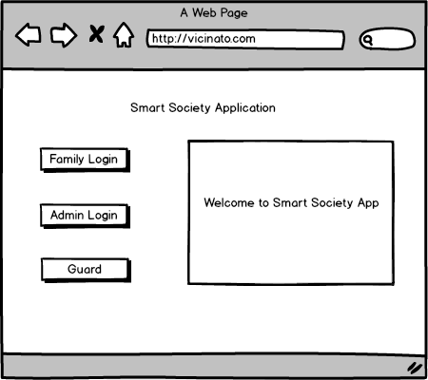**Home Page**
2. 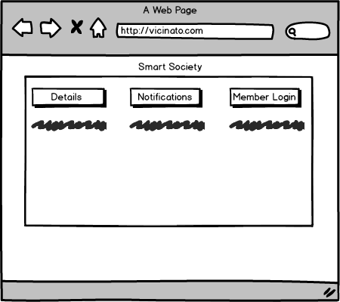**Family Login**
3. 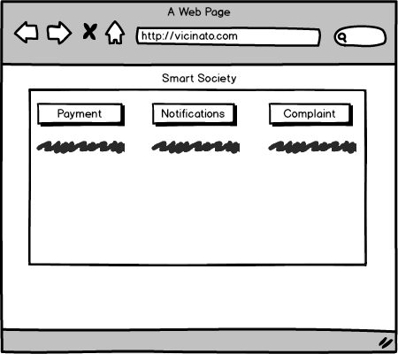**Admin Login**

**Screenshots from the actual system prototype**

1. **Home Page**

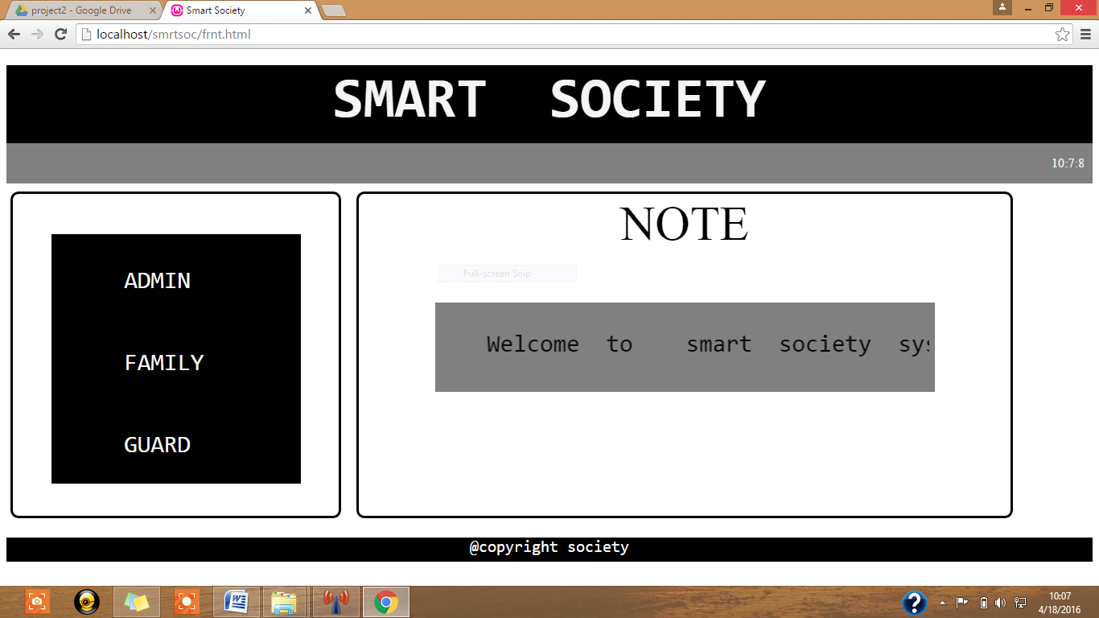

1. **Family Login**

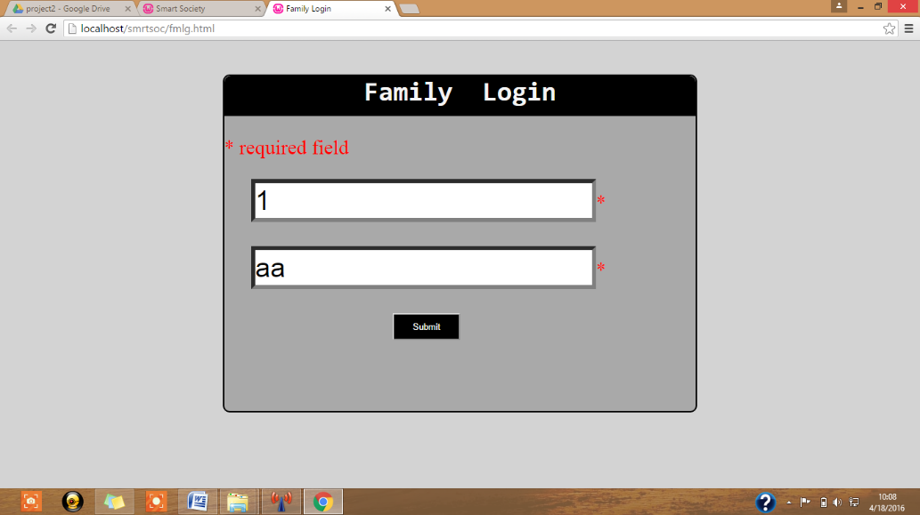

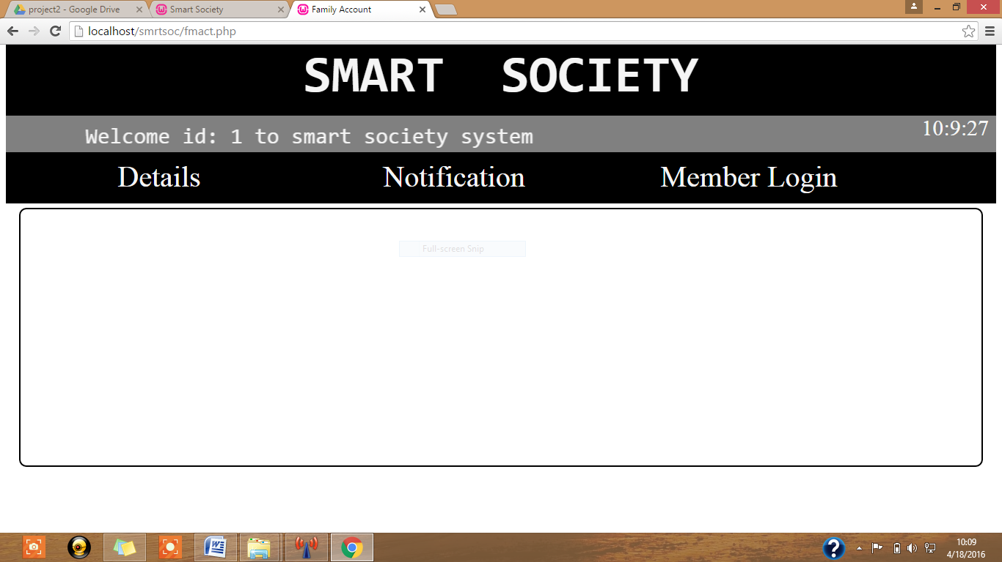

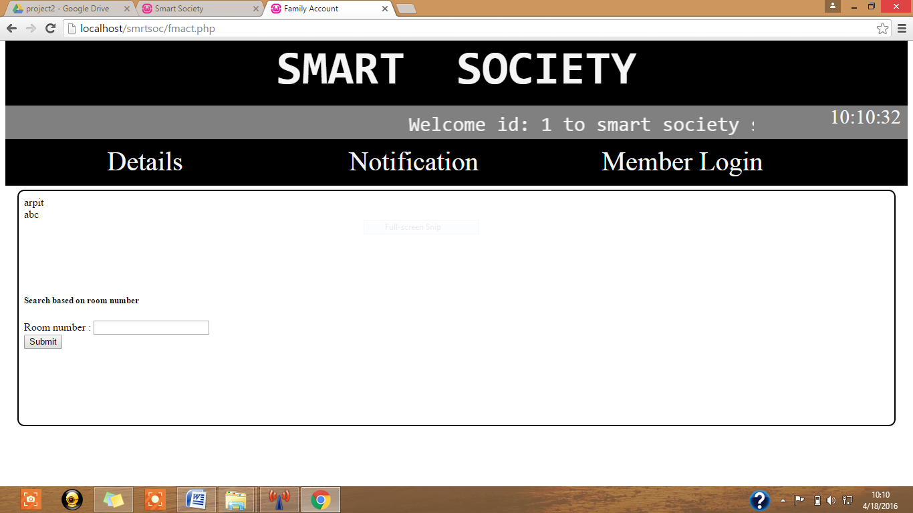

1. **Admin Login**

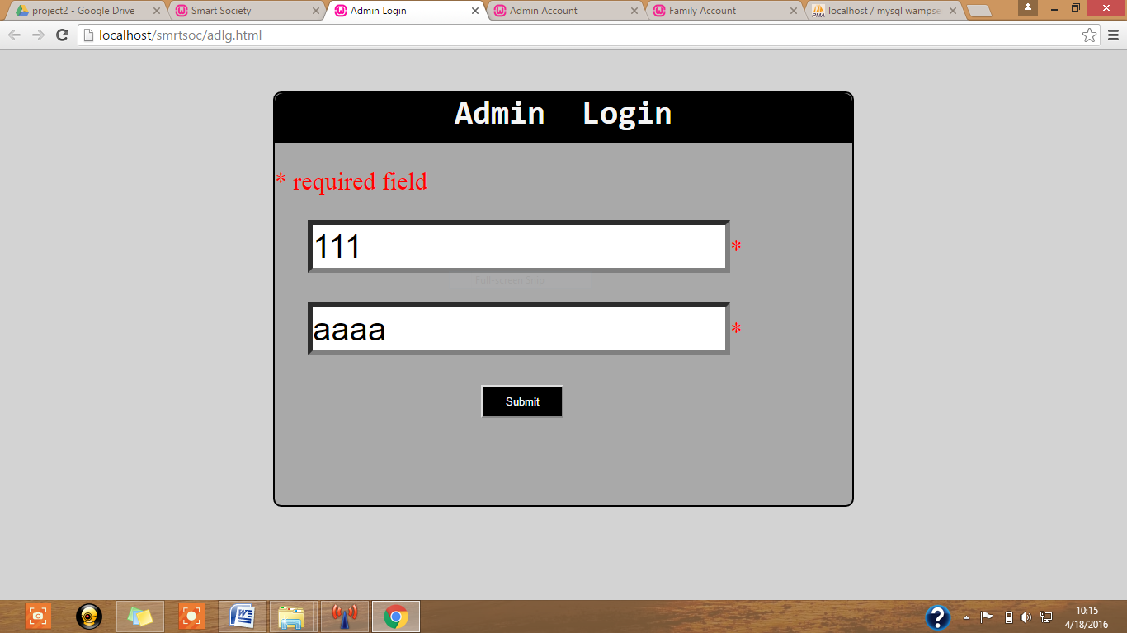

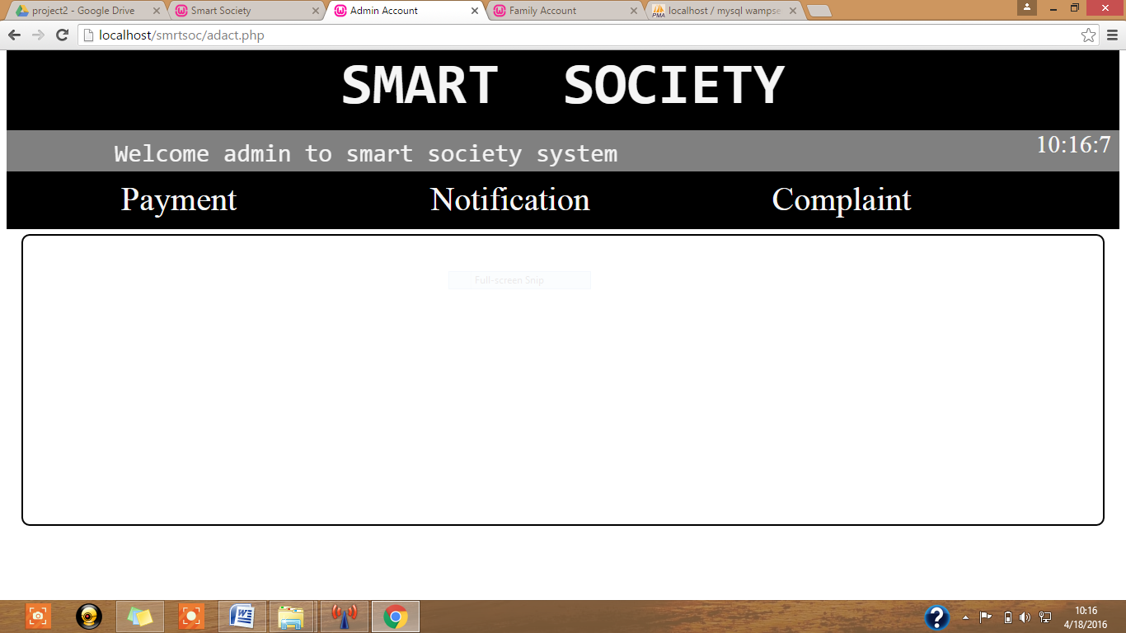

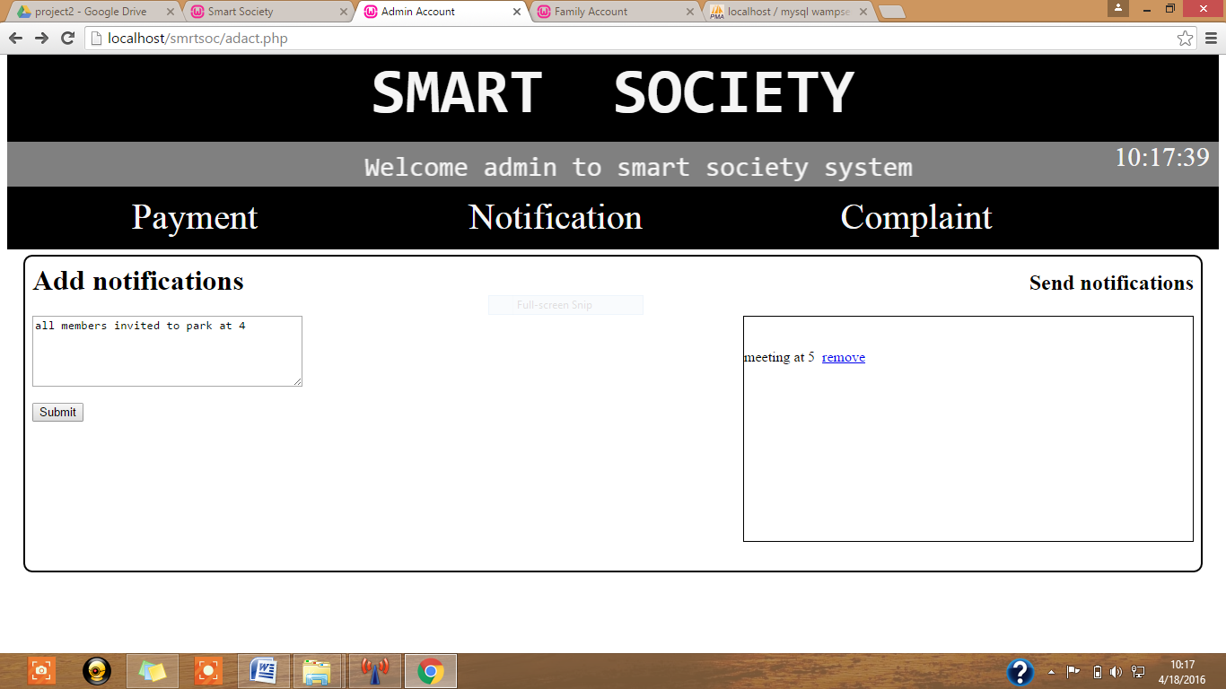

1. **Requirements Traceability Matrix**

|  |  |
| --- | --- |
| **RequirementsID** | **Design Component** |
| **8.1.1,2,3,4,5,6** | **6, 7, 9 and 10** |
| **8.2.1** |  |
|  |  |
|  |  |
|  |  |
|  |  |

1. **References**

* <https://itunes.apple.com/us/app/nextdoor-neighborhood-news/id640360962?mt=8/>
* <https://www.neighbourly.com/>
* <http://www.mysocietyapp.com/index.html/>
* <http://pn.ispirt.in/7-saas-based-software-for-managing-apartment-housing-societies/>
* <https://www.toptal.com/freelance/why-design-documents-matter>
* [www.se.rit.edu/~vdkrit/**design**/VDK-RIT_SDS.doc](http://www.se.rit.edu/~vdkrit/design/VDK-RIT_SDS.doc)

1. **Glossary**

|  |  |
| --- | --- |
| Society: | Refers to the group of residents of a residential colony or complex or an apartment |
| Neighbour: | **The other residents or society members** |
| Family | **Refers to people living in the same home** |
| DND Request | **Do not Disturb request sent by users to let other society members know that they are busy** |
| Complaint | **A grievance post sent by users to admin** |