//DEEPIKA SHARMA-124959

1.Get the details of all the database objects and their types created by the current
user.

SELECT OBJECT_NAME,OBJECT_TYPE
FROM USER_OBJECTS;
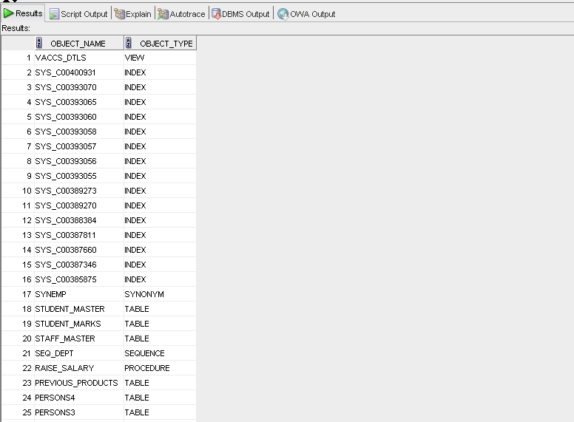

2.Get the details of all the table names owned by current user

SELECT TABLE_NAME
FROM USER_TABLES;

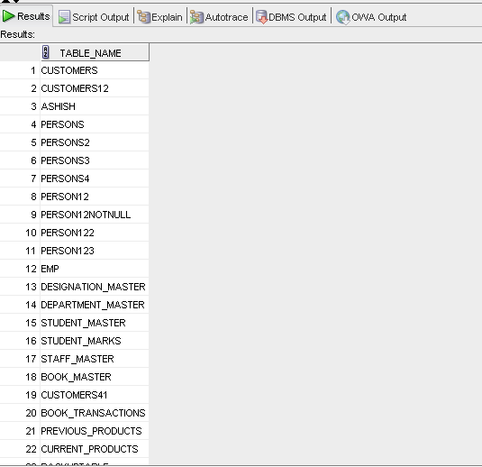

3. Get the details of table names and corresponding column names

SELECT *
FROM DICT_COLUMNS;
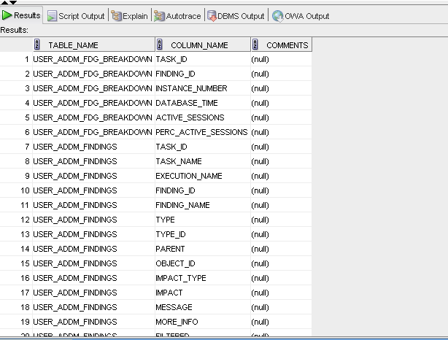

4.Get the details of column names and corresponding constraint names

SELECT *
FROM user_constraints

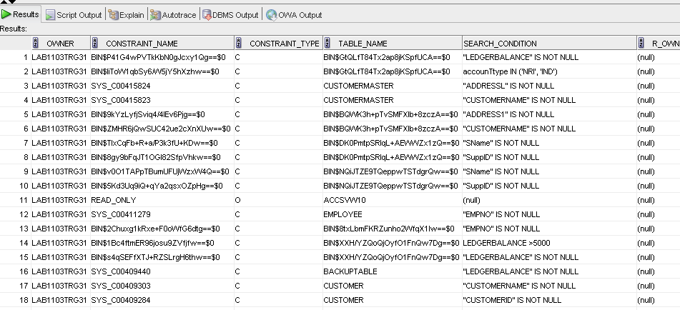

5. Get the details of the constraints and corresponding table name.

SELECT *
FROM all_cons_columns;
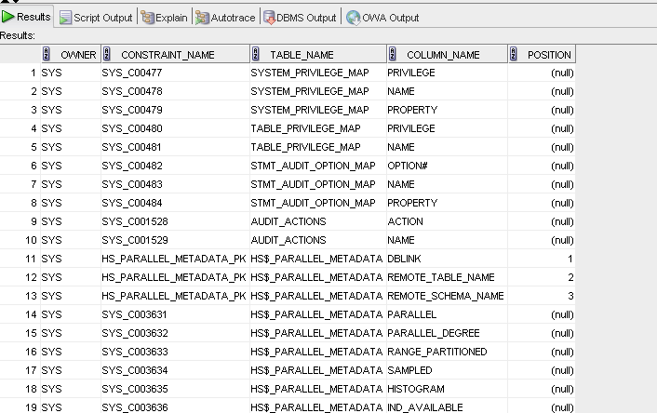

6.Get the details of all the View names and corresponding Text of the same.

select *
from user_views;
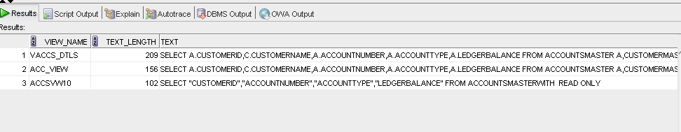

7.Get the details of all the Sequence names and their last numbers reached so far.

select * from
user_sequences;

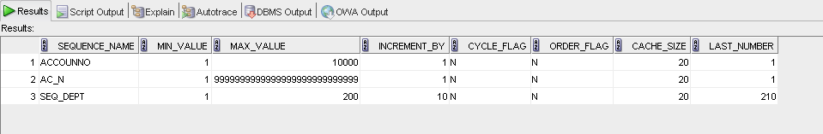

8. Get the details of all the Synonym names and their parent object names.

select *
from
user_synonyms;
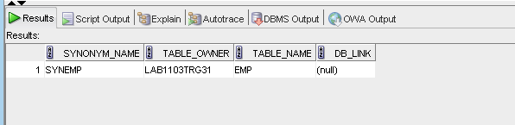

9. Get the list of all the Index names

select *
from user_indexes;

