//DEEPIKA SHARMA-124959

ASSIGNMENT -2

2.1 Identify the problems(if any) in the below declarations:
DECLARE
V_Sample1 NUMBER(2);
V_Sample2 CONSTANT NUMBER(2) ;
V_Sample3 NUMBER(2) NOT NULL ;
V_Sample4 NUMBER(2) := 50;
V_Sample5 NUMBER(2) DEFAULT 25;

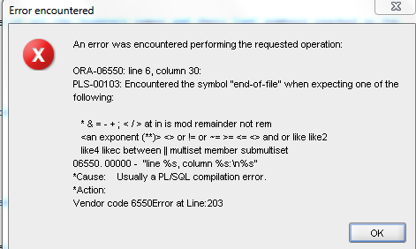

2.2 The following PL/SQL block is incomplete.
Modify the block to achieve requirements as stated in the comments in the block.
DECLARE --outer block
var_num1 NUMBER := 5;
BEGIN

DECLARE --inner block
var_num1 NUMBER := 10;
BEGIN
DBMS_OUTPUT.PUT_LINE('Value for var_num1:' ||var_num1);
--Can outer block variable (var_num1) be printed here.If Yes,Print the same.
END;
--Can inner block variable(var_num1) be printed here.If Yes,Print the same.
END;
set serveroutput on
DECLARE --outer block
var_num1 NUMBER := 5;
BEGIN

DECLARE --inner block
var_num1 NUMBER := 10;
BEGIN
DBMS_OUTPUT.PUT_LINE('Value for var_num1:' ||var_num1);
--Can outer block variable (var_num1) be printed here.If Yes,Print the same.
END;
DBMS_OUTPUT.PUT_LINE('Value for var_num1:' ||var_num1);
--Can inner block variable(var_num1) be printed here.If Yes,Print the same.
END;

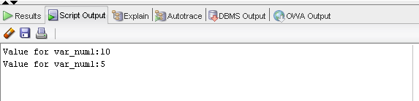
3.Write a PL/SQL block to retrieve all staff (code, name, salary) under specific
department number and display the result. (Note: The Department_Code will be
accepted from user. Cursor to be used.)

SET SERVEROUTPUT ON
DECLARE
V_CODE STAFF_MASTER.STAFF_CODE%TYPE;
V_NAME STAFF_MASTER.STAFF_NAME%TYPE;
V_SAL STAFF_MASTER.STAFF_SAL%TYPE;

CURSOR C_STAFF IS
SELECT STAFF_CODE,STAFF_NAME,STAFF_SAL
FROM STAFF_MASTER
WHERE DEPT_CODE = 30;
BEGIN
OPEN C_STAFF;
LOOP
FETCH C_STAFF INTO V_CODE, V_NAME, V_SAL;
DBMS_OUTPUT.PUT_LINE(V_CODE || ' ' || V_NAME || ' ' || V_SAL);
EXIT WHEN C_STAFF%NOTFOUND;
END LOOP;
CLOSE C_STAFF;
END;
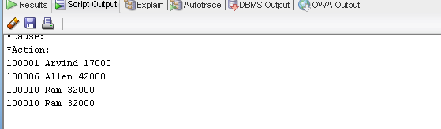

4.Write a PL/SQL block to increase the salary by 30 % or 5000 whichever minimum
for a given Department_Code.

SET SERVEROUTPUT ON

DECLARE
V_CODE STAFF_MASTER.DEPT_CODE%TYPE;
V_SAL STAFF_MASTER.STAFF_SAL%TYPE;

CURSOR C_STAFF IS
SELECT DEPT_CODE,MIN(STAFF_SAL) FROM STAFF_MASTER
WHERE DEPT_CODE = 30 GROUP BY DEPT_CODE;
BEGIN
OPEN C_STAFF;
LOOP
FETCH C_STAFF INTO V_CODE, V_SAL;
EXIT WHEN C_STAFF%NOTFOUND;
UPDATE STAFF_MASTER
SET STAFF_SAL = 1.3* V_SAL
WHERE STAFF_SAL = V_SAL ;
FETCH C_STAFF INTO V_CODE, V_SAL;
END LOOP;
CLOSE C_STAFF;
END;

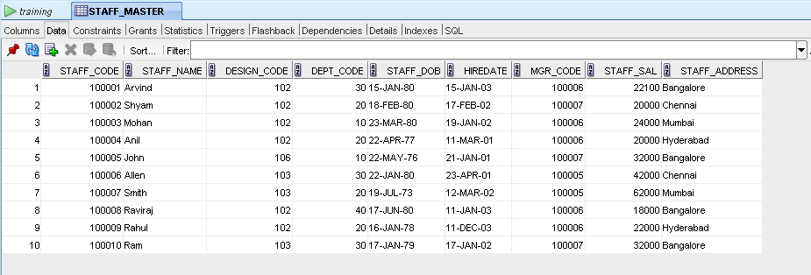

5.Write a PL/SQL block to generate the following report for a given Department code

Student_Code Sudent_Name Subject1 Subject2 Subject3 Total Percentage Grade

Note: Display suitable error massage if wrong department code has entered and if there is no student in the given department.

For Grade:
Student should pass in each subject individually (pass marks 60).
Percent >= 80 then grade= A
Percent >= 70 and < 80 then grade= B
Percent >= 60 and < 70 then grade= C
Else D

DECLARE

V_NAME STUDENT_MASTER.STUDENT_NAME%TYPE;
V_SCODE STUDENT_MARKS.STUDENT_CODE%TYPE;
V_SUB1 STUDENT_MARKS.SUBJECT1%TYPE;
V_SUB2 STUDENT_MARKS.SUBJECT2%TYPE;
V_SUB3 STUDENT_MARKS.SUBJECT3%TYPE;
TOTAL NUMBER;
PERCENTAGE NUMBER(2,0);
GRADE CHAR(1);

CURSOR C_MARKS IS
SELECT ST.STUDENT_NAME, SM.STUDENT_CODE,SM.SUBJECT1,SM.SUBJECT2,SM.SUBJECT3
FROM STUDENT_MASTER ST,STUDENT_MARKS SM WHERE ST.STUDENT_CODE = SM.STUDENT_CODE AND DEPT_CODE =10;

BEGIN
OPEN C_MARKS;
DBMS_OUTPUT.PUT_LINE('V_SCODE V_NAME TOTAL PERCENTAGE GRADE');
LOOP
FETCH C_MARKS INTO V_NAME, V_SCODE,V_SUB1,V_SUB2,V_SUB3;
EXIT WHEN C_MARKS%NOTFOUND;

TOTAL := V_SUB1+V_SUB2+V_SUB3 ;
PERCENTAGE := (TOTAL/300)*100;

IF PERCENTAGE >= 80 THEN GRADE :='A';

ELSIF (PERCENTAGE >= 70 AND PERCENTAGE < 80)
THEN GRADE:='B';

ELSIF (PERCENTAGE >= 60 AND PERCENTAGE < 70)
THEN GRADE:='C';

ELSE GRADE:= 'D';
END IF;

DBMS_OUTPUT.PUT_LINE(V_SCODE || ' ' ||V_NAME|| ' ' || TOTAL|| ' ' ||PERCENTAGE|| ' ' ||GRADE);

END LOOP;
CLOSE C_MARKS;
END;

