//DEEPIKA SHARMA-124959
LAB 3:

3.2 The following PL/SQL block attempts to calculate bonus of staff for a given MGR_CODE. Bonus is to be considered as twice of salary. Though Exception Handling has been implemented but block is unable to handle the same.
Debug and verify the current behavior to trace the problem.
DECLARE
V_BONUS V_SAL%TYPE;
V_SAL STAFF_MASTER.STAFF_SAL%TYPE;

BEGIN
SELECT STAFF_SAL INTO V_SAL
FROM STAFF_MASTER
WHERE MGR_CODE=100006;

V_BONUS:=2*V_SAL;
DBMS_OUTPUT.PUT_LINE('STAFF SALARY IS ' || V_SAL);
DBMS_OUTPUT.PUT_LINE('STAFF BONUS IS ' || V_BONUS);

EXCEPTION
WHEN NO_DATA_FOUND THEN
DBMS_OUTPUT.PUT_LINE('GIVEN CODE IS NOT VALID.ENTER VALID CODE');
END;

ANS:
DECLARE
V_SAL STAFF_MASTER.STAFF_SAL%TYPE;
V_BONUS V_SAL%TYPE;
BEGIN
SELECT STAFF_SAL INTO V_SAL
FROM STAFF_MASTER
WHERE MGR_CODE=100006;
V_BONUS:=2*V_SAL;
DBMS_OUTPUT.PUT_LINE('STAFF SALARY IS ' || V_SAL);
DBMS_OUTPUT.PUT_LINE('STAFF BONUS IS ' || V_BONUS);
EXCEPTION
WHEN TOO_MANY_ROWS THEN
DBMS_OUTPUT.PUT_LINE('GIVEN CODE IS NOT VALID.ENTER VALID CODE');
END;
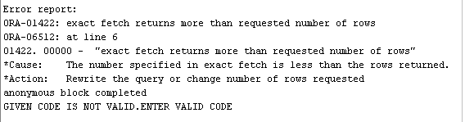

3.3 Rewrite the above block to achieve the requirement.
ANS:
DECLARE
V_SAL STAFF_MASTER.STAFF_SAL%TYPE;
V_BONUS V_SAL%TYPE;
CURSOR C IS SELECT STAFF_SAL
FROM STAFF_MASTER
WHERE MGR_CODE=100006;
BEGIN
OPEN C;
LOOP
FETCH C INTO V_SAL;
EXIT WHEN C%NOTFOUND;
V_BONUS:=(2*V_SAL);
DBMS_OUTPUT.PUT_LINE('STAFF SALARY IS ' ||V_SAL);
DBMS_OUTPUT.PUT_LINE('STAFF BONUS IS ' ||V_BONUS);
END LOOP;
CLOSE C;
EXCEPTION
WHEN TOO_MANY_ROWS THEN
DBMS_OUTPUT.PUT_LINE('GIVEN CODE IS NOT VALID.ENTER VALID CODE');
END;

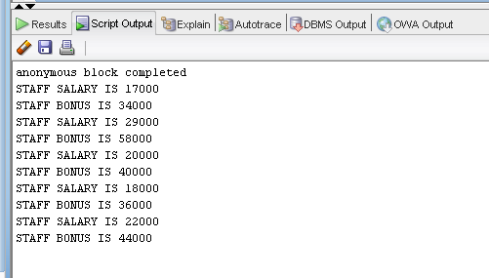

3.4
Predict the output of the following block ? What corrections would be needed to make it more efficient?

BEGIN
DECLARE
fname emp.ename%TYPE;
BEGIN
SELECT ename INTO fname
FROM emp
WHERE 1=2;

DBMS_OUTPUT.PUT_LINE('This statement will print');
EXCEPTION
WHEN OTHERS THEN
DBMS_OUTPUT.PUT_LINE('Some inner block error');
END;

EXCEPTION
WHEN NO_DATA_FOUND THEN
DBMS_OUTPUT.PUT_LINE('No data found in fname');

WHEN OTHERS THEN
DBMS_OUTPUT.PUT_LINE('Some outer block error');
END;

ANS:
Output:
Some inner block error

3.6: Write a PL/SQL program to check for the commission for an employee no 7369. If no commission exists, then display the error message. Use Exceptions.
ANS:
DECLARE
CURSOR D IS SELECT COMM FROM EMP WHERE EMPNO=7369;
ERR EXCEPTION;
COM EMP.COMM%TYPE;
BEGIN
OPEN D;
LOOP
FETCH D INTO COM;
EXIT WHEN D%NOTFOUND;
IF COM IS NULL THEN
RAISE ERR;
END IF;
END LOOP;
CLOSE D;
EXCEPTION
WHEN ERR THEN
DBMS_OUTPUT.PUT_LINE('ERROR MESSAGE');
END;
