**REGEX-PROBLEM:**

**Problem Statement**: Suppose you were to develop a system that handles a large amount of string matching requests, which may

include bad regexes as input. How would you exit the backtracking limbo?

Specifications:

1) POST api:

input JSON:

{

"regex": “”,

"textBody": ""

}

output json:

{

"match": “”,

“error”: false

}

Description: -

- "match" should contain the value picked up by the regex, for the sake of convenience just include

the first match.

- If a match isn't found for that particular regex, the value should be null.

- If the regex is a bad regex then appropriately exit the matching process, the value should be null and

error should be true.

**Design Architecture:**

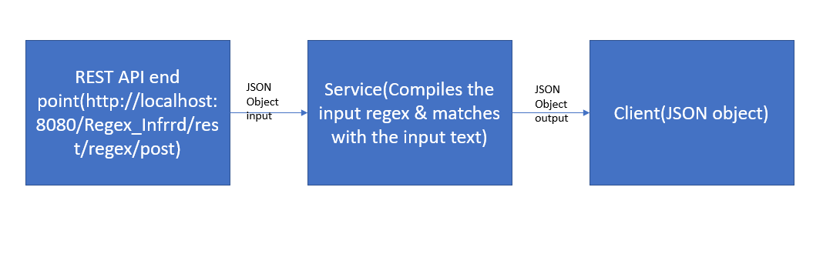

**Proof of execution:**

Please find screen shot from the execution below, here we are using POSTMAN as a rest client.

Case 1. Match Found:

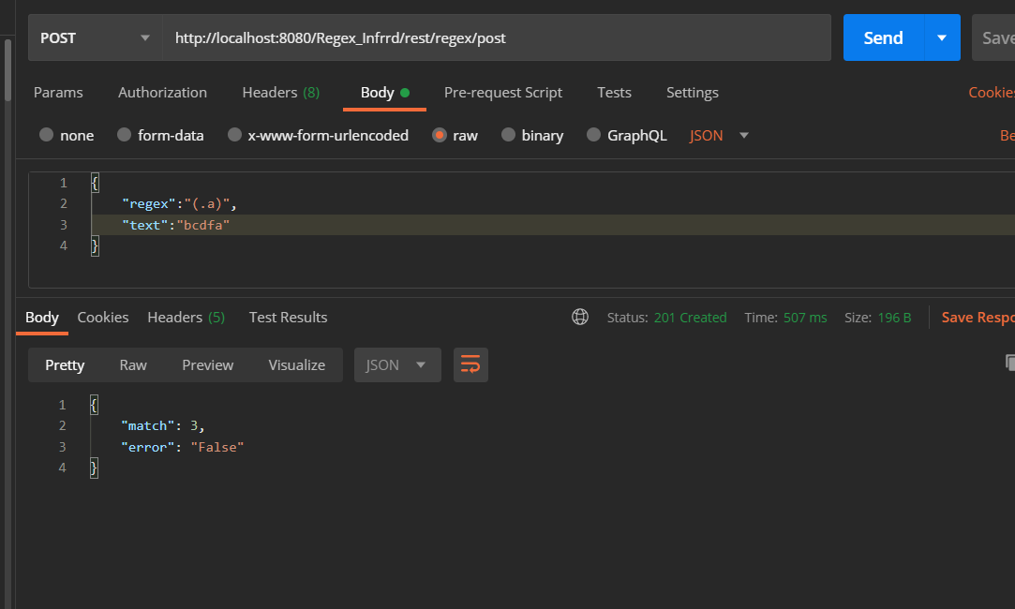

Case 2: No match found:

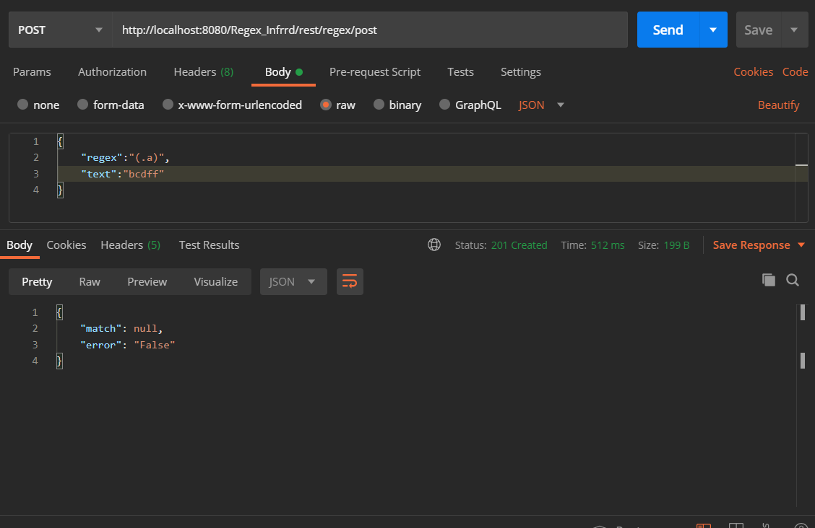

3.Evil Regex:

