Detecting Defects in Manufacturing Products from Images
Deep Learning - Project

Submitted by
Group 56:
Mohit Sharma(M25DE1001),
Arpita Kundu(M25DE1004)

Under the Supervision
Of
Dr. Angshuman Paul


Department of AIDE
Indian Institute of Technology Jodhpur
November 2025

Title | Detecting Defects in Manufacturing Products from Images using deep learning
Project Contribution | Mohit Sharma (M25DE1001), Arpita Kundu(M25DE1004)
Individual contribution | M25DE1001: Actively contributed to all stages of data processing and preparation, including applying data augmentation techniques to the training set. Responsible for analyzing and balancing the distribution of defective and non-defective samples from casted images. Effectively visualized defect regions on steel surfaces and assisted in developing functions to balance the dataset for improved model performance and training efficiency. Applied data augmentation technique on train set.  M25DE1004: Actively worked on creating and training deep learning models using Convolutional Neural Networks (CNN), including a custom optimized model, to detect defects in manufacturing products. Developed and implemented train_model.py for model training and evaluate.py to evaluate the performance of the saved best model on unseen images. Model selection was performed among a simple CNN model, a custom optimized model with augmented data, and finally, a VGG-like model, which was identified as the best-fit model. All results and code were integrated and showcased in a GitHub repository. Used transfer learning to test.

Abstract
The project focuses on automating the inspection process of casted steel manufacturing products using Deep Learning. By employing a Convolutional Neural Network (CNN) based architecture similar to the VGG model, this project aims to detect defects such as cracks, burrs, and dents on steel surfaces from top-view images. The goal is to enhance accuracy, reduce manual inspection errors, and enable efficient quality control in the manufacturing industry.

Problem Definition and Objective
Manual inspection in manufacturing environments is prone to human error and inconsistency. Detecting surface defects such as cracks, holes, and scratches in steel products is time-consuming and may result in the rejection of entire product batches. This project aims to build an automated defect detection system using CNNs to classify steel surfaces as ‘Defective’ or ‘Non-Defective’.

Dataset Information and Preparation
The dataset used in this project is the ‘Casting Product Image Dataset’ available on Kaggle (https://www.kaggle.com/datasets/ravirajsinh45/real-life-industrial-dataset-of-casting-product). It contains approximately 10,500 grayscale images categorized into ‘Defective’ and ‘OK’ parts. The images are preprocessed and resized to 224×224×3 before being fed into the CNN.
Steps to download and prepare the dataset:
1. Download dataset from Kaggle using the Kaggle CLI or direct link.
2. Extract it into the directory: `src/casting_data/train` and `src/casting_data/test`.
3. Use data augmentation techniques (rotation, flipping, normalization) for better generalization.

Model Architecture and Training
The proposed model is a lightweight VGG-like CNN architecture built using PyTorch. It includes multiple convolutional and pooling layers followed by fully connected layers for binary classification.
Key parameters:
• Input size: 224×224×3
• Loss Function: Binary Cross-Entropy
• Optimizer: Adam (learning_rate=1e-4)
• Epochs: 20
• Batch Size: 16

Training Command
Run the following command to train the model:
python src/train_model.py

Evaluation and Results
Once trained, the model was evaluated on unseen test data to measure classification accuracy and performance metrics. The model achieved 98.3% accuracy for ‘Defective’ images.
Note: trained model accuracy depends on so many parameters but especially epochs.
Run the following command to evaluate the model:
python src/evaluate.py
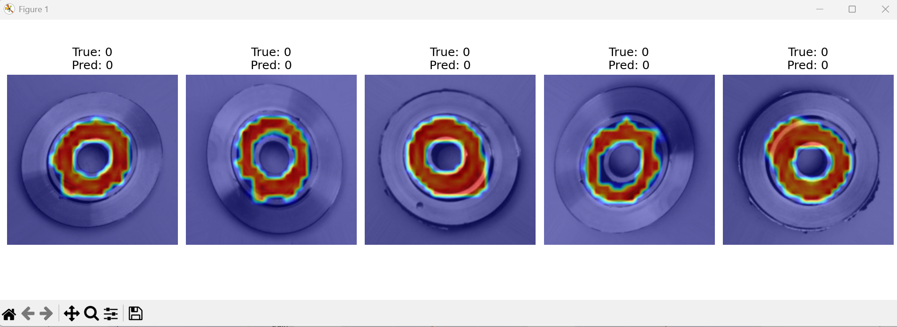
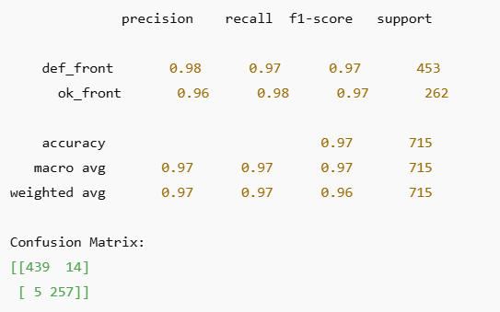

Dependencies and Setup Instructions
Required Python packages can be installed using the following commands:
pip install torch torchvision torcheval grad-cam imgaug matplotlib

Project Structure
DL_Defect_in_Manufacturing_Products/
│── README.md – Project overview, setup, and usage
│── requirements.txt – Python dependencies
│── src/ – Source code directory
│ ├── casting_data/ – Contains ‘defect’ and ‘ok’ image subfolders
│ ├── models/ – Saved trained models (.pth files)
│ ├── model.py – CNN architecture (VGG-like)
│ ├── train_model.py – Model training script
│ └── evaluate.py – Evaluation and metrics computation
│── notebooks/dl_defect_detection_images.ipynb – Jupyter notebooks for experiments
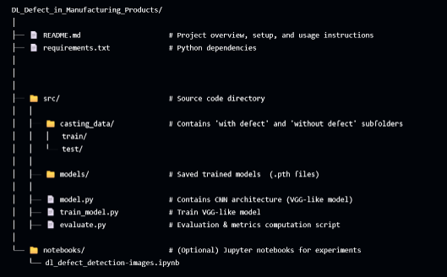

Future Improvements
- Extend the model to detect defects from videos and real-time factory streams by enabling real-time factory monitoring through CCTV integration.
- Deploying the model to Edge devices or Raspberry Pi.
- Track model drift and performance metrics during live deployment.
- Integrate PCA-based dimensionality reduction for faster and more efficient image processing.

Conclusion
This project successfully demonstrates the capability of deep learning in automating defect detection in manufacturing. The VGG-like CNN model achieved high classification accuracy with efficient training time. Future work will focus on extending this to real-time video defect detection and deployment in smart manufacturing systems.
Link to find all the files: https://github.com/arpita12-bot/DL_Defect_in_manufacturing_products/tree/main

