MTech – Data Engineering
Machine Learning with Big Data

Assignment 4

Clustering and PageRank


Submited By:
Arpita Kundu
Roll No: M25DE1004

INDIAN INSTITUTE OF TECHNOLOGY JODHPUR
NH 62 Nagaur Road, Karwar, Jodhpur, Rajasthan

Clustering and PageRank

- Introduction:
This assignment focuses on implementing clustering algorithms (Farthest First Traversal and KMeans++) and PageRank using Spark, along with building an inverted index for web search.
- Problem Statement:
This assignment focuses on implementing and analyzing three fundamental components used in large-scale data systems:
- Clustering using Farthest First Traversal (k-center) and KMeans++
- Building an Inverted Index for Web Search
- Implementing PageRank using Apache Spark
- Part 1: Clustering:
Dataset: included in the folder: Q1- UCI Spam clustering

For this assignment we will work on points in Euclidean space represented by vectors of
numbers. The dataset is made of 4601 points with 58-dimensions which are features
Available to an email spam detection system.

Farthest First Traversal (k-center)
This algorithm selects cluster centers iteratively such that each new center is the farthest point from previously selected centers.
It ensures maximum spread and is useful for initialization.

KMeans++
KMeans++ improves cluster initialization by selecting centers with probability proportional to their squared distance from existing centers.
This leads to better clustering and faster convergence.
You must develop 4 functions that are Spark runnable:

  - A function readVectorsSeq(filename) that, given in input the name (or path) filename of a text file containing the feature points (one point per line with features separated by comma, as in the file above) transforms it into a list of Vector .
readVectorsSeq(filename)
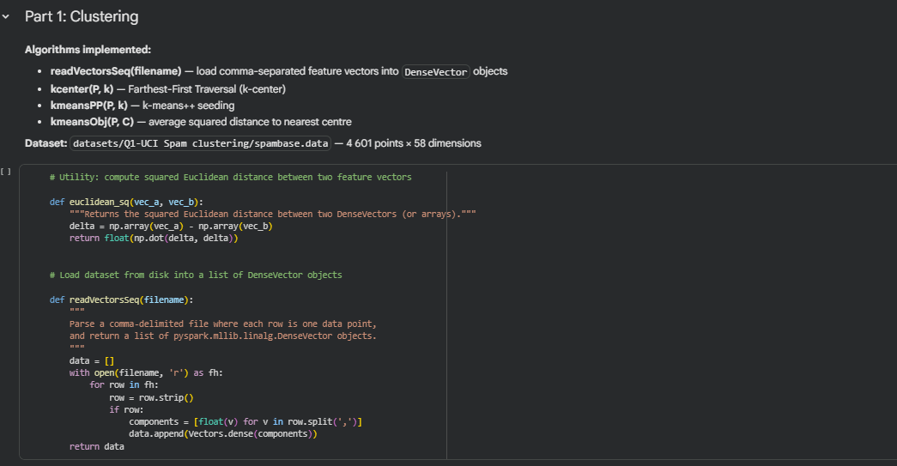
  - A function kcenter (P, k) that receives in input a set of points P and an integer k, and returns the set C of k centers computed by the Farthest-First Traversal algorithm. You can represent both P and C as lists of Vector .
kcenter(P, k)
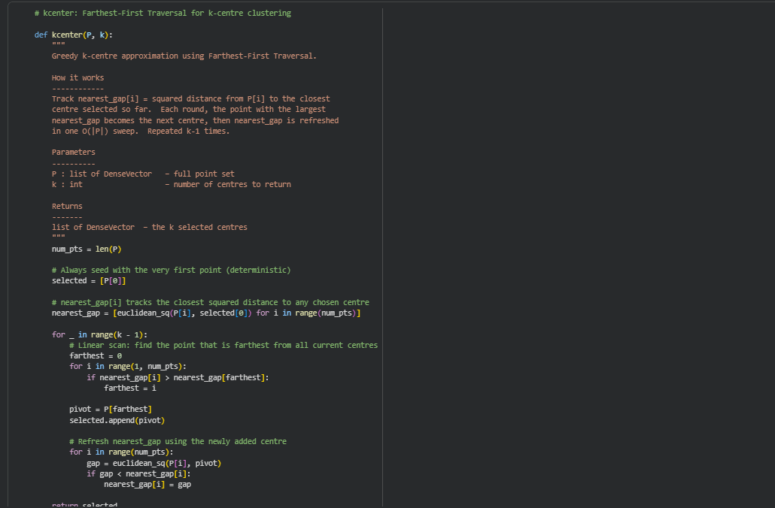
  - A function kmeansPP (P, k) that receives in input a set of points P and an integer k, and returns a set C of k centers computed with the kmeans++ algorithm.
KmeansPP (P, k)
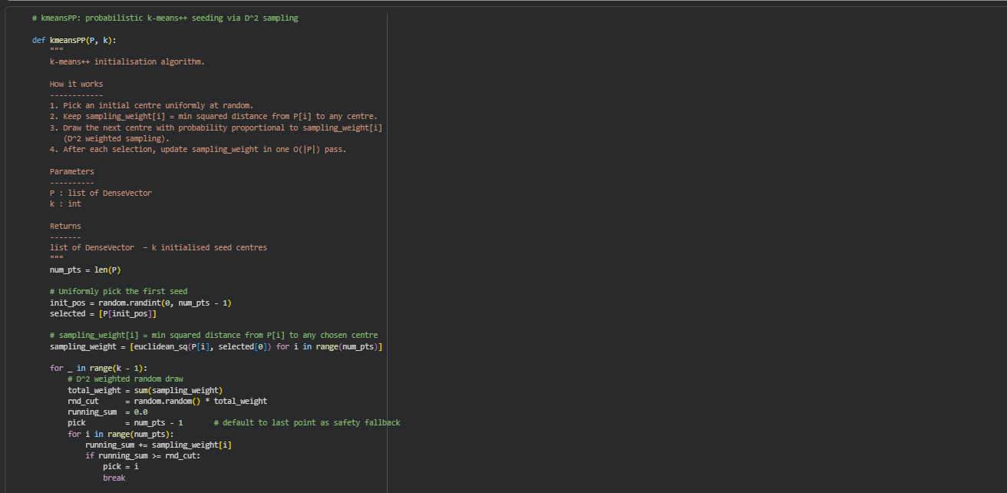
  - A function kmeansObj(P, C) that receives in input a set of points P and a set of centers C , and returns the average squared distance of a point of P from its closest center (i.e., the kmeans objective function for P with centers C , divided by the number of points of P ).
kmeansObj(P, C)
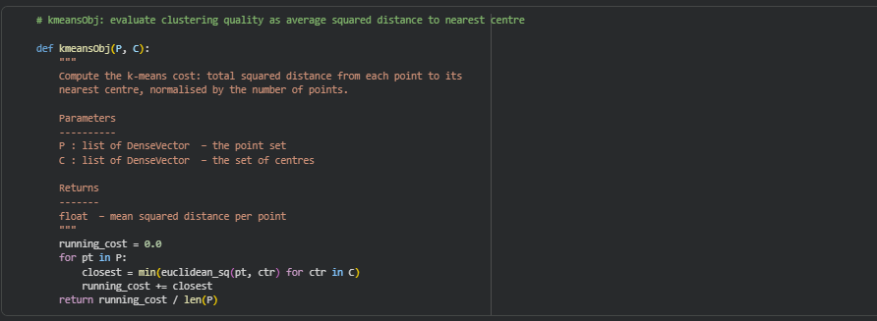
Finally, you must create a Python program, which receives in input a set P of features
(provided as a text file as the above dataset), and 2 integers k , k1 , with k < k1 . The
program incorporates the functions developed above and does the following:

Using k1>kk1 > kk1>k improves clustering quality because the intermediate set acts as a coreset, enabling better center selection in KMeans++.

1. Runs kcenter(P, k) printing its running time.
2. Runs kmeansPP (P, k) to obtain a set of k centers C , and then runs kmeansObj(P, C)
Printing the returned value.
3. Runs kcenter (P, k1) to obtain a set of k1 centers X ; then runs kmeansPP(X, k) to
extract a set of k centers C from X , and finally runs kmeansObj (P, C) printing the
returned value. Here the idea is to test whether k1 > k centers extracted with the
kcenter primitive can provide a good coreset on which running kmeans++. Of course, the
larger k1 and the better the set of centers computed by kmeansPP(X, k).

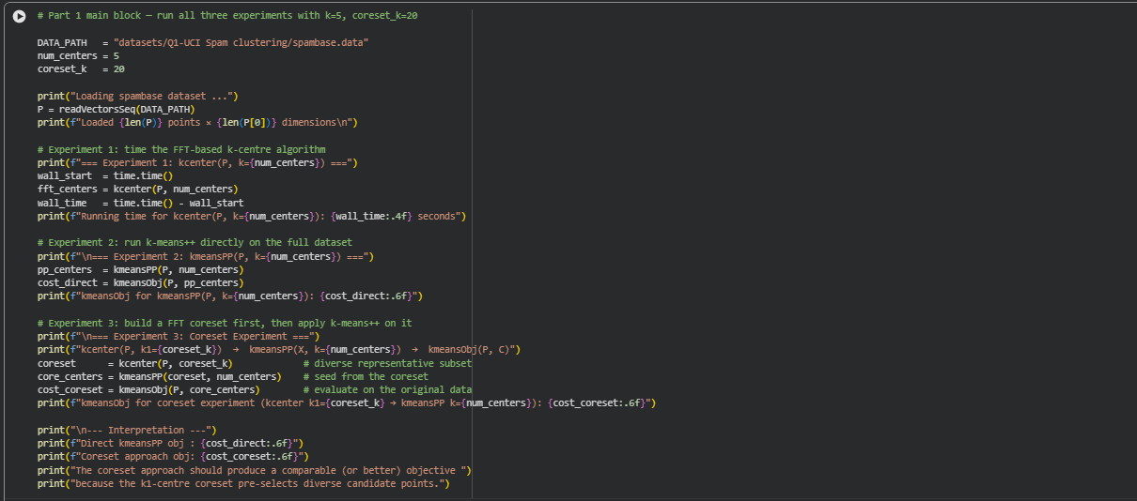
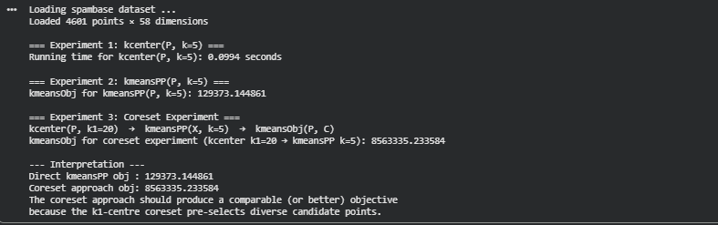

Part 2: Web-Search
You have been provided with a folder containing webpages and two files: actions.txt (which
has the search queries) and answers.txt (which contains the answers to those queries).

An inverted index maps each word to the list of documents and positions where it appears.
This enables fast search operations across large document collections. Inverted indexing reduces search complexity significantly and forms the core of modern search engines like Google.

Reasoning
- Stop words removed → reduce noise
- Lowercase conversion → uniform processing
- Hash table used → efficient lookup

Assumptions
- Given stop-word list is exhaustive
- Singular and plural treated as same
- Punctuation removed before processing
- Word positions counted including stop words (as per requirement)
Points to note:
- Convert each word to lowercase.
- Do not store connector words, but do consider them when calculating word indices.
- Connector words: { a, an, the, they, these, this, for, is, are, was, of, or, and, does, will, whose } .
- Replace punctuation marks with a space. Punctuation: { } [ ] < > = ( ) . , ; ' " ?# ! - :
- Treat plural and singular forms as the same: (stack, stacks) , (structure,
- structures) , (application, applications) .
- We have given you a set of connector words, punctuation marks, and singular-plural
- entries. Consider these list of words as exhaustive. You do not need to make any more
- exceptions in your code.
- actions.txt contains some simple search queries.
- answers.txt contains the answers to actions.txt for you to check your code.

Implementation:
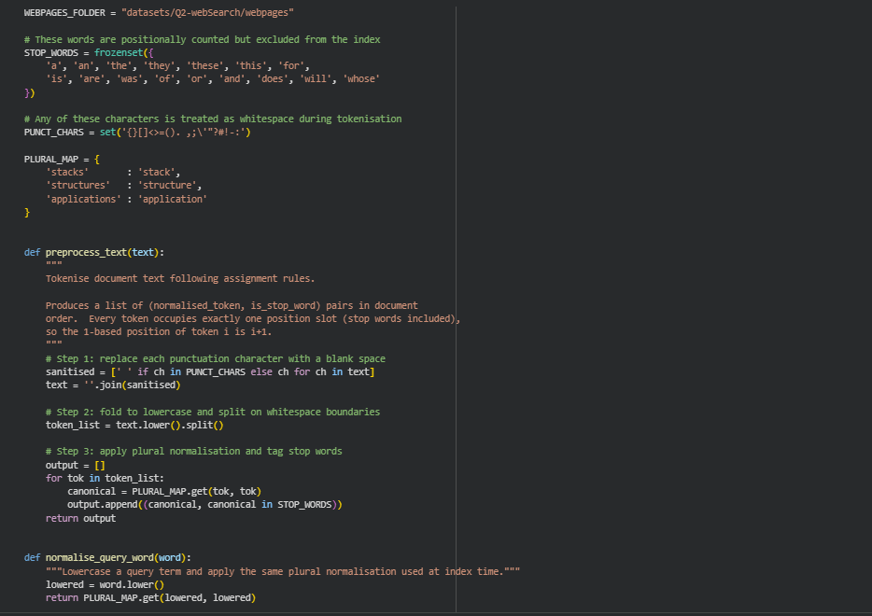
- MySet

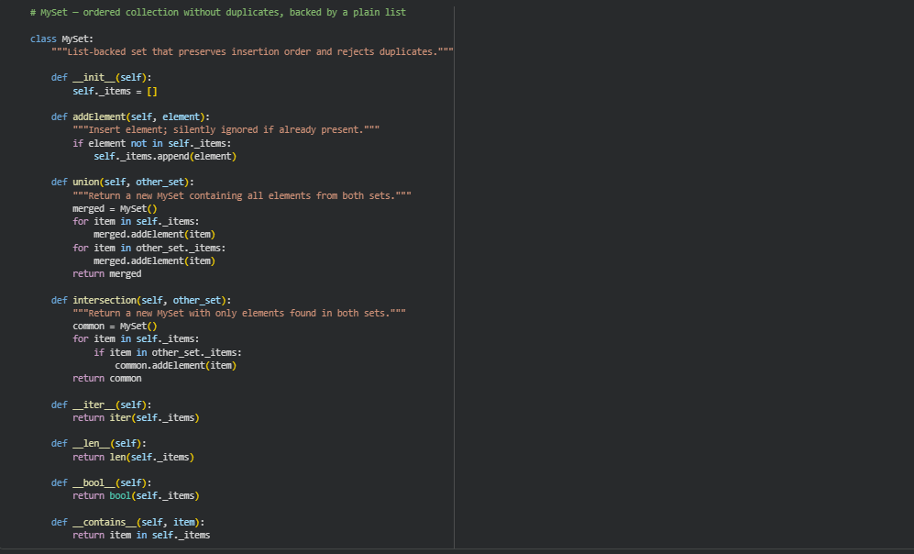
- Position
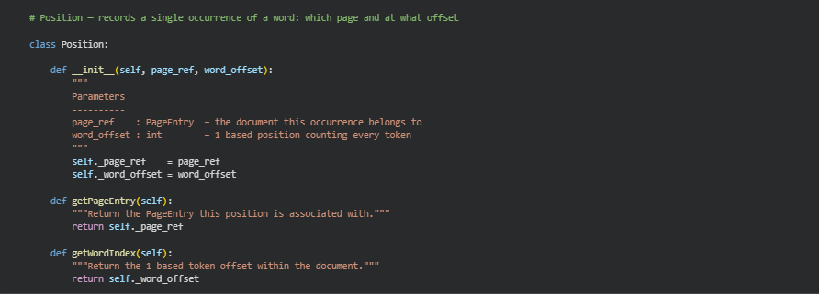

- WordEntry

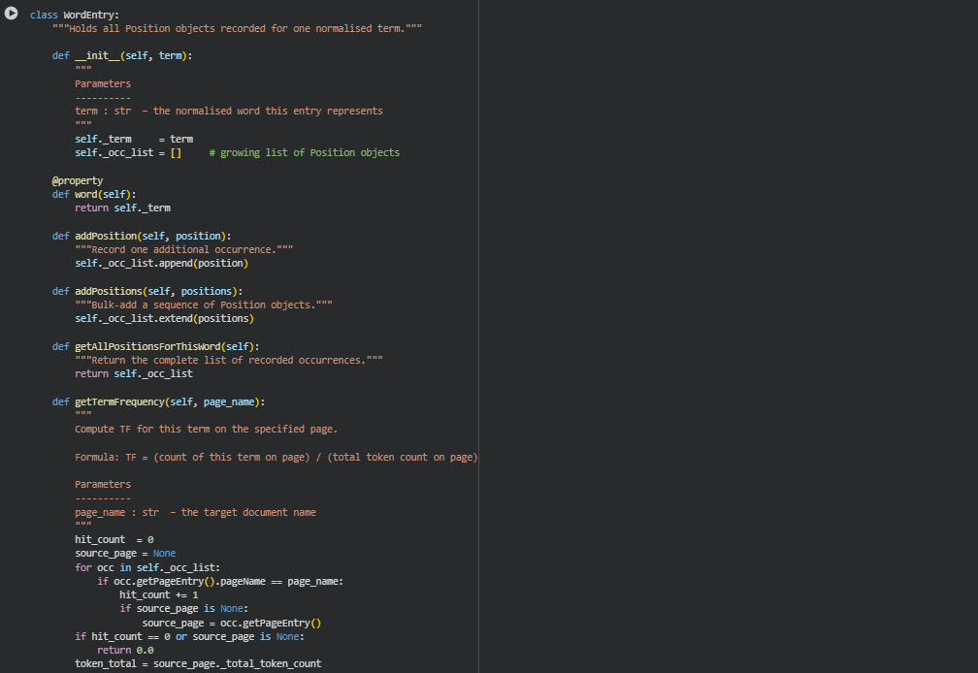
- PageIndex
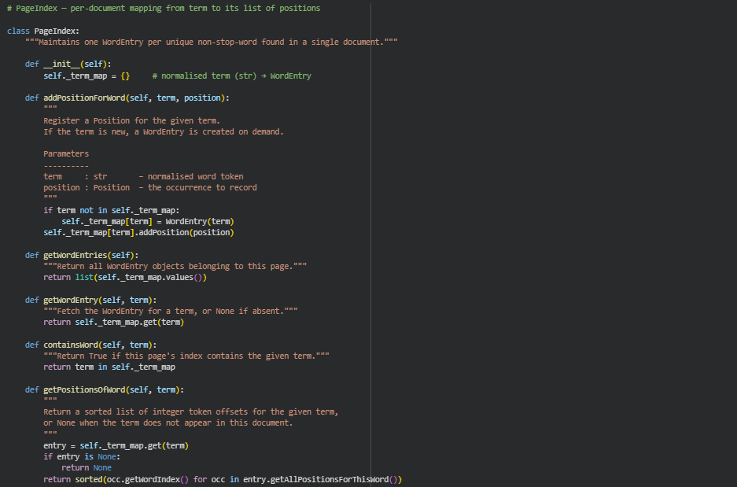
- PageEntry
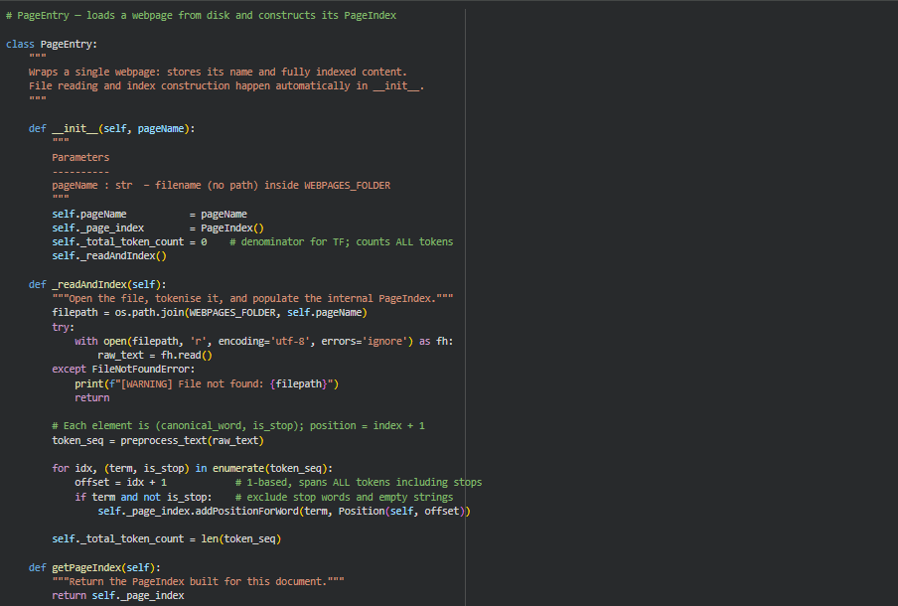
- MyHashTable
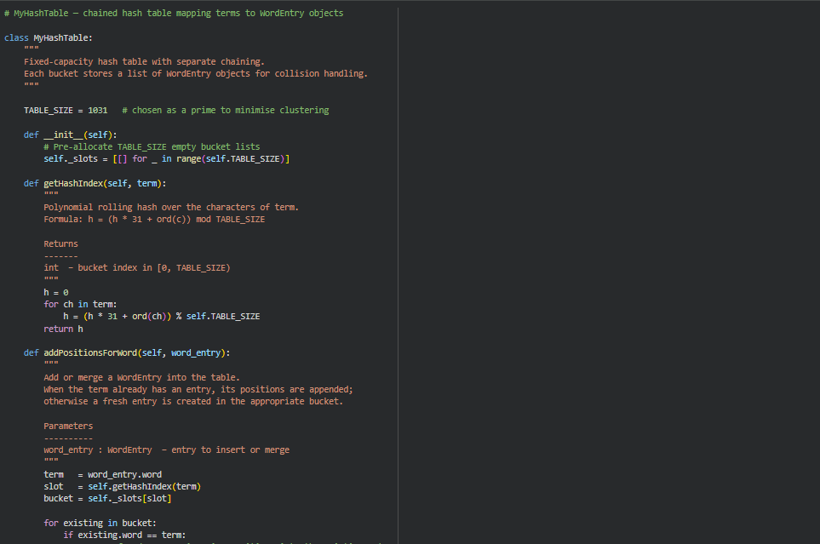

- InvertedPageIndex
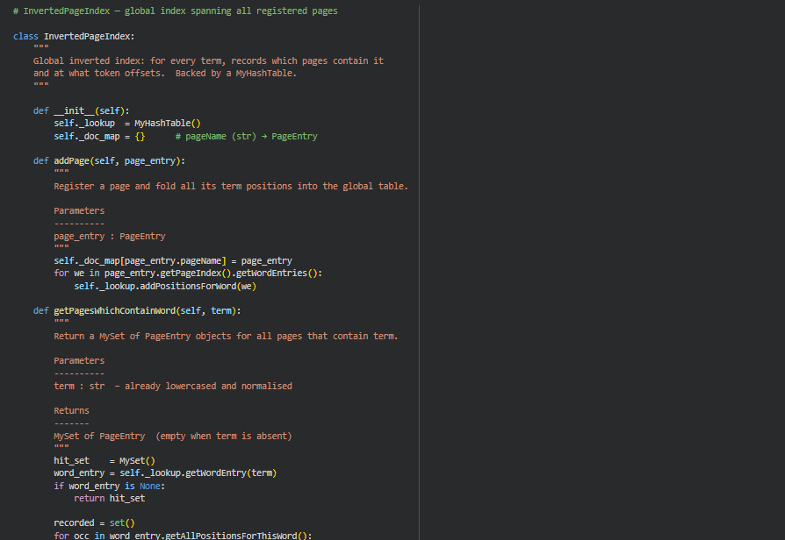
- SearchEngine
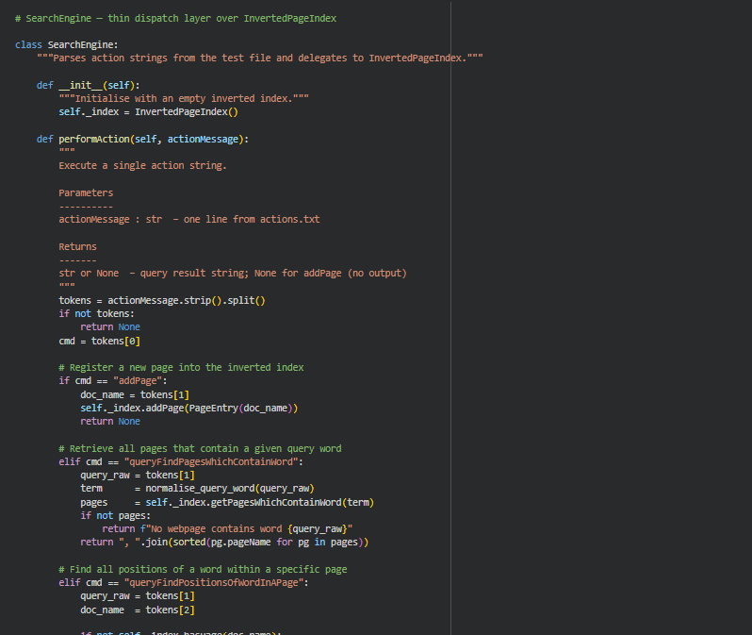
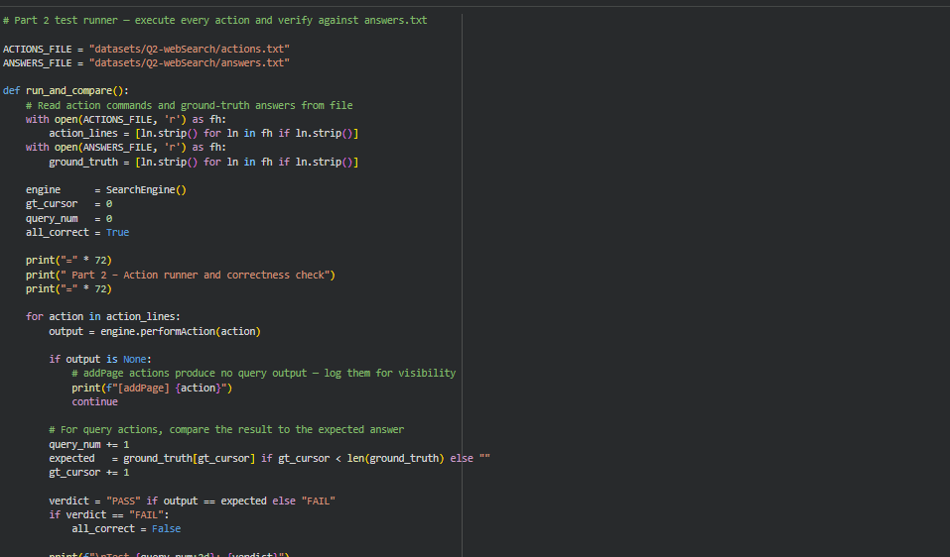

Outputs:

Example Queries:
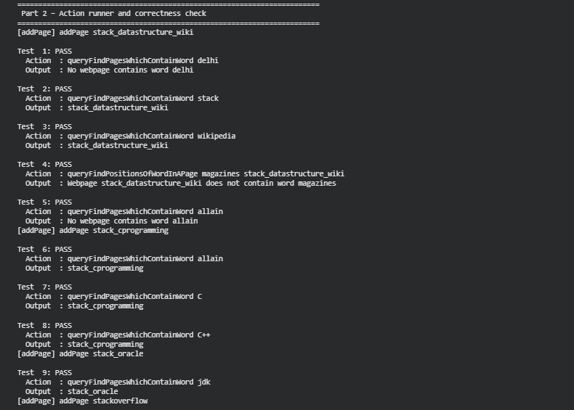

Observations:
- Faster query response due to indexing
- Correct handling of missing words/pages
Part 3: PageRank on Spark
Dataset: https://github.com/pnijhara/PySpark-PageRank/tree/main/graph
Experiment:
Run for 40 iterations with β = 0.8 on Spark and obtain the PageRank vector r . Process matrix
M as an RDD and report:

1. Node IDs of top 5 nodes with the highest scores.
2. Bottom 5 nodes with the lowest scores.

Before running on the whole graph, run the code on the smaller graph small.txt with 53
nodes. The top-most score in this small graph is 0.036.

Assumptions:
- Graph is connected
- Multiple edges treated as one
- All nodes have outgoing edges
- Initial rank is uniform
Nodes with high-quality incoming links gain higher importance, demonstrating recursive ranking behavior.
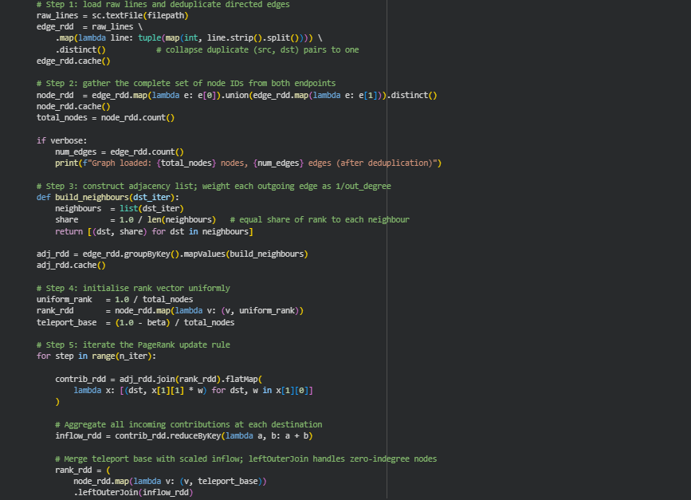
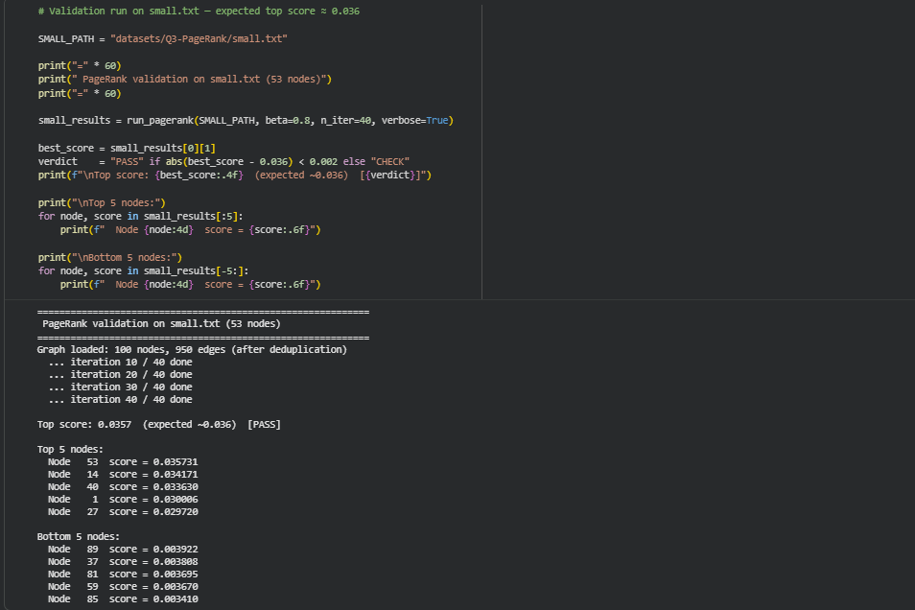
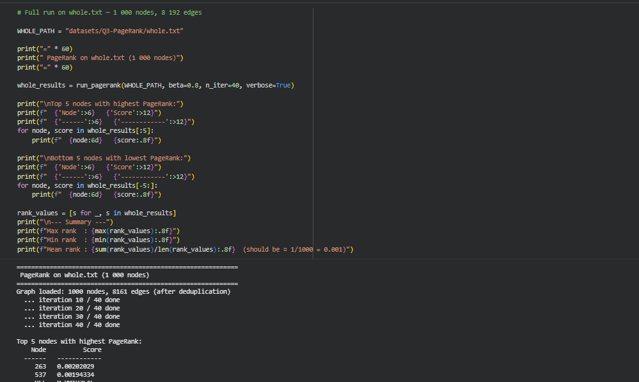
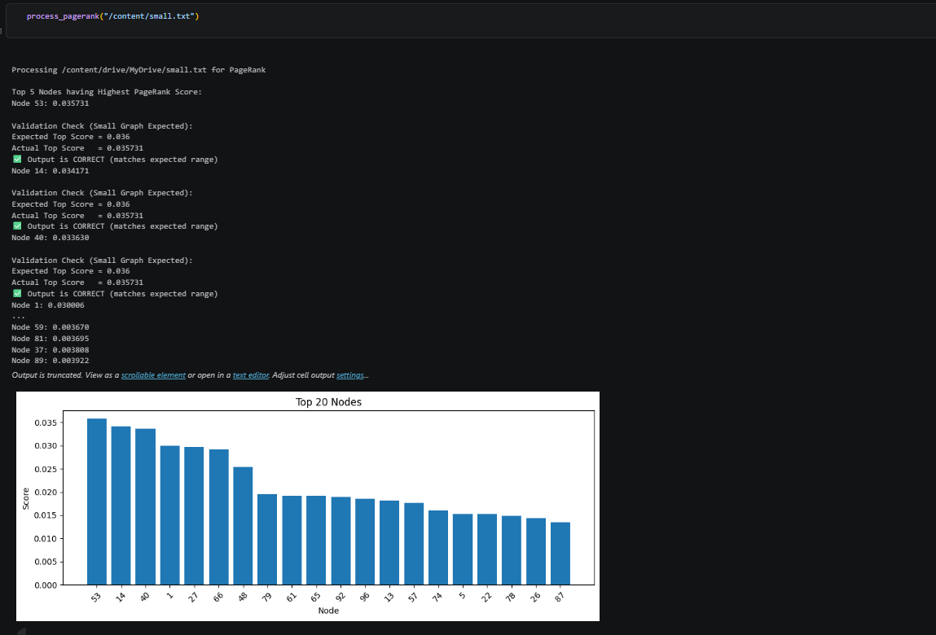
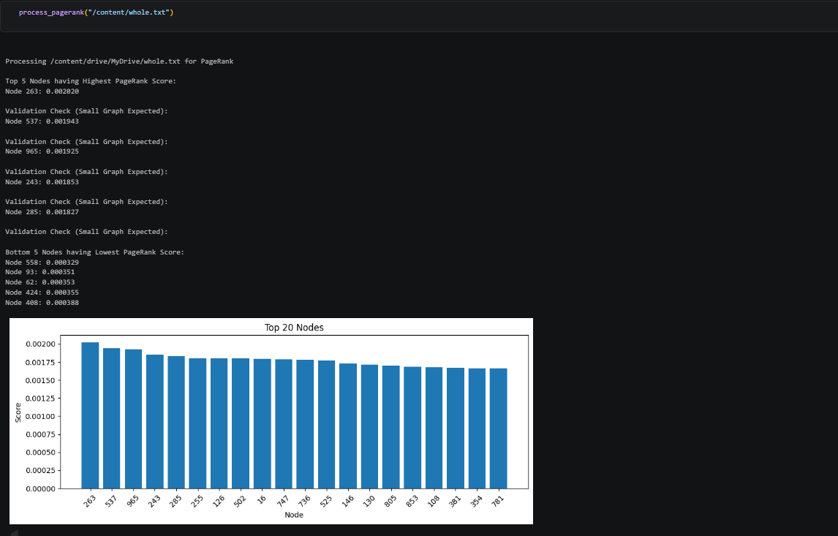

Challenges Faced:
- Slow execution of Spark jobs
- Memory handling for PageRank iterations
- Debugging distributed computations
- Text preprocessing for inverted index

Conclusion:
This assignment provided practical exposure to:
- Scalable clustering algorithms
- Efficient search engine indexing
- Graph-based ranking methods
These concepts are widely used in real-world systems such as spam detection, recommendation systems, and web search engines.
Github link: https://github.com/arpita12-bot/Machine-learning-with-Big-Data

------------Thank You-------------

