Step -1..............  
 Install Apache Web Server on ubuntu 20.04 LTS :  
 sudo apt install apache2 -y  
  
CHECK : Whether Apache web server is successfully installed or not  
So, goto browser and type anyone form following in address bar  
<http://localhost/>  
<http://127.0.0.1/>  
<http://your_machine_ip_address/>

Enable firewall settings by following commands :  
sudo ufw status  
sudo ufw enable  
sudo ufw app list  
sudo ufw allow in "Apache Full"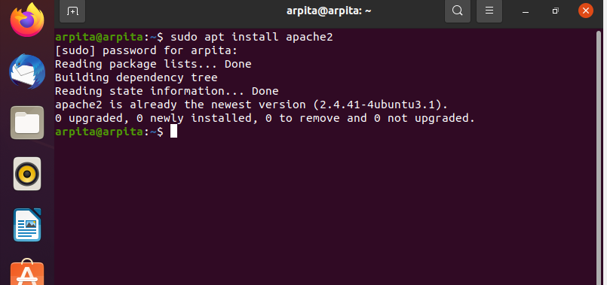

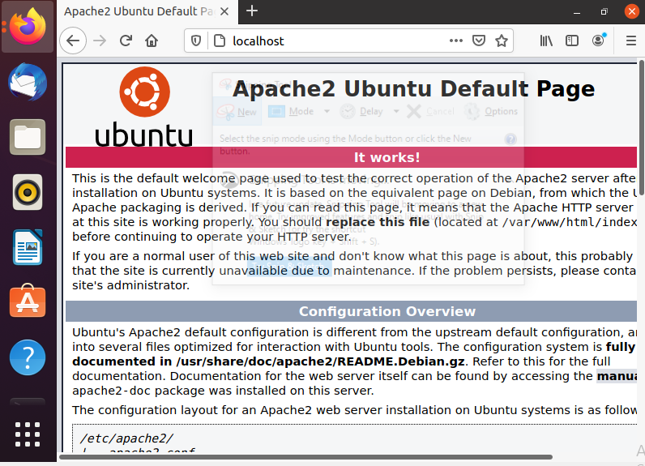

Step - 2.............  
Install mysql-server on ubuntu 20.04 LTS :  
 sudo apt install mysql-server  
press Y to continue  
CHECK : Login mysql with root user without password with sudo  
 sudo mysql  
  
create database db_name;  
use db_name;  
select database();  
exit

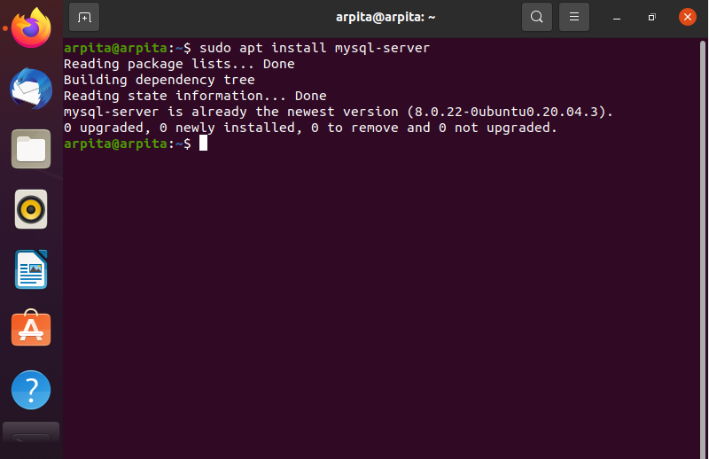

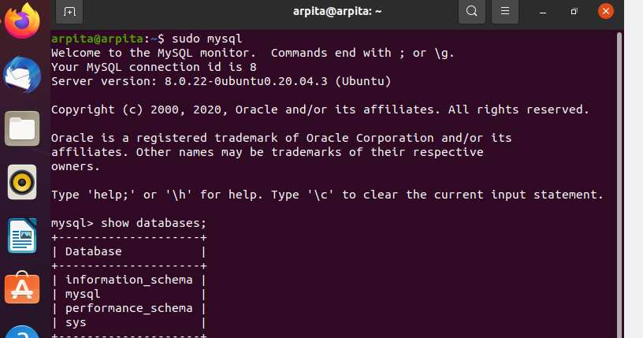

Step - 3...............  
Install php and its required libraries:  
 sudo apt install php php-mysql libapache2-mod-php    
Press Y to continue  
 php -v  
  
Create one sample php file in Apache Web server root directory  
 cd /var/www/html  
 sudo gedit file_name.php  
  
Goto browser and run  
        <http://localhost/file_name.php>  
  
PERMISSION for apache root directory  
 sudo chown -R $USER:$USER /var/www/html  
  
To enable right click - new document  
 touch ~/Templates/Empty Document  
  
Create a php file without sudo through terminal using gedit  
 gedit file_name.php  
  
Goto browser and run  
        [http://localhost/file_name.php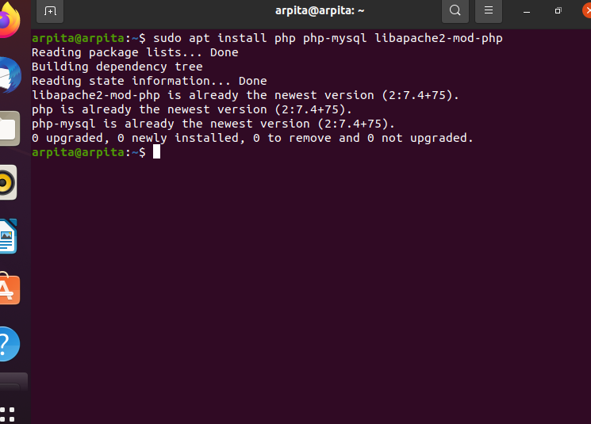](http://localhost/file_name.php)

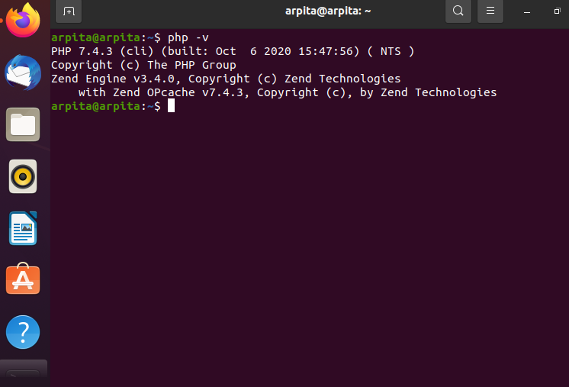

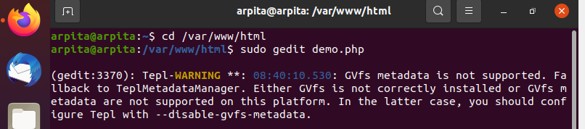

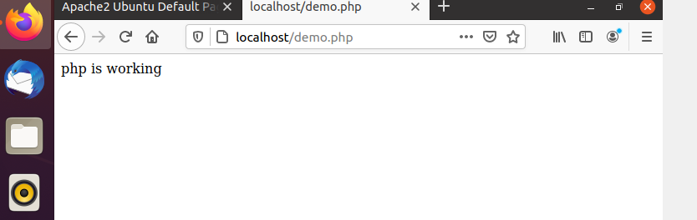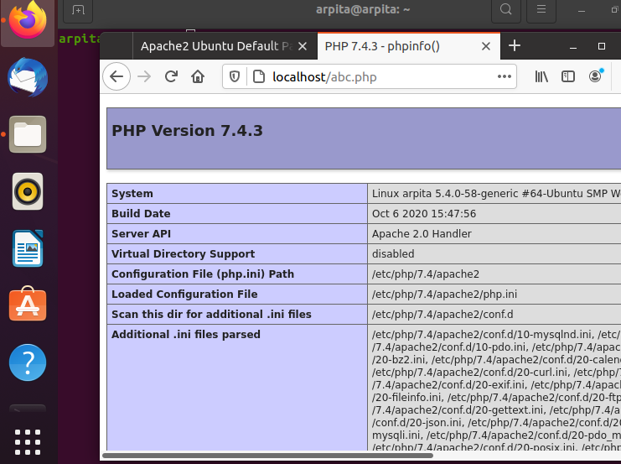

Step - 4..............  
Install PHPMyAdmin  
 sudo apt update  
 sudo apt install php-mbstring php-zip php-gd php-json php-curl  
Press Y to continue  
 sudo apt install phpmyadmin  
Press Y to continue  
Select Apache2 by pressing space and then press tab and OK  
Press Yes and set password for dummy user phpMyAdmin  
 sudo systemctl restart apache2  
  
CHECK : Whether phpMyAdmin is successfully installed or not  
So, goto browser and type    
        <http://localhost/phpmyadmin>  
Default user name : phpMyAdmin  
And enter your password  
sudo apt update  
Set root password and create a new database user with full privileges  
 sudo mysql  
 SELECT user,authentication_string,plugin,host FROM mysql.user;  
 ALTER USER ‘root’@‘localhost’ IDENTIFIED WITH caching_sha2_password BY ‘password’;  
 SELECT user,authentication_string,plugin,host FROM mysql.user;  
 exit  
 sudo mysql -p  
Enter your password  
 CREATE USER ‘new_user’@‘localhost’ IDENTIFIED WITH caching_sha2_password BY ‘password’;  
 GRANT ALL PRIVILEGES ON *.* TO ‘new_user’@‘localhost’ WITH GRANT OPTION;  
 exit

