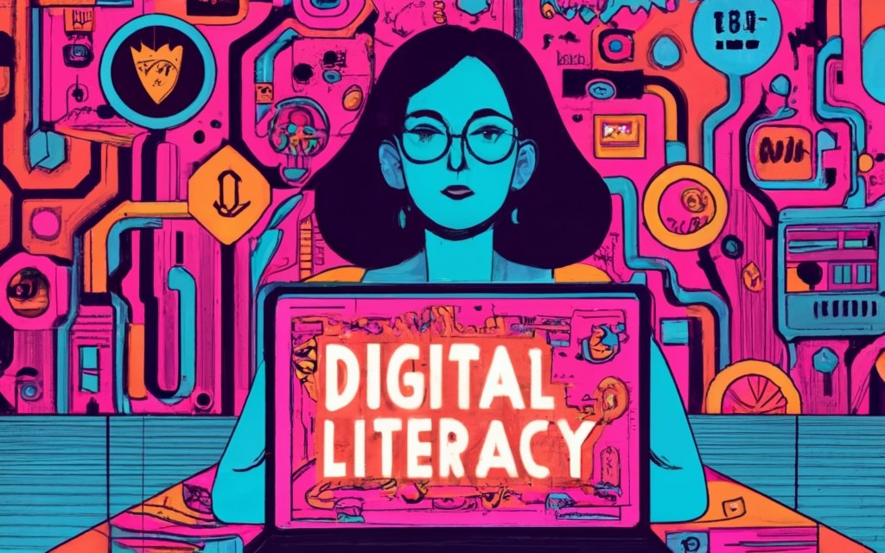
PROJECT REPORT
NAME: ARPITA SINGH
REGISTRATION NUMBER:25BEC10070
BRANCH: ELECTRONICS AND COMMUNICATION
YEAR: 1ST YEAR
COURSE CODE: CSE0001
INTRODUCTION
Digital literacy is the ability to use digital technologies effectively, responsibly, and safely in everyday life. This project focuses on understanding how digital literacy impacts individuals, especially students and communities, in accessing information, communicating, and participating in the modern digital world. In today’s fast-growing technological environment, being digitally literate is no longer optional but essential for education, employment, and social interaction.

The scenario highlights the challenges faced by people who lack basic digital skills, such as difficulty in using online platforms, identifying reliable information, or protecting personal data. It also addresses issues like the digital divide, where certain groups have limited access to technology and the internet. The project emphasizes the importance of digital education programs, awareness campaigns, and training initiatives to bridge this gap.

By promoting digital literacy, individuals can become more confident, informed, and productive users of technology. Ultimately, this contributes to personal growth, better career opportunities, and a more inclusive and connected society.

TASK-1:
For my project on digital literacy, I used Prezi, an online presentation tool, to create an engaging and visually appealing design. Prezi is different from traditional tools because it allows zooming in and out, making the presentation more dynamic and interactive. It helped me organize my ideas in a creative way and present information clearly.
My design shows the importance of digital literacy in today’s world. It highlights how people use digital tools like the internet, smartphones, and computers for education, communication, and daily activities. I also included key points about online safety, identifying reliable information, and developing essential digital skills. The zooming feature of Prezi helped me connect different ideas smoothly and made the presentation more interesting.
While making this project, I found it interesting to use the zooming effect to present information in a unique way. However, I also found it a bit difficult to arrange the content properly at first, as I had to ensure that everything looked organized and easy to understand when zooming in and out.

TASK-2:
For my project, I chose three important platforms: GitHub, Kaggle, and ResearchGate, as they are widely used for learning, collaboration, and research. GitHub is mainly used for storing and sharing code, as well as working on projects with others. It helps in version control and allows developers to build a strong portfolio. Kaggle is a platform for data science and machine learning, where users can practice with datasets, participate in competitions, and improve their analytical skills. ResearchGate is a platform for researchers to share papers, read studies, and connect with experts in different fields.
Over the next four years, I plan to use GitHub to upload my projects and track my progress in coding. I will use Kaggle to practice data analysis, learn new techniques, and participate in competitions to gain experience. I will use ResearchGate to read research papers and stay updated with new developments in technology and digital literacy. These platforms will help me improve my skills, gain knowledge, and prepare for future academic and career opportunities.

TASK-3:
For my project, I used HackerRank, an online platform that helps users improve their coding and problem-solving skills. It provides a wide range of programming challenges in different languages such as Python, Java, and C++, which makes it useful for beginners as well as advanced learners.
On HackerRank, I practiced solving coding problems related to basic programming concepts like loops, conditions, functions, and data structures. I also worked on improving my logical thinking and accuracy by attempting different levels of questions. The platform gives instant feedback, which helped me understand my mistakes and learn better ways to solve problems.
Using HackerRank will be very helpful for my academic growth. It will strengthen my programming knowledge and improve my ability to think logically and solve problems efficiently. These skills are important for subjects like computer science and mathematics. In the future, it will also help me prepare for exams, competitive coding, and job opportunities. Overall, HackerRank is a useful tool for building strong technical skills and improving academic performance.

TASK-4:
One situation where poor digital communication caused a problem is when a student misunderstood an online assignment posted in a class group. The teacher had shared instructions through a message, but it was not clearly explained, and some important details were missing. As a result, many students completed the assignment incorrectly and submitted the wrong work. This led to confusion, wasted time, and frustration for both the teacher and students.
This problem could have been avoided with clearer communication. The teacher could have provided step-by-step instructions, used simple language, and shared an example of the expected work. Students could have also asked questions to clarify their doubts before starting. Additionally, using proper formatting, such as bullet points or highlighting key points, would make the message easier to understand. Clear and effective digital communication helps prevent misunderstandings and ensures better outcomes.

TASK-5:
While researching digital literacy, what surprised me the most was how many people use digital devices every day but still lack basic skills like identifying fake information or protecting their personal data online. I realized that being able to use a smartphone or the internet does not necessarily mean someone is digitally literate. There are many risks, such as scams, misinformation, and privacy issues, that people are often unaware of.
As a result, one habit I will personally change is being more careful while using the internet. I will make sure to verify information before trusting or sharing it and avoid clicking on unknown links. I will also focus on protecting my personal information by using strong passwords and privacy settings. This will help me become a more responsible and aware digital user.

CONCLUSION:
In conclusion, this project on digital literacy has helped me understand the importance of using digital tools effectively, safely, and responsibly. I learned about different platforms, online communication, and the skills needed to navigate the digital world. It also showed me the challenges people face due to a lack of digital knowledge and awareness. Through this project, I realized that digital literacy is essential for education, career growth, and everyday life. By improving these skills, we can become more confident and responsible users of technology. Overall, this project has increased my awareness and will help me make better use of digital resources in the future.

REFERENCES:
- HackerRank – for coding practice and problem-solving
- GitHub – for project sharing and version control
- Kaggle – for data science learning and datasets
- ResearchGate – for accessing research papers and studies
- Prezi – for creating interactive presentations
- Google – for general research and information

