HCAHPS Survey Analysis Report
Hospital Consumer Assessment of Healthcare Providers and Systems
Survey Period: 2013 – 2022 | Prepared for: American Hospital Association (AHA)

Introduction
The Hospital Consumer Assessment of Healthcare Providers and Systems (HCAHPS) survey is a standardized tool used to measure patients’ perceptions of their hospital experiences in the United States. It was developed by the Centres for Medicare & Medicaid Services (CMS) in collaboration with the Agency for Healthcare Research and Quality (AHRQ).

The primary goal of the HCAHPS survey is to collect feedback from patients about their care experiences and to improve the quality of healthcare services provided by hospitals.

Role and Objective

Role
This analysis was conducted from the perspective of a Data Analyst for the American Hospital Association (AHA), a national organization that represents hospitals and their patients and acts as a source of information on healthcare issues and trends.

Objective
To analyze the HCAHPS survey results for the past 9 years and evaluate whether it has been successful in creating incentives for hospitals to improve their quality of care.

About the Data
The dataset comprised 7 tables covering measures, national results, questions, reports, responses, state results, and states. Key characteristics of the dataset:

- Survey data spans from 2013 to 2022
- Three measurement categories: Top Box Percentage (Promoters), Middle Box Percentage (Passives), and Bottom Box Percentage (Detractors)
- Data covers hospitals across all U.S. states and regions

Key Performance Indicator – Net Promoter Score (NPS)
To analyze the healthcare survey dataset, Net Promoter Score (NPS) was used as the primary key metric. NPS is a widely used measure of customer satisfaction and loyalty. Respondents are categorized into three groups:

- Promoters (score 9–10): Enthusiastic patients likely to recommend the hospital
- Passives (score 7–8): Satisfied but not enthusiastic; unlikely to actively promote or criticize
- Detractors (score 0–6): Unhappy patients who may discourage others from using the hospital

The NPS is calculated by subtracting the percentage of Detractors from the percentage of Promoters:
NPS = % Promoters − % Detractors
NPS can range from −100 to +100. Positive scores indicate higher patient satisfaction. The metric is most valuable when tracked over time or benchmarked against industry standards.

Overview
The following summary cards highlight the key metrics from the survey dataset:

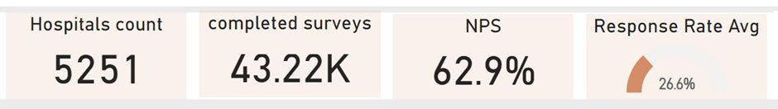
Figure 1: Summary KPIs – Hospital Count, Completed Surveys, NPS, and Response Rate

Key highlights from the overview:
- Total hospitals covered: 5,251
- Total completed surveys: 43.22K
- Overall NPS: 62.9%
- Average response rate: 26.6%

Note: The overall response rate of 26.6% is relatively low. Efforts should be made to increase survey participation, as a low response rate can lead to skewed results that may not fully represent the patient population.

NPS by Measure – Heat Map Analysis
The heat map below shows the NPS score distribution for each care measure across all survey years. Green cells indicate above-average performance, while orange/red cells highlight areas that are below average.

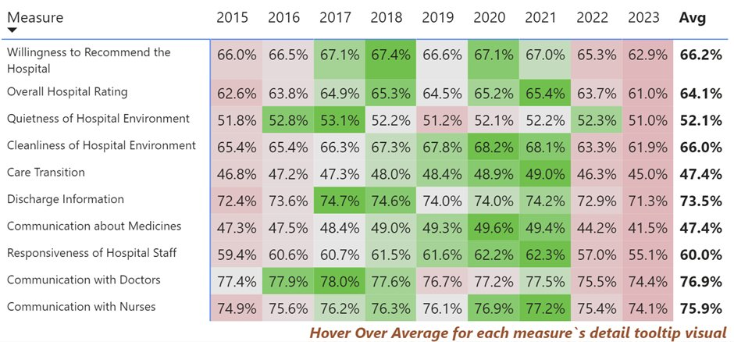
Figure 2: NPS Heat Map by Measure (2014–2022)

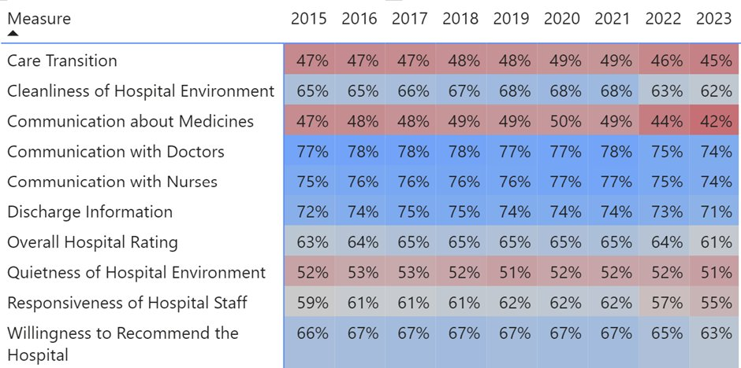
Figure 3: NPS Heat Map by Measure (2015–2023)

Key observations from the heat map:
- NPS scores for most measures showed an increasing trend from 2014 to 2020
- A notable shift occurred around 2020, likely attributed to the impact of COVID-19 on patient sentiment
- Quietness of the Hospital Environment and Communication with Doctors showed a continued decline worth further investigation
- Communication about Medicines and Care Transition consistently registered the lowest scores across all years
- Communication with Doctors and Communication with Nurses consistently scored highest in the composite category

NPS Trend by Measure Type
The line chart below illustrates how NPS scores have evolved over the years across three measure types: Individual Items, Global Items, and Composite Measures.

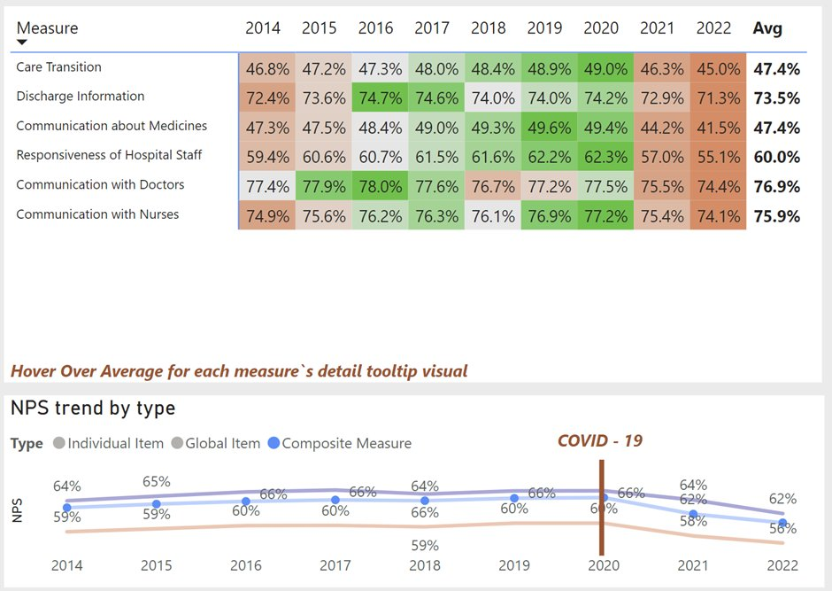
Figure 4: NPS Trend by Measure Type (2014–2022)

Findings by measure type:
- Global Items (Willingness to Recommend the Hospital and Overall Hospital Rating) recorded the highest average NPS of approximately 65%
- Individual Items such as Quietness of Hospital Environment averaged 52%, the lowest among all categories
- Composite Measures including Care Transition and Communication about Medicines both averaged around 47%
- Discharge Information, Communication with Doctors, and Communication with Nurses all scored above 73%, reflecting strong performance in these areas

The COVID-19 marker (2020) visibly correlates with a decline in scores across multiple measure types, particularly in Individual and Global Items.

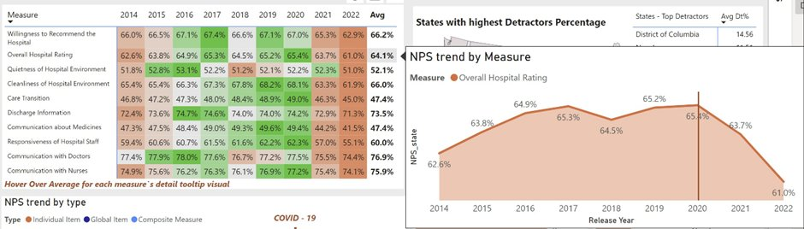
Figure 5: Detailed NPS Values by Measure (2014–2022)

State and Regional Analysis

Top States by Promoters Percentage
The map below highlights which states have the highest proportion of promoters – patients who positively rated their hospital experience.

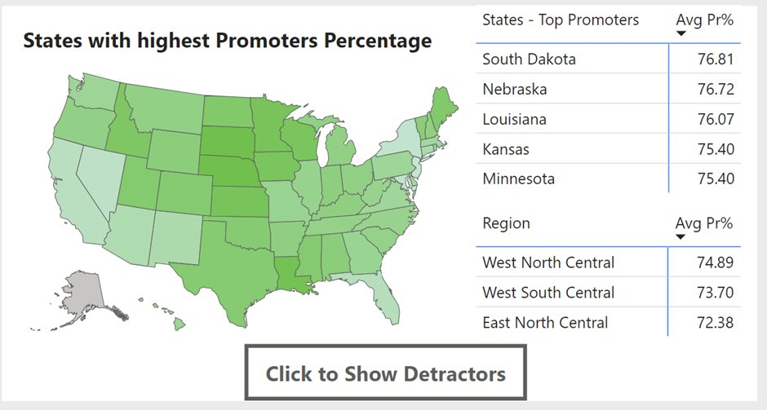
Figure 6: States with Highest Promoters Percentage

Top performing states and regions:
- South Dakota led with the highest promoter percentage at 76.81%
- Nebraska followed closely at 76.72%, and Louisiana at 76.07%
- At the regional level, West North Central (74.89%) and West South Central (73.70%) regions performed best

Top States by Detractors Percentage
The map below shows states with the highest proportion of detractors – patients who reported negative experiences.

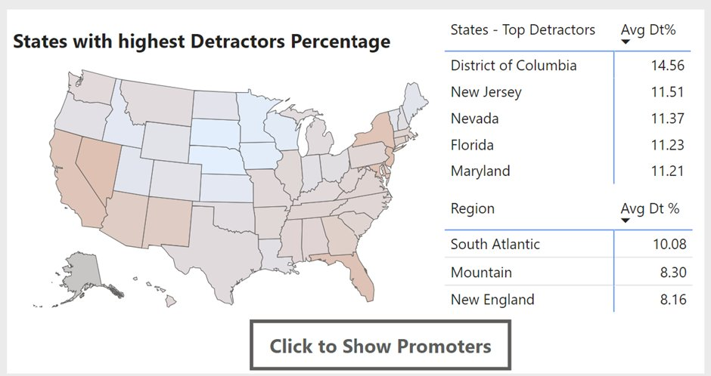
Figure 7: States with Highest Detractors Percentage

States with the most room for improvement:
- District of Columbia had the highest detractor percentage at 14.56%
- New Jersey (11.51%), Nevada (11.37%), Florida (11.23%), and Maryland (11.21%) also appeared in the top 5
- South Atlantic was the region with the most detractors at 10.08%

Survey Response Rate Analysis
The bar charts below compare the top and bottom states by average survey response rate across the study period.

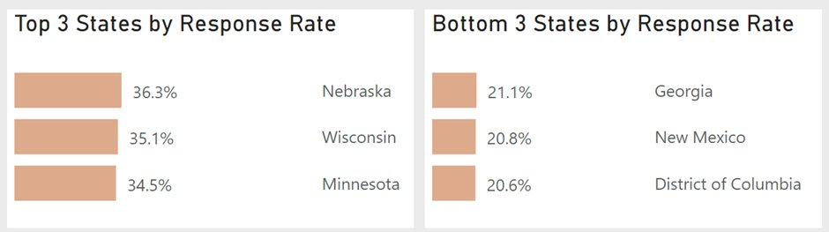
Figure 8: Top and Bottom 3 States by Response Rate

Key observations:
- Nebraska had the highest response rate at 36.3%, followed by Wisconsin (35.1%) and Minnesota (34.5%)
- The bottom three states were Georgia (21.1%), New Mexico (20.8%), and District of Columbia (20.6%)
- Overall, the survey has a low average response rate of 26.6%, which limits the reliability of the findings for underrepresented states

Final Dashboard
The complete interactive dashboard integrates all the above visualizations, with filters for Year, State, Region, and Measure. It provides a comprehensive view of hospital performance across the United States.

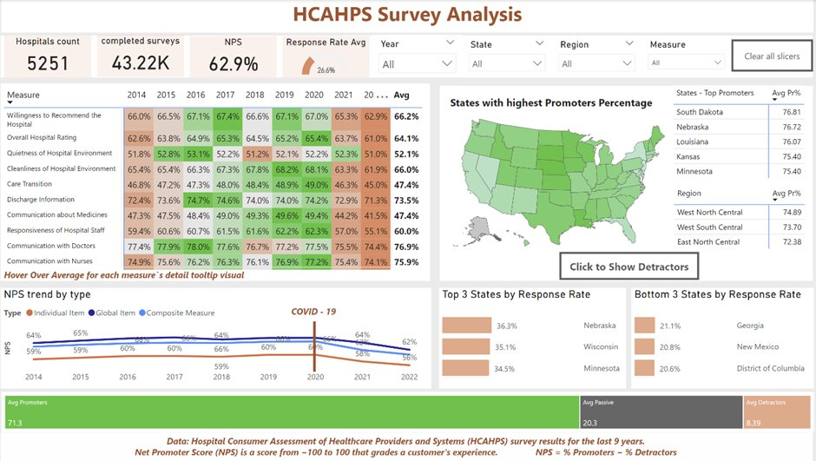
Figure 9: Full HCAHPS Survey Analysis Dashboard

Conclusion and Recommendations
The HCAHPS survey analysis over nine years revealed meaningful trends in patient satisfaction and hospital quality across the United States. The data highlights both successes and areas requiring targeted intervention.

Areas of Excellence
- Discharge Information showed noteworthy progress over the study period
- Communication with Doctors and Nurses consistently maintained high positive response rates

Opportunities for Improvement
- Care Transition and Communication about Medicines are the lowest-scoring areas and require strategic focus
- Quietness of the Hospital Environment showed the least improvement and warrants closer attention

Regional Insights
- South Dakota and Nebraska consistently showed the highest positive response rates, suggesting potential best practices for other regions to explore
- The South Atlantic region had the highest detractor rates and should be prioritized for intervention

Survey Participation
- Hospitals should intensify efforts to encourage patients to complete the survey before discharge
- A higher response rate would improve data reliability and ensure a more representative view of patient experience

This analysis demonstrates the value of data analytics in evaluating hospital performance and guiding continuous improvement in healthcare quality across the nation.

Data Source: HCAHPS Survey Results 2013–2022 | Analysis: HCAHPS Survey 2013–2022

