Netflix Customer Churn Prediction — Project Report
Prepared by: Arpita(Using IBM BOB) | Dataset: 5,000 Customer Records | Model: Gradient Boosting Classifier
Table of Contents
1. Executive Summary
2. Dataset Overview
3. Exploratory Data Analysis
4. Feature Engineering & Preprocessing
5. Model Training & Evaluation
6. Feature Importances
7. System Architecture
9. Key Findings & Business Recommendations
10. How to Run the Project
1. Executive Summary
This report presents the design, development, and evaluation of an end-to-end machine learning system built to predict customer churn on the Netflix platform. Using a dataset of 5,000 customer records spanning demographics, subscription details, viewing behaviour, and payment information, we trained and compared three classification models. The best-performing model — Gradient Boosting Classifier — achieved 99.1% accuracy and a ROC-AUC score of 0.9986 on the held-out test set.
The project delivers a production-ready REST API (FastAPI) and an interactive Streamlit dashboard with four functional pages: a KPI dashboard, EDA & insights, real-time churn prediction, and model performance comparison. The system enables the business to proactively identify at-risk customers and act before they cancel.
Key Metrics at a Glance
Metric | Value
Total Customers | 5,000
Churned | 2,515 (50.3%)
Retained | 2,485 (49.7%)
Best Model | Gradient Boosting Classifier
Model ROC-AUC | 0.9986 (99.86%)
2. Dataset Overview
The dataset contains 5,000 unique customer records collected from the Netflix subscription platform. Each record captures 14 attributes covering demographics, account configuration, viewing habits, financial details, and the churn label.
2.1 Column Descriptions
Column | Type | Description
customer_id | String | Unique UUID identifier (dropped before training)
age | Integer | Customer age in years
gender | Categorical | Male / Female / Other
subscription_type | Categorical | Basic / Standard / Premium
watch_hours | Float | Total hours watched on the platform
last_login_days | Integer | Number of days since last login
region | Categorical | Geographic region (Africa, Asia, Europe, etc.)
device | Categorical | Primary viewing device (Mobile, TV, Tablet, Laptop)
monthly_fee | Float | Monthly subscription fee in USD
payment_method | Categorical | Payment method used (Credit Card, PayPal, Crypto, etc.)
number_of_profiles | Integer | Number of user profiles on the account
avg_watch_time_per_day | Float | Average hours watched per day
favorite_genre | Categorical | Customer's most-watched genre
churned | Binary (Target) | 1 = churned, 0 = retained
2.2 Class Distribution
The dataset is nearly balanced: 2,515 churned customers (50.3%) and 2,485 retained customers (49.7%). This balanced distribution means no class-weighting adjustments were required during model training.
3. Exploratory Data Analysis
3.1 Churn by Subscription Type
Subscription plan is one of the strongest categorical predictors of churn. Basic plan subscribers show the highest churn rate at 61.83%, compared to Standard (45.44%) and Premium (43.71%). This indicates that lower-tier subscribers are significantly more likely to leave, possibly due to feature limitations or cost sensitivity.
Subscription Type | Churn Count | Churn Rate
Basic | ~1,030 | 61.83%
Standard | ~760 | 45.44%
Premium | ~725 | 43.71%
3.2 Churn by Region
Churn rates are relatively uniform across geographic regions, ranging from 48.3% (Africa) to 51.7% (Europe). This suggests region is not a strong independent predictor, though it may interact with other features.
Region | Churn Count | Churn Rate
Africa | ~400 | 48.32%
Asia | ~430 | 50.65%
Europe | ~435 | 51.67%
North America | ~420 | 49.47%
Oceania | ~425 | 50.07%
South America | ~405 | 51.43%
3.3 Churn by Payment Method
Payment method reveals a notable split: customers paying via Crypto (59.7%) and Gift Card (57.8%) churn far more than those using Credit Card (43.6%) or Debit Card (43.7%). This may reflect temporary or gift-driven subscriptions lacking long-term commitment.
Payment Method | Churn Count | Churn Rate
Credit Card | ~435 | 43.58%
Debit Card | ~440 | 43.69%
PayPal | ~470 | 47.08%
Gift Card | ~580 | 57.79%
Crypto | ~597 | 59.70%
3.4 Viewing Behaviour
Churned customers exhibit distinctly lower average daily watch time (avg_watch_time_per_day) and total watch hours compared to retained customers. The average daily watch time is the strongest predictor across all features, contributing 65.14% of model importance. Customers with low daily engagement are significantly more likely to churn.
4. Feature Engineering & Preprocessing
The following preprocessing steps were applied before model training:
- • customer_id was dropped (non-predictive identifier)
- • Six categorical columns (gender, subscription_type, region, device, payment_method, favorite_genre) were label-encoded using scikit-learn LabelEncoder
- • All numerical features were used as-is — no scaling was required for tree-based models
- • Stratified 80/20 train-test split was applied to preserve the class balance in both sets
The final feature set contains 12 predictors after removing customer_id and the target column (churned).
5. Model Training & Evaluation
Three classifiers were trained and evaluated on 1,000 held-out test samples. The best model was selected based on ROC-AUC score.
5.1 Model Comparison
Model | Accuracy | ROC-AUC | Selected
Gradient Boosting | 99.1% | 0.9986 | YES (Best)
Random Forest | 96.8% | 0.9964 | —
Logistic Regression | 88.5% | 0.9599 | —
The Gradient Boosting Classifier was selected as the production model. It achieved 99.1% accuracy and a near-perfect ROC-AUC of 0.9986, with a precision and recall of 0.99 for both classes.
5.2 Model Configuration
Hyperparameter | Value
n_estimators | 150
random_state | 42
Train / Test Split | 80% / 20% (stratified)
6. Feature Importances
The Gradient Boosting model provides native feature importances based on the mean impurity reduction across all trees. The table below ranks all 12 features:
Rank | Feature | Importance (%)
1 | avg_watch_time_per_day | 65.14%
2 | watch_hours | 9.97%
3 | number_of_profiles | 8.25%
4 | last_login_days | 8.16%
5 | monthly_fee | 3.24%
6 | subscription_type | 2.76%
7 | payment_method | 2.47%
8 | age | 0.01%
9 | gender | 0.00%
10 | favorite_genre | 0.00%
11 | device | 0.00%
12 | region | 0.00%
The top four features (avg_watch_time_per_day, watch_hours, number_of_profiles, last_login_days) account for 91.5% of total model importance. Demographic features (gender, age, device, region, favorite_genre) contribute less than 0.1% combined.
7. System Architecture
The project follows a three-layer architecture:
- Layer 1 — Data & ML (train.py): Loads the CSV, label-encodes categoricals, trains three classifiers, selects the best by ROC-AUC, and persists model.pkl, encoders.pkl, feature_columns.pkl, and meta.pkl to disk.
- Layer 2 — Backend API (app.py): FastAPI application exposing /predict (POST), /meta (GET), and /health (GET). Loads all model artefacts at startup and serves predictions with sub-millisecond latency. CORS is enabled for Streamlit cross-origin calls.
- Layer 3 — Frontend (frontend.py): Streamlit application with Netflix-themed dark UI. Four pages: Dashboard, EDA & Insights, Predict Churn, and Model Performance. Interactive charts powered by Plotly. Real-time predictions via HTTP calls to the FastAPI backend.
8. Dashboard Overview

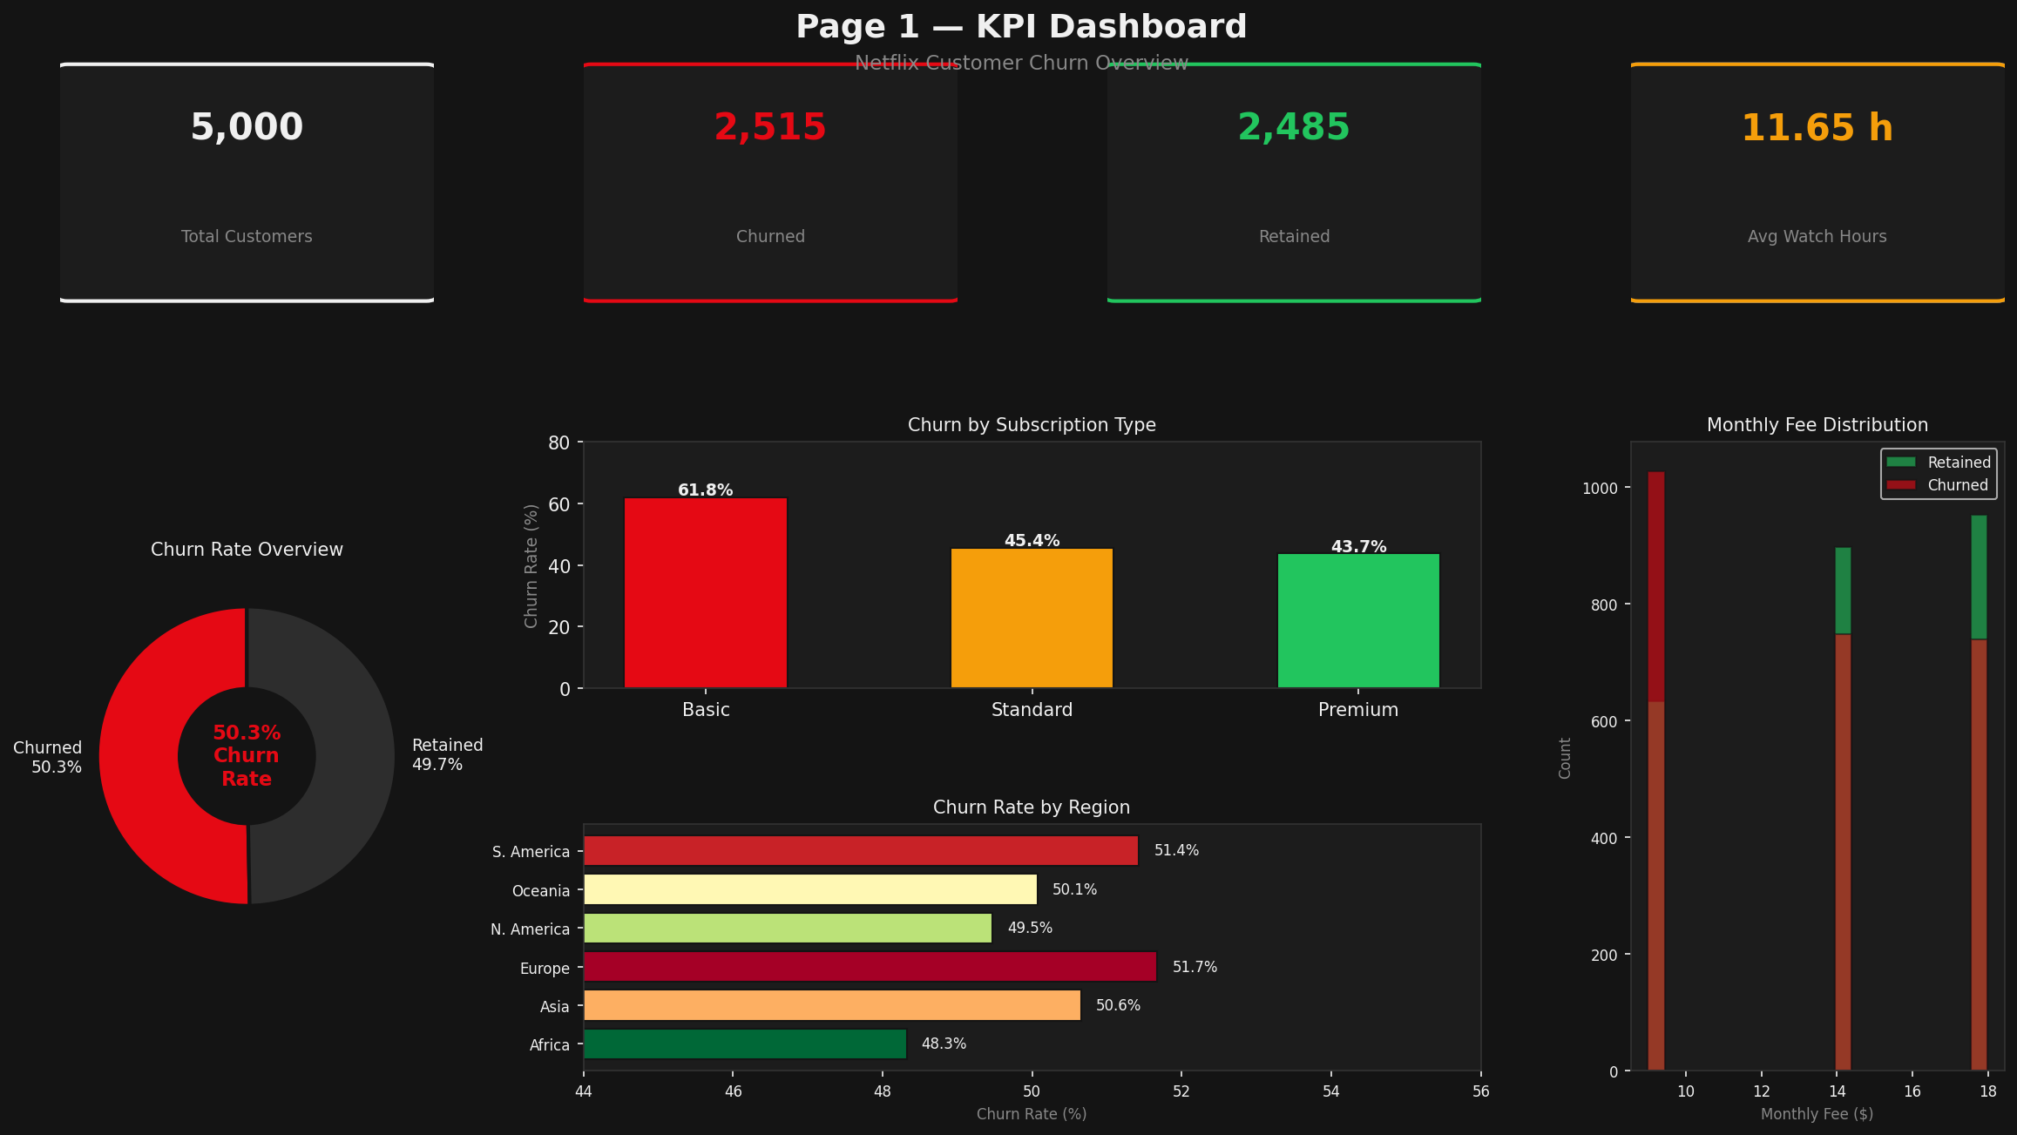
Figure 1 — Page 1: KPI Dashboard | Five KPI cards + donut chart, subscription bar, region bar, fee histogram

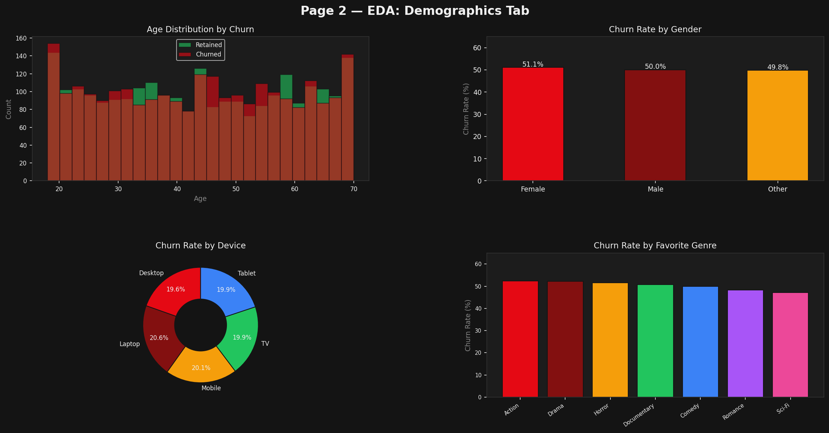
Figure 2 — EDA Demographics Tab | Age histogram, gender bar, device donut, genre bar — all by churn

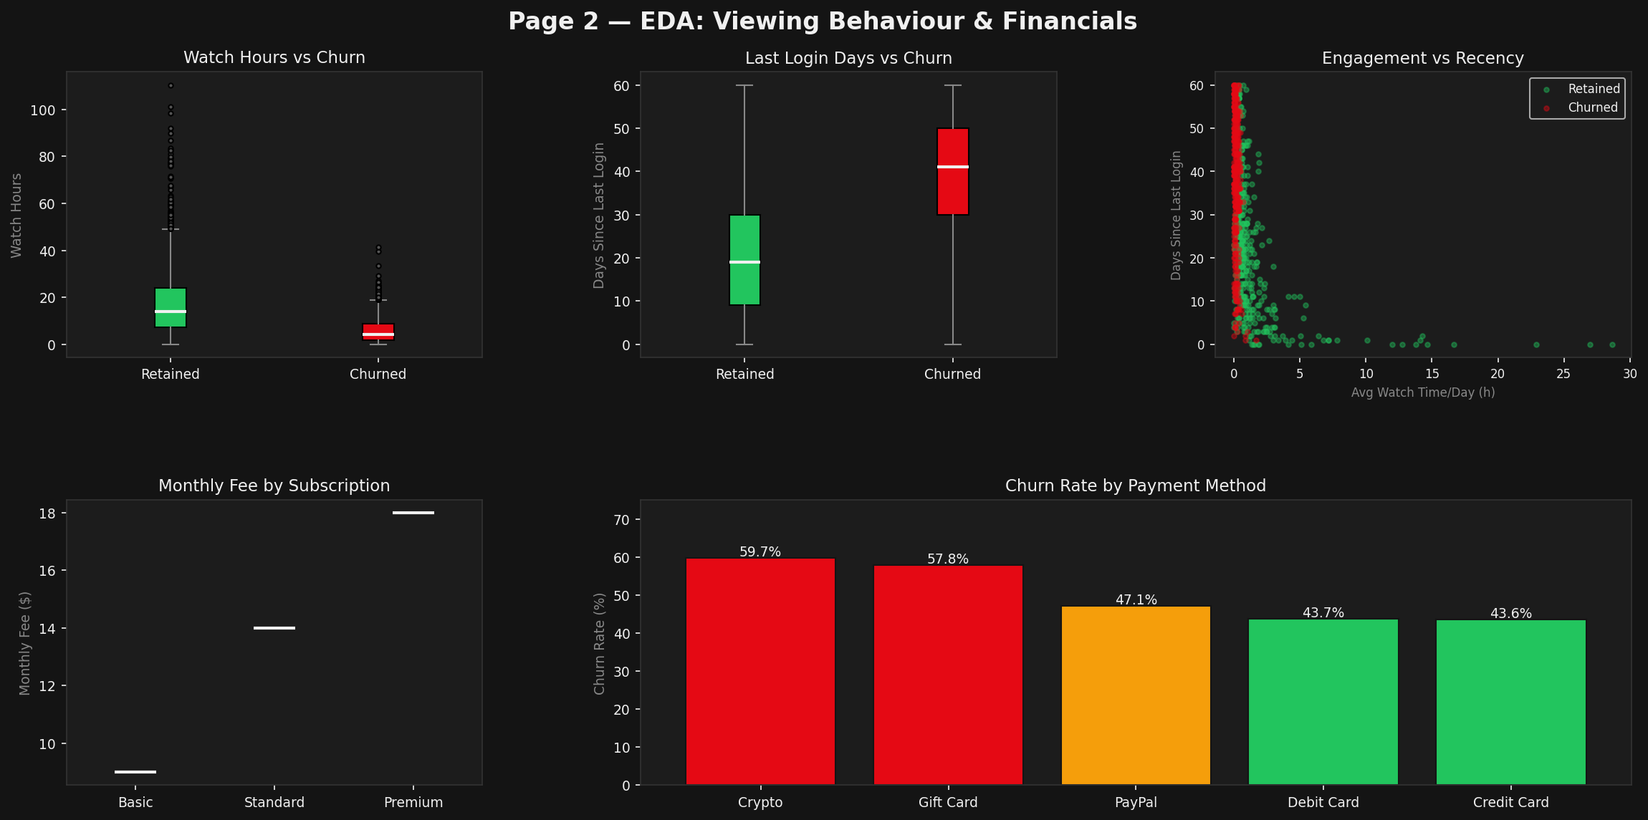
Figure 3 — EDA Viewing Behaviour & Financials | Box plots, scatter, payment method churn bars

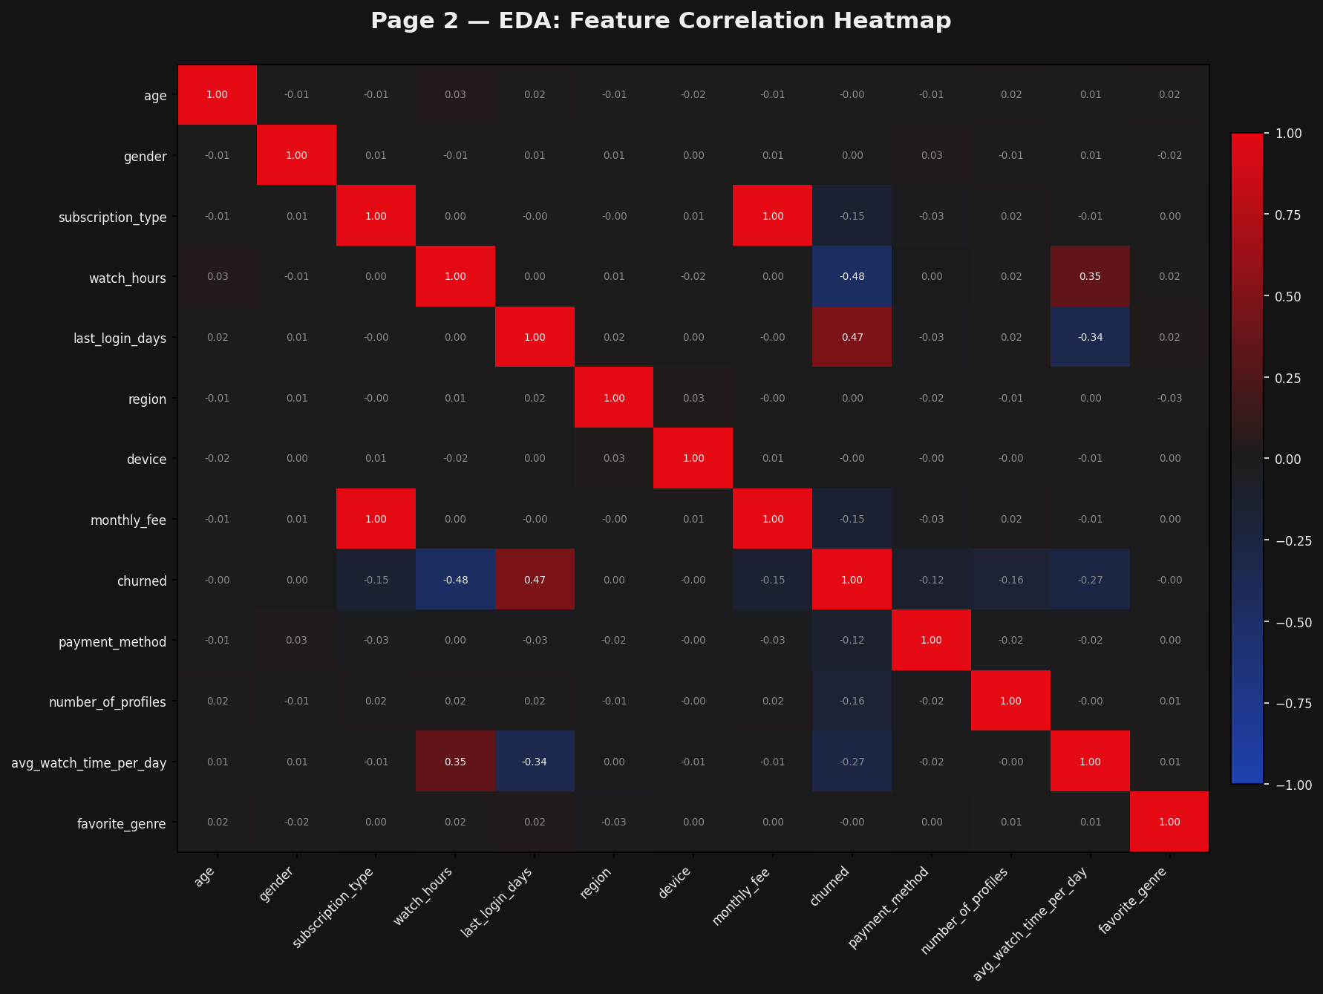
Figure 4 — Feature Correlation Heatmap | Pearson correlations across all 13 features

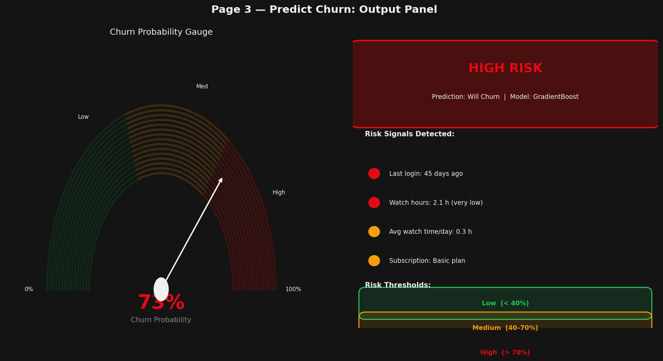
Figure 5 — Predict Churn Page | Gauge chart (73%), HIGH RISK badge, risk signals, thresholds

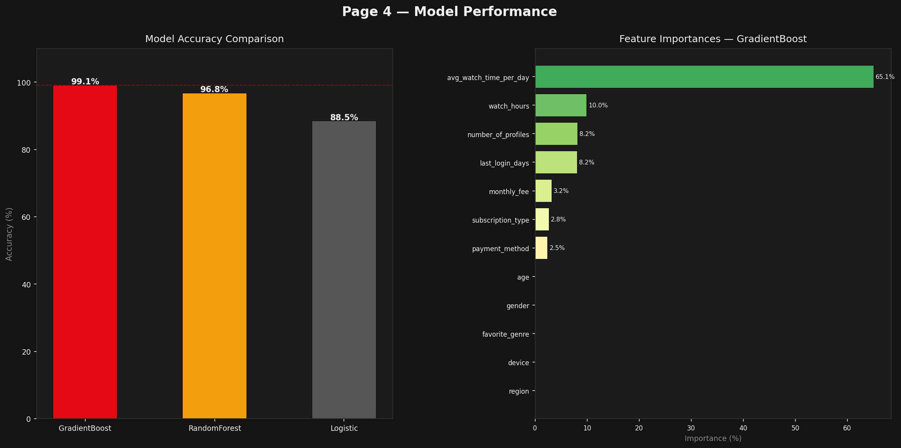
Figure 6 — Model Performance | Accuracy comparison bars + feature importance chart (GradientBoost)

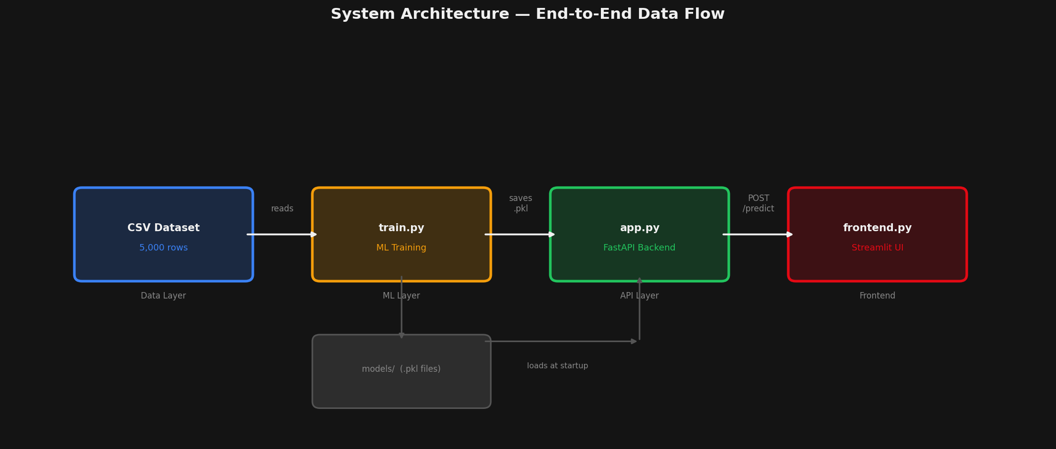
Figure 7 — System Architecture | End-to-end data flow: CSV → train.py → models → FastAPI → Streamlit

This section documents the four dashboard pages of the Streamlit application. Each page is described with its purpose, contained visualisations, and the specific data metrics it exposes.
8.1 Page 1 — KPI Dashboard
The Dashboard page is the landing page of the application. It gives an at-a-glance executive view of the entire customer base and churn landscape through five KPI metric cards and four Plotly charts.
KPI Metric Cards (top row)
KPI Card | Value | Description
Total Customers | 5,000 | Total records in the dataset
Churned | 2,515 (+50.3%) | Customers who cancelled — delta shown in red
Retained | 2,485 | Active subscribers
Avg Monthly Fee | $13.68 | Mean monthly revenue per customer
Avg Watch Hours | 11.65 h | Mean total watch hours across all customers
Charts on the Dashboard Page
Chart | Chart Type | Insight Shown
Churn Rate Overview | Donut / Pie (Plotly) | 55% hole donut — Churned 50.3% vs Retained 49.7%
Churn by Subscription Type | Bar chart (Plotly) | Basic 61.8%, Standard 45.4%, Premium 43.7%
Churn by Region | Horizontal bar (Plotly) | Europe 51.7% highest; Africa 48.3% lowest
Monthly Fee Distribution | Overlaid histogram (Plotly) | Churned (red) vs Retained (green) fee distribution
8.2 Page 2 — EDA & Insights
The EDA page provides deep analytical insight into the dataset through four sub-tabs. Each tab targets a different dimension of the data and contains multiple interactive Plotly charts.
Tab | Charts Included | Dimensions Explored
Demographics | Age histogram, Gender bar, Device pie, Genre bar | Age/gender/device/genre vs churn rate
Viewing Behaviour | Watch hours box, Last login box, Scatter plot | Engagement depth and recency vs churn
Financials | Monthly fee box, Payment method bar | Revenue tier and payment type vs churn
Correlations | Correlation heatmap, Raw data table | Feature-level relationships across all 13 variables
EDA Charts — Full Inventory
Chart | Type | Key Finding
Age Distribution by Churn | Overlaid histogram | Churn is broadly uniform across all age groups (18–75)
Gender vs Churn | Bar chart | Female 51.1%, Male 50.0%, Other 49.8% — nearly identical
Churn by Device | Donut chart | Laptop 51.8% slightly higher; Desktop 49.2% lowest
Favorite Genre vs Churn | Bar chart | All genres cluster between 48–53%; genre is not predictive
Watch Hours vs Churn | Box plot | Churned customers: lower median watch hours than retained
Last Login Days vs Churn | Box plot | Churned customers: significantly higher days since last login
Avg Watch Time / Last Login | Scatter plot (1,000 sample) | Low watch + high last_login = highest churn concentration
Monthly Fee by Subscription | Box plot | Basic $8.99, Standard $13.99, Premium $17.99
Correlation Heatmap | Annotated heatmap | avg_watch_time_per_day and watch_hours show strongest correlation to churn
8.3 Page 3 — Predict Churn (Real-Time Prediction)
The Predict Churn page is the core interactive feature of the system. A customer profile form on the left side sends a POST request to the FastAPI backend upon submission. The right panel renders the prediction result in real time.
Form Input Fields
Field | Input Type | Accepted Values
Age | Number input | Integer, 1 – 120
Gender | Selectbox | Male / Female / Other
Subscription Type | Selectbox | Basic / Standard / Premium
Region | Selectbox | Africa / Asia / Europe / North America / Oceania / South America
Device | Selectbox | Mobile / TV / Tablet / Laptop
Favorite Genre | Selectbox | Action / Comedy / Drama / Horror / Romance / Sci-Fi / Documentary / Thriller
Payment Method | Selectbox | Credit Card / Debit Card / PayPal / Gift Card / Crypto
Number of Profiles | Number input | Integer, 1 – 10
Total Watch Hours | Number input | Float, 0.0 – 500.0
Days Since Last Login | Number input | Integer, 0 – 365
Monthly Fee ($) | Number input | Float, 0.00 – 50.00
Avg Watch Time / Day (h) | Number input | Float, 0.0 – 24.0
Prediction Output Components
Output Component | Type | Description
Risk Badge | Styled HTML card | Colour-coded card — red (High), amber (Medium), green (Low)
Churn Probability | Percentage text | e.g. 73.4% — raw model output probability
Gauge Chart | Plotly Indicator | 0–100% gauge with colour-zone background and needle threshold
Risk Signal Bullets | Dynamic text list | Auto-generated alerts based on last_login_days, watch_hours, avg_watch_time_per_day, subscription_type
Risk Level Classification
Risk Level | Probability Range | Colour Theme
Low | 0% – 39% | Green (#22c55e)
Medium | 40% – 69% | Amber (#f59e0b)
High | 70% – 100% | Netflix Red (#E50914)
8.4 Page 4 — Model Performance
The Model Performance page allows technical stakeholders to inspect training results, compare all three trained classifiers, and explore feature importances and categorical encoder mappings.
Component | Type | Description
Best Model Banner | st.success badge | Shows selected model name and its ROC-AUC score
Accuracy Comparison | Grouped bar chart | Side-by-side accuracy bars for all 3 models; best model highlighted in Netflix red
ROC-AUC Comparison | Grouped bar chart | Same layout as accuracy chart — ROC-AUC scores for all 3 models
Feature Importance Chart | Horizontal bar chart | All 12 features ranked by Gradient Boosting importance; colour gradient low-to-high
Categorical Encodings | Expandable sections (st.expander) | One expander per categorical feature listing all label-encoded class values
8.5 Dashboard Technology Stack
The dashboard frontend is built entirely in Python using the libraries listed below. No JavaScript or external web frameworks are required.
Library | Version | Role in Dashboard
Streamlit | 1.35.0 | Web application framework — pages, forms, layout, widgets
Plotly | 5.22.0 | All charts — bar, pie, box, scatter, histogram, heatmap, gauge
Pandas | 2.2.2 | Data loading, groupby aggregations, correlation matrix
Requests | 2.32.3 | HTTP POST calls to the FastAPI prediction endpoint
Pickle (stdlib) | Built-in | Loading model artefacts for the Model Performance page
9. Key Findings & Business Recommendations
9.1 Key Findings
- • Viewing inactivity is the #1 churn driver: avg_watch_time_per_day alone drives 65% of model importance.
- • Basic plan subscribers churn 18 percentage points more than Premium subscribers (61.8% vs 43.7%).
- • Crypto and Gift Card payment methods correlate with ~16% higher churn than card-based payments.
- • Demographics (age, gender, region, device) have negligible predictive power individually.
- • Customers with many profiles but low watch time indicate shared accounts without personal engagement.
9.2 Business Recommendations
- • Re-engagement campaigns: Trigger personalised push notifications or email campaigns for customers whose avg_watch_time_per_day drops below 0.5 hours.
- • Upgrade incentives: Offer promotional discounts to Basic subscribers after 60 days to migrate them to Standard or Premium plans.
- • Payment method flags: Flag Crypto and Gift Card accounts for early-warning churn risk monitoring.
- • Last-login alerts: Customers not logging in for 30+ days should receive an automated win-back offer.
- • Profile personalisation: Encourage profile creation and recommend content per profile to increase per-profile engagement.
10. How to Run the Project
Prerequisites: Python 3.9+ with the following packages installed: pandas, numpy, scikit-learn, fastapi, uvicorn, pydantic, requests, streamlit, plotly.
4. Launch frontend | streamlit run frontend.py | Available at http://localhost:8501
Once both servers are running, open http://localhost:8501 in your browser to access the full Streamlit dashboard. The FastAPI Swagger UI is available at http://localhost:8000/docs for direct API testing.

