Simulation and PSO Instructions

Run the Simulation
1. Open the file 'dfig.slx'
2. Open the file 'fitness.m'
3. With 'fitness.m' open, click 'Run'
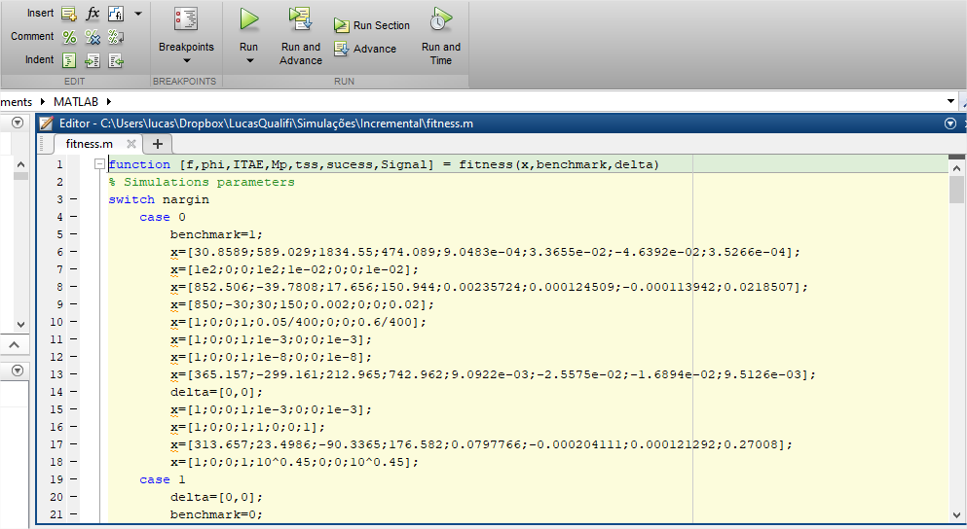

Simulation Variables (inside 'fitness.m')
Ny = 20 - Prediction horizon
Nu = 10 - Control horizon
Variac = 120 - DC bus voltage
StepInit = [1,1] - Initial step response value
StepFinal = [3,3] - Final step response value
StepTime = [1,1.5] - Time when step response occurs

Function Parameters (Optional)
x - Values of the weighting matrices
benchmark - Shows results in graphical form
delta - Parameter variation

Function Outputs
f - Objective function value
phi - Constraint function value
tss - Settling time
ITAE - Performance index
Mp - Overshoot
success - Simulation ran successfully
Signal - Signal vector for later plotting

Run PSO
1. Follow the simulation steps and run it at least once.
2. Open the file 'pso.m'
3. With 'pso.m' open, click 'Run'
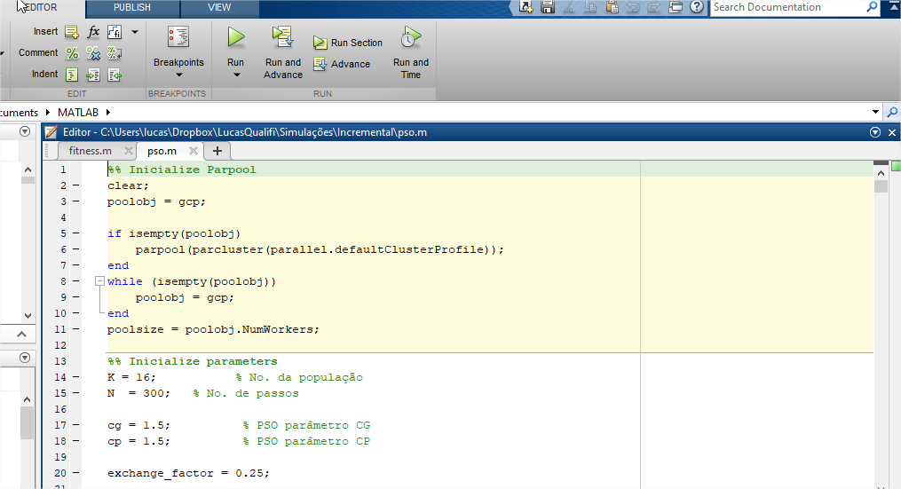

PSO Variables
K = 16 - Population size
N = 300 - Number of iterations
cg = 1.5 - PSO parameter CG
cp = 1.5 - PSO parameter CP

