Name – Arpita Waghmare
PRN – 24070521006
Batch – A1

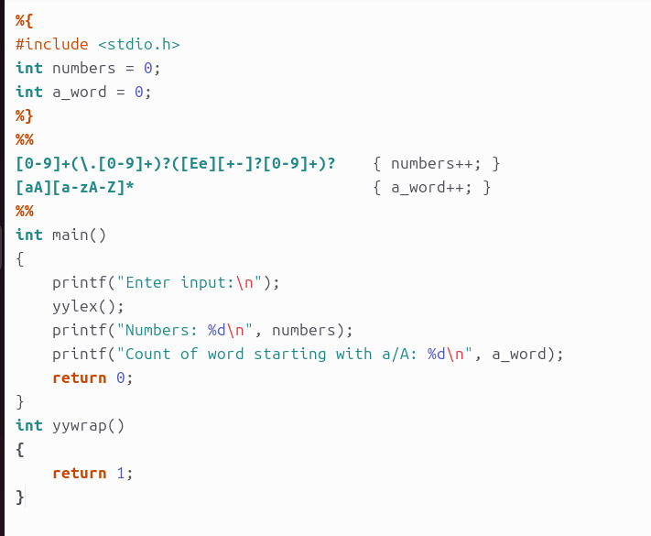

Name – Arpita Waghmare
PRN – 24070521006
Batch – A1


