Name – Arpita Waghmare
PRN-24070521006
Batch-A1
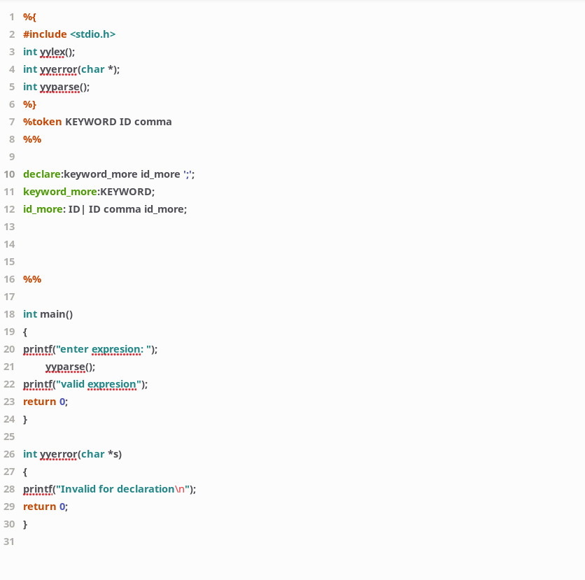

Name – Arpita Waghmare
PRN-24070521006
Batch-A1
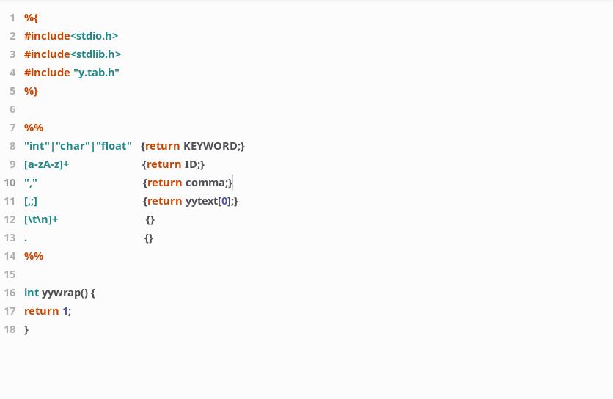

Name – Arpita Waghmare
PRN-24070521006
Batch-A1


