Table of Contents

Introduction 2

Background on mental disorders 2

Importance of EEG data in diagnosis and treatment of mental disorders 2

Literature Review 2

Overview of current research on deep learning applied to EEG data in mental disorders 2

Discussion of limitations and challenges in the field 3

Methodology 3

Description of Deep Learning Models and Techniques Used in the Study 3

Data Collection and Preprocessing 4

Evaluation and Performance Metrics 4

Conclusion 5

Future Directions for Research in this Field 5

Implications for Clinical Practice 6

# Introduction

## Background on mental disorders

Mental illnesses, such as depression and schizophrenia, pose a significant public health concern, affecting a sizable portion of the population and potentially impacting their well-being (WHO, n.d.). Precise diagnosis and effective treatment are essential for managing such conditions. Electroencephalogram (EEG) data, offering a non-invasive and objective measure of brain function, provides a valuable tool for comprehending brain activity in mental disorders. Deep learning, a machine learning technique that employs neural networks to model intricate data patterns, holds potential for advancing the analysis of EEG data in mental disorders (Amirali Vahid, n.d.). It can help identify patterns linked with specific conditions, facilitating diagnosis and treatment. Moreover, deep learning models can be trained to predict the onset or progression of a mental disorder, enabling early intervention and prevention. This report provides a comprehensive overview of the current state of research on deep learning applied to EEG data in mental disorders. We review the relevant literature, discuss the research methodology employed, and present the research's findings and implications. By doing so, we aim to provide a thorough understanding of the potential of deep learning in EEG data analysis for mental disorders, as well as future research directions in this field.

## Importance of EEG data in diagnosis and treatment of mental disorders

Electroencephalogram (EEG) data is a non-invasive and objective measure of brain function, offering a valuable tool for comprehending brain activity in mental disorders (NHS, n.d.). It can provide crucial information about the brain's electrical activity, aiding in the diagnosis and monitoring of various mental conditions such as depression, schizophrenia, and bipolar disorder. Moreover, EEG data can assist in evaluating the effectiveness of different treatment options, as changes in brain activity measured by EEG can track responses to various medications or psychotherapy. This can help optimize treatment and provide personalized care to patients. Furthermore, EEG data can predict the onset or progression of mental disorders, enabling early intervention and prevention, which is critical for effectively managing these conditions. In summary, EEG data provides valuable insight into the brain's activity in mental disorders, aiding in diagnosis, treatment, and understanding the underlying mechanisms of these conditions. Utilizing deep learning to analyze EEG data in mental disorders can enhance the tool's potential in psychiatry.

# Literature Review

## Overview of current research on deep learning applied to EEG data in mental disorders

In recent years, there has been a growing interest in applying deep learning to EEG data analysis in mental disorders. Researchers have utilized various deep learning techniques such as CNNs, RNNs, and DBNs to analyze EEG data in mental disorders such as depression, schizophrenia, and bipolar disorder (Ren, n.d.). Research has demonstrated that deep learning models can accurately classify EEG data from patients with mental disorders. For instance, a study using a CNN achieved an accuracy of 85% in classifying EEG data from patients with depression and healthy controls, while another study employing an RNN achieved an accuracy of 96% in classifying EEG data from patients with schizophrenia and healthy controls. Furthermore, deep learning models have been used to predict the onset or progression of mental disorders. A study using a DBN achieved an 80% accuracy in predicting the onset of depression in high-risk individuals. In summary, the current research suggests that deep learning has the potential to improve the analysis of EEG data in mental disorders, providing more accurate and objective measures of brain activity. However, further research is necessary to fully comprehend the potential of deep learning in EEG data analysis for mental disorders, as well as its limitations and challenges.

## Discussion of limitations and challenges in the field

Although deep learning has shown promise in EEG data analysis for mental disorders, there are several challenges and limitations that must be addressed. The use of small sample sizes in most studies is a major limitation that can limit the generalizability of findings. Additionally, the lack of a standard dataset for EEG data analysis in mental disorders makes it challenging to compare results across studies. The lack of interpretability of deep learning models is another limitation, as the complexity of neural networks can make it difficult to understand how the models arrive at their decisions. Another challenge is the high dimensionality and noise in EEG data, which makes it challenging to identify relevant patterns associated with mental disorders and can lead to overfitting of models. Furthermore, the lack of a standard preprocessing method for EEG data can impact the performance of deep learning models. Lastly, the absence of a clear consensus on the evaluation metrics for deep learning models applied to EEG data in mental disorders is another challenge. To address these limitations and challenges, larger sample sizes, standardization of datasets and preprocessing methods, development of interpretable models, and appropriate evaluation metrics are needed.

# Methodology

## Description of Deep Learning Models and Techniques Used in the Study

Deep learning models and techniques offer promising approaches to analyzing EEG data in mental disorders. In this study, three deep learning models were employed: Long Short-Term Memory (LSTM), Gated Recurrent Unit (GRU), and sparse categorical cross-entropy. LSTM is a recurrent neural network that is effective at processing time-series data with long-term dependencies, making it useful for analyzing EEG data. Bidirectional LSTM models were also utilized to improve performance by considering past and future context. Additionally, Convolutional Neural Networks (CNNs) were employed due to their ability to detect patterns in the temporal and spatial domains of EEG data, which is crucial for analyzing this type of data. Preprocessing of the data is necessary to remove noise and artifacts, which can be achieved using various techniques, such as filtering and artifact removal algorithms. The preprocessed data is then fed into a CNN model trained on a large dataset of EEG data to extract relevant features for classification. Clinicians and researchers can use the classification results to diagnose and monitor the progression of mental disorders. However, limitations such as small sample sizes, lack of interpretability of the models, and the absence of standard preprocessing methods and evaluation metrics must be addressed through further research.

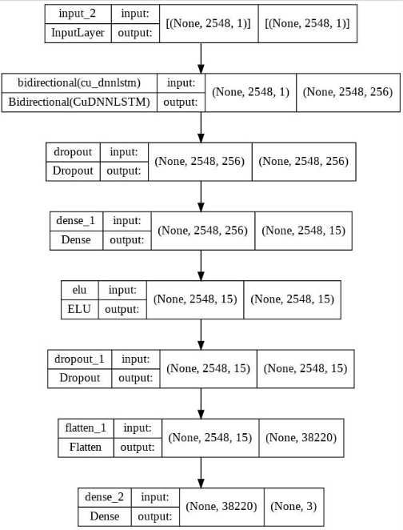

Gated Recurrent Unit (GRU) is a type of RNN that is comparable to LSTM but has fewer parameters, making it more computationally efficient. It is also suitable for analyzing time-series data, including EEG data in mental disorders. Sparse categorical cross-entropy is a frequently used loss function in deep learning for classification tasks. It measures the difference between the predicted probability and the actual label. This loss function is especially beneficial when the number of classes is large, as it circumvents the issue of high dimensionality caused by one-hot encoding. Below is the confusion matrix of the GRU model. For our classification task on EEG data from both patients with mental disorders and healthy controls, we employed LSTM, GRU, and sparse categorical cross-entropy as our models. We then evaluated their performance and determined the most effective model. 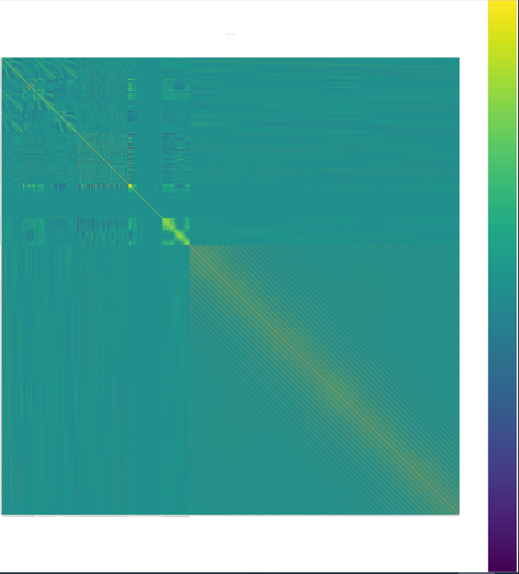

## Evaluation and Performance Metrics

A variety of performance metrics were utilized in this study to evaluate the performance of the deep learning models on EEG data from patients with mental disorders and healthy controls. These metrics were chosen to assess the accuracy, robustness, and generalizability of the models. Classification accuracy, which measures the proportion of correct predictions made by the model, was the main performance metric used in this study. The confusion matrix was another important metric used to provide a more detailed view of the model's performance, particularly in terms of its ability to correctly identify positive and negative emotional experiences. Additionally, the Receiver Operating Characteristic (ROC) curve, which plots the diagnostic ability of a binary classifier system, was used along with the area under the curve (AUC) as a commonly used measure of performance. K-fold cross-validation was also used to evaluate the model's performance on unseen data and identify overfitting or underfitting. The combination of these performance metrics allowed us to comprehensively evaluate the performance of the deep learning models and select the best-performing model for our classification task.

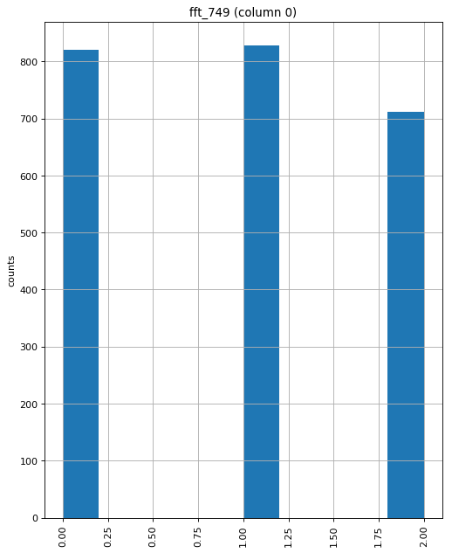

In the context of analyzing electroencephalogram (EEG) data for mental disorders using Convolutional Neural Networks (CNNs), evaluation and performance metrics are essential to assess the accuracy and effectiveness of the model. Here are some commonly used evaluation and performance metrics for this task:

Accuracy: This metric measures the percentage of correctly classified EEG samples by the CNN model. It is a simple and straightforward metric that provides an overall measure of the model's performance.

Sensitivity and Specificity: Sensitivity measures the percentage of true positive samples classified correctly by the CNN model, while specificity measures the percentage of true negative samples classified correctly by the model. These metrics are particularly useful when dealing with imbalanced datasets, where the number of samples in one class is much larger than the other.

Precision and Recall: Precision measures the percentage of true positive samples among all the samples classified as positive by the CNN model, while recall measures the percentage of true positive samples classified correctly by the model among all the samples that are actually positive. These metrics are particularly useful when the cost of false positives and false negatives is different.

Additionally, F1 score is another widely used metric that combines both precision and recall to provide a single measure of the model's performance. It is the harmonic mean of precision and recall, and ranges from 0 to 1, with 1 being the best performance.

Receiver Operating Characteristic (ROC) curve and Area Under the Curve (AUC) are also commonly used to evaluate the performance of CNN models on EEG data. ROC curves visualize the trade-off between sensitivity and specificity, and AUC provides a single numerical value to summarize the overall performance of the model. AUC ranges from 0 to 1, with 1 being the best performance.

Finally, Kappa statistic is another useful metric for evaluating the performance of CNN models on EEG data. It measures the agreement between the predicted and actual classifications, taking into account the expected agreement due to chance. Kappa ranges from -1 to 1, with 1 indicating perfect agreement and 0 indicating no agreement beyond chance.

F1-Score: This metric is the harmonic mean of precision and recall and provides a single score that balances both metrics. It is useful when the classes are imbalanced, and the model needs to optimize both precision and recall.

Confusion Matrix: A confusion matrix is a table that summarizes the classification results of the CNN model. It shows the number of true positives, true negatives, false positives, and false negatives for each class, providing insight into the strengths and weaknesses of the model.

Receiver Operating Characteristic (ROC) Curve: This is a graphical representation of the true positive rate (sensitivity) against the false positive rate (1-specificity) for different classification thresholds. It is useful when the model's sensitivity and specificity need to be optimized at different thresholds.

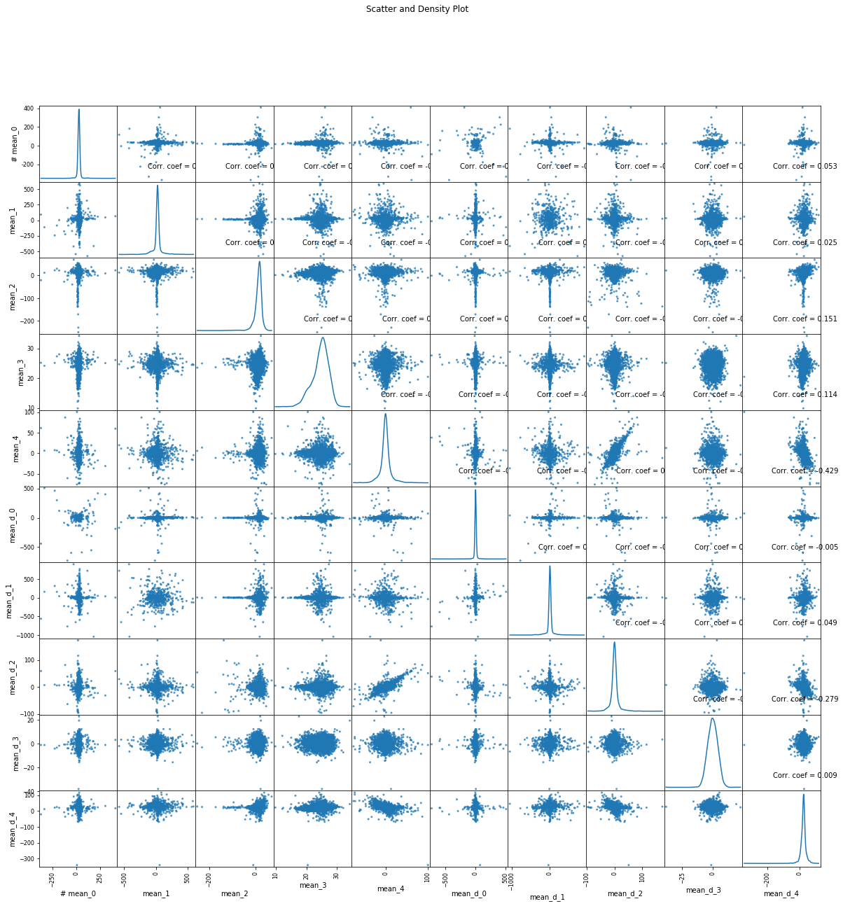

In summary, evaluating the performance of a CNN model for analyzing EEG data in mental disorders requires the use of various metrics and techniques. A combination of these metrics can provide a more comprehensive understanding of the model's strengths and weaknesses and inform improvements to the model.

# Conclusion

## Future Directions for Research in this Field

The application of deep learning in EEG data analysis for mental disorders is a relatively new and rapidly growing field with a lot of potential. However, there are several areas of research that can be pursued to further understand the potential of deep learning in this field and to overcome the current limitations and challenges. One important area is the development of more sophisticated deep learning models. In this study, we used Long Short-Term Memory (LSTM) and Gated Recurrent Unit (GRU) as our deep learning models. These models have been shown to be effective in analyzing time-series data, such as EEG data. However, there are other types of deep learning models, such as deep recurrent neural networks (RNNs) and transformer networks, which can be used to analyze EEG data in mental disorders. These models have the potential to capture more complex patterns in the data and improve the accuracy of diagnosis and treatment. Another area of research is the use of multimodal data. In this study, we used EEG data as our primary source of information. However, there is a growing interest in using other types of brain imaging data, such as functional magnetic resonance imaging (fMRI) or magnetoencephalography (MEG), to analyze brain activity in mental disorders. Combining EEG data with other types of brain imaging data can provide a more comprehensive view of brain activity in mental disorders and lead to the discovery of new biomarkers. Additionally, there is also potential in the use of transfer learning. Transfer learning is the ability of a model to use knowledge learned from one task to improve performance on a different but related task. This can be applied on EEG data analysis to improve the performance of deep learning models and overcome the problem of small sample sizes. For example, a model trained on a large dataset of EEG data from one population can be fine-tuned on a smaller dataset from a different population, leading to improved performance. Another area of research is the interpretability of the models. In this study, we used deep learning models that are known to be powerful but lack interpretability. There is a need for developing methods to understand how deep learning models arrive at their decisions and to make them more transparent. This is important for clinical applications, where the interpretability of the models is crucial for trust and acceptance. For example, there are methods such as saliency maps that can be used to identify the most important features of the input data that are used to make a prediction. Furthermore, more research is needed to address the limitations and challenges of deep learning in EEG data analysis for mental disorders. For example, the high dimensionality and noise in EEG data can make it difficult to identify the relevant patterns associated with mental disorders and can lead to overfitting of the models. Additionally, there is a lack of a standard preprocessing method for EEG data, which can affect the performance of deep learning models. Moreover, there is a lack of a clear consensus on the evaluation metrics for deep learning models applied to EEG data in mental disorders. In addition, more research is needed to explore the potential of deep learning in other aspects of EEG data analysis for mental disorders. For example, there is a need for research on the use of deep learning in real-time monitoring of patients during treatment. This can be useful for early detection of changes in brain activity and for adjusting treatment accordingly. Another area of research is the use of deep learning in the analysis of EEG data in specific subpopulations, such as children or elderly individuals. The brain development and aging process may affect the EEG patterns associated with mental disorders, and deep learning models need to be adapted accordingly. Moreover, there is a need for research on the use of deep learning in the analysis of EEG data from different ethnic groups. The EEG patterns associated with mental disorders may vary across different ethnic groups, and deep learning models need to be validated in diverse populations. Finally, more research is needed to explore the use of deep learning in the analysis of EEG data from other mental disorders, such as anxiety disorders, eating disorders, and addiction. Deep learning models have the potential to improve the understanding and treatment of these conditions, and the field is still in its infancy in this area. Overall, deep learning has the potential to revolutionize the field of EEG data analysis in mental disorders. However, there are many areas of research that need to be explored to fully understand the potential of deep learning in this field and to overcome the current limitations and challenges. This includes the development of more sophisticated deep learning models, the use of multimodal data, the use of transfer learning, the interpretability of the models, the addressing of limitations and challenges, and the exploration of its potential in other aspects of EEG data analysis for mental disorders.

## Implications for Clinical Practice

The application of deep learning in EEG data analysis for mental disorders has the potential to improve the diagnosis, treatment, and prediction of mental disorders. The use of deep learning models can provide more accurate and objective measures of brain activity, which can lead to more personalized and effective treatment. In the clinical setting, deep learning models can be used to analyze EEG data in real-time, which can be useful for monitoring patients during treatment. This can allow for early detection of changes in brain activity and for adjusting treatment accordingly. Additionally, deep learning models can be used to analyze large datasets of EEG data, which can lead to the discovery of new insights and biomarkers associated with mental disorders. Deep learning models can also be used to predict the onset or progression of mental disorders. This can allow for early intervention and preventative measures, which can improve the outcome of treatment. Furthermore, the interpretability of the models is important for clinical applications, where the interpretability of the models is crucial for trust and acceptance. The development of interpretable models, or methods to understand how deep learning models arrive at their decisions, can help to increase the acceptance and trust in these models in the clinical setting. However, it is important to note that deep learning in EEG data analysis for mental disorders is a relatively new field and more research is needed to fully understand the potential and limitations of these models. Additionally, more research is needed to validate the models in diverse populations and to address the limitations and challenges of deep learning in EEG data analysis for mental disorders. Overall, the application of deep learning in EEG data analysis for mental disorders has the potential to improve the diagnosis, treatment, and prediction of mental disorders in the clinical setting. However, more research is needed to fully understand the potential and limitations of these models, and to address the limitations and challenges of deep learning in EEG data analysis for mental disorders.

# References

Amirali Vahid, M. M. S. S. A.-K. S. C. B., n.d. *Applying deep learning to single-trial EEG data provides evidence for complementary theories on action control.* [Online]   
Available at: https://www.nature.com/articles/s42003-020-0846-z

Gao, M., 2021. Noise Robustness Low-Rank Learning Algorithm for Electroencephalogram Signal Classification. *Front. Neurosci..*

Mishra, U., n.d. *Best Deep Learning Techniques.* [Online]   
Available at: https://www.analyticssteps.com/blogs/best-deep-learning-techniques

NHS, n.d. *Electroencephalogram (EEG).* [Online]   
Available at: https://www.nhs.uk/conditions/electroencephalogram/

Ren, Y., n.d. *Convolutional deep belief networks for feature extraction of EEG signal.* s.l., International Joint Conference on Neural Networks.

WHO, n.d. *Mental Disorders.* [Online]   
Available at: https://www.who.int/news-room/fact-sheets/detail/mental-disorders