
SCHOOL OF COMPUTER ENGINEERING

DIGITAL CRIME SCENE INVESTIGATION OF A DELETED FILE
A Project Report Submitted
to
MANIPAL ACADEMY OF HIGHER EDUCATION
BACHELOR OF TECHNOLOGY
in
INFORMATION TECHNOLOGY
Submitted by
Student Name
Registration Number
Under the guidance of
Faculty Guide Name and Designation
SCHOOL OF COMPUTER ENGINEERING
OCTOBER 2026

2 Abstract
This project develops and evaluates a digital forensics application for investigating a deleted file in a controlled Windows NTFS disk image. The problem addressed is that ordinary deletion removes a file from the active namespace while recoverable metadata and content may remain in the Master File Table or previously allocated clusters. The proposed solution uses a read-only, pure-Python workflow that calculates image hashes, detects volume geometry, parses the NTFS Volume Boot Record and Master File Table, applies update-sequence fixups, extracts file attributes, identifies deallocated records, recovers resident or non-resident data, and constructs a chronological timeline. A command-line interface supports repeatable examination, while a Streamlit dashboard provides visual exploration and report generation. In the experimental case, the application examined a 2,097,152-byte image whose SHA-256 value matched the master baseline. It parsed eight MFT records and found BUDGET_DRAFT.txt in Record 38 with flags 0x0000, sequence number 2, a size of 327 bytes, and a resident data stream. The application recovered all 327 bytes and produced SHA-256 812c8c38e44b0cf4a6501bf015b6e079c2b376b453f3b37874710a49598ce6b4, exactly matching the pre-deletion baseline. It also generated 64 timestamp events and passed 15 automated tests. The expected outcome was therefore achieved: the tool established file existence, deallocation, surviving metadata, recoverability, and content integrity while correctly treating user attribution and an exact deletion mechanism as outside the available evidence.
Keywords: digital forensics, NTFS, Master File Table, deleted file recovery, SHA-256, timeline analysis

3 Need for the Project

3 1 Background
Windows investigations frequently require an examiner to determine whether a file existed before it was deleted and whether any trace remains. NTFS keeps a file record for each object in the Master File Table. Deletion normally changes allocation state before it overwrites the record or the underlying content, so a carefully preserved image can retain evidentiary value after the file disappears from File Explorer.

3 2 Motivation
Many classroom demonstrations depend on opaque commercial tools or pre-generated tables. This project makes the parsing and recovery steps visible. It reads structures byte by byte, connects every conclusion to an MFT record or cryptographic value, and presents the same evidence through both command-line and web interfaces.

3 3 Problem Identification
The central problem is to distinguish a supported forensic conclusion from an assumption. The examiner must prove whether BUDGET_DRAFT.txt existed, identify the surviving NTFS artifacts, recover content if possible, and verify the recovered bytes without claiming that the MFT alone identifies the responsible user or deletion command.

3 4 Objectives
- Verify a working image against the master SHA-256 baseline.
- Parse the NTFS VBR, MFT record headers, fixups, attributes, and data runs.
- Identify allocated and deleted records and reconstruct file paths.
- Recover deleted content and compare its SHA-256 and MD5 values with ground truth.
- Build a chronological timeline and generate an auditable report.
- Validate behavior through automated tests and a reproducible demonstration.

4 Introduction

4 1 Domain Overview
Digital forensics applies repeatable methods to collect, examine, analyze, and report digital evidence. NIST SP 800-86 describes a process centered on collection, examination, analysis, and reporting [1]. This project implements those stages for a small NTFS image and keeps the source image unchanged throughout the examination.

4 2 Existing Scenario
Commercial suites and established tools such as Autopsy and The Sleuth Kit can enumerate deleted NTFS records and recover streams. Their outputs remain most defensible when examiners understand the underlying file system structures and validate results independently. Research has also shown that deleted-file recovery tools can behave differently across fragmentation and overwrite scenarios [5], motivating transparent test images and cryptographic checks.

4 3 Scope
The project covers raw and partitioned disk images, automatic partition-offset detection, NTFS VBR parsing, MFT scanning, selected attributes, resident and non-resident recovery, timeline construction, cross-check import, and report export. The controlled image contains eight parsed records and one deleted target. Parsing of the USN Change Journal, Windows Security logs, compressed streams, EFS-encrypted content, and full production-scale media is outside the current implementation.

4 4 Organization of the Report
The next sections review related work, explain the methodology and architecture, list system requirements, describe implementation modules, present screenshots and measured results, discuss performance and comparison, state the conclusion, and identify future work.

5 Literature Review
Table 1 reviews foundational guidance and technical references that inform the project. The review separates each source's method and finding from the gap addressed by this implementation.
S No | Author | Year | Title | Methodology | Findings | Research Gap
1 | Kent et al. | 2006 | NIST SP 800-86 | Incident-response forensic process and scenarios | Defines collection, examination, analysis, and reporting | General guidance; no NTFS parser implementation
2 | Microsoft | Current | Master File Table | NTFS developer reference | Explains record segments, attributes, and reserved records | Structure reference; no recovery workflow
3 | Carrier | 2005 | File System Forensic Analysis | File-system structures and investigative techniques | Connects allocation metadata to recoverability | Predates the project's interactive Python workflow

Table 1 Literature review of foundational guidance and NTFS references
The first three sources establish the forensic process and the internal structures required for interpretation. They support preservation, parsing, and reporting, but they do not provide a compact end-to-end application that students can execute and inspect in a restricted Windows laboratory environment.

5 Literature Review
Continued review of implementation and deleted-file recovery references.
S No | Author | Year | Title | Methodology | Findings | Research Gap
4 | Medeiros | 2008 | NTFS Forensics | Programmer-oriented raw NTFS extraction | Shows how MFT attributes expose metadata and streams | Needs integration with modern UI, tests, and reporting
5 | Meyer and Roy | 2020 | Do Metadata Based DFR Tools Meet NIST Guidelines | Canonical FAT and NTFS images; comparative experiments | Tool results vary with fragmentation and overwrite conditions | File carving and other file systems left for later work
6 | Sharifi et al. | 2019 | Recovery of Deleted Files from NTFS | Five-tool comparison under three deletion methods | Recovery capability depends on deletion condition and tool | Does not expose a custom parser or record-level logic
7 | The Sleuth Kit | Current | NTFS Implementation Notes | Open-source NTFS metadata analysis | Supports MFT, cluster, timeline, and deleted-file analysis | Large toolkit; less focused on a small teachable workflow

Table 2 Literature review of recovery methods and implementation references
The literature supports two design decisions in this project: test with a controlled image whose pre-deletion hash is known, and report the limits of the result. A matching recovered hash proves byte identity for this scenario, but it does not imply that every fragmented, overwritten, compressed, or SSD-resident deleted file is recoverable.

6 Methodology

6 1 Proposed Methodology
The examination follows a preservation-first workflow. The application opens the working copy in binary read-only mode, calculates SHA-256 and MD5 in streaming chunks, compares the SHA-256 value with the master baseline, and records the case metadata. It then detects the partition offset and validates the NTFS signature before scanning MFT records.
- Create a controlled NTFS image containing active control files and the target file.
- Record target size, timestamps, and hashes before clearing the target record's in-use flag.
- Create an untouched master image and an identical working copy.
- Hash the working copy and verify it against the master baseline.
- Parse the VBR, calculate cluster and record geometry, and locate the MFT.
- Apply update-sequence fixups, parse attributes, and resolve parent paths.
- Inspect deleted records, recover the selected data stream, and hash the output.
- Build the timeline, generate reports, and validate behavior with automated tests.

6 2 Evidence Controls
Control | Recorded value
Case identifier | CASE-2026-001
Image size | 2,097,152 bytes
Master and working SHA-256 | 2f76ab5c2c3521c784fa013290070a7ff88d99bd27eb2ff567b798e06a7897ac
Partition offset | 0 bytes
Evidence mode | Working copy; read-only analysis

6 System Architecture and Algorithm
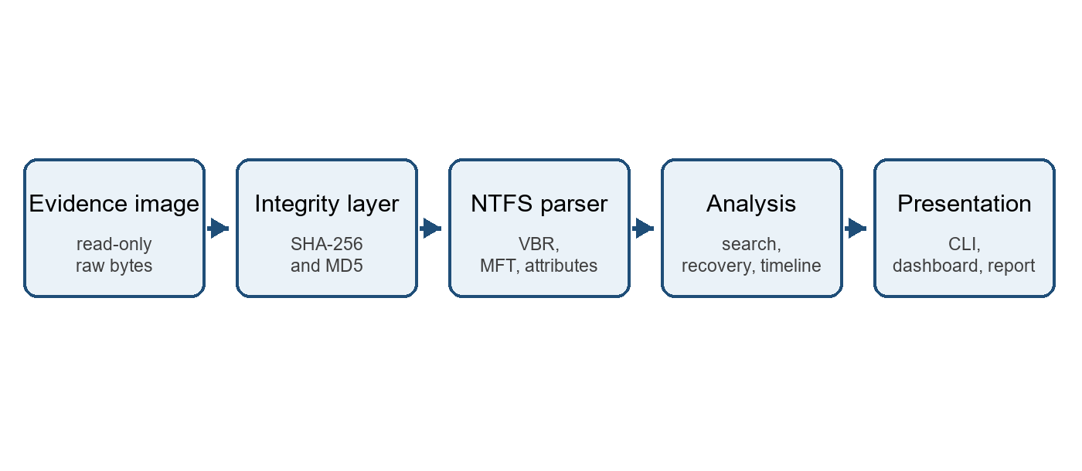
Figure 1 System architecture from evidence input to investigator-facing output
The architecture separates integrity verification from parsing, analysis, and presentation. A CaseRecord object carries hashes and geometry forward, while parsed FileRecord objects provide a shared evidence model for search, inspection, recovery, timelines, and reports.

6 3 Algorithm
Step | Action | Output
1 | Stream image and calculate hashes | Verified case record
2 | Detect partition and parse VBR | NTFS geometry
3 | Locate and scan MFT | FileRecord collection
4 | Filter records with in-use flag cleared | Deleted candidates
5 | Extract resident bytes or follow data runs | Recovered stream
6 | Hash and compare recovered bytes | MATCH, MISMATCH, or unavailable
7 | Sort SI and FN timestamps | Chronological timeline

6 Modules and Working Procedure
Module | Responsibility
image_integrity.py | Streaming hashes, case creation, case persistence, and immutability checks
ntfs_parser.py | Partition detection, VBR geometry, fixups, MFT records, attributes, paths, and searches
recovery.py | Resident and non-resident extraction plus ground-truth comparison
timeline.py | SI and FN timestamp events, chronological ordering, and cautious interpretation
reporter.py | Self-contained HTML case report
cross_check_importer.py | Autopsy CSV and Sleuth Kit bodyfile import
cli.py | Scriptable commands and end-to-end orchestration
app.py | Interactive Streamlit investigation dashboard

6 4 Working Procedure
The end-to-end command initializes the case, scans the image, selects BUDGET_DRAFT.txt, attempts recovery, constructs the timeline, and exports the HTML report. The dashboard performs the same operations through six tabs. Both interfaces call the same forensic modules, which avoids conflicting interpretations between demonstrations and automated execution.
python src/cli.py run-all --image evidence/working_copy.raw --target-file BUDGET_DRAFT.txt --ground-truth evidence/ground_truth.json

7 Tools and Technology

7 1 Hardware Requirements
Component | Minimum requirement | Laboratory use
Processor | 64-bit dual-core | Any recent Intel or AMD processor
RAM | 4 GB | 8 GB recommended for larger images
Storage | Project plus evidence capacity | At least 1 GB free for this case
Display | 1366 by 768 | 1600 by 900 or higher for dashboard review
Peripherals | Keyboard and pointing device | External write blocker for real evidence

7 2 Software Requirements
Category | Technology
Operating system | Windows 10 or Windows 11
Programming language | Python 3.10 or later
Framework | Streamlit
Data presentation | pandas and Rich
Testing | pytest
Development tools | Visual Studio Code or another Python IDE; PowerShell
Database | Not required; case records use JSON
Optional cross-check | Autopsy or The Sleuth Kit exports

The core parser uses Python's standard binary I/O and struct facilities, avoiding a required compiled pytsk3 extension on Windows systems with application-control restrictions.

8 Implementation

8 1 Module Wise Implementation
Image intake calculates SHA-256 and MD5 without loading the complete image into memory. The parser validates the NTFS OEM signature, derives sector, cluster, and MFT record sizes, locates the MFT, restores sector-boundary bytes through the Update Sequence Array, and walks attributes until the end marker. Standard Information and File Name attributes supply two timestamp sets; the Data attribute supplies either resident bytes or a non-resident runlist.
The recovery module writes extracted bytes only under outputs/recovered/<case-id>. It calculates hashes immediately and returns an explicit status. MATCH means the recovered SHA-256 equals the recorded ground truth; MISMATCH indicates different bytes; NOT_AVAILABLE avoids a false success when content or a baseline is missing.
The timeline module converts parsed timestamps into a normalized event list. The reporter converts case data, target metadata, recovery results, and timeline events into a self-contained HTML file. The dashboard exposes the workflow in six tabs and keeps case state in the active Streamlit session.

8 2 Validation Controls
- Evidence image opened only in binary read-only mode.
- Master and working-copy SHA-256 values compared before interpretation.
- Recovery output written outside the evidence directory.
- Target recovery checked against a pre-deletion SHA-256 baseline.
- Fifteen automated tests cover integrity, parsing, recovery, timeline, reporting, and imports.

8 Implementation Screenshots
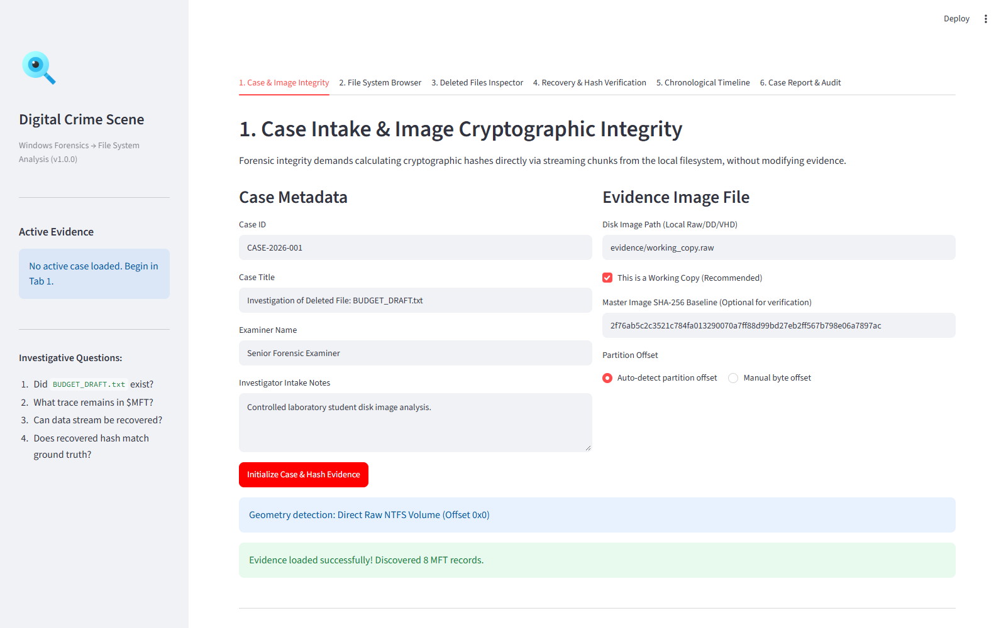
Figure 2 Case intake and evidence hashing after successful image loading
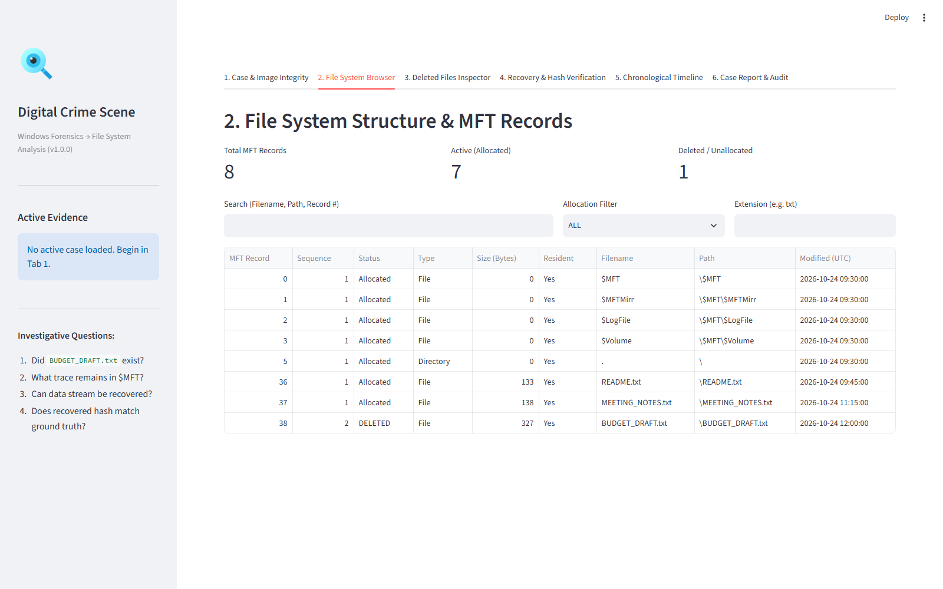
Figure 3 MFT browser showing eight records and one deleted entry

8 Deleted File Inspection and Recovery
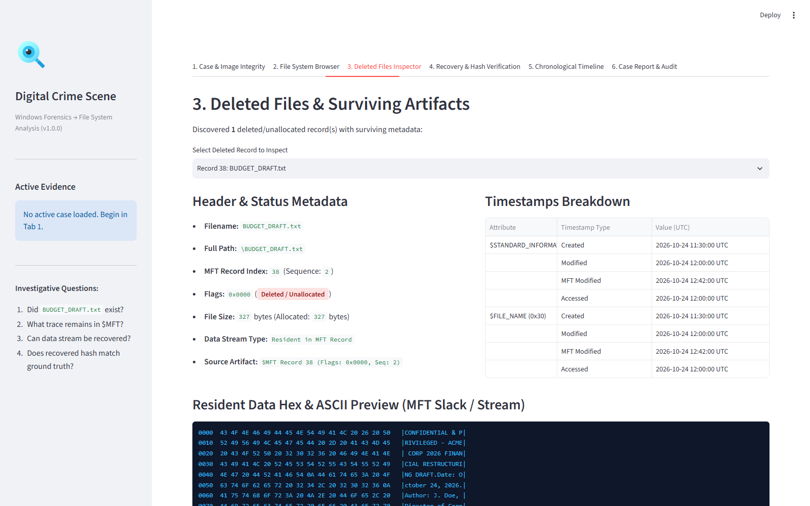
Figure 4 Deleted Record 38 metadata, timestamps, and resident data preview
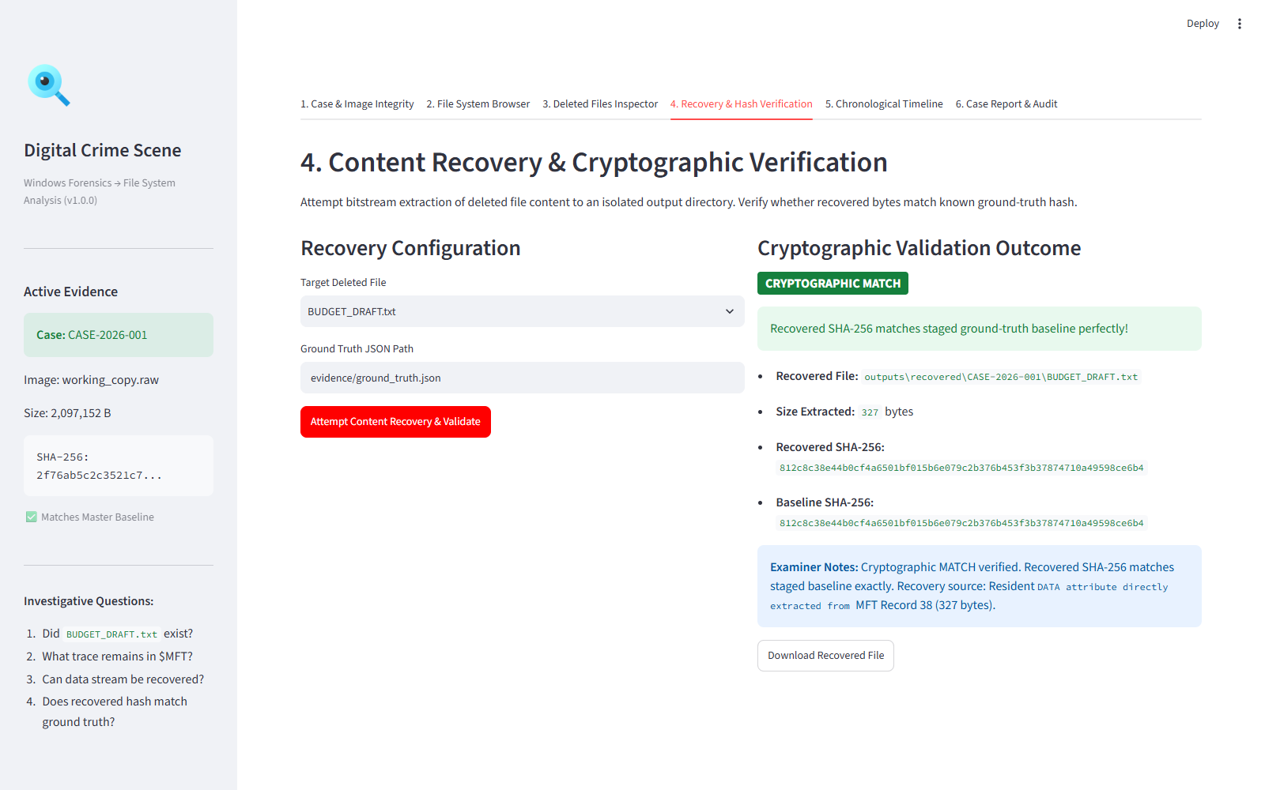
Figure 5 Recovery output with matching recovered and baseline SHA-256 values

8 Timeline and Report Generation
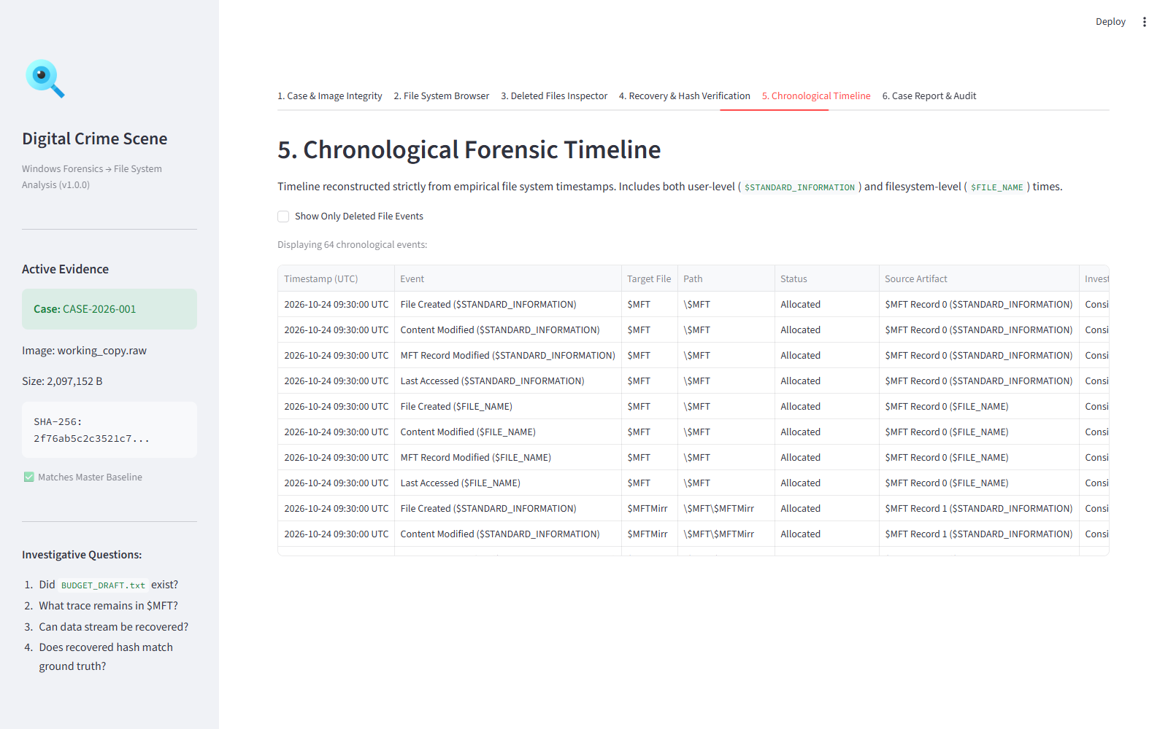
Figure 6 Chronological timeline containing 64 SI and FN timestamp events
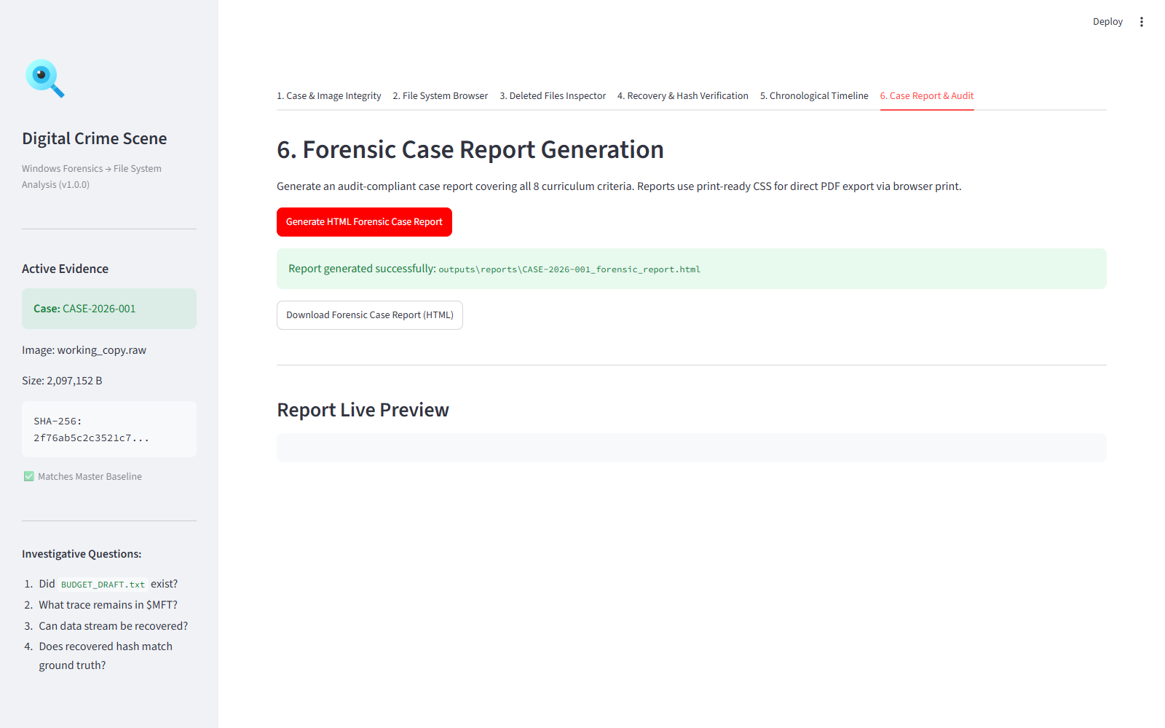
Figure 7 Successful HTML forensic case-report generation

9 Results and Discussion

9 1 Experimental Results
Forensic parameter | Measured result | Interpretation
Image integrity | SHA-256 master match | Working copy is byte-identical to baseline
Image size | 2,097,152 bytes | Controlled 2 MiB NTFS image
MFT enumeration | 8 records | 7 allocated and 1 deleted
Target | BUDGET_DRAFT.txt, Record 38 | Historical record located
Record state | Flags 0x0000; sequence 2 | In-use bit cleared
Storage | Resident DATA | Content remained inside the MFT record
Recovered size | 327 bytes | All expected bytes extracted
SHA-256 | 812c8c38e44b0cf4a6501bf015b6e079c2b376b453f3b37874710a49598ce6b4 | Exact match with ground truth
Timeline | 64 events | SI and FN timestamps normalized
Automated tests | 15 passed | All repository tests succeeded locally

9 2 Discussion
The allocation flag proves that Record 38 was not active when examined. The surviving File Name attribute proves the target name and parent reference, and the Data attribute supplied 327 resident bytes. The matching SHA-256 demonstrates that the recovered stream is identical to the recorded original. The 12:42 UTC MFT-modified timestamp is consistent with the staged unlinking event, but NTFS does not store a dedicated deletion timestamp in this record. The report therefore treats it as a correlated file-system change.

9 Performance Analysis and Comparison

9 3 Performance Analysis
The application completed the controlled case without loading the entire evidence image into memory. Hashing is streamed, MFT records are scanned by fixed-size reads, and only selected content is written during recovery. For the 2 MiB image, the complete workflow enumerated eight records, generated 64 timeline events, recovered 327 bytes, and produced both HTML and Word reports. These measurements show correct behavior at laboratory scale; they do not establish production performance on multi-terabyte media.

9 4 Comparison with Existing Methods
Approach | Strength | Constraint | Project relationship
Manual hex analysis | Maximum visibility into raw bytes | Slow and error-prone | Parser automates repeated structure decoding
Autopsy | Mature case workflow and broad artifact support | Large suite; internals may be less visible to students | CSV importer supports independent cross-checks
The Sleuth Kit | Established file-system and timeline tools | Command syntax and output require expertise | Bodyfile importer supports comparison
File carving | Can recover data without intact metadata | May lose names, paths, and fragmentation context | Current project uses metadata-based recovery
This project | Transparent Python code, hashes, tests, GUI, and reports | Limited NTFS feature coverage | Designed for a reproducible teaching case

The project does not replace validated forensic suites. Its contribution is a compact and inspectable workflow that shows how MFT evidence supports each conclusion and how cryptographic comparison prevents a visually plausible but incorrect recovery from being reported as successful.

10 Conclusion
The project achieved its stated objectives. It preserved a read-only evidence workflow, verified the working image against the master SHA-256 baseline, parsed the NTFS VBR and MFT, identified BUDGET_DRAFT.txt in unallocated Record 38, recovered the complete resident stream, and confirmed byte identity through matching SHA-256 and MD5 values. It also reconstructed a 64-event timeline, generated case reports, exposed the evidence through command-line and web interfaces, and passed all 15 automated tests.

10 1 Achievements
- Direct pure-Python parsing of essential NTFS structures.
- Automatic support for raw volumes and common partition offsets.
- Record-level deleted-file inspection with SI and FN timestamps.
- Cryptographically verified recovery with explicit outcome states.
- Interactive dashboard, command-line workflow, and report export.
- Automated validation and import paths for external-tool cross-checks.

10 2 Limitations
The case does not identify the user who deleted the file, prove a deletion command, or establish intent. The parser does not yet cover every NTFS feature and has been demonstrated on a small controlled image. Deleted records and clusters can be overwritten, and SSD TRIM can make recovery impossible. Operational use would require broader validation, stronger chain-of-custody controls, and support for additional artifacts.

11 Future Scope

11 1 Possible Enhancements
- Parse the USN Change Journal and selected Windows event logs for stronger event correlation.
- Support compressed, sparse, encrypted, alternate, and highly fragmented NTFS streams.
- Add E01 evidence containers and write-blocker metadata to the intake workflow.
- Introduce batch processing and indexed search for larger forensic images.
- Create a cross-tool validation harness for Autopsy and The Sleuth Kit outputs.
- Package the application as a signed Windows executable for laboratory deployment.

11 2 Future Research Directions
Future evaluation should use a matrix of controlled images that varies file size, resident state, fragmentation, overwrite position, deletion method, allocation reuse, file-system version, and storage medium. Each result should be compared against a recorded original and at least one independently validated tool. This would test whether the current conclusions generalize beyond the simple resident-file scenario.
A second direction is evidentiary correlation. Combining MFT state with USN records, Recycle Bin metadata, LNK files, prefetch, shell history, and Windows Security logs could narrow the deletion time and connect the file-system event with a user session. Such correlation must still distinguish observed facts from inference.

12 References
[1] K. Kent, S. Chevalier, T. Grance, and H. Dang, Guide to Integrating Forensic Techniques into Incident Response, NIST SP 800-86, 2006. https://doi.org/10.6028/NIST.SP.800-86
[2] Microsoft, Master File Table, Windows Developer Notes. https://learn.microsoft.com/en-us/windows/win32/devnotes/master-file-table
[3] B. Carrier, File System Forensic Analysis. Addison-Wesley Professional, 2005.
[4] J. Medeiros, NTFS Forensics A Programmers View of Raw Filesystem Data Extraction. Grayscale Research, 2008.
[5] A. Meyer and S. Roy, Do Metadata-based Deleted-File-Recovery Tools Meet NIST Guidelines, EAI Endorsed Transactions on Security and Safety, 2020. doi:10.4108/eai.13-7-2018.163091
[6] A. Sharifi, P. Shamala, C. F. M. Foozy, and A. Hussain, Recovery of Deleted Files from NTFS File System Using Digital Forensics Tools, Journal of Advanced Research in Dynamical and Control Systems, vol. 11, pp. 1049-1058, 2019.
[7] The Sleuth Kit, NTFS Implementation Notes. https://wiki.sleuthkit.org/NTFS-Implementation-Notes/
[8] Deleted File Forensics project source code and tests, C:\deleted-file-forensics, accessed 26 October 2026.
[9] Project evidence record, evidence/ground_truth.json, generated 24 October 2026.
[10] Generated case record and forensic report for CASE-2026-001, 26 October 2026.

