Submitted by: Arpita Prakash
500101990
R2142220234
Batch B7 CCVT (NH)

BAKERY MANAGEMENT SYSTEM
PART 1: Basic Implementation
- Set up a PostgreSQL container with proper configuration (environment variables, volumes)

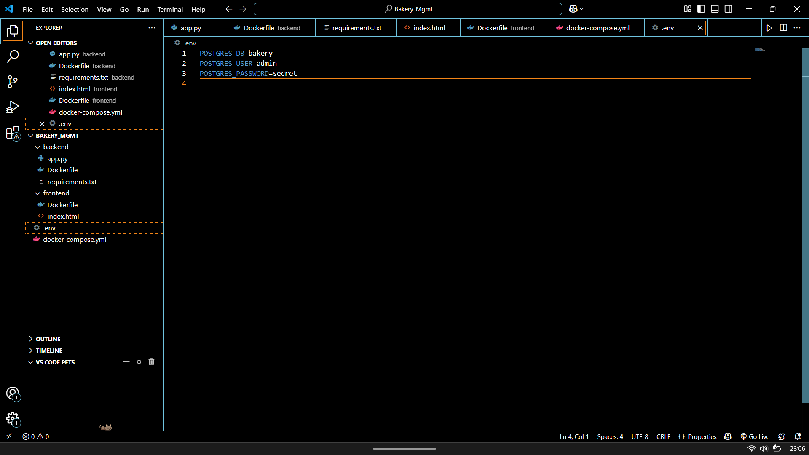
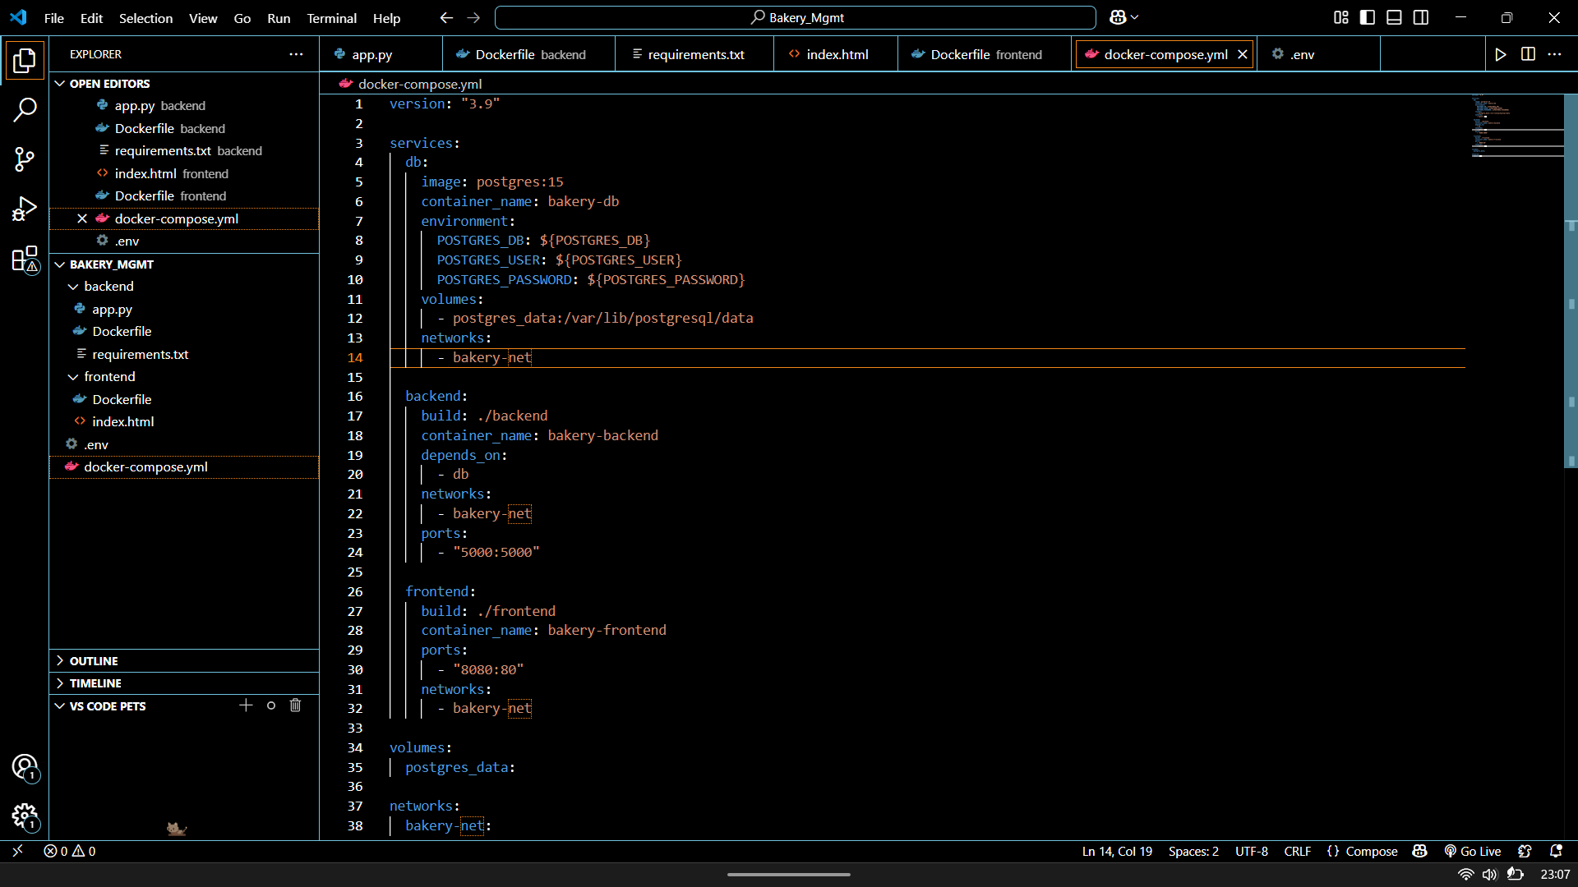


- Create a backend service with at least 3 API endpoints:
  - List all bakery products
  - Place an order
  - Check order status
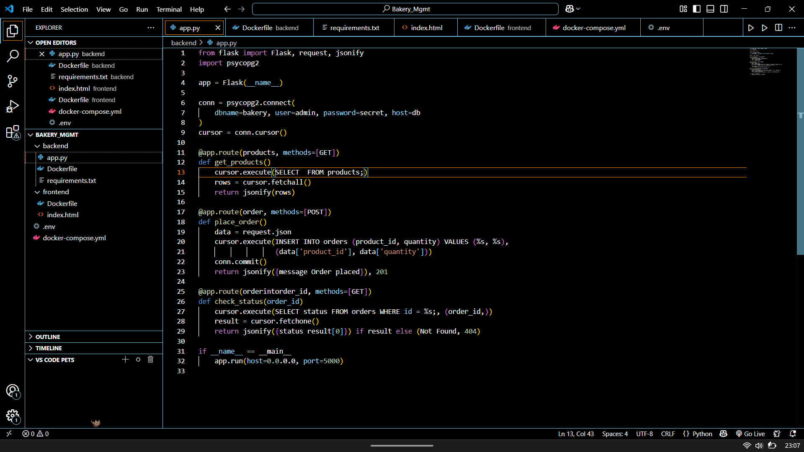
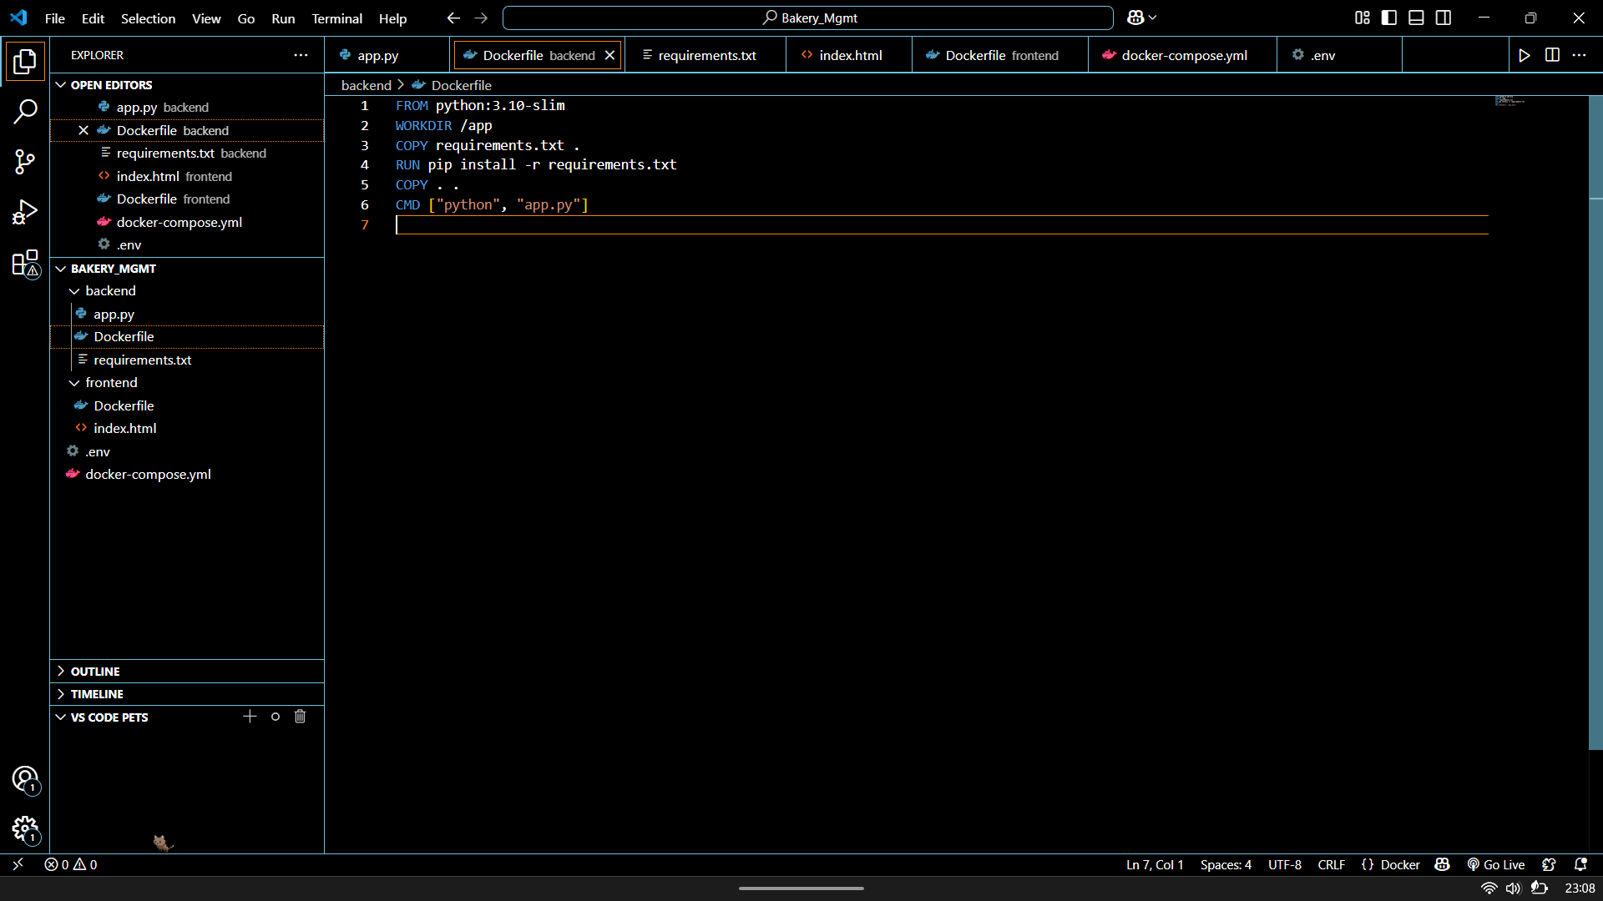
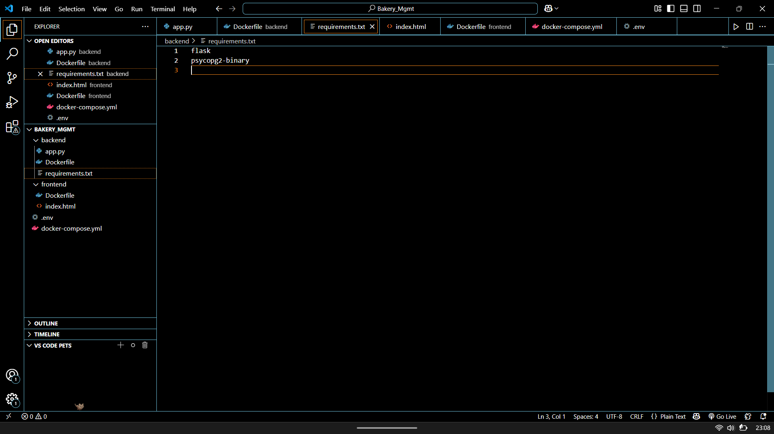

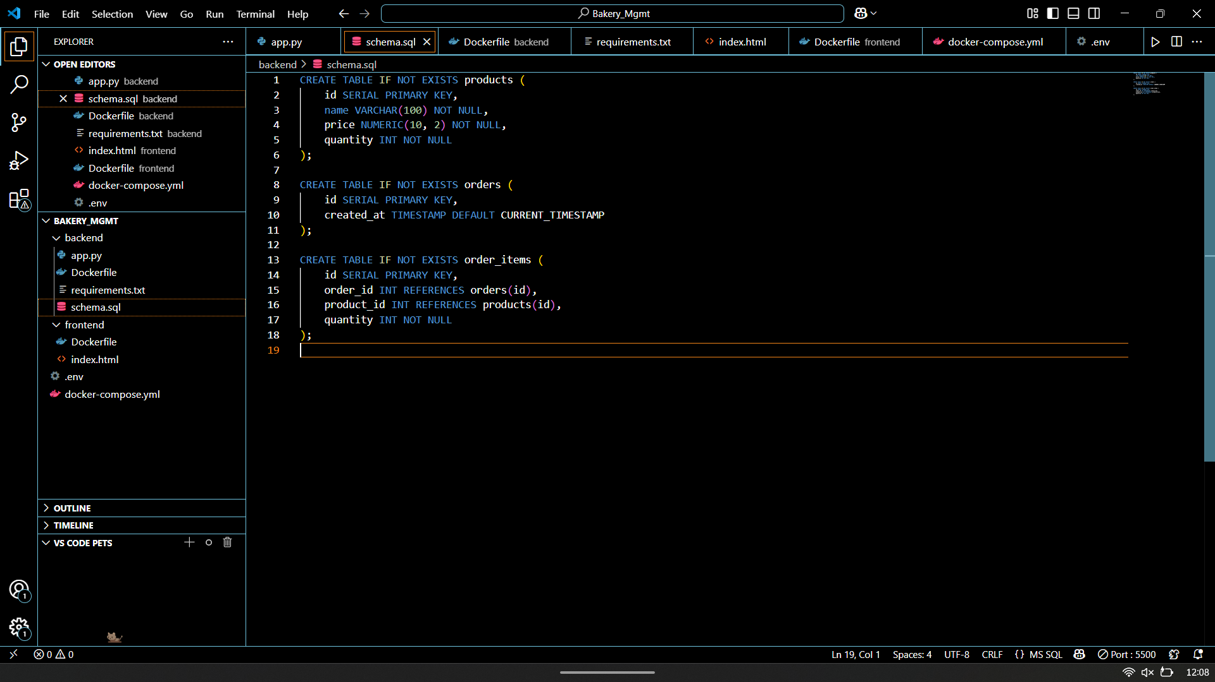
- Implement a frontend that connects to your backend
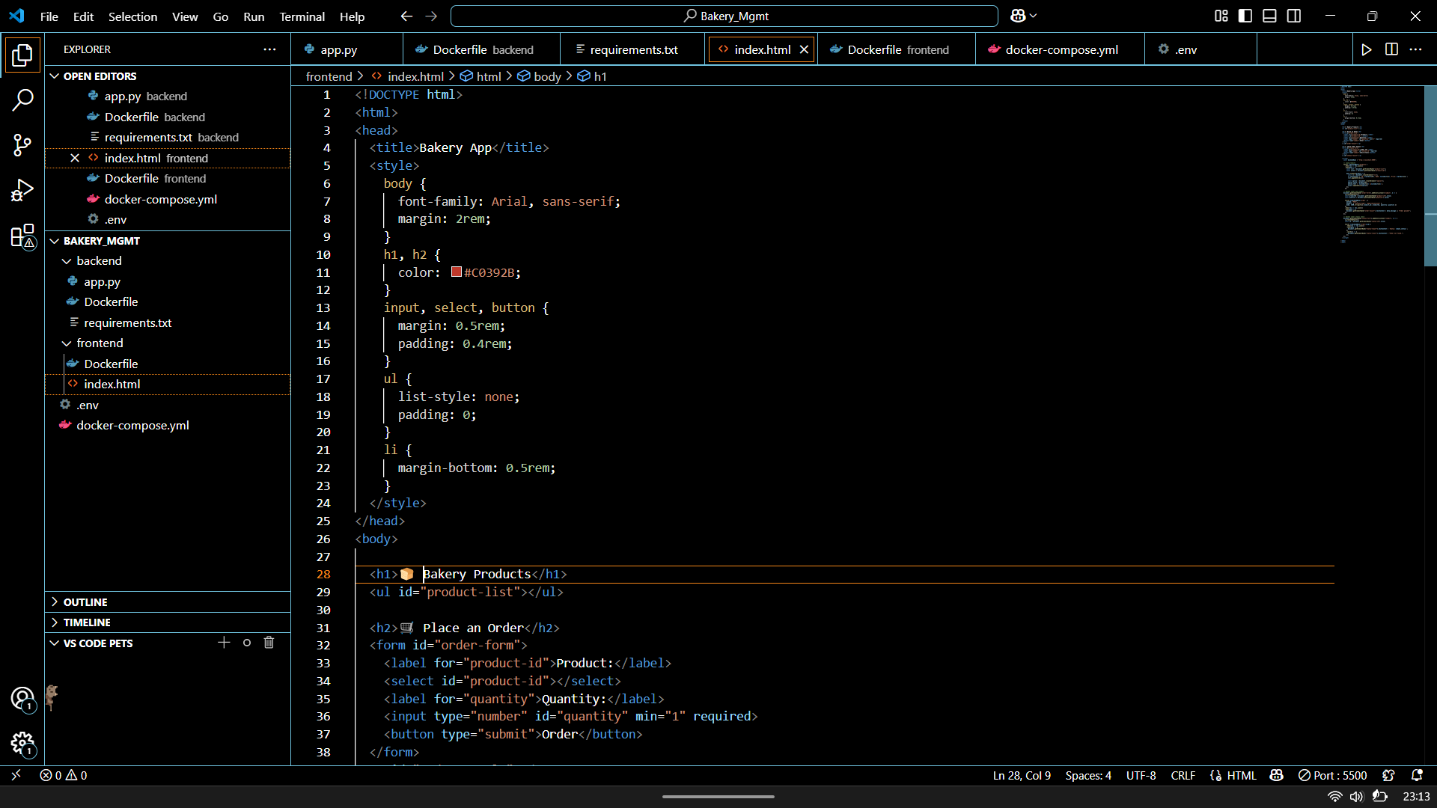
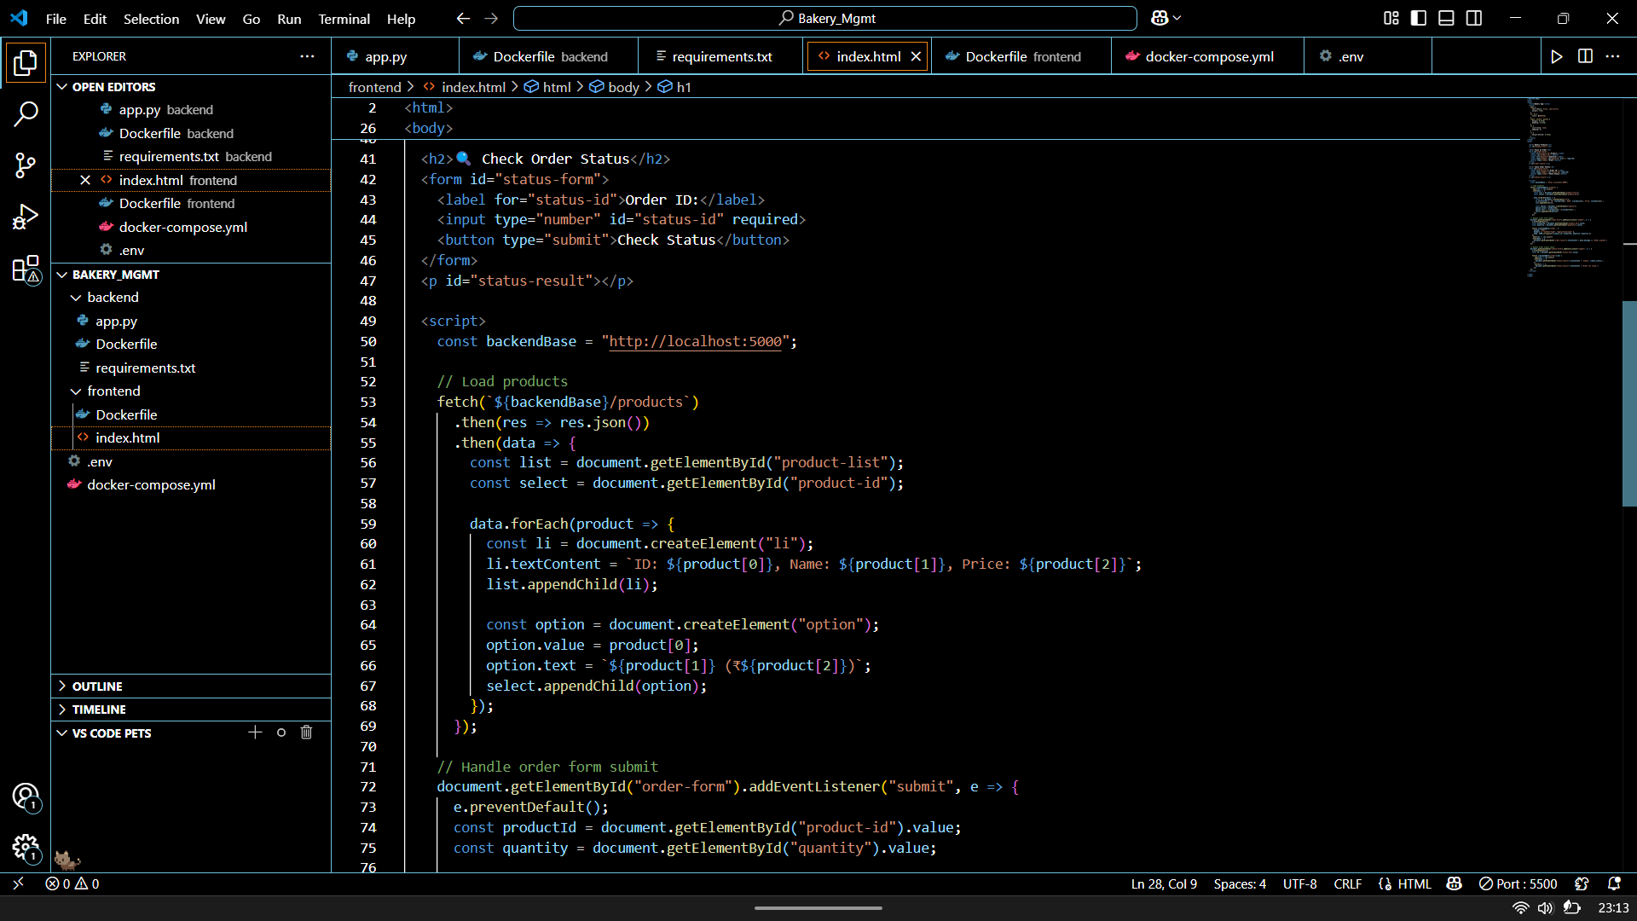
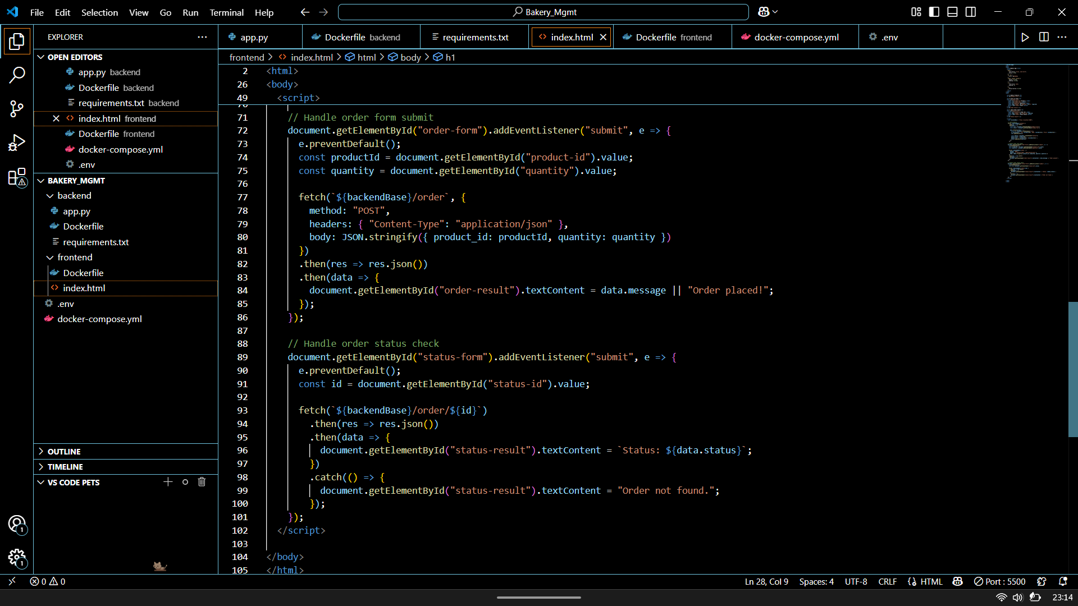
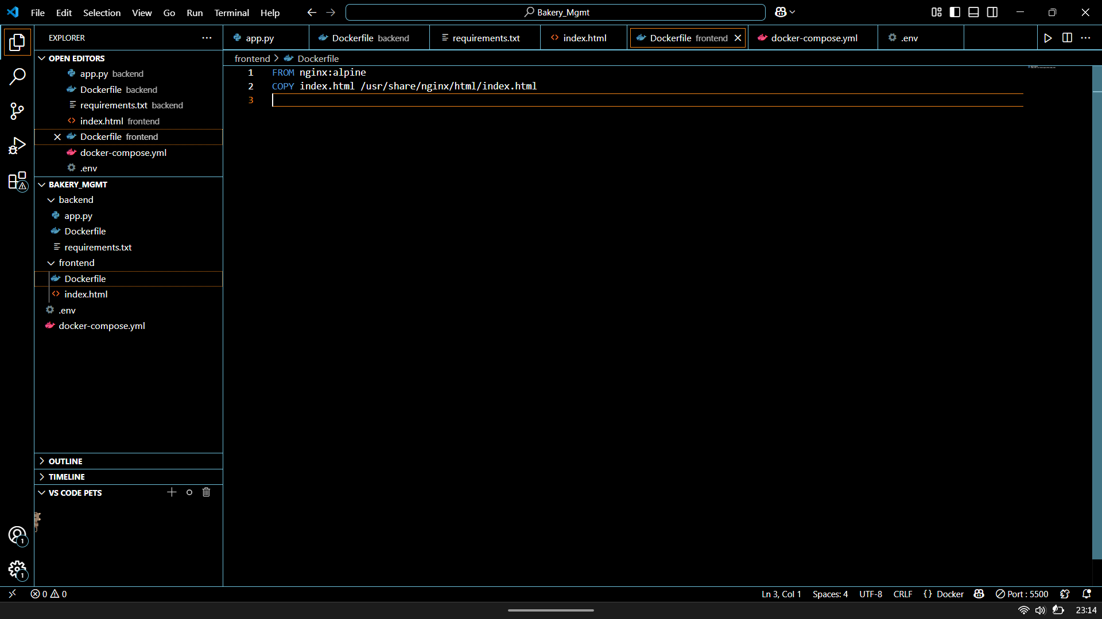

- Configure all services using Docker Compose
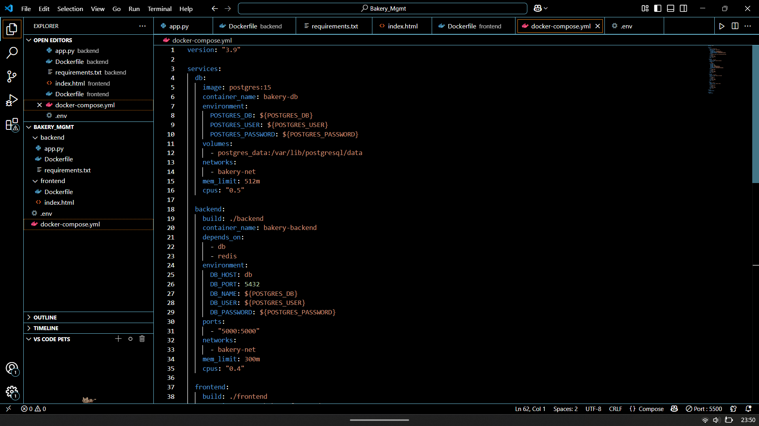
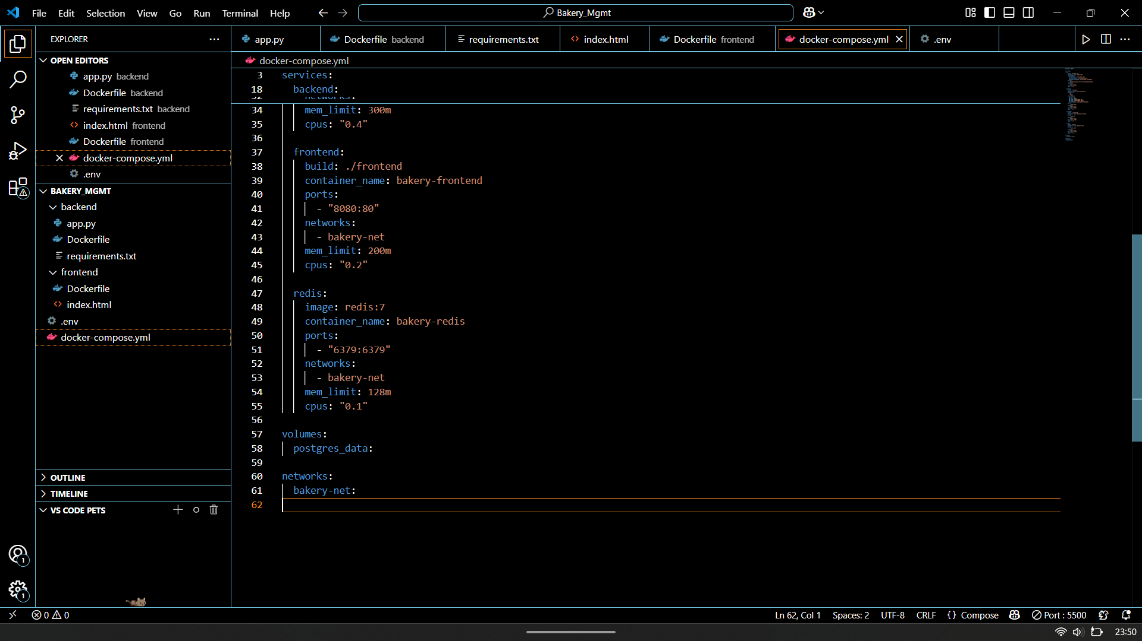
PART 2: Advanced features
- Add Redis caching for product listings
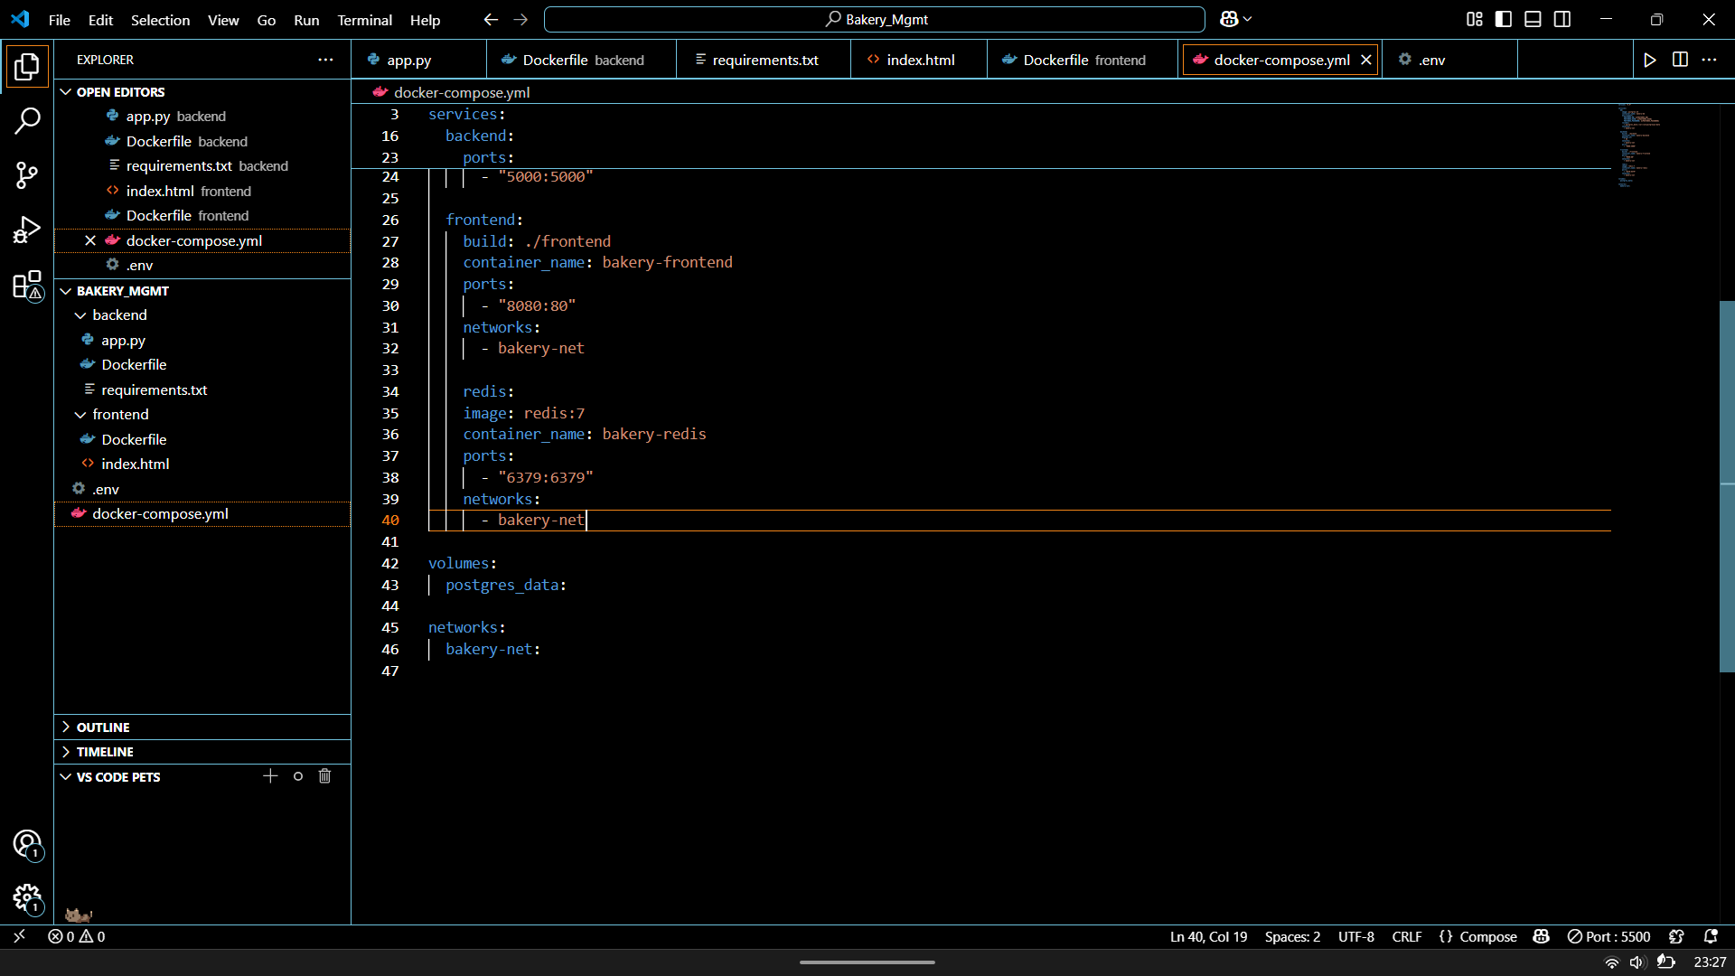
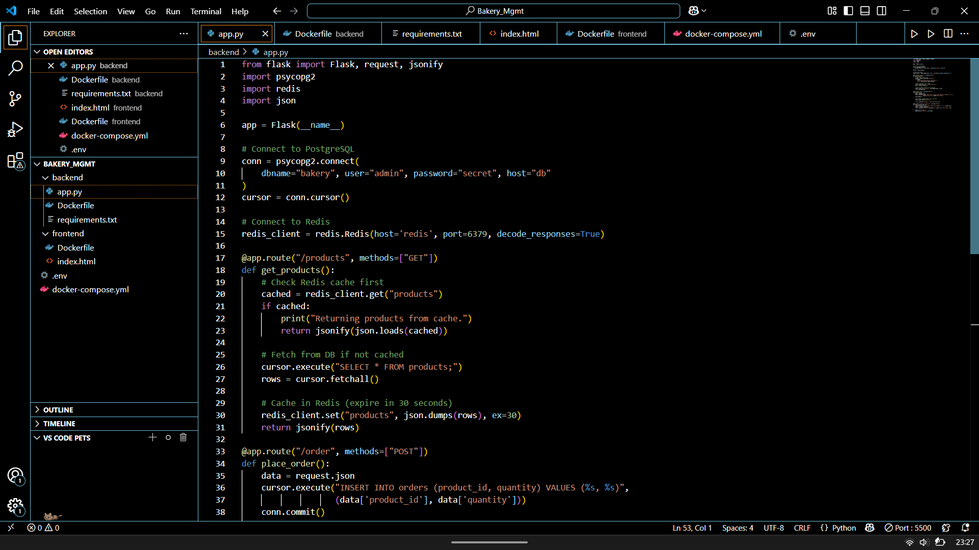
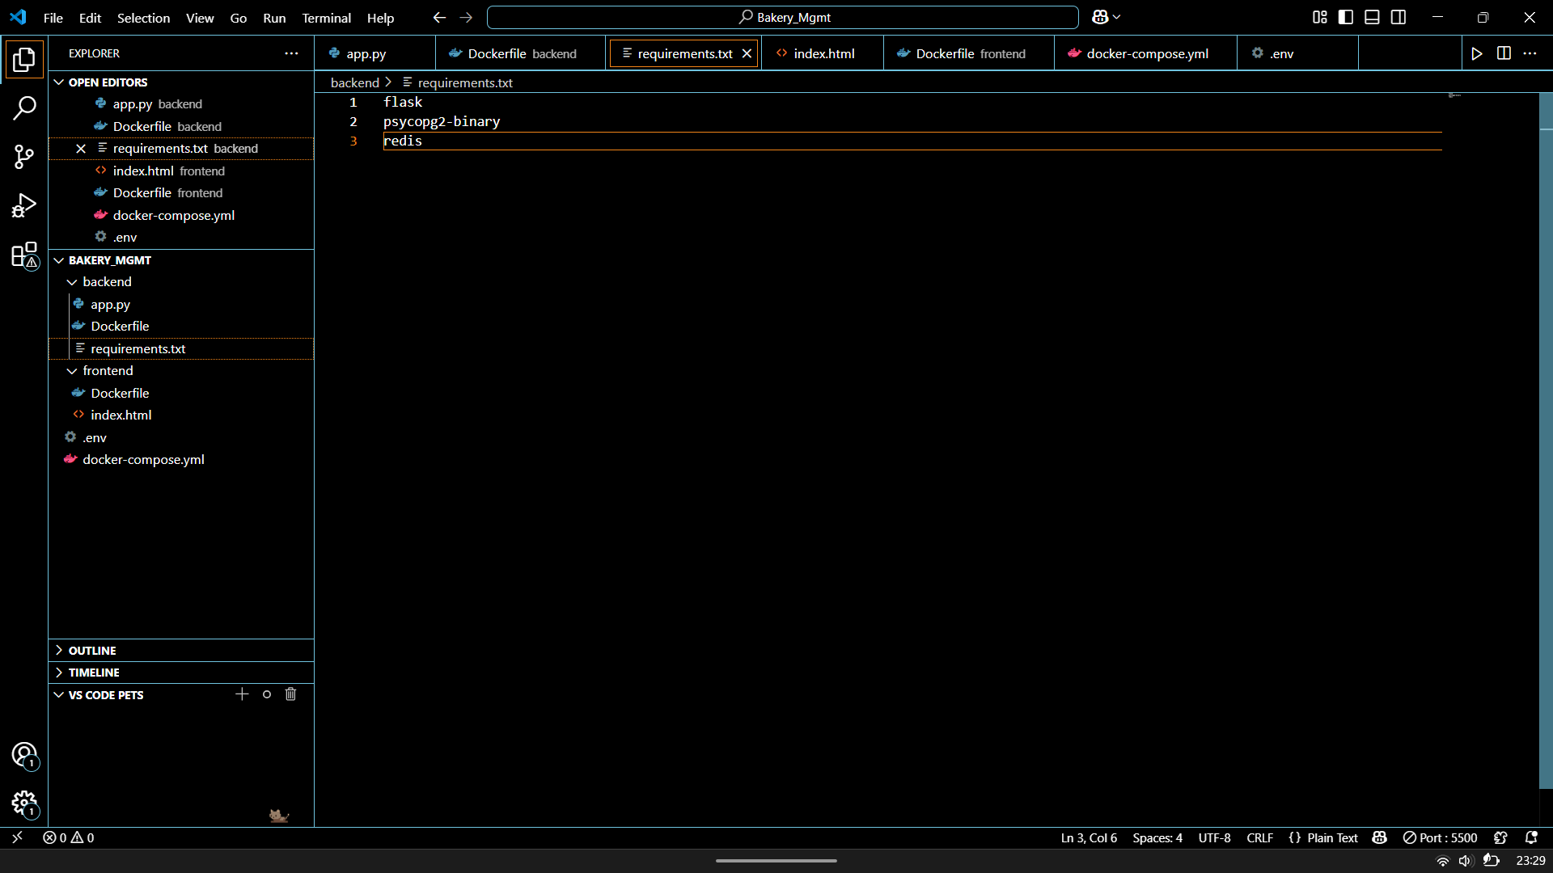

- Implement container resource limits
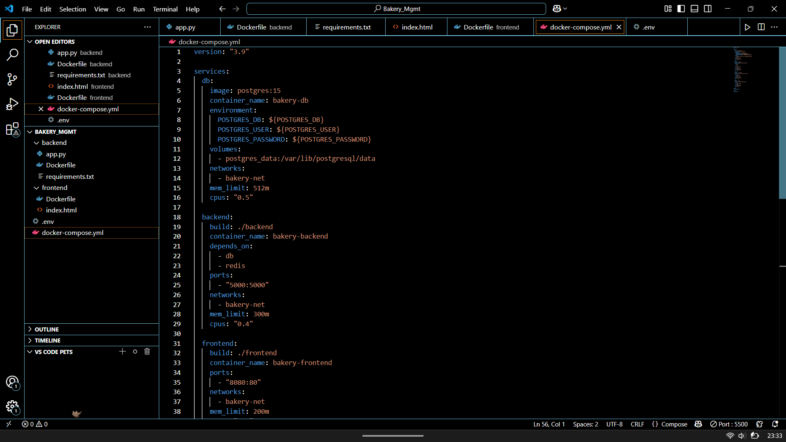
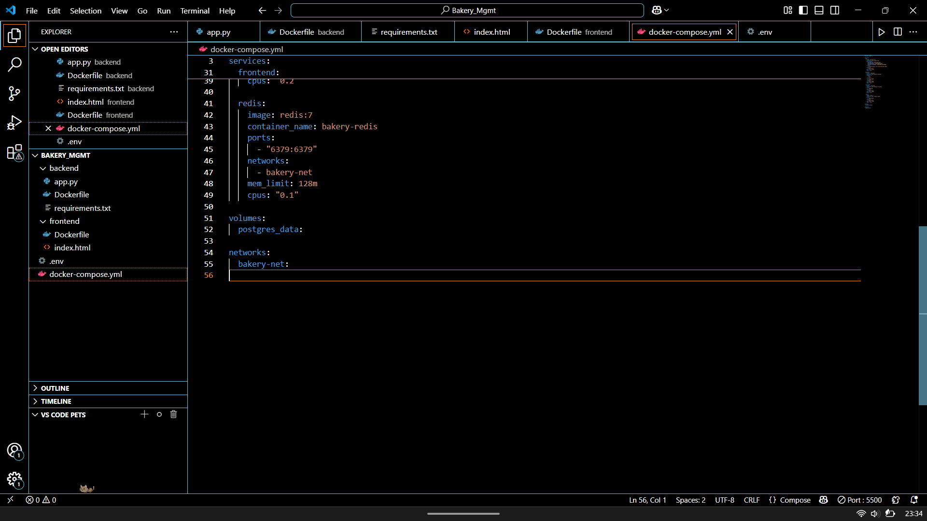

Now, the project will be build using Docker and Docker compose
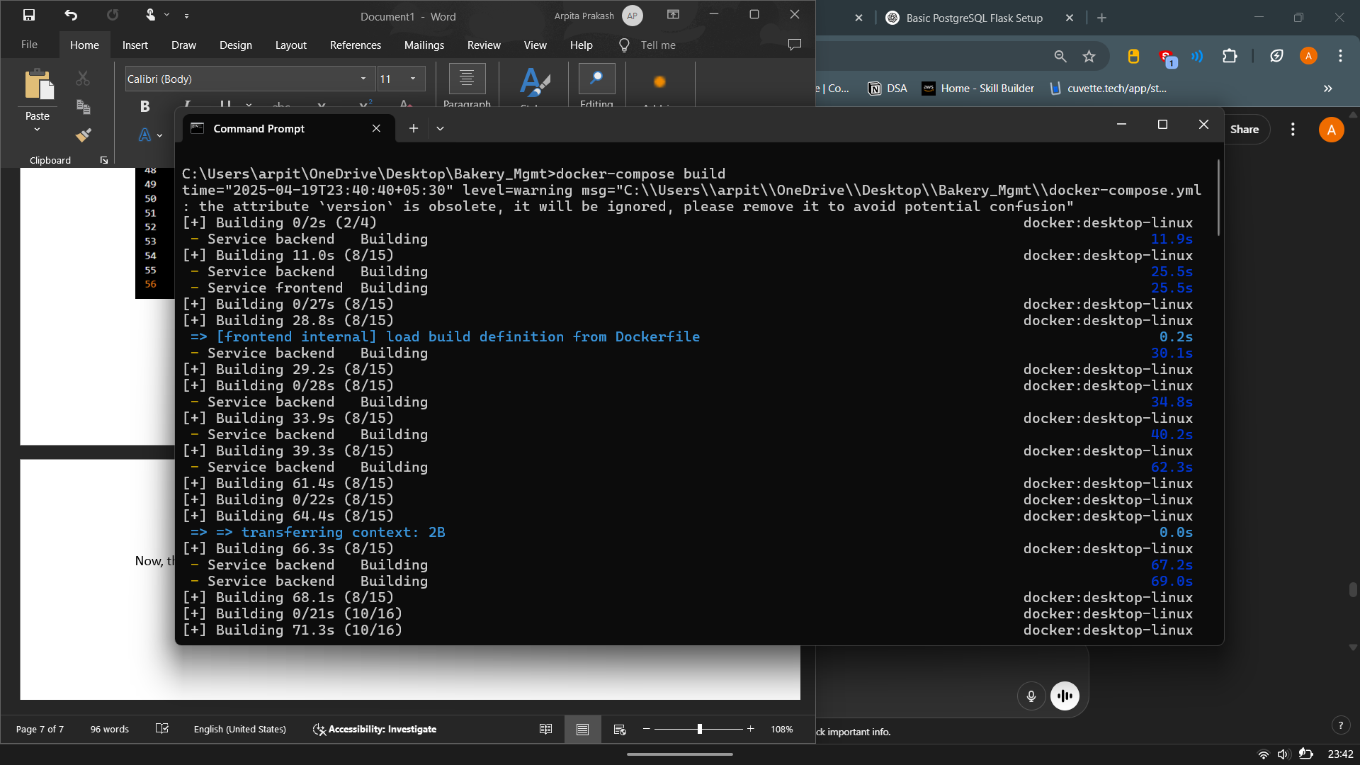
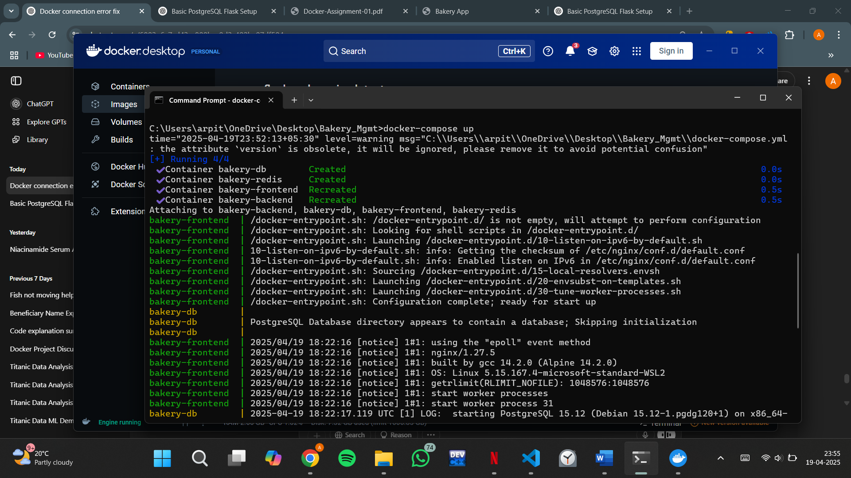
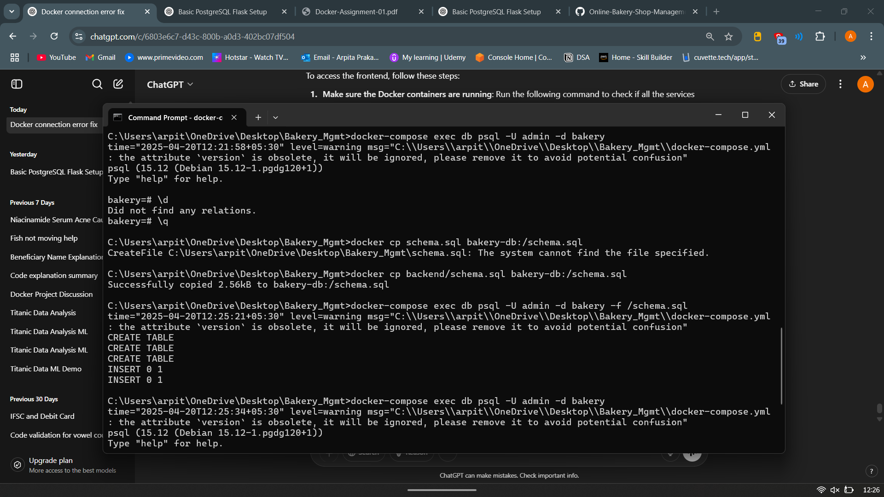
This is the front end of the bakery management system
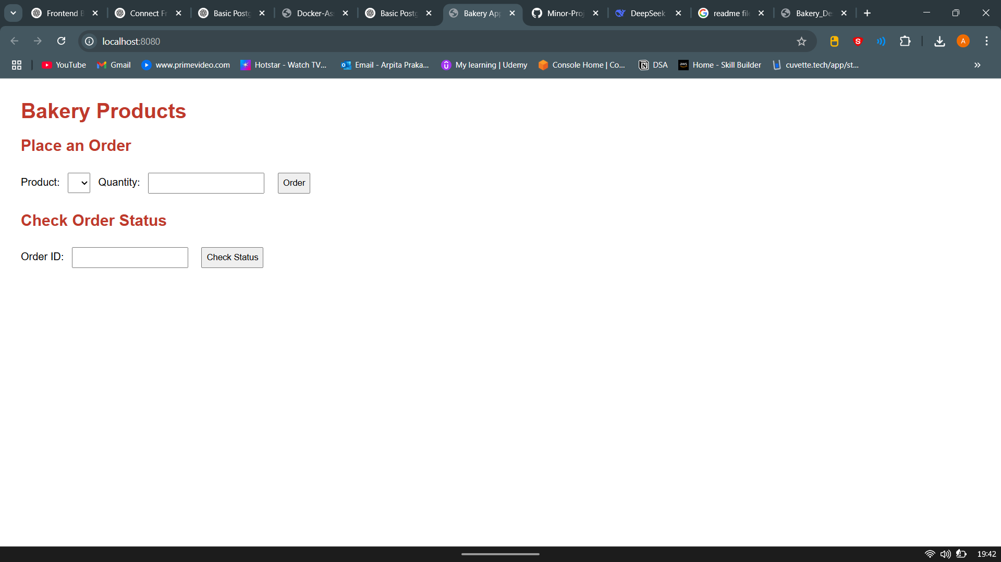
PART 3: Design Explanation
- Multi-Service Architecture
The system uses separate containers for each function (backend, frontend, database, and caching), ensuring modular design, easy maintenance, and scalability.
- Docker & Docker Compose
Docker containerizes all components, making dependency management easier. Docker Compose manages the services, enabling a simple one-command setup.
- Redis for Caching
Redis caches product listings to reduce database load, boost performance, and optimize the system.
- Resource Limits
Memory and CPU limits are set in docker-compose.yml to mimic real-world conditions and prevent overloading the system.
- Simplicity in Frontend
The frontend is minimal, using HTML served by Nginx, making it easy to test backend integration without unnecessary complexity.
- Environment Configuration
Database credentials and other settings are stored in a .env file, ensuring security and following best practices for configuration management.

