Software Requirements Specification

Version 1.0

6th September 2023

Laundry Management System

Arpit Sharma

UMD Email ID – [arpit777@umd.edu](mailto:arpit777@umd.edu)

UMD Directory ID – arpit777

Submitted in partial fulfillment

Of the requirements of

ENPM809W - Introduction to Secure Coding for Software Engineering

# Table of Contents

Table of Contents i

List of Figures ii

1.0. Introduction 1

1.1. Purpose 1

1.2. Scope of Project 1

1.3. Glossary 1

1.4. References 2

2.0. Overall Description 2

2.1 System Environment 2

2.2 Functional Requirements Specification 3

2.2.1 **User Use Cases** 3

Use case 1: Check washer availability 3

Use case 2: Check dryer availability 4

Use case 3: Update User information 4

Use case 4: Initiate washing process 5

Use case 5: Initiate drying process 5

Use case 6: Process completion notification 6

2.2.2 **Admin User Use Cases** 7

Use case 7: Read/Write/Delete Washer information 7

Use case 8: Read/Write/Delete Dryer information 8

Use case 9: Read/Write/Delete User information 8

# List of Figures

Figure 1 - System Environment 2

Figure 2 - User Use Cases 3

Figure 3 - Admin User Use Cases 7

# 1.0. Introduction

## 1.1. Purpose

The purpose of this document is to present a detailed description of the Laundry Management System. The purpose of this project is to track the availability of laundry services like washing and drying and notify the customers about the process completion. This document contains an explanation of the interfaces and the features of the system.

## 1.2. Scope of Project

This software system will be a Web Laundry Management System for a local laundry room in an apartment building. This project will alert the users in real time about the laundry services completion and will provide availability of washers and dryers in the laundry room. This will enhance the time management and centralize the process by enabling the user to initiate the laundry process through the application itself. The application will provide an easy to use interface for the user to look for available machine, start the laundry by paying through the payment portal and then get alert when the laundry is completed.

## 1.3. Glossary

|  |  |
| --- | --- |
| **Term** | **Definition** |
| Washer | The machine used to wash clothes |
| Dryer | The machine used to dry the washed clothes |
| User | The person who will use the system to perform laundry services |
| Admin User | User with admin privileges, who can create, update, delete anything in the system |
| Payment Details | The credit/debit card details of the user using the laundry management system |
| Availability | It shows the machines which are idle, i.e. available to use. |
| Cost | The amount deducted from the user account to use the laundry service like washing or drying. |
| PII | Personally Identifiable Information of the user like email id, phone number, name, date of birth etc. |

## 1.4. References

IEEE. *IEEE Std 830-1998 IEEE Recommended Practice for Software Requirements Specifications.* IEEE Computer Society, 1998.

# 2.0. Overall Description

## 2.1 System Environment

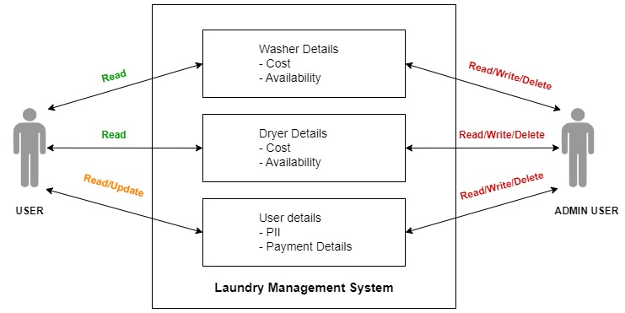

Figure - System Environment

The Laundry Management System has two active actors and one cooperating system. The User and Admin User accesses the Resident portal through the Internet and interact with the application.

The user can view washer and dryer information and availability. The user can also read/update the user’s PII and payment details.

The admin user on the other hand can Read/Write/Delete everything in the application like washer information, dryer information and any user information.

## 2.2 Functional Requirements Specification

This section outlines the use cases for each of the active readers separately. The user and the admin user.

### 2.2.1 **User Use Cases**

The User has the following sets of use cases:

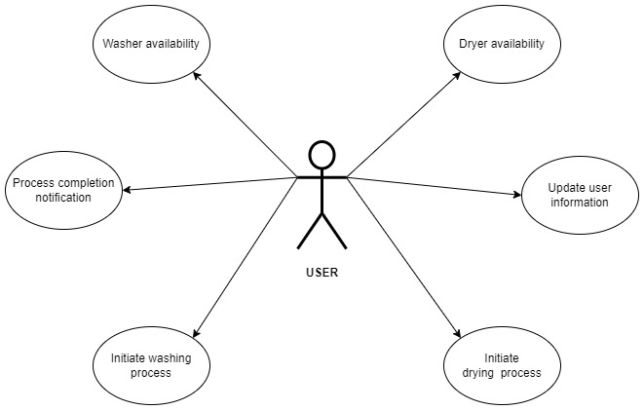

Figure - User Use Cases

#### Use case 1: Check washer availability

**Diagram:**

User

Washer Availability

**Brief Description**

The User signs in into the Resident Portal on Laundry management system website and then checks the availability of the washer.

**Initial Step-By-Step Description**

The user must sign up for the application and provide the details of the laundry room and payment information as well.

1. The user signs into the resident portal on laundry management system application
2. The user can see the availability of the washers in the laundry room as provided by the application.

#### Use case 2: Check dryer availability

**Diagram:**

User

Dryer Availability

**Brief Description**

The User signs in into the Resident Portal on Laundry management system website and then checks the availability of the dryer.

**Initial Step-By-Step Description**

The user must sign up for the application and provide the details of the laundry room and payment information as well.

1. The user signs into the resident portal on laundry management system application
2. The user can see the availability of the dryers in the laundry room as provided by the application.

#### Use case 3: Update User information

**Diagram:**

User

User Information

-PII and Payment

**Brief Description**

The User can provide the PII and payment details at the time of sign up.

**Initial Step-By-Step Description**

The user must sign up for the application.

1. The user signs into the resident portal on laundry management system application
2. The user can goto the profile section to update the PII and Payment information.
3. User saves the updated information.

#### Use case 4: Initiate washing process

**Diagram:**

User

Initiate washing process

**Brief Description**

The User initiates the washing process by selecting the available washing machine and then paying using the payment information stored in the application.

**Initial Step-By-Step Description**

The user must sign up for the application.

1. The user signs into the resident portal on laundry management system application
2. The user can select the available washing machine.
3. The user physically goes to the laundry room and puts all the laundry in the available machine along with the detergent.
4. The user then go to the application and go to payment and pay for the washing process.
5. The application will start the washing machine.

#### Use case 5: Initiate drying process

**Diagram:**

User

Initiate drying process

**Brief Description**

The User initiates the drying process by selecting the available dryer machine and then paying using the payment information stored in the application.

**Initial Step-By-Step Description**

The user must sign up for the application.

1. The user signs in to the resident portal on laundry management system application
2. The user can select the available dryer machine.
3. The user physically goes to the laundry room and put all the laundry in the available machine.
4. The user then goto the application and goto payment and pay for the drying process.
5. The application will start the dryer machine.

#### Use case 6: Process completion notification

**Diagram:**

User

Process completion notification

**Brief Description**

The User gets the notification once the washing/drying process has been completed.

**Initial Step-By-Step Description**

The user must sign up for the application.

1. The user signs in to the resident portal on laundry management system application
2. The user will get notification in the application once the washing/drying has been finished.

### 2.2.2 **Admin User Use Cases**

The Admin User has the following sets of use cases:

**Admin User**

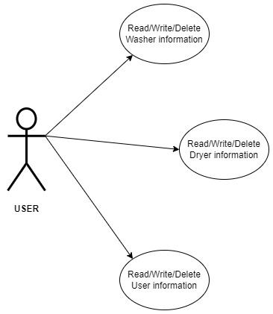

Figure - Admin User Use Cases

#### Use case 7: Read/Write/Delete Washer information

**Diagram:**

Admin user

Read/Write/Delete Washer information

**Brief Description**

The Admin User can Read/Write/Delete Washer information from the application

**Initial Step-By-Step Description**

The admin user must use the admin account to sign into the application.

1. The admin user signs in to the resident portal on laundry management system application
2. The admin user can perform any action on the washer information.

#### Use case 8: Read/Write/Delete Dryer information

**Diagram:**

Admin user

Read/Write/Delete Dryer information

**Brief Description**

The Admin User can Read/Write/Delete Dryer information from the application

**Initial Step-By-Step Description**

The admin user must use the admin account to sign into the application.

1. The admin user signs in to the resident portal on laundry management system application
2. The admin user can perform any action on the dryer information.

#### Use case 9: Read/Write/Delete User information

**Diagram:**

Admin user

Read/Write/Delete User information

**Brief Description**

The Admin User can Read/Write/Delete any User information from the application

**Initial Step-By-Step Description**

The admin user must use the admin account to sign into the application.

1. The admin user signs in to the resident portal on laundry management system application
2. The admin user can perform any action on the user information.