**Title of the project : DETECTION OF DENGUE USING AI**

Subject: Artificial Intelligence

Name of the project leader : **Arpita Sarkar**

Address : **10,NABAPALLY, Kol-84**  Contact No. **9775676711**

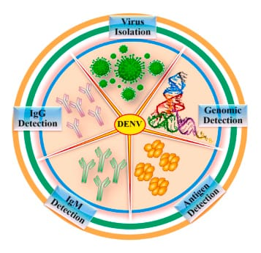

Participants in this project:

|  |  |  |
| --- | --- | --- |
| Name | Enrolment ID | Roll no |
| **Arpita Sarkar** | 2112200001098 | 20 |
| **Diya Ghosh** | 2112200001104 | 26 |
| **Isita Jana** | 2112200001106 | 28 |
| **Sneha Khan** | 2112200001125 | 44 |
| **Suparna Biswas** | 2112200001128 | 47 |
| **Trisha Samaddar** | 2112200001131 | 50 |

**Acknowledgement**

Special thanks to our esteemed teacher, Dr. Saikat Maity sir, for their invaluable guidance, expertise, and unwavering support throughout this project.His vast knowledge, extensive experience, and professional competence in ARTIFICIAL INTELLIGENCE enabled us to successfully accomplish this project. This endeavour would not have been possible without his help and supervision.This initiative would not have been a success without the contributions of each and every individual. We were always there to cheer each other on, and that is what kept us together until the end. We are also grateful to our esteemed Vice Chancellor for their encouragement and support.I’d like to thank The University of Sister Nivedita University for providing me with the opportunity to work on the project **(DETECTION OF DENGUE USING AI ).**

Signature of the Teacher :

------------------------------------

# **TABLE OF CONTENTS:- WhatsApp Image 2023-11-29 at 5.47.22 PM**

|  |  |  |
| --- | --- | --- |
| **Serial no.** | **Topic Name** | **Page No.** |
| 1. | Introduction | 4 |
| 2. | Purpose of the project, Objective | 5 |
| 3. | Goals of the project | 6 |
| 4. | Summury | 7 |
| 5. | Cause of Dengue | 8 |
| 6. | Common symptoms of Dengue Fever | 9 |
| 7. | Global impact of Dengue | 10 |
| 8. | Methodology | 11,12 |
| 9. | Decision Table | 13 |
| 10. | IgG-IgM graph | 14 |
| 11. | Keywords,References | 15 |

INTRODUCTION

Laboratory diagnosis methods for confirming dengue virus infection may involve detection of the virus, viral nucleic acid, antigens or antibodies, or a combination of these techniques. After the onset of illness, the virus can be detected in serum, plasma, circulating blood cells and other tissues for 4–5 days.

Dengue fever is a mosquito-borne viral infection caused by the dengue virus. It is transmitted primarily by the Aedes mosquito and is prevalent in tropical and subtropical regions worldwide.It can lead to dengue haemorrhagic fever or dengue shock syndrome, which can be life-threatening due to severe bleeding, organ impairment, and low blood pressure. Dengue can indeed be dangerous, especially in its severe forms, but early detection and proper medical care signific.

PURPOSE OF THE PROJECT :-

To detect the circulation of specific viruses in the human or mosquito populations.

OBJECTIVE

To identify and monitor the prevalence and circulation of specific viruses within human and mosquito populations through comprehensive surveillance and diagnostic measures, aiding in the assessment of transmission patterns, disease burden, and the effectiveness of control strategies for targeted intervention and prevention of viral diseases, particularly focusing on viruses transmitted by mosquitoes.

**Goals of the Project :-**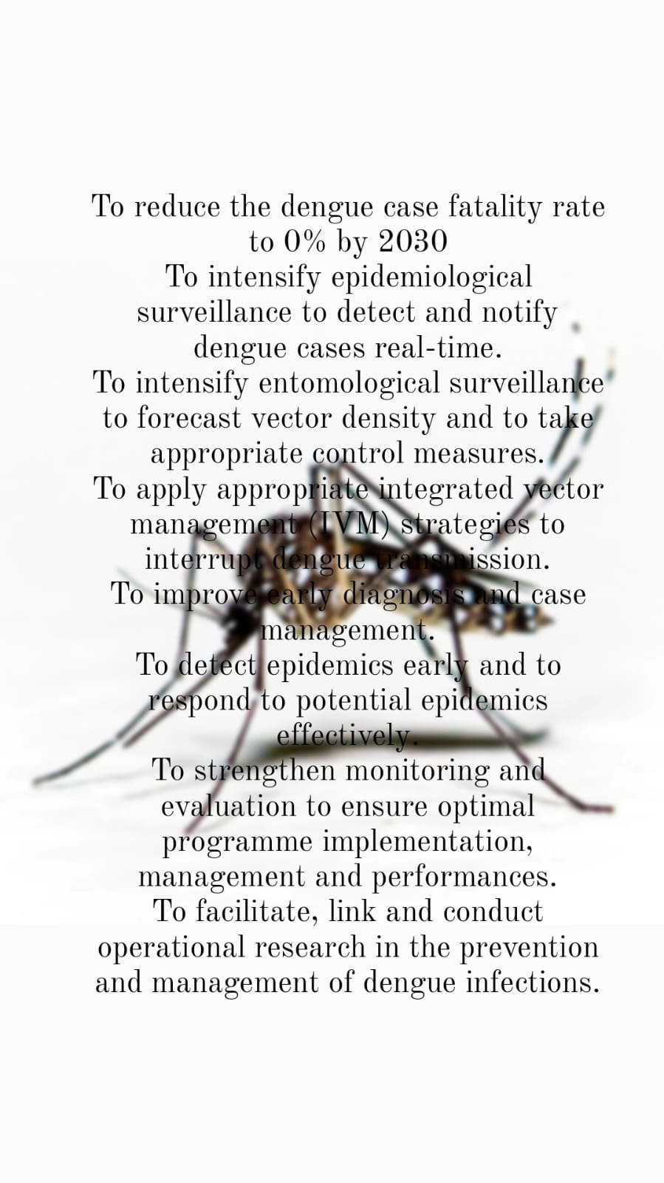

**Summary-**

Dengue is a viral infection caused by four related but distinct viruses transmitted primarily by Aedes mosquitoes. It affects millions annually, particularly in tropical and subtropical regions. The symptoms vary from mild fever, rash, and muscle pain (dengue fever) to severe and potentially fatal forms, like dengue haemorrhagic fever and dengue shock syndrome.

**Impact & Hospitalization Duration:** The duration of hospitalization for dengue patients varies. Mild cases might require only a few days, while severe cases, especially those progressing to haemorrhagic fever or shock syndrome, may need longer hospital stays for monitoring and supportive care.

**Recovery & Wellness:** There is no specific treatment for dengue, so management focuses on relieving symptoms and preventing complications. Adequate rest, hydration, and monitoring for any worsening symptoms are crucial. Patients are advised to avoid non-steroidal anti-inflammatory drugs (NSAIDs) and take acetaminophen for fever and pain relief.

**Virus & Transmission:** Dengue is caused by one of four closely related viruses: DEN-1, DEN-2, DEN-3, and DEN-4. These viruses are transmitted to humans primarily through the bite of infected Aedes mosquitoes, primarily Aedes aegypti and, to a lesser extent, Aedes albopictus.

**Lifecycle & Transmission Source:** The Aedes mosquitoes responsible for transmitting dengue typically breed in stagnant water sources around human habitation, such as water storage containers, flower pots, and discarded tires. Controlling mosquito populations and minimizing breeding sites are critical for prevention.

Causes of dengue -

**Virus Transmission:** Dengue is caused by a virus transmitted primarily by the Aedes mosquito species, particularly Aedes aegypti. These mosquitoes become carriers of the dengue virus after biting an infected person and can then transmit it to others when they bite again.

**Four Serotypes:** There are four different but closely related dengue virus serotypes (DEN-1, DEN-2, DEN-3, DEN-4), all of which can cause the disease. Infection with one serotype doesn’t grant immunity to the others and can even lead to more severe symptoms if a person is infected with a different serotype later.

**Human-Mosquito-Human Cycle:** The transmission cycle involves mosquitoes becoming infected when they feed on a person with dengue fever. The virus then incubates in the mosquito for about 8-10 days, after which it can be transmitted to another person through a mosquito bite.

**Global Distribution:** Dengue fever occurs in tropical and subtropical regions around the world, mainly in urban and semi-urban areas. Factors such as rapid urbanization, inadequate sanitation, and increased travel contribute to the spread of the disease.

**Risk Factors:** Factors such as stagnant water (where mosquitoes breed), poor sanitation, and lack of mosquito control measures increase the risk of dengue transmission. Additionally, lack of immunity to the virus and prior exposure to a different serotype can also heighten the risk of severe dengue.

**Common symptoms of dengue fever :**

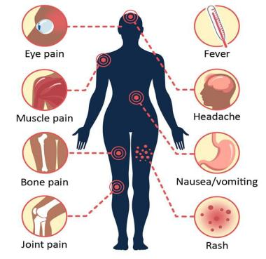

* **Sudden high fever,Abdominal pain or tenderness**
* **Severe headache, often behind the eyes**
* **Pain in muscles and joints**
* **Fatigue and weakness,Decreased platelet count**
* **Nausea and vomiting**
* **Skin rash, which may appear after a few days of fever**
* **Mild bleeding from the nose or gums**

**Global impact of dengue**

Dengue fever has a significant global impact, affecting millions each year. It is endemic in over 100 countries, particularly in tropical and subtropical regions. The disease causes flu-like symptoms but can progress to severe dengue, leading to hospitalizations and, in some cases, death. Dengue’s burden on healthcare systems, economies, and the well-being of affected communities is substantial. Efforts to control mosquito populations and improve healthcare infrastructure remain crucial in managing its impact.

*Countries facing dengue outbreaks worldwide significantly:-*

1. ***Asia:*** Countries like India, Thailand, Philippines, and Indonesia frequently experience dengue

outbreaks, with varying levels of severity based on factors like climate and population density.

1. ***South and Central America:*** Places like Brazil, Mexico, and Costa Rica have also faced significant outbreaks. For instance, Brazil experienced a severe outbreak in 2019, with over a million reported cases.
2. ***Caribbean:*** Countries like Puerto Rico and the Dominican Republic have seen periodic outbreaks. Puerto Rico, for instance, faced a substantial outbreak in 2010.

These regions have dealt with varying scales of dengue outbreaks, impacting public health systems, and prompting efforts to control mosquito populations and raise awareness to prevent further spread.

**Our Detection Methodology:-**

A total of 23 samples were collected from clinically suspected cases of dengue who either reported directly or who were referred to Peerless Hospital, Kolkata for treatment from the regions in and around Kolkata, between 15th Oct 2023 to 15th Nov, 2023 were included in the table. The cases were divided into two charts, the first chart comprised of those who are the positive patients(+) and the second chat with those who are Negative patients(-) between 1month (30days) from the onset of illness.

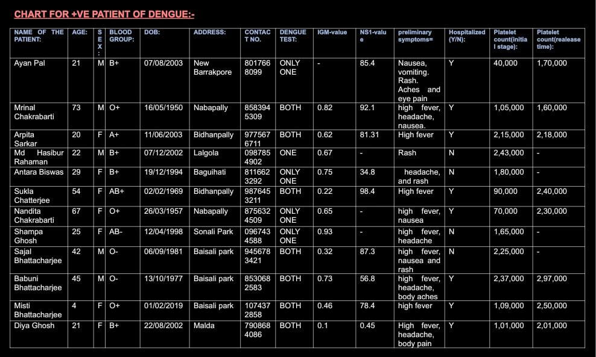

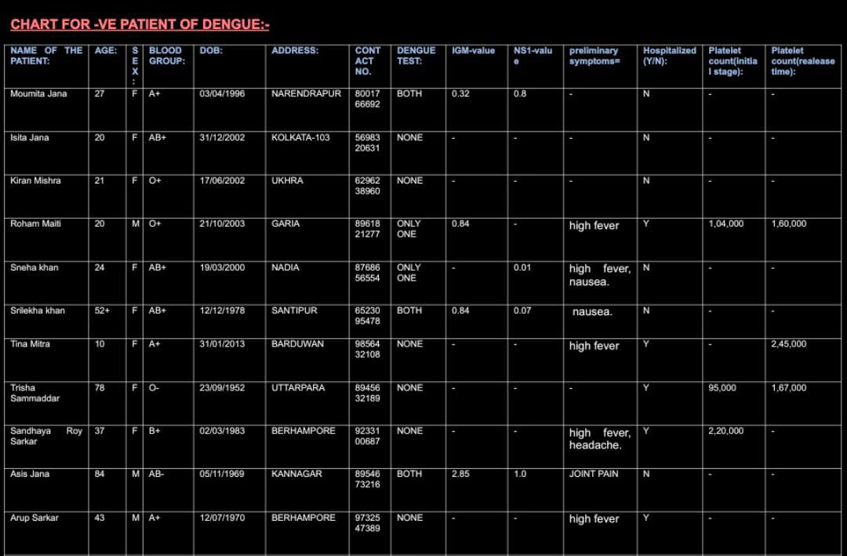

* Out of the suspected cases, 12 are positives. Day wise distribution of suspected dengue cases and positive cases during the study period is shown in Table 1. Out of 12 positive cases, 5 are males and 7 are females.
* Out of the suspected cases, 11 are Negatives. Day wise distribution of suspected dengue cases and positive cases during the study period is shown in Table 2. Out of 11 negative cases, 3 are males and 8 are females.

Decision Table :-

A decision table is a compact means of documenting the different decisions or actions to be taken in different sets of conditions. Here, we are try to give a brief visual representation for specifying which actions to perform depending on the two charts(+ve & -ve)of dengue detection conditions with the help of **Artificial Intelligence.**

**RULES :**

* R1= If NS1 <1.0 Then Result= Negative
* R2= If NS1 >=1.0 Then Result=Positive
* R3= If IGM < 1.0 Then Result= Negative
* R4= If IGM >=1.0 Then Result= Positive
* R5= If NS1 <1.0 and IGM <1.0 Then Result=Negative
* R6= If NS1<1.0 and IGM>=1.0 Then Result=Positive
* R7= If NS1>=1.0 and IGM<1.0 Then Result=Positive
* R8= If NS1>=1.0 and IGM >=1.0 Then Result=Positive

|  |  |  |  |  |  |  |  |  |
| --- | --- | --- | --- | --- | --- | --- | --- | --- |
|  | R1 | R2 | R3 | R4 | R5 | R6 | R7 | R8 |
| NS1<1.0 | Y |  |  |  | Y | Y |  |  |
| NS1>=1.0 |  | Y |  |  |  |  | Y | Y |
| IGM<1.0 |  |  | Y |  | Y |  | Y |  |
| IGM>=1.0 |  |  |  | Y |  | Y |  | Y |
| Positive |  | Y |  | Y |  | Y | Y | Y |
| Negative | Y |  | Y |  | Y |  |  |  |

Trying to draw the graph on the basis of IgG-IgM - - -

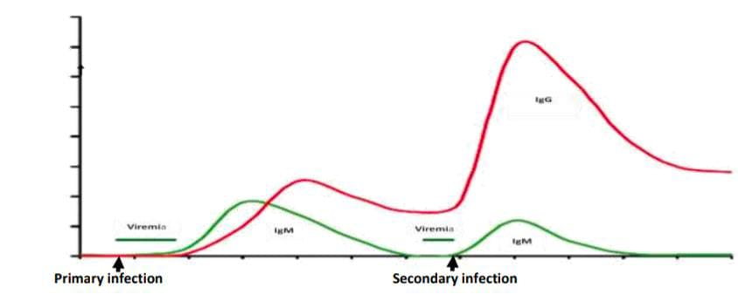

IgG = immunoglobulin G; IgM= immunoglobulin M

• Primary infection: Infected for the first time with a flavivirus

- Viraemia develops from 1– 2 days before the onset of fever until 4–5 days after

- Anti-dengue specific IgM antibodies can be detected 3-6 days after onset of fever in 50% of cases and

by days 6-10 in 95–98% of cases

- Low levels of IgM remain detectable up to one to three months after fever

- In addition, the primary infection is characterized by slowly increasing but low levels of dengue-

specific IgG, becoming elevated by days 9-10

- Low IgG levels persist for decades, an indication of a past dengue infection.

• Secondary infection:

- Rapid and higher increase of anti-dengue specific IgG antibodies

- Slower and lower levels of IgM are noticed

- High IgG levels remain for 30–40 days

- A short-lasting but higher viremia level characterizes the secondary infection compared to the

primary infection

Primary infections are characterized by high levels of IgM and low levels of IgG, while low levels of IgM with

high levels of IgG characterize secondary infections.

**Keywords:** Dengue, Survey, Kolkata, 2023, blood feeding mosquito, platelet, Viral, infection.

**References:-**

1. Academic journal articles, newspapers, graphs, charts, and google images,websites, and social media content

2. Book of **Artificial Intelligence Basics: A Non-Technical Introduction by Tom Taulli**

3. Bhatt, S., et al., The global distribution and burden of dengue. Nature, 2013. 496(7446):

p. 504–507.

4. Brady, O.J., et al., Refining the global spatial limits of dengue virus transmission by evidence-based consensus. PLOS Neglected Tropical Diseases, 2012. 6(8): p. e1760.

[](https://www.google.com/url?sa=i&url=https://collegeindia.in/college/57435-sister-nivedita-university-school-of-sciences/reviews&psig=AOvVaw2uVOYa3ivbCa8nAqN-HAaF&ust=1701400712538000&source=images&cd=vfe&opi=89978449&ved=0CBIQjRxqFwoTCKD0p4Li6oIDFQAAAAAdAAAAABAJ" \t "/Users/arpita/Documents/x/_blank)

**DEPARTMENT OF COMPUTER SCIENCE**

**AND ENGINEERING**

**(Project Leader : Arpita Sarkar)**

****

**- - - -**

**Prof.(Dr.) Saikat Maity sir**