Project Design Phase-II
Data Flow Diagram & User Stories

Date | 25 October 2026
Team ID | Individual Project
Project Name | Electric Vehicle Market Performance & Insights
Maximum Marks | 4 Marks

Data Flow Diagrams:
A Data Flow Diagram (DFD) is a traditional visual representation of the information flows within a system. A neat and clear DFD can depict the right amount of the system requirement graphically. It shows how data enters and leaves the system, what changes the information, and where data is stored.
DFD Symbol Legend
Symbol | Name | Description
Oval / Rounded  shape | External Entity | A person, organization, or system outside the project that sends or receives data (e.g., Customer, Payment Gateway).
Rectangle with  numbered header | Process | An activity that transforms incoming data into outgoing data (e.g., Validate Request, Process Order).
Rectangle (solid fill, no number) | Data Store | A place where data is held for later use (e.g., Customer Database, Inventory).
Labeled arrow | Data Flow | The movement of data between entities, processes, and data stores, labeled with what data is being passed.

Example: DFD Level 0 (Industry Standard)

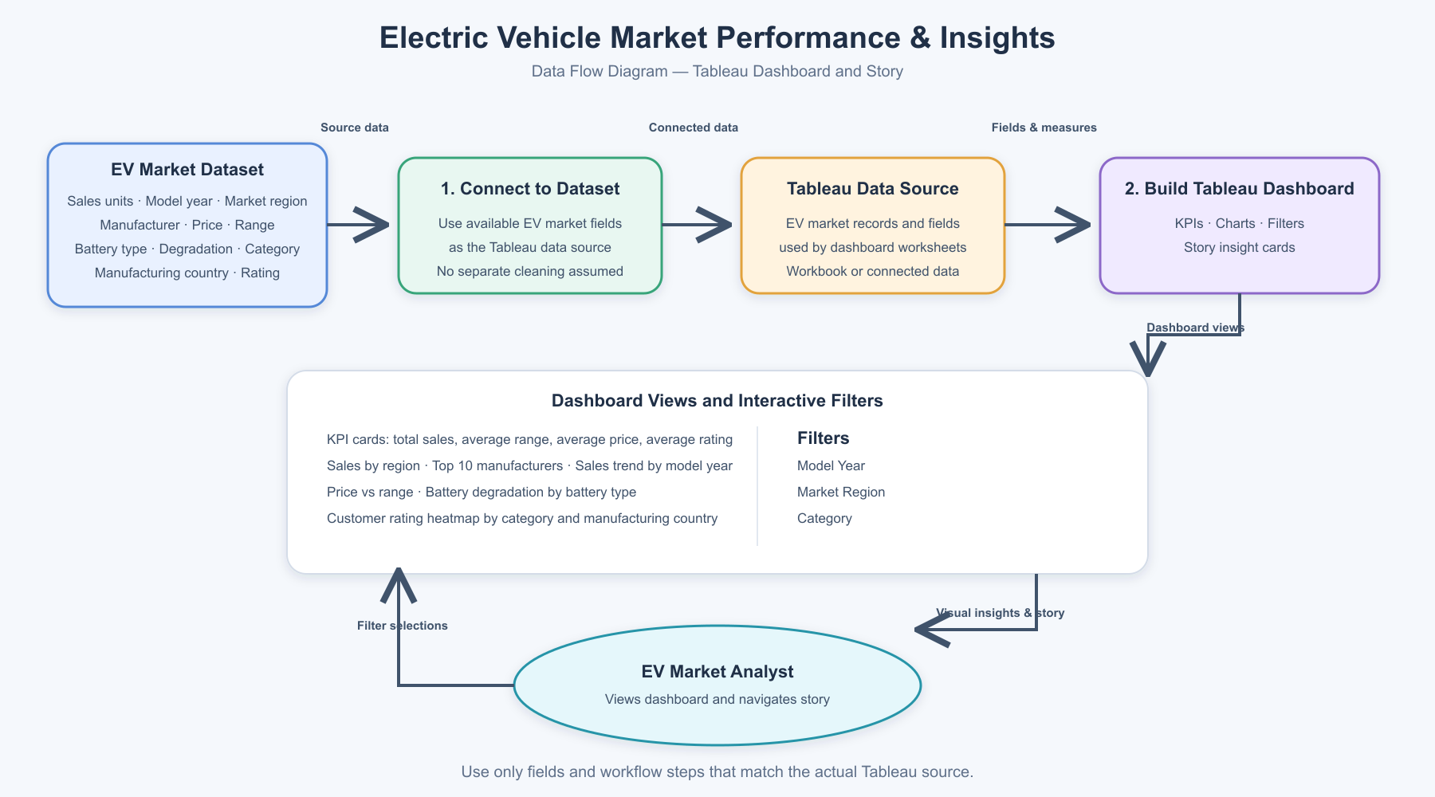
User Stories
Use the below template to list all the user stories for the product.
Epic | User Story | Acceptance Criteria | Priority
View Market Overview | As an EV market analyst, I want to see total sales units, average range, average price and average customer rating so that I can understand the overall market at a glance. | Dashboard shows the four KPI values for the selected filter state. | High
Compare Regional Sales | As an EV market analyst, I want to compare annual sales units across market regions so that I can identify regional differences. | Region chart shows each region and its sales units; filters update the view. | High
Analyse Manufacturers | As an EV market analyst, I want to see the top 10 manufacturers by annual sales units so that I can compare leading manufacturers. | Chart displays manufacturer names and sales units in ranked order. | High
Explore Sales Trends | As an EV market analyst, I want to view sales units by model year so that I can examine changes over time. | Trend chart covers the displayed model years and responds to filters. | High
Compare Price and Range | As an EV market analyst, I want to explore average price against average range so that I can compare vehicle options. | Scatter plot shows price and range values for the selected data. | Medium
Review Battery and Customer Measures | As an EV market analyst, I want to compare battery degradation by battery type and customer ratings by category and manufacturing country so that I can explore these market measures. | Battery chart shows degradation by battery type; heatmap shows ratings by category and country. | Medium
Follow the Tableau Story | As an EV market analyst, I want to move through the story cards so that I can review the dashboard’s key findings in sequence. | Story navigation lets me view the available insight cards. | Medium

