Electric Vehicle Market Performance & Insights
Submitted by: Arpita Singh
Team ID: N/A – Individual Project
Dataset Source: ev_market_train.csv
Tools Used: Tableau Public
Submission Date: 25 October 2026
1. Introduction
1.1 Project Overview
Electric Vehicle Market Performance & Insights explores EV sales and related market measures using an interactive Tableau dashboard and story. The dashboard presents four key metrics: total sales units, average range, average price, and average customer rating. Its visualizations compare sales by region and model year, the top 10 manufacturers, price and range, battery degradation by battery type, and customer ratings by vehicle category and manufacturing country. Users can explore the views using the Model Year, Market Region, and Category filters.
1.2 Purpose
The purpose of this project is to bring key EV market measures into one interactive view. The dashboard helps users compare sales patterns and explore vehicle price, range, battery degradation, and customer ratings. The findings apply to the dataset and filters used in the dashboard.
2. Ideation Phase
2.1 Problem Statement
PS-1: An EV market analyst wants to understand overall market performance and compare sales across model years, market regions, and manufacturers. Reviewing these measures across different charts can make it harder to connect the patterns quickly.
PS-2: An EV market researcher wants to compare price and range, battery degradation by battery type, and customer ratings by category and manufacturing country. Since each measure answers a different question, comparing them can take time.
2.2 Empathy Map Canvas
- Says: “I want to compare EV sales across regions and model years.” “I need to understand price, range, battery degradation, and customer ratings.”
- Thinks: “Which manufacturers have the highest sales?” “How do price and range compare?” “Which battery types show lower degradation?”
- Does: Reviews the dashboard KPIs and charts, explores the data using the Model Year, Market Region, and Category filters, and navigates through the story cards.
- Feels: Finds it easier to compare market measures when they are presented together in one dashboard.
- Pains: Comparing different measures can take time, and filter changes may affect the results.
- Needs / Gains: Clear charts for sales, manufacturers, price and range, battery degradation, and customer ratings, along with interactive filters and a story summarizing key findings.
2.3 Brainstorming
The project ideas considered were:
- Compare sales units by market region.
- Show the top 10 manufacturers by annual sales units.
- Show sales trend by model year from 2018 to 2026.
- Explore average price versus average range.
- Compare battery degradation by battery type.
- Compare customer ratings by category and manufacturing country.
The selected ideas were based on their relevance to the project and whether the required data was available.
3. Requirement Analysis
3.1 Customer Journey Map
The user opens the Tableau dashboard and reviews the KPI overview. The user then selects a Model Year, Market Region, or Category filter and compares the available charts. The user reviews the story cards to follow the key findings.
3.2 Solution Requirements
Functional requirements
- Show total sales units, average range, average price, and average customer rating.
- Show sales by region, top 10 manufacturers, and sales trend by model year.
- Show price versus range, battery degradation by battery type, and the customer rating heatmap.
- Provide Model Year, Market Region, and Category filters.
- Allow users to navigate the story insight cards.
Non-functional requirements
- The dashboard should be easy to read and navigate.
- Labels, titles, and chart formats should be clear.
- The dashboard should display results consistently.
- The project should identify its dataset source and scope.
3.3 Data Flow Diagram
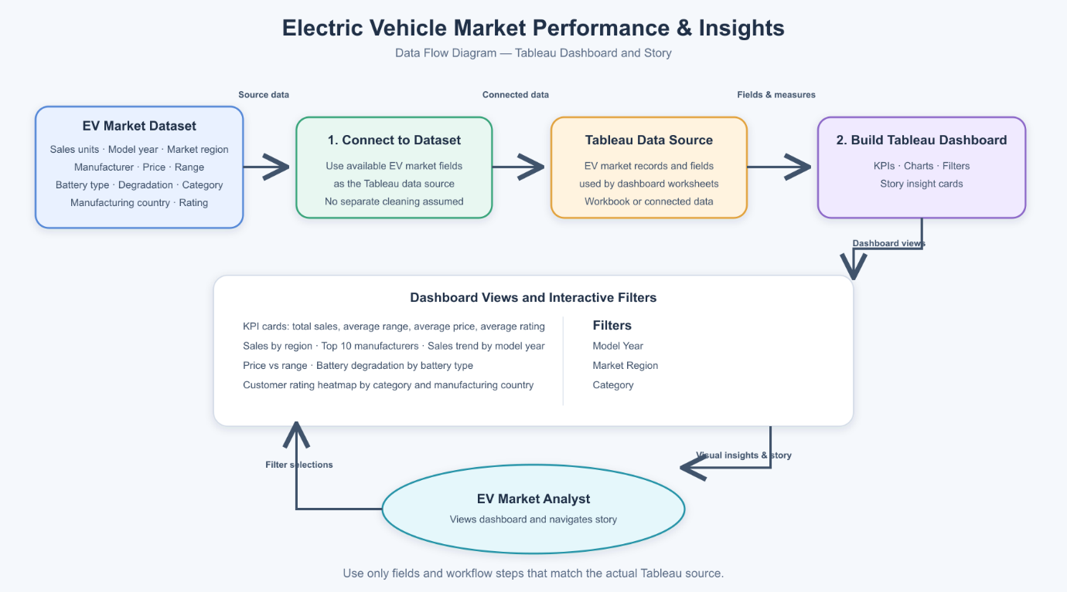
3.4 Technology Stack
Component | Technology Used | Purpose
Data source | ev_market_train.csv | Provides the EV market data for analysis
Data preparation | No separate data preparation tool used. The CSV dataset was connected to Tableau Public for analysis and visualization. | Used to review or prepare the data, if applicable
Data visualization | Tableau Public | Used to create charts and the interactive dashboard
Project documentation | Microsoft Word | Used to prepare the project report
4. Project Design
4.1 Problem–Solution Fit
EV market data includes several measures, such as sales, price, range, battery degradation, and customer ratings. Reviewing these measures separately can make it difficult to understand overall market performance and compare patterns across regions, model years, manufacturers, and vehicle categories. The Tableau dashboard brings these measures together in one interactive view, helping users explore the data through charts, KPIs, and filters.
4.2 Proposed Solution
The proposed solution is an interactive Tableau dashboard and story for exploring electric vehicle market performance. The dashboard displays key metrics, including total sales units, average range, average price, and average customer rating. It includes visualizations for sales by region, the top 10 manufacturers, sales trends by model year, price versus range, battery degradation by battery type, and customer ratings by vehicle category and manufacturing country. Users can explore the data using the Model Year, Market Region, and Category filters, then review the story cards for key insights.
4.3 Solution Architecture
The project workflow is:
ev_market_train.csv → Tableau data source/workbook → Dashboard visualizations, KPI cards, and filters → EV Market Analyst
Tableau dashboard findings → Tableau Story → EV Market Analyst
5. Project Planning & Scheduling
5.1 Project Planning
The project was organized into phases, beginning with a review of the EV dataset and selection of analysis questions. Tableau visualizations were then created and arranged in an interactive dashboard with Model Year, Market Region, and Category filters. A Tableau story was prepared to present selected findings. The final phase is to validate the dashboard results and complete the project report. No separate data preparation phase was included because no separate preparation tool was used.
Task | Description | Status
Review the dataset | Identify the source, fields, and model years available in ev_market_train.csv. | Completed
Prepare the data | Perform separate data cleaning or preparation, if required. | Not Applicable
Define analysis questions | Select questions about sales, manufacturers, price and range, battery degradation, and customer ratings | Completed
Create visualizations | Build the dashboard charts and KPI cards in Tableau Public. | Completed
Build the dashboard | Arrange the dashboard views, add the Model Year, Market Region, and Category filters, and prepare the story cards. | Completed
Review the results | Check chart labels, values, and filter behavior against the dataset. | In progress, or Completed after you verify them
Prepare the report | Add the project description, results, screenshots, and links. | Completed
6. Functional and Performance Testing
6.1 Performance Testing
The dashboard was reviewed to confirm that its charts display the selected EV data and that the available filters work as expected. The visualizations were checked against the fields and values in the dataset.
Checks performed:
- Dataset fields used in the dashboard were reviewed.
- Dashboard charts were checked for appropriate titles and labels.
- Available filters were tested
- Chart values were compared with the source data
7. Results
7.1 Output Screenshots
Figure 1: Tableau Dashboard Overview
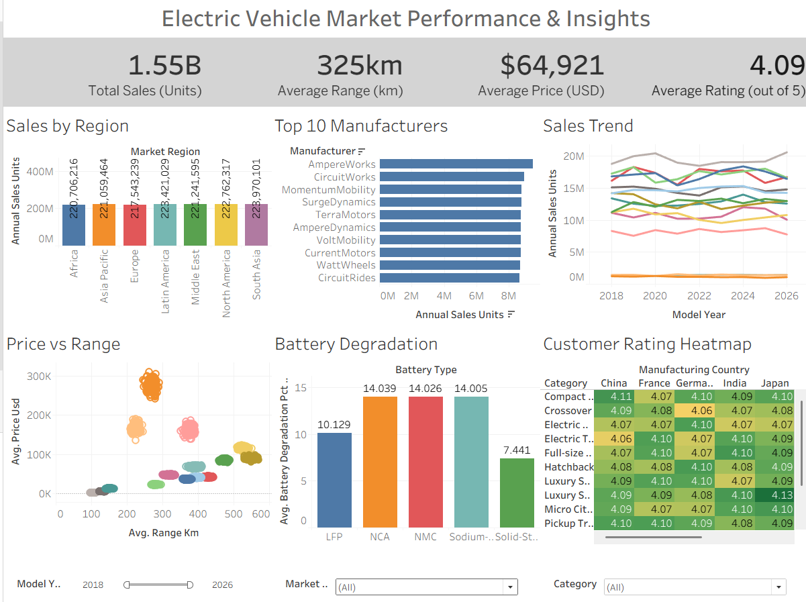
Figure 2: Sales Trend
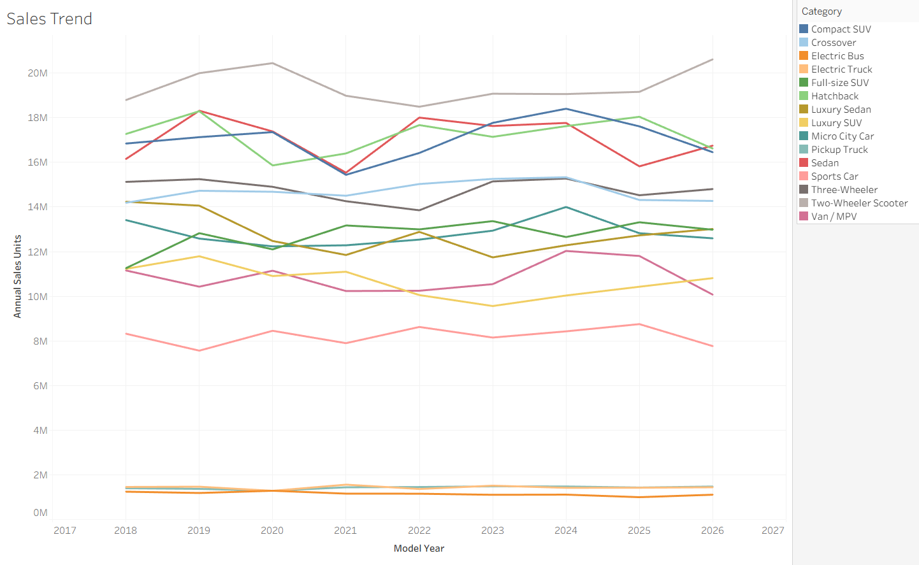
Figure 3: Battery Degradation
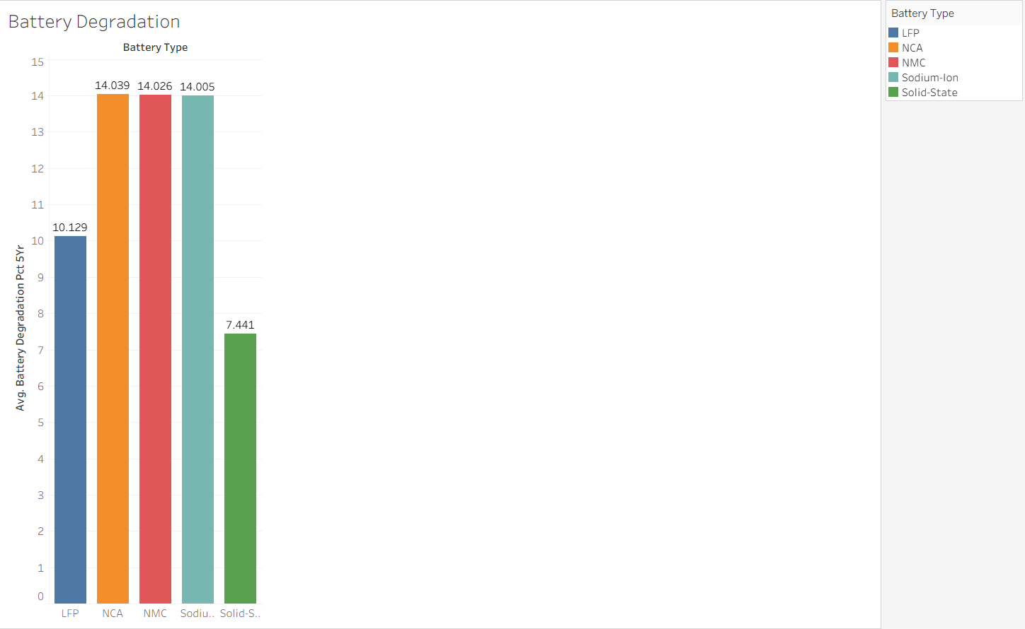
8. Advantages & Disadvantages
Advantages
- The dashboard brings key EV market metrics together in one place.
- It presents sales by region, manufacturer, and model year for easy comparison.
- The price-versus-range chart helps users explore the relationship between vehicle price and range.
- Battery degradation and customer ratings are shown across battery types, vehicle categories, and manufacturing countries.
- Model Year, Market Region, and Category filters let users explore selected parts of the data.
- The Tableau story presents selected findings in a sequence of insight cards.
Limitations
- The analysis is limited to the fields and time period available in the selected dataset.
- The dashboard reflects the dataset used for the project and may not include live or current market updates.
- Filter selections can change the displayed values, so users need to note the selected filters when interpreting results.
- The dashboard shows patterns in the data but does not explain the causes behind those patterns.
- The story screenshot contains some partially clipped text; ensure the full insight text is readable in the published version.
9. Conclusion
This project uses Tableau Public to explore electric vehicle market performance through an interactive dashboard and story. The dashboard presents key metrics for total sales, average range, average price, and average customer rating. It also enables users to examine sales by region and model year, compare manufacturers, explore price versus range, review battery degradation by type, and compare customer ratings by vehicle category and manufacturing country.
The Model Year, Market Region, and Category filters help users explore different segments of the available data. The findings should be interpreted within the scope of the dataset and the selected filters.
10. Future Scope
The project could be extended by adding more recent EV market data and additional regions, manufacturers, or vehicle attributes. Future versions could include further comparisons, such as changes in battery performance over time or customer ratings across additional categories. The dashboard could also be improved with clearer story text and additional filters, if the required data is available.
These are possible future enhancements and are not part of the current project unless they have already been implemented.

11. Appendix
- Dataset source: ev_market_train.csv (provided dataset)
- GitHub repository: https://github.com/arpitasingh-pixel/EV-Market_Performance_and_Insights
- Tableau Public dashboard: https://public.tableau.com/app/profile/arpita.singh2167/viz/EVMarketDashboard_17929405783170/EVMarketPerformanceInsights?publish=yes
- Tableau Public story: published

