Sequence Diagram for Admin Login

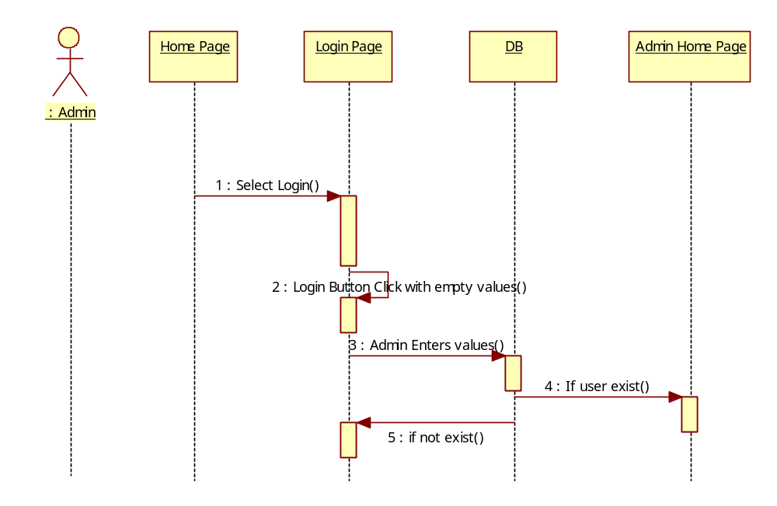

Sequence Diagram for Admin adding a country
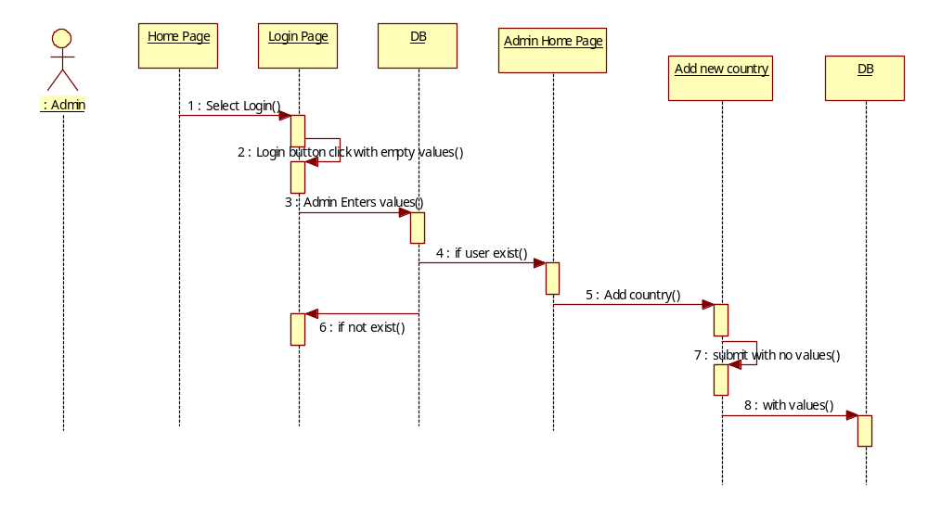

Sequence Diagram for Admin adding a state

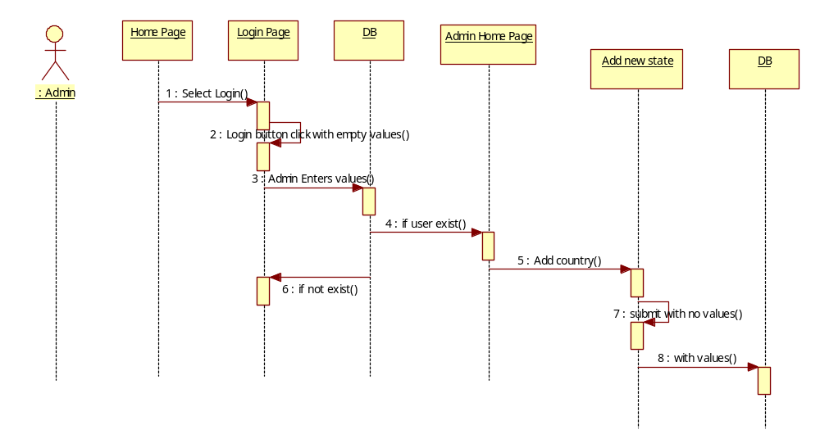

Sequence Diagram for Admin adding income

Home Page
Login Page
DB
Admin Home Page
Add income
DB
: Admin
1 : Select Login()
2 : Login button click with empty values()
3 : Admin Enters values()
4 : if user exist()
5 : Add income()
6 : if not exist()
7 : submit with no values()
8 : with values()

Sequence diagram for user Mail Checking

Home Page
Login Page
DB
User Home Page
INBOX
Mail Page
User
1 : Select Login()
2 : Login button click with empty values()
3 : Admin Enters values()
4 : if user exist()
5 : Click on Inbox()
6 : if not exist()
7 : Select a mail()

Collaboration diagram for Admin Login
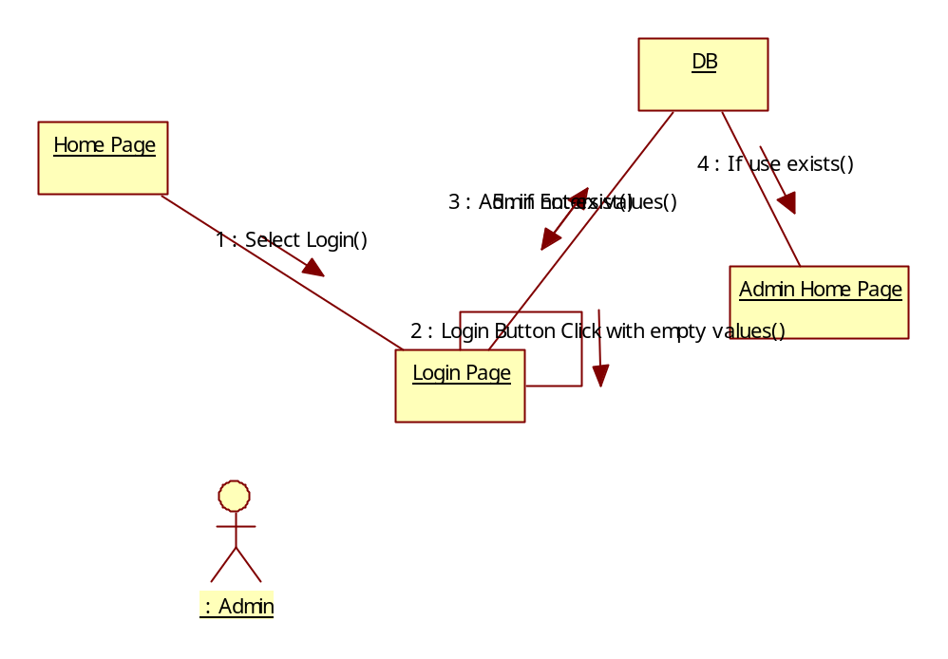

Collaboration diagram for Admin adding country

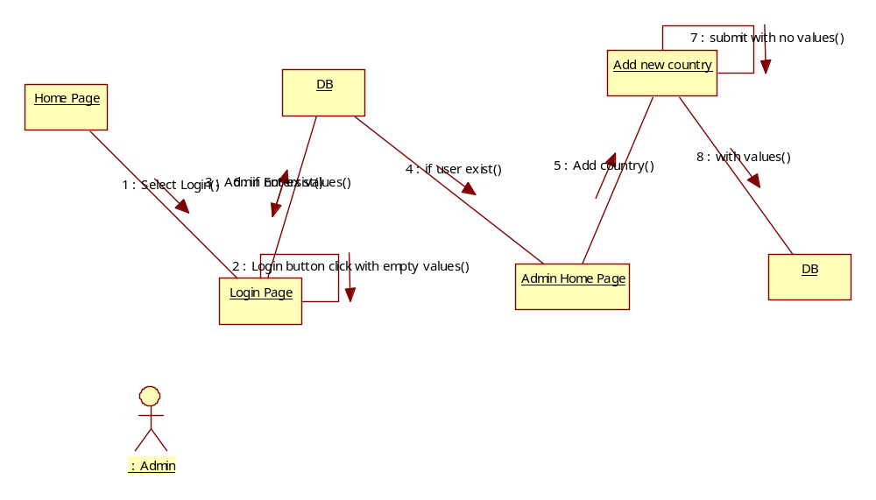

Collaboration diagram for Admin adding State

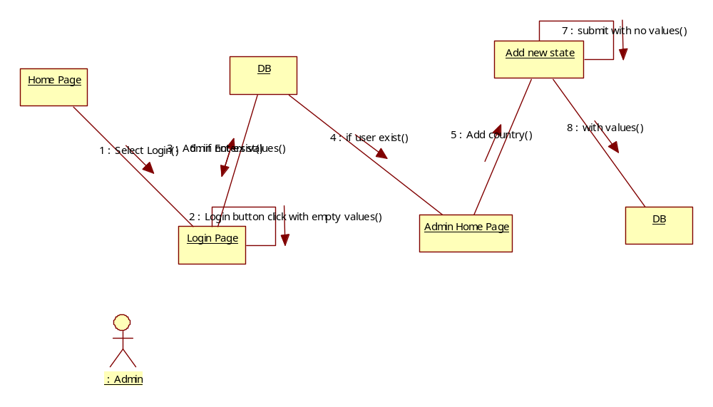

Collaboration diagram for Admin adding income

Home Page
Login Page
DB
Admin Home Page
Add income
DB
: Admin
1 : Select Login()
2 : Login button click with empty values()
3 : Admin Enters values()
4 : if user exist()
5 : Add cIncome()
6 : if not exist()
7 : submit with no values()
8 : with values()

Collaboration diagram for Alumni Mail Checking
Home Page
Login Page
DB
useri Home Page
INBOX
Mail Page
: user
1 : Select Login()
2 : Login button click with empty values()
3 : Admin Enters values()
4 : if user exist()
5 : Click on Inbox()
6 : if not exist()
7 : Select a mail()

