An Internship Report
Of
Internal Audit Virtual Internship
Submitted
To
School of Computer Science and Engineering
IILM University, Greater Noida, U.P.
In partial fulfilment of the requirement of degree of
B.Tech (Computer Science and Engineering)

By
Roll Number of Student: 2410030177
Name of Student: ARPITA SRIVASTAVA
Batch: 2024-2028

TABLE OF CONTENTS
1. Candidate's Declaration i
2. Acknowledgement ii
3. Internship Completion Certificate -
4. Project Description 1
4.1 Introduction 1
4.2 Organization Profile 1
4.3 Problem Statement 1
4.4 Project Objectives 2
4.5 Scope of the Project 2
4.6 Technologies and Tools Used 2
4.7 System Architecture 2
4.8 Methodology 3
4.9 Expected Outcomes 3
4.10 Certificates of Completion and Communication Proof 4
5. Bibliography/References 5

CANDIDATE'S DECLARATION
I hereby declare that the work presented in this internship report entitled “Internal Audit Virtual Internship” is an authentic record of my own work carried out during the course of my internship, under the guidance of the faculty of School of Computer Science and Engineering, IILM University, Greater Noida, U.P.
I further declare that the work reported in this report has not been submitted, either in part or in full, for the award of any other degree or diploma of this institute or any other institute or university.
All the information furnished in this report is based on my own study and observations during the internship period, and has been presented as accurately and honestly as possible.
Date: ______________
Place: Greater Noida
Signature of the Student
Name: ARPITA SRIVASTAVA
Roll Number: 2410030177

ACKNOWLEDGEMENT
I would like to express my sincere gratitude to everyone who supported and guided me throughout the completion of my Internal Audit Virtual Internship and this accompanying report.
First and foremost, I am thankful to the School of Computer Science and Engineering, IILM University, Greater Noida, U.P., for providing me the opportunity and platform to undertake this internship as part of my B.Tech (Computer Science and Engineering) curriculum.
I would like to extend my heartfelt thanks to my project guide and mentors, whose valuable guidance, constant encouragement and constructive feedback helped me understand the practical aspects of internal audit and risk assessment and successfully complete this internship.
I am also grateful to the faculty members of the department for their continuous support and for sharing their knowledge, which greatly enriched my learning experience during this internship.
Finally, I would like to thank my family and friends for their constant motivation and support, without which the successful completion of this internship report would not have been possible.
Name: ARPITA SRIVASTAVA
Roll Number: 2410030177

INTERNSHIP COMPLETION CERTIFICATE
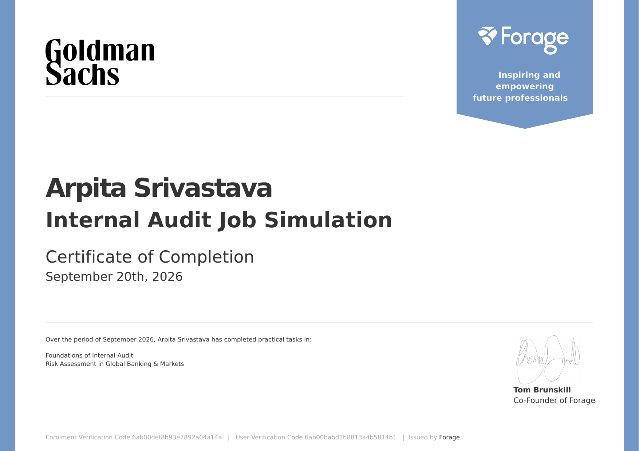

4. PROJECT DESCRIPTION
4.1 Introduction
This report presents a detailed account of the Virtual Job Simulation Internship undertaken through the Forage platform, in the domain of “Internal Audit”, in collaboration with Goldman Sachs. The internship was carried out in September 2026 as part of the requirement of the Bachelor of Technology (Computer Science and Engineering) programme at IILM University, Greater Noida. The primary aim of this internship was to build a strong practical foundation in internal audit and risk assessment, and to apply it to a real-world context — understanding how internal audit provides independent assurance in a large financial institution and how risks in global banking and markets are identified, assessed and prioritised.
The internship followed a structured, task-wise format combining the foundations of internal audit with a hands-on risk assessment exercise. On successful completion of both tasks, a Certificate of Completion for the Internal Audit Job Simulation was issued by Forage on September 20, 2026.
4.2 Organization Profile
Forage is a global virtual work experience platform that partners with leading organizations to offer free, self-paced job simulations, allowing students to gain practical, industry-relevant skills and a realistic understanding of the day-to-day work in a given role.
Goldman Sachs is a leading global investment banking, securities and investment management firm, founded in 1869 and headquartered in New York. It serves corporations, financial institutions, governments and individuals around the world. The internal audit function of a financial institution such as Goldman Sachs provides independent and objective assurance on the effectiveness of governance, risk management and internal controls. In this simulation, the tasks placed the participant in the role of an internal auditor working on a global banking and markets business.
4.3 Problem Statement
Large financial institutions operate in complex and heavily regulated environments where weaknesses in controls can lead to financial loss, regulatory penalties and reputational damage. Internal audit exists to independently examine whether risks are being identified and managed properly, and to direct management’s attention to the areas that matter most.
At the same time, although engineering students learn the theoretical foundations of computing and technology, very few get structured exposure to how risk, controls and audit work in a real business — an understanding that is increasingly valuable as financial services depend more and more on technology. The problem addressed by this internship was to practically learn and apply the foundations of internal audit and the risk-based approach, by assessing risk in a global banking and markets setting.
4.4 Project Objectives
- To understand the role, purpose and importance of internal audit within an organization.
- To understand the stages of an audit engagement, from planning to reporting and follow-up.
- To understand the risk-based approach used to decide where audit effort is most needed.
- To identify and assess key risks in a global banking and markets business.
- To evaluate the importance of internal controls in reducing risk.
- To communicate risk assessment findings clearly and professionally.
4.5 Scope of the Project
The scope of this internship covers two areas — the foundations of internal audit, and risk assessment in global banking and markets. The internship was limited to a virtual, simulation-based learning environment provided by the Forage platform in collaboration with Goldman Sachs, and did not involve any live audit engagement or access to confidential systems or data of any organization.
4.6 Technologies and Tools Used
- Learning Platform: Forage Virtual Work Experience Program (Goldman Sachs Internal Audit Job Simulation)
- Audit Concepts: Risk-based audit approach and the audit lifecycle
- Risk Assessment Techniques: Risk identification, and rating of risks by likelihood and impact
- Control Frameworks: Internal controls and the roles of the business, risk functions and internal audit
- Documentation Tools: Word processing and spreadsheet tools for notes, analysis and written responses
- Research Sources: Publicly available information on financial markets and banking businesses
4.7 System Architecture
The general audit workflow followed during the internship can be summarized in the following layers:
- Understanding Layer: Understanding the organization, its business activities and objectives.
- Risk Identification Layer: Identifying the risks that could prevent the business from achieving its objectives.
- Risk Assessment Layer: Rating each risk by its likelihood and potential impact to prioritise attention.
- Control Evaluation Layer: Considering whether controls exist and are effective in reducing the identified risks.
- Reporting Layer: Communicating observations and recommendations clearly to stakeholders.
- Follow-up Layer: Tracking whether agreed actions have been taken to address the issues raised.
4.8 Methodology
The internship followed a structured, task-wise methodology moving from the foundations of internal audit to their application in a risk assessment exercise, as summarized in the table below.
Task | Module | Description
1 | Foundations of Internal Audit | Learned the purpose of internal audit, its role in governance, risk management and control, and the stages of an audit engagement.
2 | Risk Assessment in Global Banking and Markets | Applied risk-based thinking to a global banking and markets business by identifying key risks, assessing their likelihood and impact, and prioritising areas for audit attention.
Note: There was no stipend associated with this internship.
The two tasks built on each other: the foundations learned in the first task provided the framework and vocabulary used to carry out the risk assessment in the second task.
4.9 Expected Outcomes
- Understanding of the role and importance of internal audit in a financial institution.
- Knowledge of the stages of an audit engagement and the risk-based approach.
- Ability to identify and assess risks in a banking and markets context.
- Awareness of how internal controls reduce risk.
- Skill in communicating findings in a clear and professional manner.
- A completed Goldman Sachs Internal Audit Job Simulation with a Certificate of Completion issued via Forage.
4.10 Certificates of Completion and Communication Proof
The Certificate of Completion for the Internal Audit Job Simulation, issued via the Forage platform confirming the successful completion of all simulation tasks, is attached at the beginning of this report as proof of completion. Its details are summarized below.
Participant | Arpita Srivastava
Program | Internal Audit Job Simulation (Goldman Sachs)
Issued by | Forage
Period | September 2026
Date of Completion | September 20, 2026
Enrolment Verification Code | 6ab00def8b93e7892a04a14a
User Verification Code | 6ab00babd1b8813a4b5814b1

5. BIBLIOGRAPHY / REFERENCES
- Forage – Virtual Work Experience Programs. https://www.theforage.com
- Goldman Sachs. https://www.goldmansachs.com
- The Institute of Internal Auditors (IIA). https://www.theiia.org
- Bank for International Settlements – Basel Committee on Banking Supervision. https://www.bis.org/bcbs/

